# Introduction

Zendesk Ticket Viewer is a web application that allows users to view and manage the support tickets. The web application connects to Zendesk API, requests all the tickets for user’s account, displays them in a list and displays individual ticket details. There are several steps for installation.

# Installation

* Creating Zendesk at Zendesk website (<https://zendesk.com>)
  + After creating Zendesk account, you can import tickets for testing.
  + Json ticket can be downloaded from (<https://gist.github.com/svizzari/c7ffed8e10d3a456b40ac9d18f34289c>)
  + Running the following command in your machine to import tickets. Make sure that the Json file will be in the same directory when the command is run

Example for importing tickets.

Curl https://helloworld.zendesk.com/api/v2/imports/tickets/create_many.json

-v -u Dung2781993@gmail.com:hellomama -X POST -d @tickets.json -H "Content-Type:

application/json"

* Testing the imported tickets in your account
  + You can use Postman to list all the tickets in your account

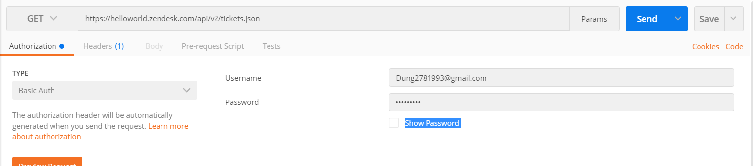

Figure : Credential values

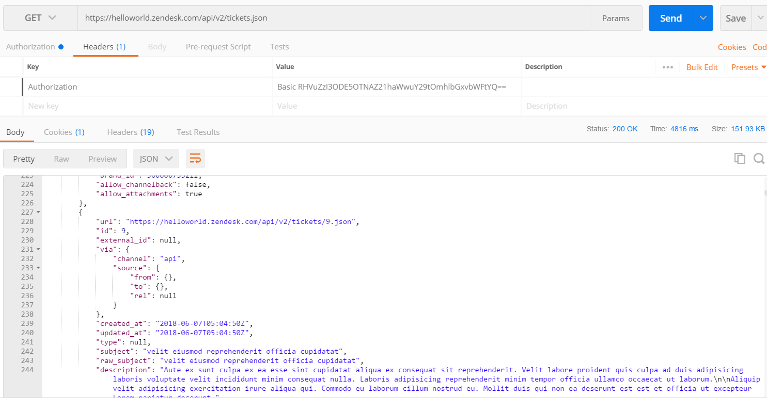

Figure : Ticket List

* + Or you can access through this URL to see all the tickets

( <https://helloworld.zendesk.com/api/v2/tickets.json/> )

* After importing tickets to your account, we can setup a web application to display the list of tickets.
  + To setup a web application, ASP.NET is used for creating a webpage, which displays tickets in a list and individual ticket details.
  + The code can be found under the folder named “TicketApplication”.

# Usage Instructions

The web application uses the MVC model, which easily handles the changes from the back-end and the front-end.

**Code Structure**

* The main functionality for this web application can be found in “HomeController.cs” file in Controller folder (Controllers/HomeController.cs).
* There are 4 main methods in “HomeController.cs” file including:
  + Index() : return the view
  + TicketList_Read(): return a list of tickets
  + TicketDetailed_Read(): return the detailed information for each ticket
  + GetTicket(): Call **GET** request to Zendesk account and return the response
* The content of the web application can be found in the “Index.chtml” file (Views/Home/Index.chtml)
  + The html file uses the Razor view, Bootstrap (HTML5, CSS3), jQuery and Kendo.UI (JavaScript library)
  + The Kendo library can be found in this link

( <https://www.telerik.com/kendo-ui/> )

**Web Application functionality**

The users can access the web application by clicking the following URL (<http://ticketapplicationzendesk.azurewebsites.net/> ). The web application is hosted on Azure server for testing. The web application displays a list of ticket from my Zendesk account (helloworld.zendesk.com).

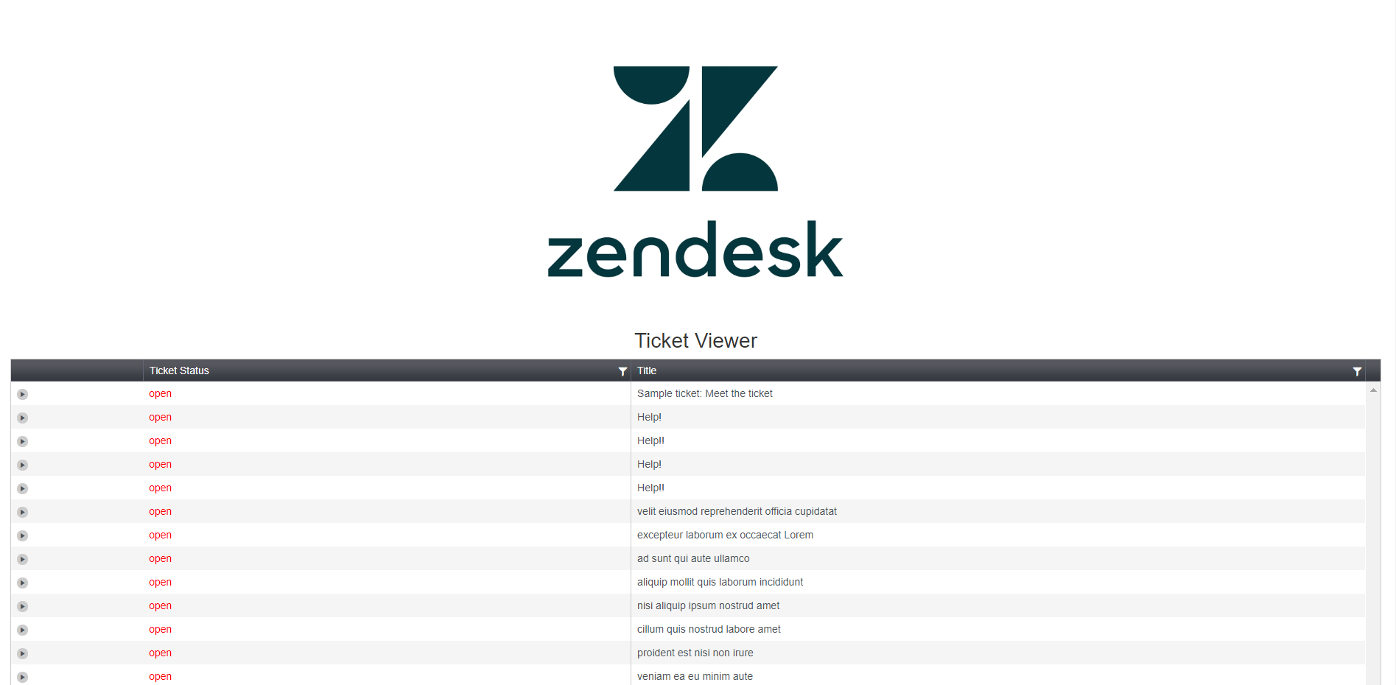

Figure : Ticket Viewer 1

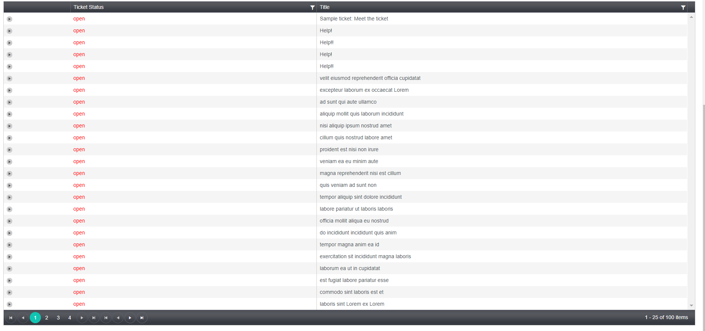

Figure : Ticket Viewer 2

A table will display all the ticket in my account (100 tickets). In this case, I set the default value for numbers of tickets on each page is 25.

If users want to see the detail of each ticket, they can click on the arrow icon to see the details of each ticket including requested number, title, description and created date.

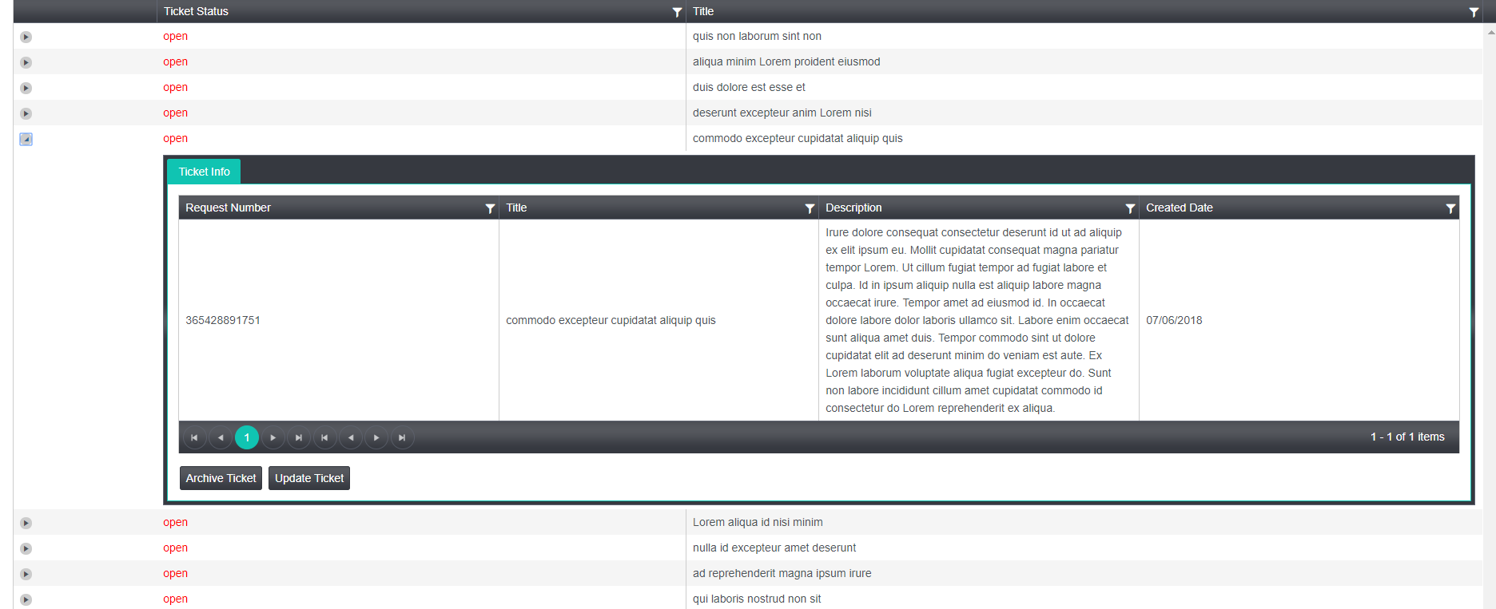

The table structure allows users to look at multiple tickets ‘s details rather than looking at one specific ticket.

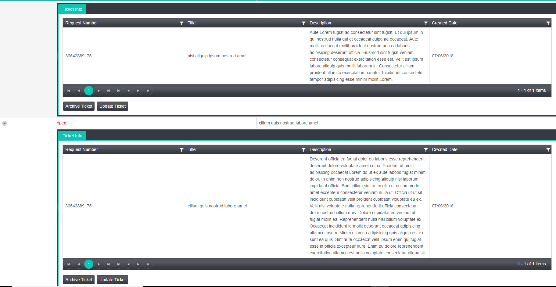

**Future Development**

On each ticket, there are 2 buttons named “archive ticket” and “update ticket”. The “archive ticket” will remove this ticket from the table and the “update ticket” will update the ticket’s status.

**Handle unavailable API**

If there is an issue with API connection (authentication), the web page will return the 404 message to inform the situation to users.



# Test Cases

**Handle unavailable API**

To display the error message if the API is unavailable or the repose is invalid, you can change the value of “*username*” and “*password*” in “GetTicket” method

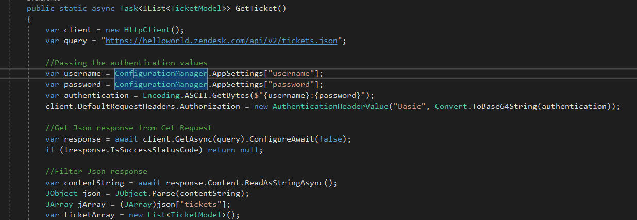

Figure : Get Ticket method

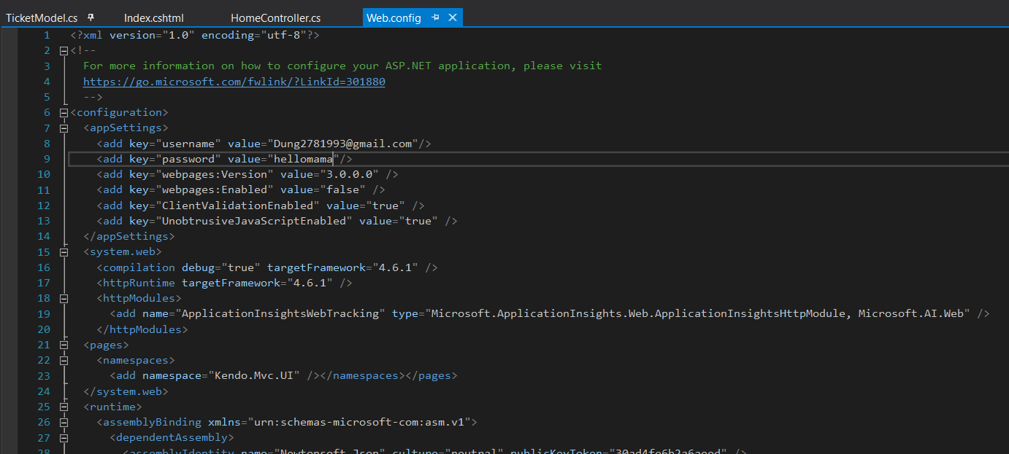

Figure : Credential value

The values of username and password are getting from “web.config” file. You can modify the values of username and password to see the error message.

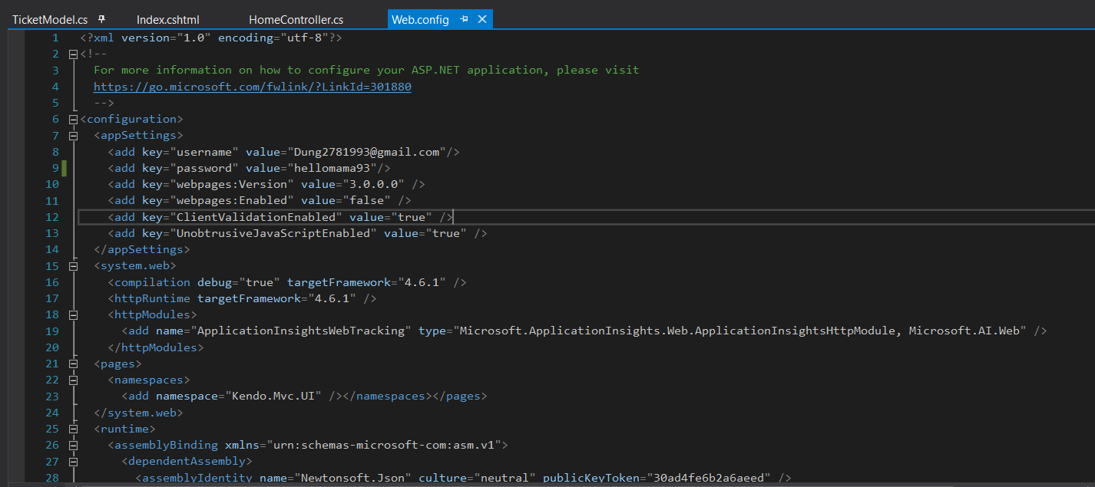

Figure : Updated password value

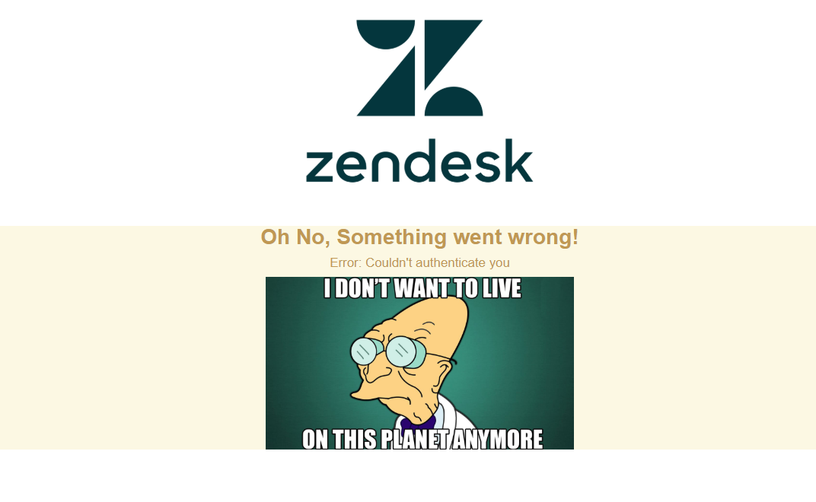

Figure : Warning Message

**Display the ticket value**

In this case, I am going to display the value of the following ticket in my account.

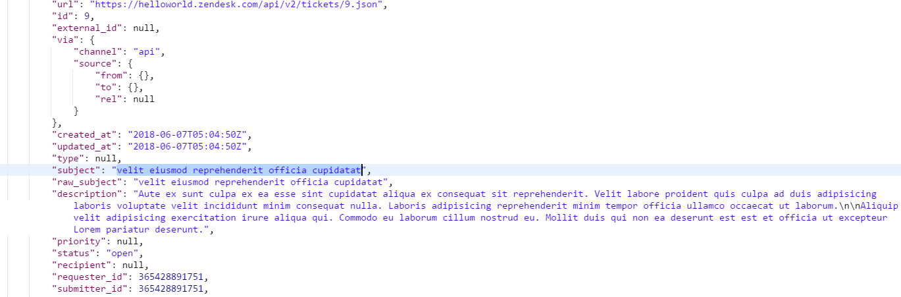

Figure : Ticket value

The ticket’s subject is “*velit eiusmod reprehenderit officia cupidatat*”. This ticket will be displayed in the ticket list.

