TUTORIAL

The 1’st Taste Café

--- Café Thượng Giác ---

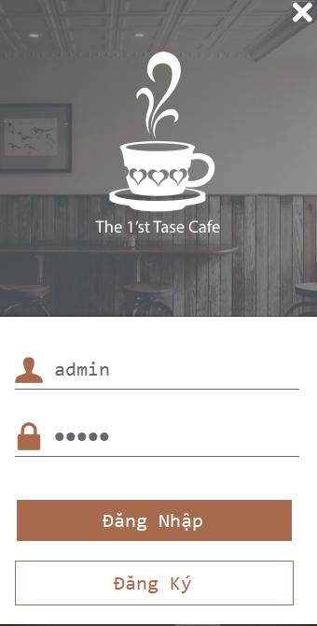

Login with username: admin

Password: admin

If not, you can register a new account in Register with 3 fields: account, password and re-enter the password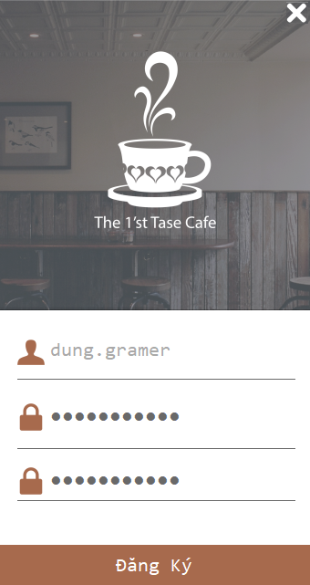

When entering the main interface, you can click on the image or text to select the dish. After selecting, click on the total to charge. The total amount of money is completed, enter the amount of money that the guest gave and press enter the software to calculate the excess.

When finished, print the invoice for the customer and press reset to reuse.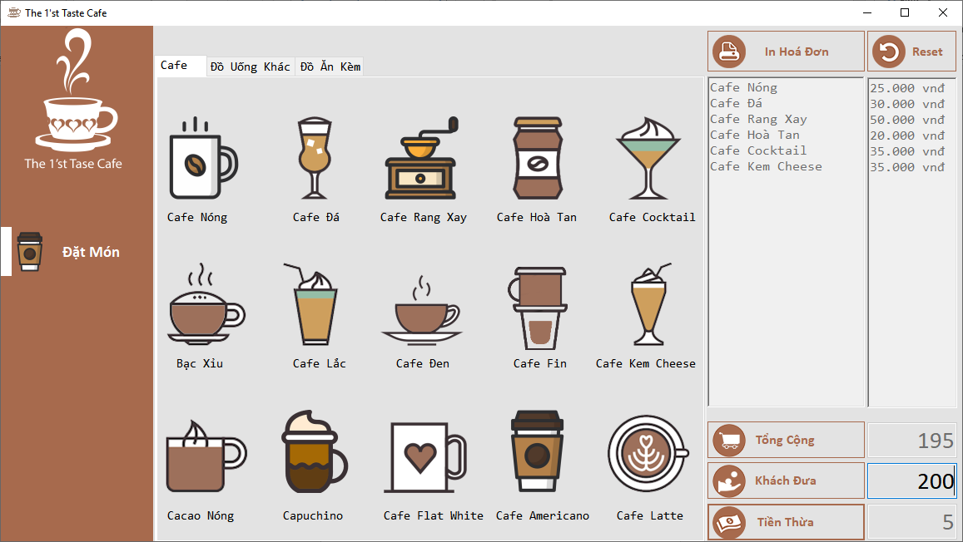

Please use and experience

----