# Overview

Configure-OA is a PowerShell script that leverages the HPE OA cmdlets to automate configuration of settings in OA including:

* Alert Mail
* Enclosure Bay IP Addresses (EBIPA)
* LDAP Authentication
* SNMP Settings/ SNMP User / SNMP Traps

# Prerequisites

* Windows 10 desktop or Windows Server 2012/2016
* HPE OA cmdlets: <http://h20566.www2.hpe.com/hpsc/swd/public/detail?sp4ts.oid=1008862655&swItemId=MTX_faf40660fdd346ae9548b86b57&swEnvOid=4210>
* Excel spreadsheet OA.Xlsx

# Configuring OA in your environment

1. Use the Excel spreadsheet OA.xlsx included in the package to customize settings that suits your environment
2. Save each tab as a CSV file
3. Run the script

# Script in Action!

### Configure AlertMail

.\Configure-OA.ps1 -OAApplianceIP <IP> -OAAdminName <AdminName> -OAAdminPassword <Password> -OAAlertMailCSV .\C7000\OA-AlertMail.csv

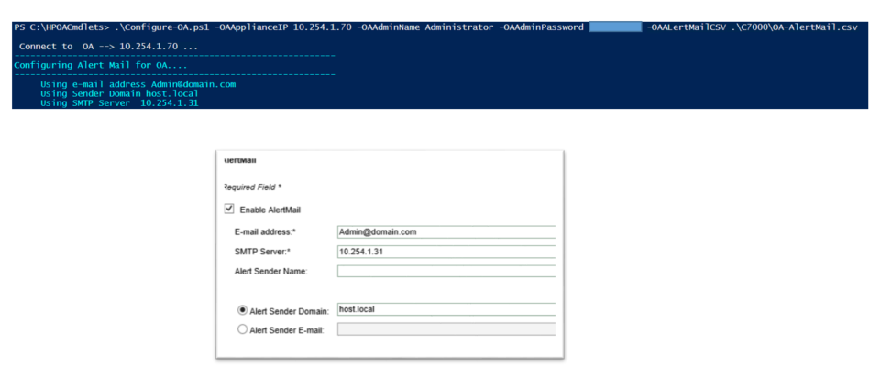

### Configure EBIPA

.\Configure-OA.ps1 -OAApplianceIP <IP> -OAAdminName <AdminName> -OAAdminPassword <Password> -OAEBIPACSV .\C7000\OA-EBIPA.csv

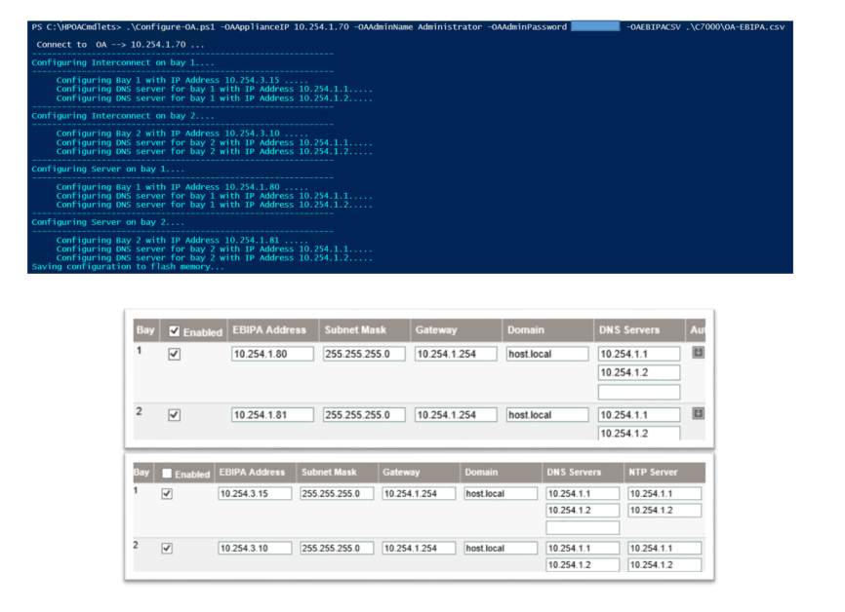

### Configure LDAP Authentication

.\Configure-OA.ps1 -OAApplianceIP <IP> -OAAdminName <AdminName> -OAAdminPassword <Password> -OALdapCSV .\C7000\OA-LDAP.csv

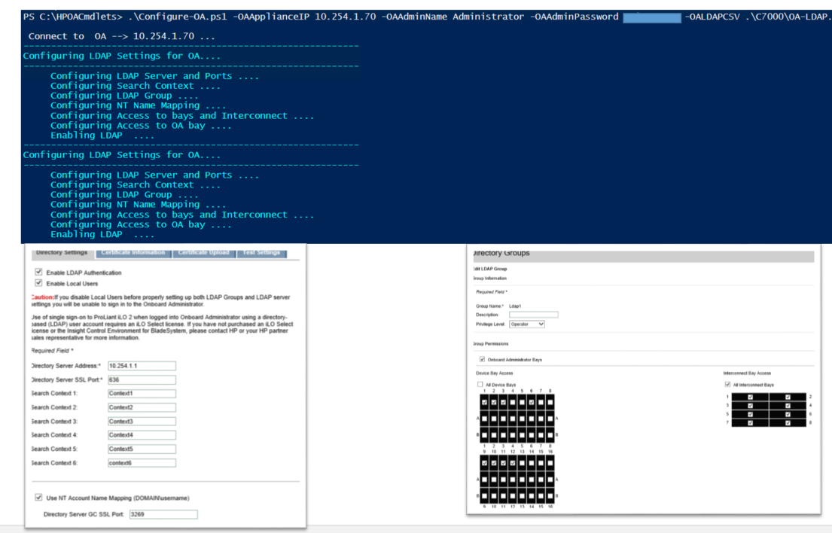

### Configure SNMP Settings

.\Configure-OA.ps1 -OAApplianceIP <IP> -OAAdminName <AdminName> -OAAdminPassword <Password> -OASnmpCSV .\C7000\OA-SNMP.csv

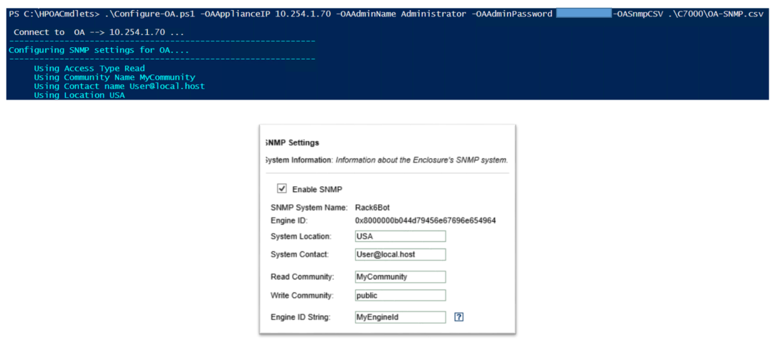

### Configure SNMP Users

.\Configure-OA.ps1 -OAApplianceIP <IP> -OAAdminName <AdminName> -OAAdminPassword <Password> -OASnmpUserCSV .\C7000\OA-SNMPUsers.csv

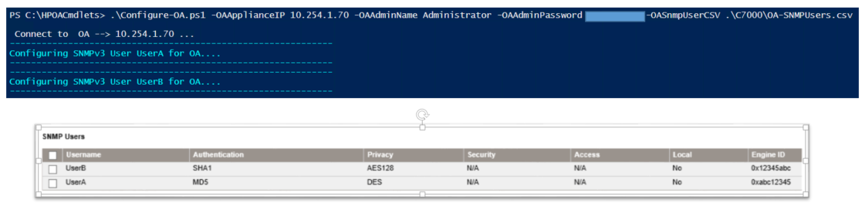

### Configure SNMP Traps

.\Configure-OA.ps1 -OAApplianceIP <IP> -OAAdminName <AdminName> -OAAdminPassword <Password> -OASnmpTrapCSV .\C7000\OA-SNMPTraps.csv

