Statistical Analysis Report on Graduation Rates and SAT Scores

Introduction
This report investigates the relationship between SAT scores (the sum of Math and Verbal) and graduation rates among colleges and universities. The data encompass 20 public institutions and 27 private institutions. Our primary questions are:
• Is there a significant positive association between SAT scores and graduation rates?
• How do the regression models differ between public and private schools?
• How well does the regression model predict the graduation rate for Truman, a public institution with an equivalent SAT score of approximately 1190?
We hypothesize that higher SAT scores are generally associated with higher graduation rates, although the strength of this relationship may differ by school type.

Analysis and Results
- Scatter Plot and Correlation Analysis
  - A scatter plot of graduation rates versus SAT scores (with different colors or symbols distinguishing public and private schools) reveals a positive trend for both groups.
  - Calculated correlation coefficients suggest a stronger relationship for public schools (approximately r ≈ 0.70) compared to private schools (approximately r ≈ 0.57).
  - These results indicate that while both groups show a positive correlation, the quality of the incoming students (as measured by SAT scores) may have a more pronounced effect on graduation rates in public institutions.
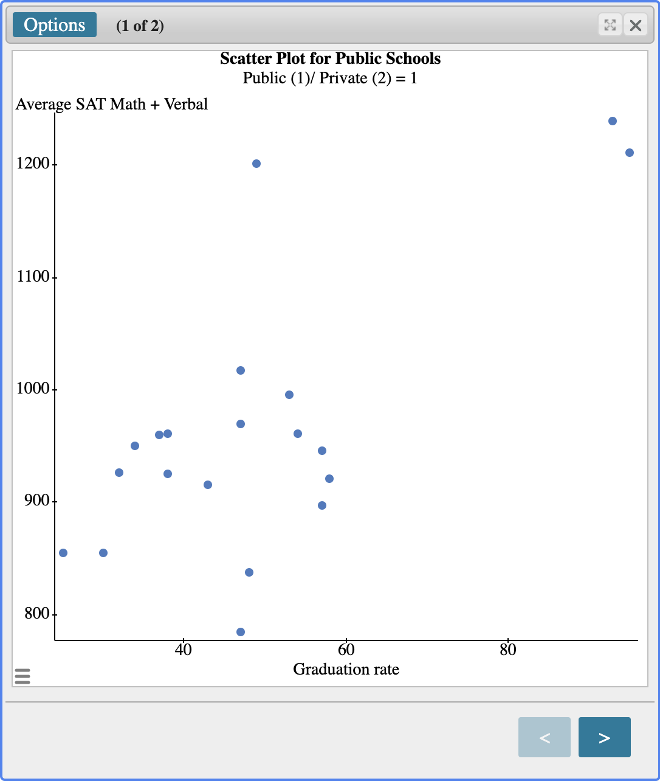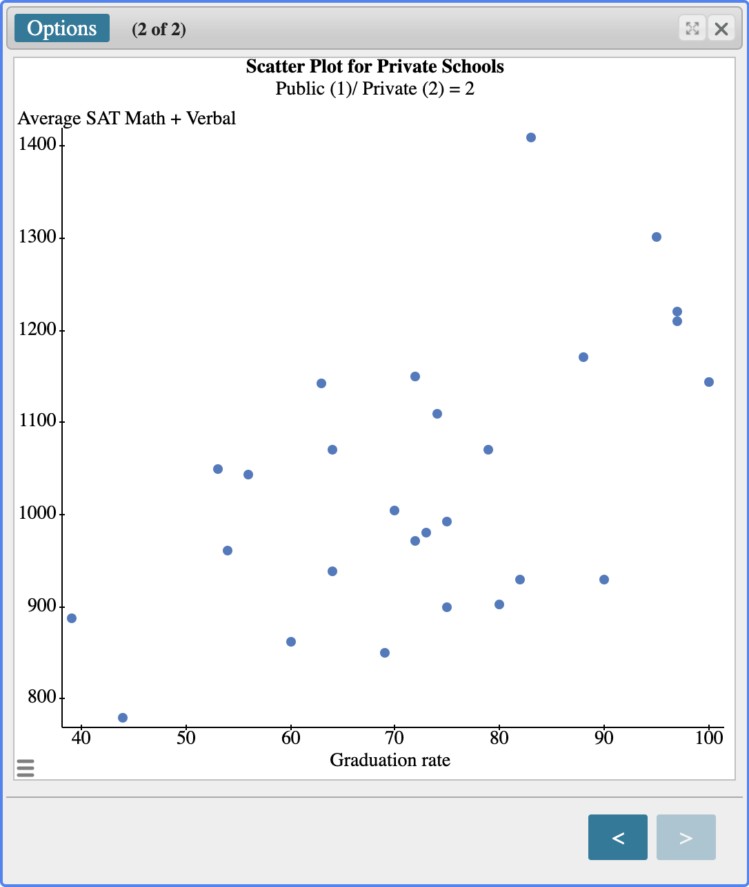

- Linear Regression Models
  - For public schools, the least squares regression analysis yields the equation:
Graduation Rate = –51.36 + 0.104 × (SAT Score)
This implies that for every one-point increase in SAT score, the graduation rate increases by about 0.104 percentage points.
  - For private schools, the regression analysis produces a different model:
Graduation Rate = 9.19 + 0.0615 × (SAT Score)
Here, each additional SAT point corresponds to an increase of approximately 0.062 percentage points in graduation rate.
  - The slope (0.104 for public schools and 0.0615 for private schools) indicates the estimated increase in graduation rate (in percentage points) for every additional point in the SAT score. This suggests that higher SAT scores are associated with higher graduation rates.
  - The intercept (–51.36 for public and 9.19 for private) represents the estimated graduation rate when the SAT score is zero. Although these values aren’t directly meaningful (since no student scores zero on the SAT), they are necessary for fitting the linear model over the observed range of SAT scores.
- Prediction for Truman
  - Using the public school regression model, the predicted graduation rate for Truman (with an equivalent SAT score of 1190) is calculated as:
–51.36 + 0.104 × 1190 ≈ 72.4%
  - The actual graduation rate for Truman is 76%, indicating that the model underestimates the graduation rate by about 3.6 percentage points. This small discrepancy suggests that while the model captures the general trend, other factors may also influence graduation outcomes.

Conclusion
The analysis confirms a positive relationship between SAT scores and graduation rates for both public and private colleges, with a stronger correlation observed among public institutions. The regression models reveal that increases in SAT scores are associated with corresponding increases in graduation rates. While the public school model predicts Truman's graduation rate at approximately 72.4%—a slight underestimation compared to the actual rate of 76%—this modest discrepancy suggests that the model is reasonably effective. However, it also indicates that other factors beyond SAT scores may influence graduation outcomes, pointing to potential avenues for further research and model refinement.

