


Subject: Introduction to Database – DBI202
Class: SE2002 - Lecturer: NhungNTH

BOOK STORE DATABASE MANAGEMENT SYSTEM

Group: 1
Nguyễn Trần Đức Anh – CE200031
Lê Tiến Dũng – CE201046
Trần Huỳnh Giác – CE200291
Huỳnh Nhật Duy – CE201224
Nguyễn Phú Trọng – CE200340

=======================================================
PROJECT REPORT
BOOK STORE DATABASE MANAGEMENT SYSTEM
=========================================================

- Course: DBI202 - Database Systems
- Class: SE2002
- Instructor: NhungNTH
- Date: UNKNOWN

- INTRODUCTION

1. TEAM MEMBERS
No. | Student ID | Full Name | Role / Contribution
1 | CE200031 | Nguyễn Trần Đức Anh | Team Leader, BOOK
2 | CE201046 | Lê Tiến Dũng | Project Manager, AUTHOR
3 | CE200291 | Trần Huỳnh Giác | Supporter, ORDER_DETAIL
4 | CE201224 | Huỳnh Nhật Duy | Supporter, ORDER
5 | CE200340 | Nguyễn Phú Trọng | Supporter, CUSTOMER

2. PROJECT OVERVIEW
This project aims to design and implement a relational database for a Book Store Management System. The system handles core business operations, including managing inventory (books and authors), storing customer information, and processing sales orders. The main goal is to ensure data integrity, prevent data loss, and optimize query performance for daily store management.

3. PROBLEM STATEMENT
Currently, small bookstores often face difficulties in managing inventory, tracking customer orders, and maintaining sales history manually. This leads to errors such as selling out-of-stock items or losing track of customer information. The Bookstore Management System is designed to digitize these processes. It provides a structured database to store books, authors, and customers, ensuring that every transaction is recorded accurately and inventory is updated automatically.

4. BUSINESS ROLES
Inventory Management: Each book has a specific quantity in stock. When a customer buys
a book, the stock must decrease.
Order Processing: A customer can place multiple orders. Each order can contain many different books with different quantities.
Author Information: A book can be written by one or more authors, and an author can write multiple books.
Data Integrity: * Cannot delete a book if it has been sold (exists in an order).
- Cannot delete a customer if they have an existing order history.
Cannot change the Book ID within an existing order detail.

- ENTITY RELATIONSHIP DIAGRAM – ERD

The system consists of 5 main entities:
- Strong Entities: BOOK, AUTHOR, CUSTOMER, ORDERS.
- Weak Entity: ORDER_DETAIL (Depends on ORDERS and BOOK).
Relationships:
- AUTHOR — BOOK: Many-to-Many (N-N).
- CUSTOMER — ORDERS: One-to-Many (1-N).
- ORDERS — ORDER_DETAIL: One-to-Many (1-N).
- BOOK — ORDER_DETAIL: One-to-Many (1-N).
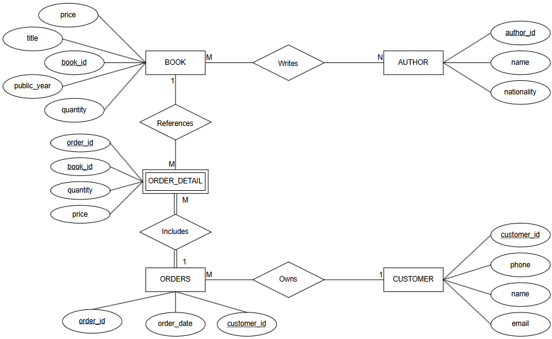

- RELATIONAL SCHEMA

Converted from ERD to Tables (3NF):
- BOOK (book_id, title, price, public_year, quantity, description)
- AUTHOR (author_id, name, nationality)
- BOOK_AUTHOR (book_id, author_id) -> Junction table for N-N relationship
- CUSTOMER (customer_id, name, phone, email, password)
- ORDERS (order_id, customer_id, order_date, status, shipping_address)
- ORDER_DETAIL (order_id, book_id, quantity, price)
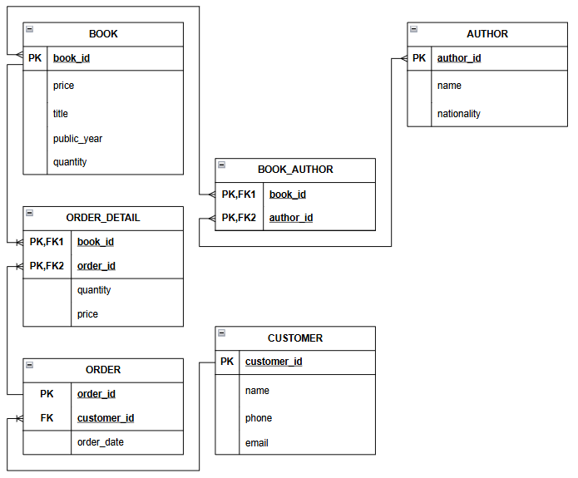
- TREE DIAGRAM

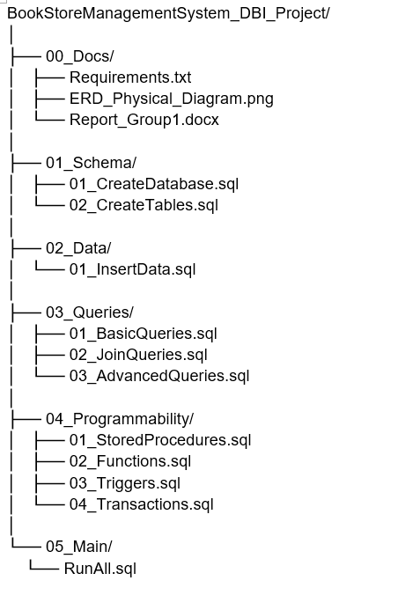

- DATA DICTIONARY

1. BOOK
Attribute | Data Type | Constraint | Description
book_id | INT | PK | Book identifier
title | VARCHAR(100) | NOT NULL | Book title
price | DECIMAL(10,2) | CHECK > 0 | Book price
public_year | INT | CHECK <= Current_year | Year of publication
quantity | INT | CHECK >= 0 | Available stock

2. AUTHOR
Attribute | Data Type | Constraint | Description
author_id | INT | PK | Author identifier
name | VARCHAR(100) | NOT NULL | Author name
nationality | VARCHAR(50) | NOT NULL | Author nationality

3. BOOK_AUTHOR
Attribute | Data Type | Constraint | Description
book_id | INT | PK, FK | Reference to BOOK
author_id | INT | PK, FK | Reference to AUTHOR

4. CUSTOMER
Attribute | Data Type | Constraint | Description
customer_id | INT | PK | Customer identifier
name | VARCHAR(100) | NOT NULL | Customer name
phone | VARCHAR(15) | NOT NULL | Phone number
email | VARCHAR(100) | UNIQUE | Email address

5. ORDERS
Attribute | Data Type | Constraint | Description
order_id | INT | PK | Order identifier
customer_id | INT | FK | Reference to CUSTOMER
order_date | DATE | NOT NULL | Order date

6. ORDER_DETAIL
Attribute | Data Type | Constraint | Description
order_id | INT | PK, FK | Reference to ORDERS
book_id | INT | PK, FK | Reference to BOOK
quantity | INT | CHECK > 0 | Quantity ordered
price | DECIMAL(10,2) | CHECK > 0 | Price at order time

- PHYSICAL IMPLEMENTATION

1. Overview
This section details the physical deployment process of the Book Store Management System Database. It outlines the mandatory sequential execution of all SQL scripts, strictly following the project's directory structure, to ensure correct object creation, resolve dependencies, and establish business logic without constraint errors.

2. Prerequisites
To ensure successful deployment, the following requirements must be met before execution, referencing the project's folder structure:
- Database Engine: SQL Server must be installed and operational.
- Client Tool: A suitable SQL client (e.g., SSMS, Azure Data Studio) is connected to the server.
- Project Structure: All project directories (01_Schema, 02_Data, 03_Queries, 04_Programmability) are fully accessible.
3. Execution Sequence and Dependency Logic
The database must be built by strictly following the four phases below, which ensures that all objects are created in the necessary order before they are referenced.
Phase | File | Action | Dependency Logic
Phase 1: Schema Initialization (01_Schema) | 01_CreateDatabase.sql | Creates the BookStoreManagementSystem database container and sets the execution context. | Must be executed first, as all subsequent scripts rely on this database context.
 | 02_CreateTables.sql | Creates all six relational tables (BOOK, AUTHOR, CUSTOMER, ORDERS, BOOK_AUTHOR, ORDER_DETAIL). | Tables without Foreign Key constraints (e.g., BOOK, AUTHOR, CUSTOMER) must be created first. Tables with Foreign Keys (e.g., ORDER_DETAIL referencing ORDERS and BOOK) must be created subsequently to ensure primary keys exist for reference.
Phase 2: Data Population (02_Data) | 01_InsertData.sql | Populates the tables with initial mock records. | Data must be inserted into parent tables (BOOK, AUTHOR, CUSTOMER) before inserting records into any child tables (BOOK_AUTHOR, ORDERS, ORDER_DETAIL) to satisfy Foreign Key constraints.
Phase 3: Programmability Setup (04_Programmability) | 03_Triggers.sql | Creates and attaches five system Triggers to enforce automated inventory management and data integrity. | Must be executed after the base tables (BOOK, ORDER_DETAIL, CUSTOMER, ORDERS) are established. Triggers implement critical business rules: automatically adjusting BOOK stock upon ORDER_DETAIL modifications (trg_Insert_OrderDetail, trg_Delete_OrderDetail, trg_Update_OrderDetail), and preventing the deletion of a BOOK or CUSTOMER that has existing historical records (trg_Prevent_Delete_Book, trg_Prevent_Delete_Customer).
 | 01_StoredProcedures.sql | Compiles and deploys all stored procedures. | Must be executed after the base schema and all Triggers are in place. Procedures often implement complex transactions (e.g., sp_CreateCustomerAndOrder, sp_CancelOrder) and rely heavily on the underlying table structure and the inventory management logic enforced by the Triggers.
 | 02_Functions.sql & 04_Transactions.sql | Deploys any user-defined functions or standalone transaction scripts. | These must be deployed after all dependent schema objects and business logic procedures have been established.
Phase 4: System Verification (03_Queries) | 01_BasicQueries.sql | Executes simple SELECT statements. | Verifies basic data retrieval and confirms successful population of all tables.
 | 02_JoinQueries.sql | Executes multi-table join queries. | Validates that Foreign Key relationships between tables are functioning correctly.
 | 03_AdvancedQueries.sql | Executes aggregation, grouping, and subqueries. | Validates the system's ability to handle complex reporting and analytics requirements.

- CONCLUSION

1. PROJECT SUMMARY
The current database successfully manages the basic operations of a bookstore. It ensures data integrity through Primary Keys, Foreign Keys, constraints (CHECK, UNIQUE), and automated Triggers. Normalization forms (up to 3NF) have been applied to eliminate data redundancy.

2. FUTURE ENHANCEMENTS (Development Ideas)

Due to the time limits of the assignment, the system can be upgraded in the future with the following features:
* Category Management: Add a `CATEGORY` table (e.g., Fiction, Science, Comic) to classify books for easier searching.
* Payment Methods: Add a `PAYMENT` table to track different payment types (Cash, Credit Card, E-wallet like Momo/VNPay).
* Discount & Voucher System: Add a `PROMOTION` table to manage seasonal sales and discount codes for loyal customers.
* Employee Management: Add a `STAFF` table to track which employee processed which order, useful for calculating KPI and shifts.
* Book Reviews & Ratings: Allow customers to rate books and write comments after purchasing.

