For the submission of your work:
- Create a folder named RollNo_Name_DBI202_PaperNo, e.g. se01245_LongNT_DBI202_01. Do not create any subfolder in this folder. All file created will be located in the above folder.
- For each question, you are required to write a database script. Create a file with the name corresponding to the index of the question. For example, for question 1, we will create a file named Q1.sql and create a file Q2.sql for question 2. So, if you do 10 questions, your folder must contain only 10 files Q1.sql, Q2.sql, Q3.sql, Q4.sql, Q5.sql, Q6.sql, Q7.sql, Q8.sql, Q9.sql and Q10.sql.
- Do not use any commands having the database name such as create database, alter database, use [database name], etc.
- Your response must contain only necessary commands for answering the question. Do not include any other command. For example, if you are required to create a trigger/procedure, then your response should contain only commands for creating the corresponding trigger/procedure; all commands for testing the created trigger/procedure are forbidden.
- On completion, import your work by browsing to the above folder.
- Note that:
+ You could use only SQL Server, SQL Server Management Studio, and paper or offline document in your computer.
+ If any of the previous requirements is not respected, your mark will be 0.

From the 2nd question, you should use the database provided in the .sql file which has the following database diagram. Please, run the provided script to create tables and insert data into your database.

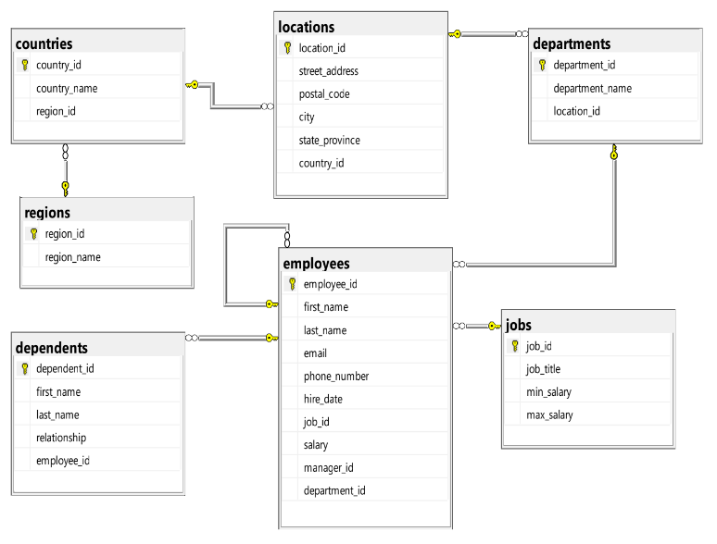

Question 1:
Create one database and then write SQL statements to create, in this database, all tables derived from the ERD given in the following picture with appropriate attributes, primary keys and foreign keys.
NOTE that when creating the SQL commands as request, you MUST keep the name of tables, relationship, attributes and data type of attributes as SAME as given in the given ERD.
Attributes with underline belong to the Primary Key of each entity.
Attributes which reference to the primary key of another table must have the same name as the attributes in the primary key of the referencing table.
When submitting the responses for this question, submit only SQL statements for creating tables with corresponding keys and foreign keys. Do not use “create database”, “Alter database”, “use database_name” or any statements using database’s name in your submission.

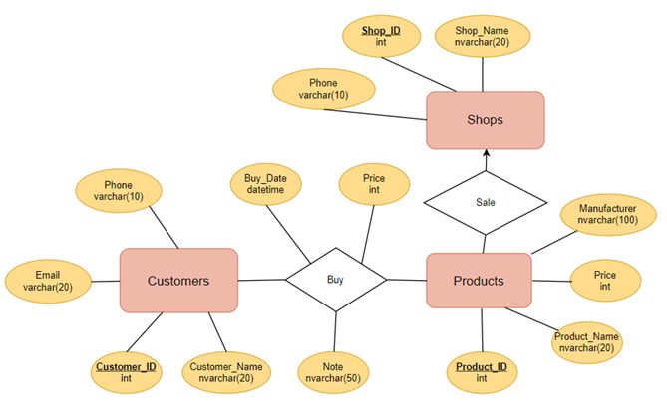
Picture 1.1
Question 2:
Write a query to find all departments with location_id 1700.
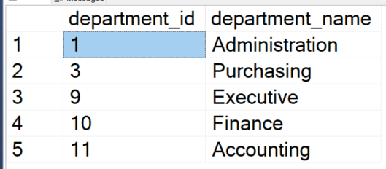
Picture 2.1

Question 3:
Write a query to find the employees who do not belong to any dependent.
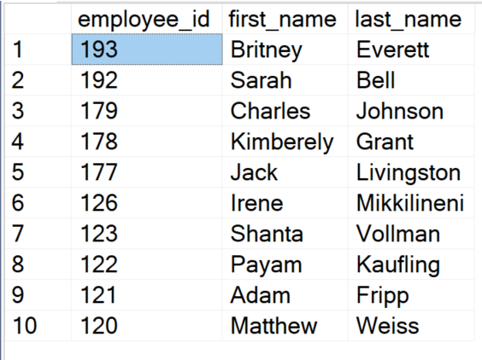
Picture 3.1
Question 4:
Write a query to get the first_name, last_name, job_title, department_name, country_name, salary of employees who work in Europe and have a salary greater than 7000.
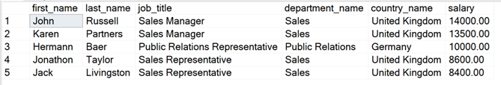
Picture 4.1
Question 5:
Write a query to count how many departments can be opened in each country, show only greater than 1 and sort by number of departments in descending order.
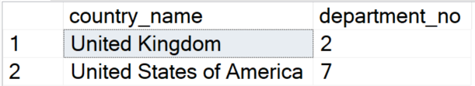
Picture 5.1
Question 6:
Write a query to find employees who joined the company between 1990 and 1993, in which employees’ names shown as full names

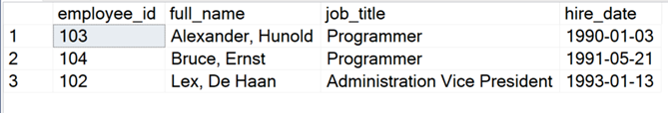
Picture 6.1

Question 7:
Write a query to find the departments that have the average salaries of employees between 5000 and 7000, with avg salary round 2 numbers after the decimal point.
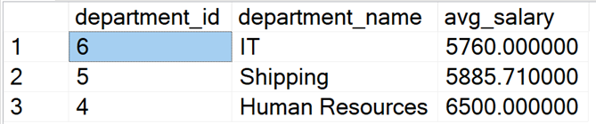
Picture 7.1
Question 8:
Create a procedure named proc1 to calculate the number of employees in the department.
For example, when the statement below (to find the number of employees in the department 9) is executed, the result should be as in the following figure:
declare @numberOfEmployees int
exec proc1 9, @numberOfEmployees output
select @numberOfEmployees
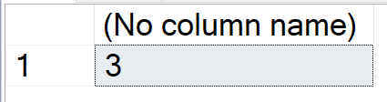
Picture 8.1
Question 9:
Write a statement to increase the min_salary to 6000 and the max_salary to 12000 for the job_title = ‘Programmer’.

Question 10:
Create a trigger named trig2 for the insert statement on table Employees so that when we insert a new records, the system will LOWERCASE the email attribute.
For example, when the following statement is executed, the result will be as in the following figure:
INSERT INTO employees (first_name, last_name, email, phone_number, hire_date, job_id, salary, manager_id, department_id)
VALUES('Van An', 'Nguyen', 'AnNV12@fpt.edu.vn', '0123456789', '1/1/2022', 1, 10000, 100, 1);
SELECT first_name, email
FROM employees e
WHERE e.employee_id = (SELECT max(employee_id) FROM employees)
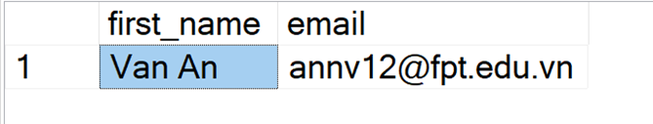
Picture 10.1

