Practical Exam Answer Sheet
Subject Code | SWE202c
Subject name | Introduction Software Engineering
Page no | 1
Topic
Time | 120’
Tools | MS Word, Draw.io for desktop, MS Visio, Astah, Visual paradigm, Start UML
Student ID | CE201046
Student Name | Lê Tiến Dũng
Date | <Exam date>

Question 1. Software development model (2.0)
<Student write the answer here>
1.1
Chosen Model: Agile (Scrum) framework.
Justification:
- Requirements stability: While the core business logic of the Clothes Shopping Online System might be understood, the detailed UI/UX expectations for various user groups Customers, Vendors, Customer Support Agents, Marketing Staff, System Administrator are rarely fixed from the start. Agile allows the team to refine requirements iteratively based on actual user feedback.
- Iterative delivery & Feedback: Iterative delivery provides immense value. The team can release a critical module, such as Browse and Search,early for user testing, and develop subsequent modules like Filter service in later sprints.
- Risk factors: The project faces significant technical risks regarding handling 2000 concurrent users and data security. Agile allows the team to conduct load and security testing early in the initial sprints, mitigating the risk of critical system failure near the deadline.
- Team size, duration, and process: Assuming a standard development team and tight time constraints, Agile maximizes productivity through short sprints. Even if StyleHub has a strict change-control process, Agile integrates well by managing changes transparently through a prioritized Product Backlog.
1.2
Alternative Model: Waterfall Model.
Comparison:
- Agile (Scrum):
  - Advantage 1: Highly adaptable to UI/UX changes, ensuring the final product is user-friendly and meets standards like: WCAG 2.1 AA.
  - Advantage 2: Early detection of fatal technical risks (e.g., performance bottlenecks) through continuous testing.
  - Disadvantage 1: Difficult to accurately estimate the exact final budget and complete timeline on day one.
  - Disadvantage 2: Requires continuous time commitment from StyleHub stakeholders for feedback.
- Waterfall Model:
  - Advantage 1: Facilitates highly detailed architectural planning upfront, aligning well with traditional bureaucracy.
  - Advantage 2: Produces comprehensive system documentation for long-term maintenance.
  - Disadvantage 1: Late testing phase means if the system fails to handle the peak user load, it causes catastrophic delays.
  - Disadvantage 2: Lack of early user feedback might result in a practically difficult system for end-users.

Question 2. UC Modeling (1.5)
<Student write the answer here>
2.1
Customers
  - Primary Goal: browse and search, filter, rating, view detailed product pages ,add items to a persistent wishlist or shopping cart, complete a secure checkout with multiple payment options and track their orders from dispatch to doorstep.
  - Type: Primary Actor.
Vendors
  - Primary Goal: List and manage their own products, update invetory, configure time-limited promotions or flash-sale prices, and view sales analytics dashboards showing revenue, conversion rates, and return frequencies.
  - Type: Primary Actor.
Customer Support Agents
  - Primary Goal: Look up any order, process returns and refunds, respond to product inquiries, and escalate complex cases.
  - Type: Primary Actor.
Marketing Staff
  - Primary Goal: require a campaign management module to configure site-wide vouchers, banner advertisements, push-notification schedules, and loyalty-point rules.
  - Type: Primary Actor.
System Administrator
  - Primary Goal: responsible for user and role management, payment-gateway configuration, platform-level monitoring, and automated data backups.
  - Type: Primary Actor.
2.2
- Browse Product | Initiator: [Customer | Goal: System allow to browse an extensive product catalogue
- Search product | Initiator: Customer| Goal: System allow to Search an extensive product catalogue
- Filter service| Initiator: Customer | Goal: filterable by category, brand, size, colour, price range, and customer rating
- Manage products| Initiator: Vendors| Goal: System allow to list and manage their own products, update inventory levels,
- configure time-limited | Initiator: Vendors | Goal: System allow configure time-limited promotions or flash-sale prices
- Look up service | Initiator: Customer Support Agents | Goal: look up any order, process returns and refunds, respond to product inquiries
- Manage User Accounts | Initiator: System Administrator | Goal: To create, update, or deactivate accounts.
- Login System | Initiator: Any User | Goal: To authenticate and access the system safely.
2.3
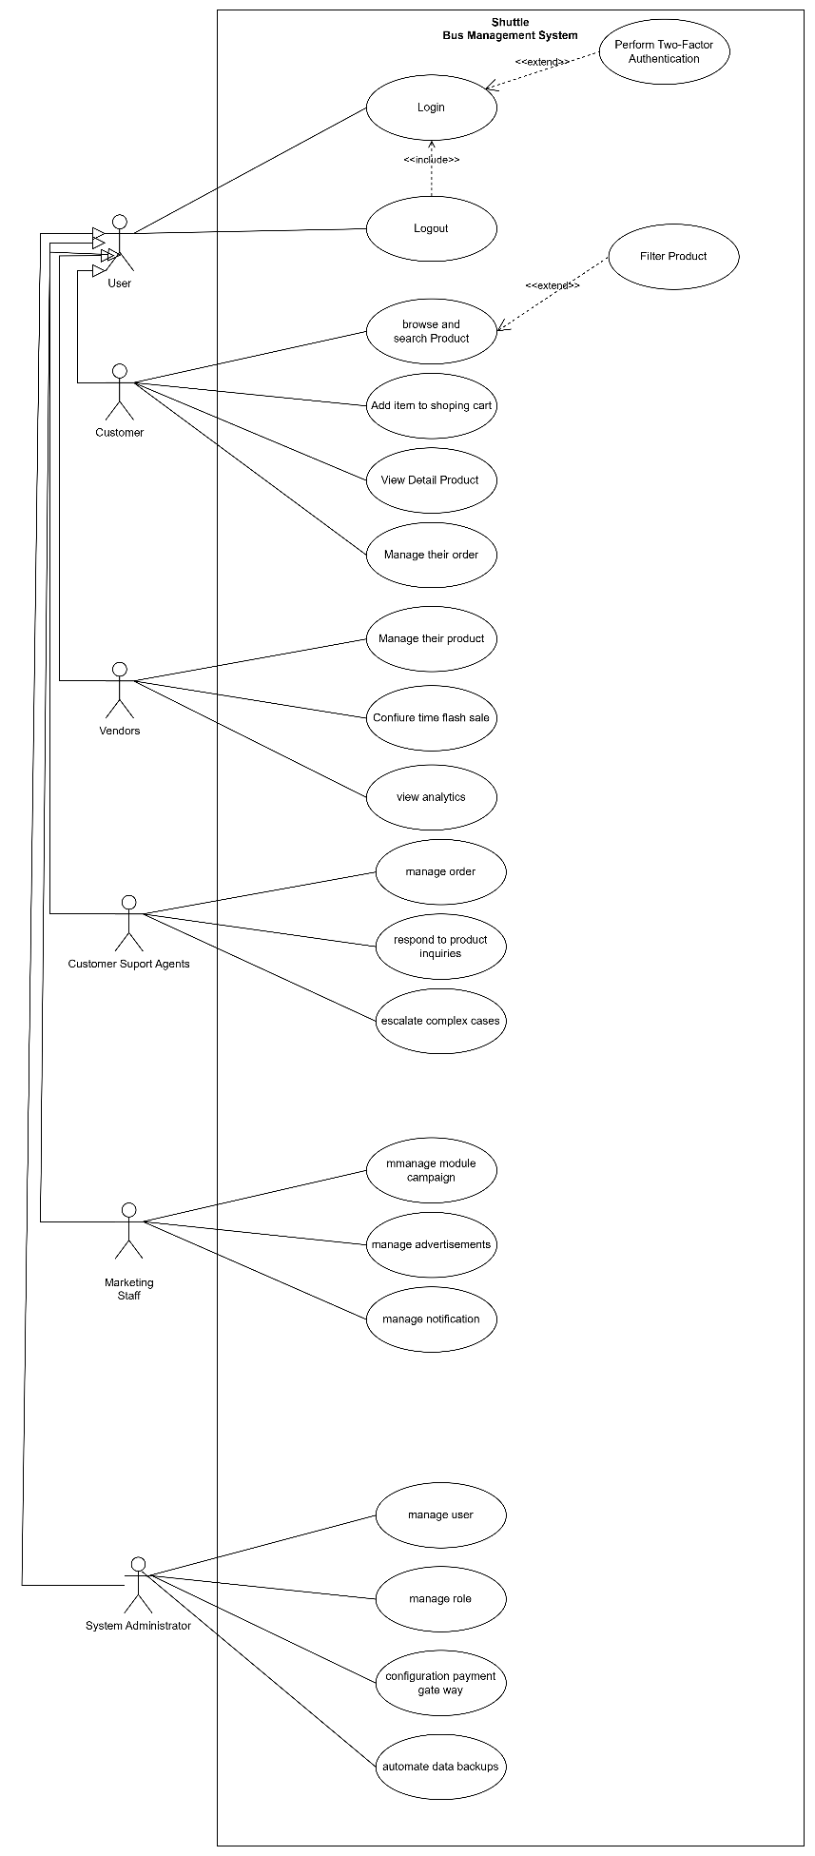

Question 3. UC Specification (1.5)
<Student write the answer here>
UC SPECIFICATION TEMPLATE
Use Case Name | Place Order
Use Case ID | UC_01
Actor(s) | Customer
Preconditions | 1. The Customer is successfully logged into the system.  2. The Order window is opened.
Post conditions | The customer has successfully completed creating order and the new record is saved in the database.
Main Flow (Basic Path) | 1. The Customer clicks on the "Add order" button.  2. The System displays the input form.  3. The Customer enters the required information Product name, Code, Price,...  4. The [Actor] clicks "Submit" / "Save".  5. The System validates the input data and verifies that the Code is unique.  6. The System saves the new order to the database.  7. The System displays a success message.
Alternative Flow A | Auto-fill  3a. The customer chooses to select a template.  3b. The System saves current inputs without full validation.  3c. The Use Case ends temporarily.
Alternative Flow B | Duplication Error  5a. The System detects that the Product Code already exists in the database.  5b. The System displays a specific error message: " Product Code must be unique."  5c. The customer is asked to re-enter the data.
Exception Flow | 1. All mandatory fields (*) must be filled.  2. The ID/Code must follow the format ABC-123].
Business Rules | The system must process the creation within 2 seconds
Non-Functional Requirements | UC_01

Question 4. Non-functional requirements (1.0)
<Student write the answer here>
Non-functional requirements (NFRs) into appropriate quality categories described in the table below.
Category | NFR Description | Acceptance criterion
1. Performance | The system must load any page within 2 seconds to ensure quick access without delays. | When navigating to any page under normal network conditions, the system shall fully render the page in strictly under 2 seconds for 95% of requests.
2. Security | All customer personal data and payment credentials must be encrypted | All customer personal data and payment credentials must be encrypted in transit (TLS 1.3) and at rest (AES-256), and the system must comply with Vietnam's Personal Data Protection Decree (PDPD 2023). Access must be enforced through a role-based access control (RBAC) model.
3. Availability | The platform must target 99.9% monthly availability | planned maintenance windows scheduled between 02:00 and 04:00 local time.
4. Maintainability | The architecture must support horizontal auto-scaling | so that additional application nodes can be added transparently behind a load balancer as traffic grows.

Security vs. Performance
- Conflicting NFRs: Security (Authentication/Authorization) vs. Performance.
- Why the conflict arises: To ensure high security (such as enforcing 2FA or continuous data encryption), the system must execute additional complex verification and encryption algorithms. This consumes significant CPU resources and increases response time, causing the page to load slower than the required limit.
- Proposed Trade-off Strategy: Apply a flexible prioritization strategy. For highly sensitive data (e.g., passwords, grades), strictly enforce Security even if it slightly degrades performance. For public, non-sensitive data (e.g., course catalog), reduce security checks and utilize caching to guarantee speed.

Question 5. Class Diagram (1.5)
<Student write the answer here>
5.1 Class List and Description
Class name | Attributes | Methods
1. User | - id: String  - email: String  - password: String | + login(): boolean  + logout(): void
2. Customer | - address: String  - phone: String | + updateProfile(): void  + viewHistory(): List
3. Product | - itemId: String  - name: String  - price_or_quota: float | + getDetails(): String  + checkAvailability(): boolean
4. Order | - transactionId: String  - createdDate: Date  - status: String | + confirm(): void  + cancel(): void
5. Vendor | - department: String  - vendorId: String | + manageItems(): void
6.customerSupportAgents | - staffID: String  -salary: float | + manageOrder(): void
7.MarketingStaff | - staffID: String  -salary: float | + manageAdvertisements(): void
8. SystemAdministrator | - staffID: String  -salary: float | + manageUser(): void  + manageRole(): void  + manageConfiuration(): void
6. Report | - reportId: String  - generatedDate: Date | + exportPDF(): void

5.2 Class Diagram

Question 6. AI in Coding (1.0)
<Student write the answer here>
Prompt 1:
Role & Context: Act as a Senior Java/Spring Boot Developer and Security Expert working on the Stucture Project Source Code with MVC Architecture
Intended Behavior: The development team has started the project but all classes (controllers, services, repositories, models, DTOs, and configuration files) are placed in a single package com.stylehub without any further organisation. The team wants to refactor the project into a clean MVC (Model-View-Controller) architecture so that the codebase is easier to maintain, test, and scale.
The current flat package: 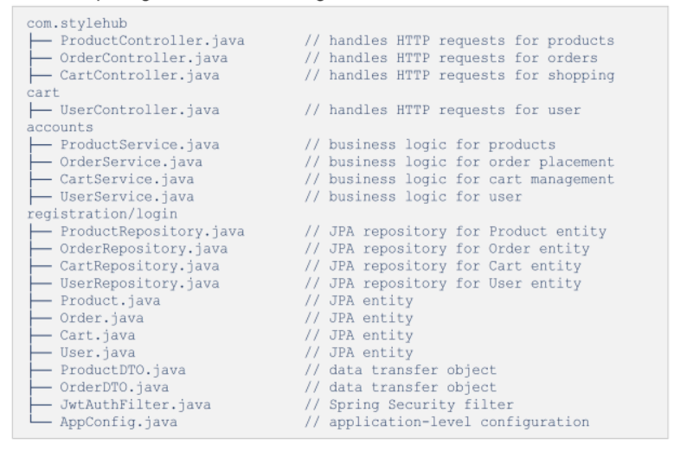
The Goal: (1) the system context (CSOS, Java Spring Boot), (2) the goal (restructure into MVC with clear package naming), (3) the full list of existing classes provided above, and (4) the expected output format (a proposed directory tree with package names and brief justification for each layer).
Expected Output Format: Present this as a table with columns: Class Name | MVC Layer |Justification.

Question 7. Testing Stage and Type (1.5)
7.1 Testing Stage and Responsibility
- Unit Testing: Tests individual components/functions (e.g., a specific method like checkEligibility()). Responsible: Developers. Applicable Types: White-box testing, Statement coverage.
- Integration Testing: Tests the interaction between grouped components or APIs (e.g., Registration Service interacting with Database). Responsible: Developers or QA Engineers. Applicable Types: API Testing, Interface testing.
- System Testing: Tests the complete, integrated system as a whole to verify compliance with both functional and non-functional requirements. Responsible: Independent QA Team. Applicable Types: End-to-end testing, Load testing, Security testing.
- Acceptance Testing (UAT): Tests if the system satisfies business needs from the user's perspective before final release. Responsible: End-users / Stakeholders. Applicable Types: Alpha/Beta testing, Black-box testing.
……
7.2 Test Cases
TCID | Test Case Name | Precondition | Test steps | Expected result | Test type
TC1 | Happy Path: Successfully places an order and receives a confirmation | User is logged in. System is ready. | 1. Navigate to Add screen.  2. Fill all mandatory fields with valid data.  3. Click "Save". | System saves the Place Order, displays success message, and updates the list. | Functional (Positive)
TC2 | Boundary: places an order for the very last item in stock (stock quantity = 1) | User is logged in. Form is opened. | 1. Enter Stock quantity = 1 in the Stock field.  2. Fill other fields.  3. Click "Save". | System accepts the input successfully without crashing or truncating text. | Boundary Value Analysis
TC3 | Negative: Submit form with payment declined by the Payment Gate way | User is logged in. A record with payment already exists in DB. | 1. Enter existing payment into the payment field.  2. Click "Save". | System rejects submission, shows explicit duplication error message, and retains form data. | Functional (Negative)

