Practical Exam Answer Sheet
Subject Code | SWE202c
Subject name | Introduction Software Engineering
Page no | 1
Topic
Time | 120’
Tools | MS Word, Draw.io for desktop, MS Visio, Astah, Visual paradigm, Start UML
Student ID | <Fill student no here>
Student Name | <Fill student name here>
Date | <Exam date>

Question 1. Software development model (15%)
<Student write the answer here>
1.1 Selected Model: Agile / Scrum Framework
- Justification:
• Whether requirements are fully known and stable at the outset: Agile prioritizes adapting to change rather than strictly following a rigid plan. Requirements are managed via a Product Backlog (a list of all desired system functions). In the SBMS, requirements are not fully stable because the system must support multiple user roles (lecturers/staffs, academic staff, admin manager) and evolving rules.
• The need for iterative delivery and regular stakeholder feedback: Iterations (Sprints) are driven by the Product Owner, who represents the customer and prioritizes requirements. Focus is on individuals and interactions over processes. For SBMS, features such as bus routes, record and summarize costs, allowing allows managers to view bus schedules for weekly trips, approve weekly bus schedules, and view vehicle cost summary.
• Risk factors specific to the project: Risks are mitigated through Continuous Integration (CI), where code is integrated daily, helping to detect errors quickly and reduce integration conflicts. This is important for SBMS because the system must handle plan and view bus schedule functions, are built to ensure no critical bugs during acceptance phase. SBMS is designed to operate continuously every hour with minimal downtime, ensuring that schedule planning and viewing are never interrupted
• Team size, project duration, and the change-control process: The team is self-organizing to determine the best way to deliver the product. Daily Scrums answer what was done, what will be done, and identify any impediments. Agile is suitable for a mid-sized project like SBMS in a university with approximately many people, where policies and requirements may change frequently during development.

1.2. Comparison with Alternative Model: Phased-Release Process
Advantages:
• Advantage 1: Plans for inevitable change]
• Advantage 2: Releases are developed and used in parallel.
• Advantage 3: Supports both incremental development and iterative development.
Disadvantages:
• Disadvantage 1: Requires strong architectural planning upfront.
• Disadvantage 2: Early releases may lack full functionality.
• Disadvantage 3: Integration complexity increases over time.
# Agile / Scrum Framework
Advantages:
• Advantage 1: Prioritizes adapting to change rather than strictly following a rigid plan
• Advantage 2: Working software is valued more than comprehensive documentation
• Advantage 3: Continuous Integration helps detect errors quickly and reduce integration conflicts.
Disadvantages:
• Disadvantage 1: Requires high customer involvement.
• Disadvantage 2: Less emphasis on documentation.
• Disadvantage 3: Difficult to predict cost and timeline.

Question 2. UC Modeling (15%)
- Admin Staff
  - Primary Goal: The system allows administrative staff to synthesize weekly bus schedules of staffs and lecturers, schedule vehicles for bus routes, record and summarize costs for bus trips.
  - Type: Primary Actor.
- Lecturers
  - Primary Goal: The system allows lecturers and staff to register bus routes, change bus routes and view currently registered bus routes
  - Type: Primary Actor.
- Staff
  - Primary Goal: The system allows lecturers and staff to register bus routes, change bus routes and view currently registered bus routes
  - Type: Primary Actor.
- Academic Staff
  - Primary Goal: The system allows entering lecturers' lecture schedules exported from FAP, synthesizing lecturers' bus schedules from lecturers' lecture schedules, transferring lecturers' bus schedules to the administrative department
  - Type: Primary Actor.
- Admin Manager
  - Primary Goal: The system allows managers to view bus schedules for weekly trips, approve weekly bus schedules, and view vehicle cost summary
  - Type: Primary Actor.

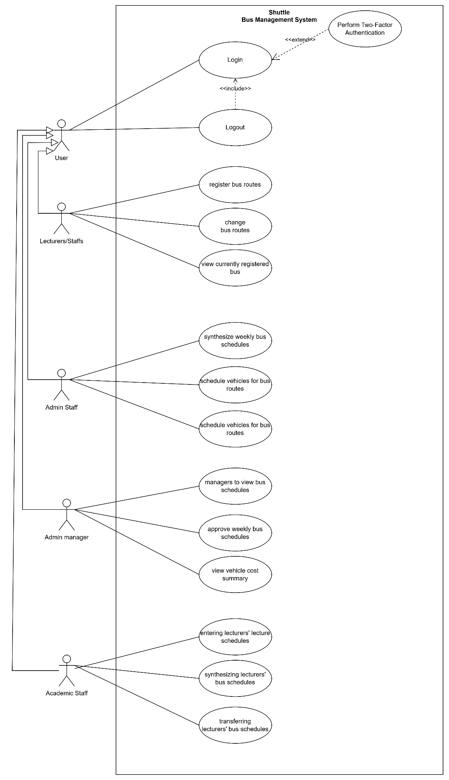

Question 3. UC Specification (15%)
<Student write the answer here>
UC SPECIFICATION TEMPLATE
Use Case Name | Register Bus Route
Use Case ID | UC_02
Actor(s) | Lecturer/Staff
Preconditions | 1. The Lecturer/Staff is successfully logged into the system.  2. The Registration window is opened.
Post conditions | The Lecturer/Staff has successfully completed creating bus route the new record is saved in the database.
Main Flow (Basic Path) | 1. The Lecturer/Staff clicks on the Add Bus Route button.  2. The System displays the input form.  3. The Lecturer/Staff enters the required information.  4. The Lecturer/Staff clicks "Submit" / "Save".  5. The System validates the input data and verifies that the Code is unique.  6. The System saves the new Bus Route to the database.  7. The System displays a success message.
Alternative Flow | Save as draft  3a. The Lecturer/Staff chooses to save as draft.  3b. The System saves current inputs without full validation.  3c. The Use Case ends temporarily.
Exception Flow | Duplication Error  5a. The System detects that the Bus Route ID already exists in the database.  5b. The System displays a specific error message: Bus Route ID must be unique.  5c. The Lecturer/Staff is asked to re-enter the data.
Business Rules | 1. All mandatory fields (*) must be filled.  2. The ID/Code must follow the format ABC-123.
Non-Functional Requirements | The system must process the creation within 2 seconds.

Question 4. Non-functional requirements (10%)
<Student write the answer here>
Non-functional requirements (NFRs) into appropriate quality categories described in the table below.
Category | NFR Description | Acceptance criterion
Security | the system is built on multiple layers to protect both business and user data | All user accounts are protected by password authentication, with options for two-factor authentication for managerial roles.
Recoverability | The software keeps an audit log of all critical actions—such as schedule approvals, bus fee, and—recording who made the change, when, and from which device | This ensures accountability and deters internal misuse.
Maintainability | The application code must follow predefined clean coding standards to facilitate easier maintenance and updates. | When analyzed using a static code analysis tool (e.g., SonarQube), the source code shall maintain a technical debt ratio of less than 5% and show 0 critical vulnerabilities.
Performance | The system must load any page within 1 seconds to ensure quick access without delays. | When navigating to any page under normal network conditions, the system shall fully render the page in strictly under 1 seconds for 95% of requests.

Security vs. Performance
- Conflicting NFRs: Security vs. Performance.
- Why the conflict arises: To ensure high security (such as enforcing 2FA or continuous data encryption), the system must execute additional complex verification and encryption algorithms. This consumes significant CPU resources and increases response time, causing the page to load slower than the required limit.
- Proposed Trade-off Strategy: Apply a flexible prioritization strategy. For highly sensitive data (e.g., passwords, grades), strictly enforce Security even if it slightly degrades performance. For public, non-sensitive data (e.g., course catalog), reduce security checks and utilize caching to guarantee speed.

Question 5. Class Diagram (20%)
<Student write the answer here>
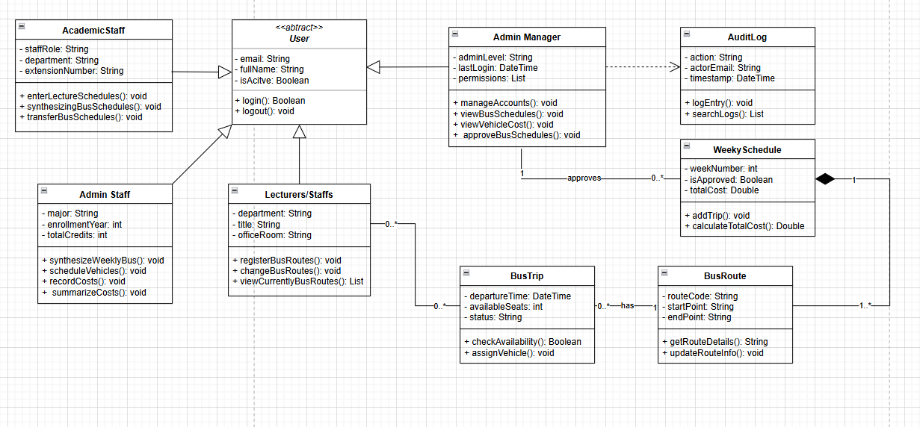

Question 6. AI in Coding (10%)
<Student write the answer here>

Question 7. Testing Stage and Type (15%)
7.1 Testing Stage and Responsibility
<Student write the answer here>
- Unit Testing: Tests individual components/functions (e.g., a specific method like checkEligibility()). Responsible: Developers. Applicable Types: White-box testing, Statement coverage.
- Integration Testing: Tests the interaction between grouped components or APIs (e.g., Registration Service interacting with Database). Responsible: Developers or QA Engineers. Applicable Types: API Testing, Interface testing.
- System Testing: Tests the complete, integrated system as a whole to verify compliance with both functional and non-functional requirements. Responsible: Independent QA Team. Applicable Types: End-to-end testing, Load testing, Security testing.
- Acceptance Testing (UAT): Tests if the system satisfies business needs from the user's perspective before final release. Responsible: End-users / Stakeholders. Applicable Types: Alpha/Beta testing, Black-box testing.
7.2 Test Cases
TCID | Test Case Name | Precondition | Test steps | Expected result | Test type
TC_01 | Happy Path: Successfully create Bus Route with all valid inputs | a lecturer successfully registers for an available bus route that does not conflict with their lecture schedule | 1. Navigate to Add screen.  2. Fill all mandatory fields with valid data.  3. Click "Save". | System saves the Bus Route, displays success message, and updates the list. | Functional (Positive)
TC_02 | Boundary: Maximum characters allowed for capacity | a staff member registers for the last available seat on a bus route | 1. Enter exactly 1 characters in the capacity field.  2. Fill other fields.  3. Click "Save". | System accepts the input successfully without crashing or truncating text. | Boundary Value Analysis
TC_03 | Negative: Submit form with existing departure time | a lecturer attempts to register for a bus route whose departure time conflicts with an existing lecture schedule imported from FAP | 1. Enter existing departure time into the departure time field.  2. Click "Save". | System rejects submission, shows explicit duplication error message, and retains form data. | Functional (Negative)

