INSTRUCTIONS - PRACTICAL EXAM – CSD201
Read the instructions below carefully before starting coding.
Students are ONLY allowed to use:
- Software tools must be used: NetBeans IDE 8.x and Java JDK 1.8.
- His / her own study materials like presentation slides, notes, sample codes, program examples, electronic books stored on his / her computer only.
- For distance learning: Google Meet, Hangout (for Exam Monitoring Purpose).
Instructions
- Step 1: run “Clean and Build Project” (Shift+F11) to create dist folder and .jar file.
- Step 2: Prepare to submit answer:
  - For each question (e.g., question 1), please create two sub-folders: run and src.
  - Copy *.jar file into run folder
  - Compress source code into .zip, then copy .zip file into src folder.
- Step 2: Submit solution for each question:
  - Choose question number (e.g., 1) in PEA software, and then attach corresponding solution folder (e.g., 1). Click Submit button to finish submitting this question.
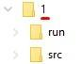
nộp trên lớp không qua khảo thí, .zip folder account sinh viên vd => 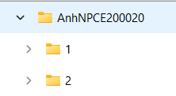

Notes
- Do not use accented Vietnamese when writing comments in programs.
- Solutions will be marked by Automated Marking Software.
- If at least one of the above requirements is not followed, the exam will get ZERO.
======================================================================
Question 2: (4 marks)
Build a Min Heap and Display Information
Write a program to build a Min Heap by inserting N integer values one by one.
Your task is to display:
- The number of nodes in the heap.
- The level-order traversal of the heap (array representation).
- The minimum value in the heap.
Input
- First line: N (1 ≤ N ≤ 100)
- Second line: N integers
Output
- Nodes: value
- Heap: x1,x2,x3,...
- Min: value
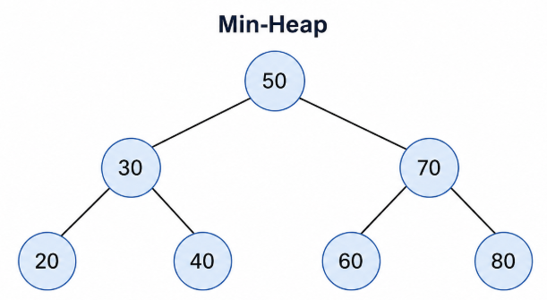
Sample Input 1 | Sample Output 1
7  50 30 70 20 40 60 80 | Nodes: 7  Heap: 20,30,60,50,40,70,80  Min: 20

Sample Input 2 | Sample Output 2
6  10 5 15 3 8 20 | Nodes: 6  Heap: 3,5,15,10,8,20  Min: 3

Sample Input 3 | Sample Output 3
5  8 4 12 2 6 | Nodes: 5  Heap: 2,4,12,8,6  Min: 2

