

Q1 (0.5 point):

Software Requirements Specification

for
Online Car Rental Management System
Version 1.0 approved
Prepared by
Lê Tiến Dũng - CE201046
FPT University Campus Can Tho
29/07/2026

Q2 (2.5 points):

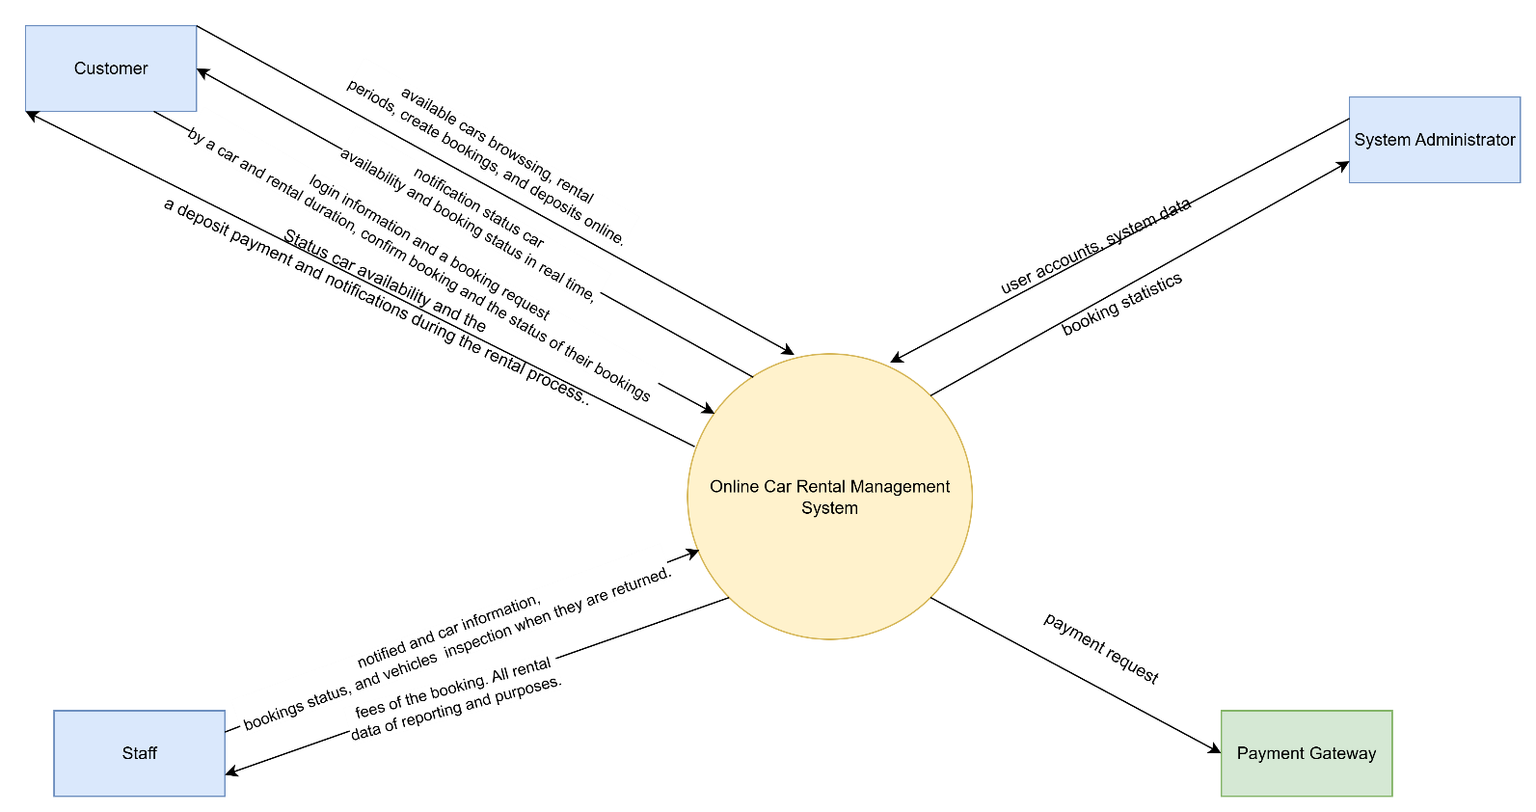

Q3 (4.0 point):
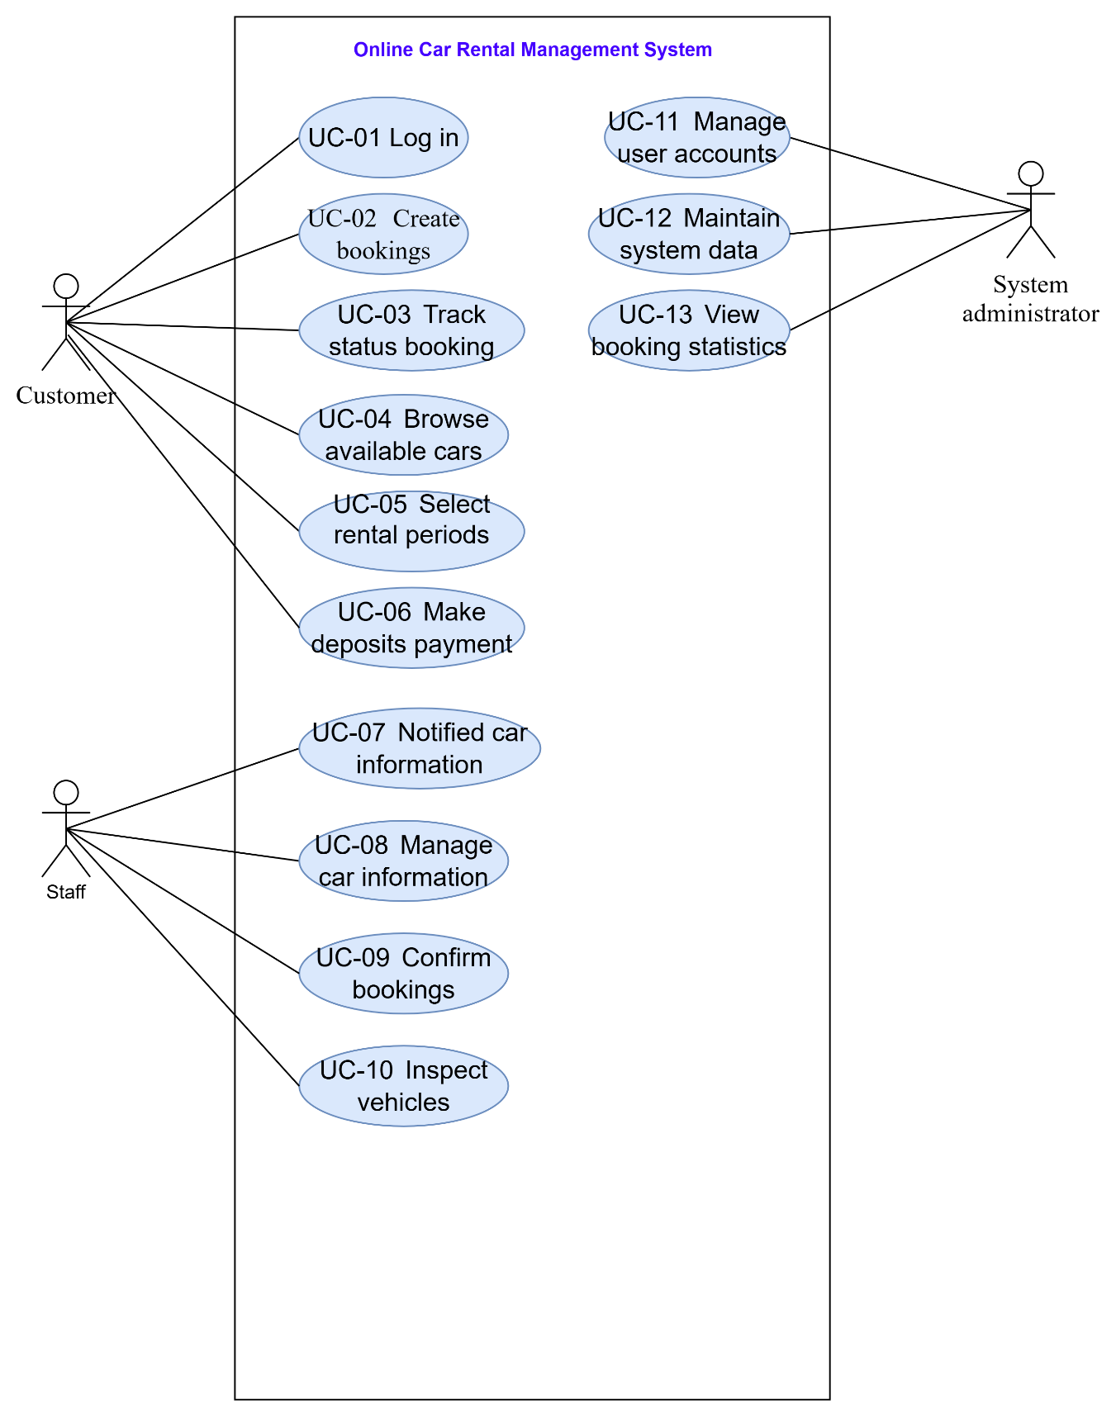

# | Actor | Description
01 | Customer | they log into the system and submit a booking request by choosing a car and rental duration. allows the customer to confirm the booking and make a deposit payment. Customers can also track the status of their bookings and receive notifications during the rental process.
02 | Staff | staff members are notified and can manage car information, confirm bookings, and inspect vehicles when they are returned.
03 | Administrator | responsible for managing user accounts, maintaining system data, monitoring booking statistics, and ensuring the system operates smoothly.

# | Use Case | Actors | Description
UC-01 | Log in | Customer | This system allows customers to login
UC-02 | Create bookings | Customer | submit a booking request by choosing a car and rental duration
UC-03 | Track status booking | Customer | can also track the status of their bookings and receive notifications during the rental process.
UC-04 | Browse available cars | Customer | This system allows customers to browse available cars
UC-05 | Select rentalperiods | Customer | This system allows customers to select rental  periods
UC-06 | Make deposits payment | Customer | This system allows customers to make deposits payment
UC-07 | Notified car information | Staff | This system allows customers to notified car information
UC-08 | Manage car information | Staff | This system allows customers to manage car information
UC-09 | Confirm bookings | Staff | This system allows customers to confirm bookings
UC-10 | Inspect vehicles | Staff | This system allows customers to inspect vehicles
UC-11 | Manage user accounts | System administrator | This system allows customers to manage user accounts
UC-12 | Maintain system data | System administrator | This system allows customers to maintain system data
UC-13 | View booking statistics | System administrator | This system allows customers to view booking statistics

Q4 (3.0 points):
< Student must replace this line
Notes:
- Draw the correct syntax to describe the conceptual ERD
- Draw entities and brief descriptions
- Draw relationships
>
<Student must replace this line, answer Q4 by drawing 1 conceptual ERD that reflect this exam paper and copy and then paste the image of that conceptual ERD here >

< Student must replace this line, briefly describe the entities of the diagram by fill the content to below table>
# | Entity | Description
01 | Account | To store account info using for authentication and authorization. Fields: id, email, password, role...
02 | Booking
03 | Car
04 | Payment

