

Q1 (0.5 point):

Software Requirements Specification

for
Restaurant Management System at Vincom
Version 1.0 approved
Prepared by
Lê Tiến Dũng - CE201046
FPT University Campus Can Tho
29/07/2026

Q2 (2.5 points):

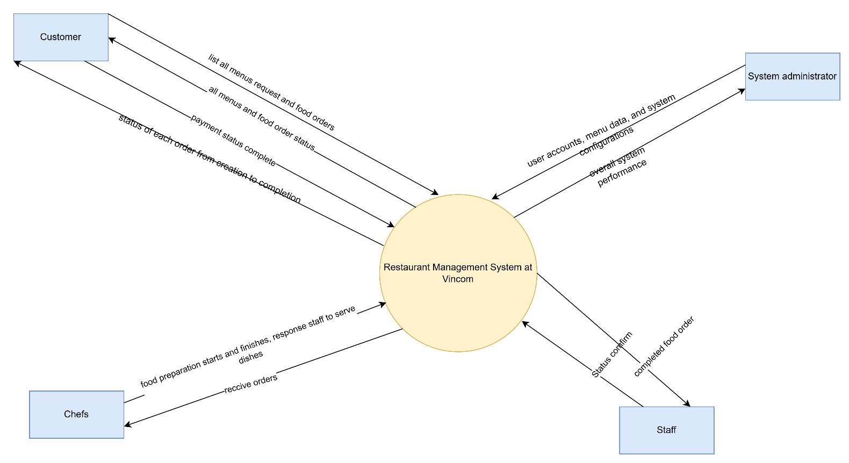

Q3 (4.0 point):
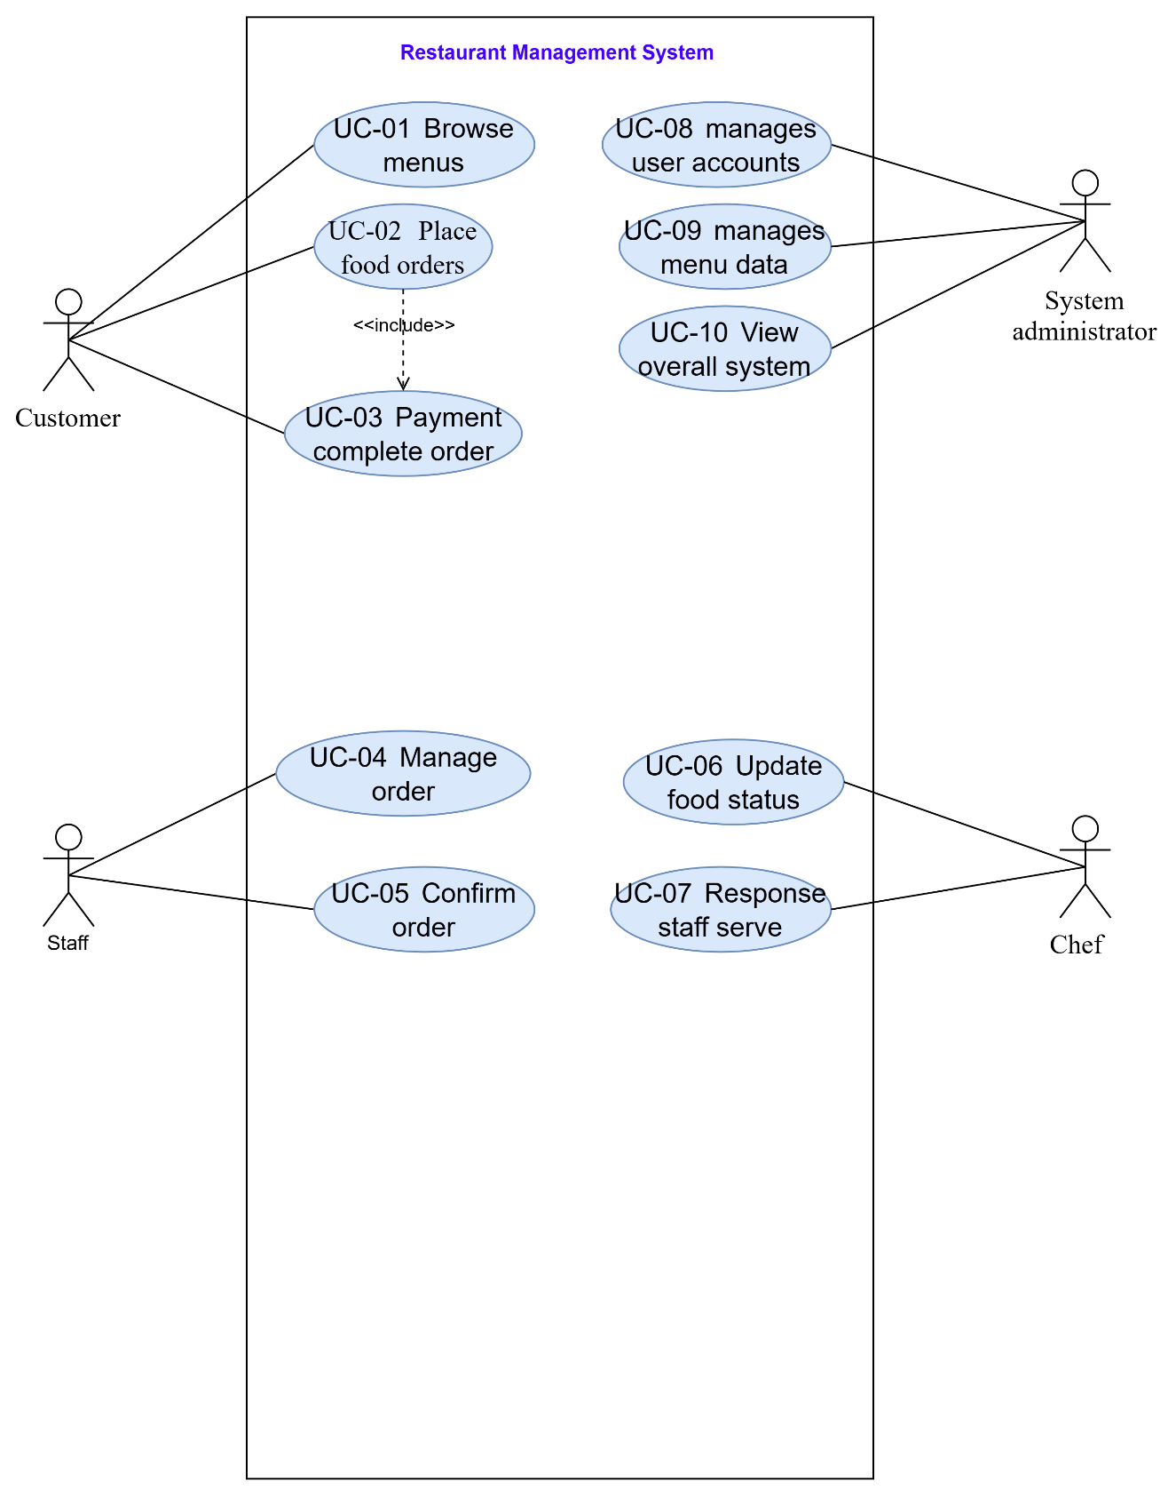

# | Actor | Description
01 | Customer | They can browse menus and place food orders, customers complete payment through the system before the order is sent to the kitchen.
02 | Chefs | Chefs reccive orders from the system and prepare dishes accordingly. , update the system when food preparation starts and finishes, response staff to serve dishes promptly
03 | Staff | staff to serve dishes promptly. Once the food is served, the order is marked as completed
04 | Administrator | manages user accounts, menu data, and system configurations, and monitors overall system performance.

# | Use Case | Actors | Description
UC-01 | Browse menus | Customer | This system allows customers to login
UC-02 | Place food orders | Customer | places an order, the system records the order details
UC-03 | Payment complete order | Customer | This system allows customers to pay for complete order.
UC-04 | Manage order | Staff | This system allows customers to manage order
UC-05 | Confirm order | Staff | This system allows customers to confirm order
UC-06 | Update food status | Chef | This system allows customers to update food status
UC-07 | Response staff serve | Chef | This system allows customers to response staff serve
UC-08 | manages user accounts | system administrator | This system allows customers to manage user accounts
UC-09 | manages menu data | system administrator | This system allows customers to manage menu data
UC-10 | View overall system | Staff | This system allows customers to View overall system

Q4 (3.0 points):
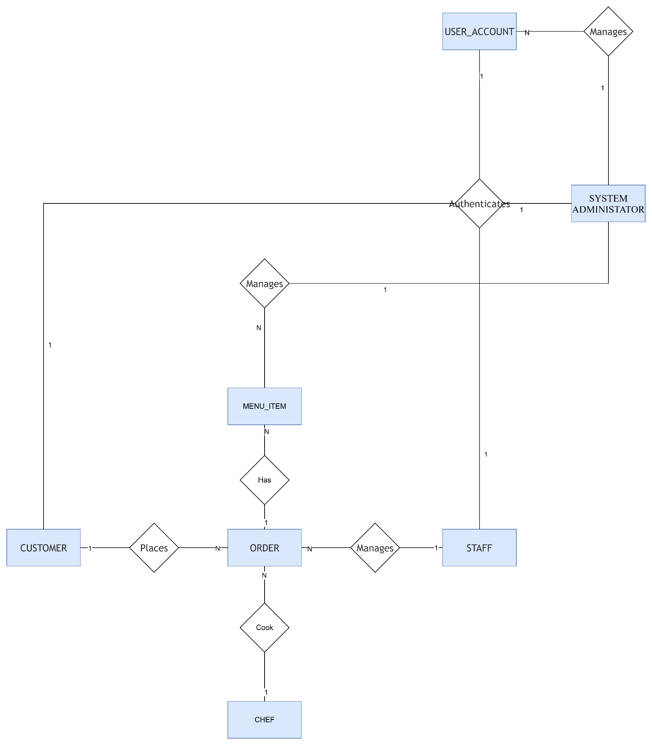
# | Entity | Description
01 | USER_ACCOUNT | To store account info using for authentication and authorization. Fields: id, email, password, role...
02 | STAFF | Represents employee personal profiles, job roles, assigned shift schedules.
03 | CHEF | Represents chef personal profiles, job roles, assigned shift schedules.
04 | CUSTOMER | Stores customer personal profile data, contact details, and reward program points.
05 | MENU_ITEM | Stores individual food and beverage catalog items, pricing, and availability states.
06 | ORDER | Tracks active dine-in table ordering sessions, financial subtotal estimations, and overall status.

