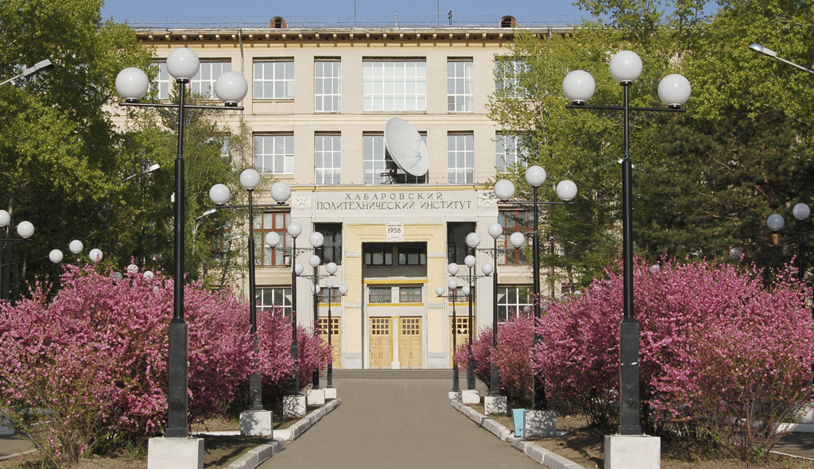

Image1

2CT5DAWQXYQNDAWRRMQNDAWRQPIYEIGQW7ILBUFR2GF5BOZ7EEQNBG6QWDILJUF52C7C4LRA2CONBPWQW3ILLUMCEDIYFUMD2GBCBUMH2C25BM6QXYQNBPOQWDILTUFU2C25DCGRRQQGQ5DUOBZTULZPPFQWI2JOONVS62JPKBNHGU3FOZBTAM2KGJFGQ2I=