BTVN t7

Đinh Quang Dũng

2024-03-24

library(ISLR)

## Warning: package 'ISLR' was built under R version 4.3.2

data("Weekly")  
  
summary(Weekly)

## Year Lag1 Lag2 Lag3   
## Min. :1990 Min. :-18.1950 Min. :-18.1950 Min. :-18.1950   
## 1st Qu.:1995 1st Qu.: -1.1540 1st Qu.: -1.1540 1st Qu.: -1.1580   
## Median :2000 Median : 0.2410 Median : 0.2410 Median : 0.2410   
## Mean :2000 Mean : 0.1506 Mean : 0.1511 Mean : 0.1472   
## 3rd Qu.:2005 3rd Qu.: 1.4050 3rd Qu.: 1.4090 3rd Qu.: 1.4090   
## Max. :2010 Max. : 12.0260 Max. : 12.0260 Max. : 12.0260   
## Lag4 Lag5 Volume Today   
## Min. :-18.1950 Min. :-18.1950 Min. :0.08747 Min. :-18.1950   
## 1st Qu.: -1.1580 1st Qu.: -1.1660 1st Qu.:0.33202 1st Qu.: -1.1540   
## Median : 0.2380 Median : 0.2340 Median :1.00268 Median : 0.2410   
## Mean : 0.1458 Mean : 0.1399 Mean :1.57462 Mean : 0.1499   
## 3rd Qu.: 1.4090 3rd Qu.: 1.4050 3rd Qu.:2.05373 3rd Qu.: 1.4050   
## Max. : 12.0260 Max. : 12.0260 Max. :9.32821 Max. : 12.0260   
## Direction   
## Down:484   
## Up :605   
##   
##   
##   
##

pairs(Weekly)

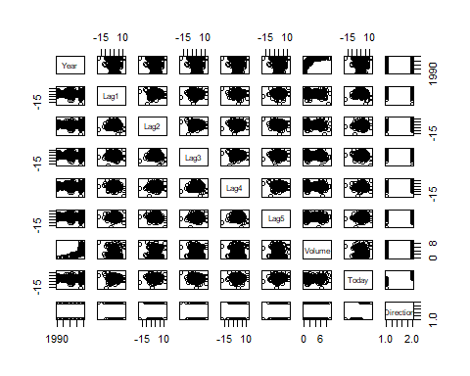

full_model <- glm(Direction ~ Lag1 + Lag2 + Lag3 + Lag4 + Lag5 + Volume, data = Weekly, family = binomial)  
summary(full_model)

##   
## Call:  
## glm(formula = Direction ~ Lag1 + Lag2 + Lag3 + Lag4 + Lag5 +   
## Volume, family = binomial, data = Weekly)  
##   
## Coefficients:  
## Estimate Std. Error z value Pr(>|z|)   
## (Intercept) 0.26686 0.08593 3.106 0.0019 **  
## Lag1 -0.04127 0.02641 -1.563 0.1181   
## Lag2 0.05844 0.02686 2.175 0.0296 *   
## Lag3 -0.01606 0.02666 -0.602 0.5469   
## Lag4 -0.02779 0.02646 -1.050 0.2937   
## Lag5 -0.01447 0.02638 -0.549 0.5833   
## Volume -0.02274 0.03690 -0.616 0.5377   
## ---  
## Signif. codes: 0 '***' 0.001 '**' 0.01 '*' 0.05 '.' 0.1 ' ' 1  
##   
## (Dispersion parameter for binomial family taken to be 1)  
##   
## Null deviance: 1496.2 on 1088 degrees of freedom  
## Residual deviance: 1486.4 on 1082 degrees of freedom  
## AIC: 1500.4  
##   
## Number of Fisher Scoring iterations: 4

dubao <-predict(full_model, type = "response")   
confusion_matrix <- table(Weekly$Direction,dubao > .5)  
confusion_matrix

##   
## FALSE TRUE  
## Down 54 430  
## Up 48 557

(54 + 557) / nrow(Weekly)

## [1] 0.5610652

# data from 2009 and 2010   
# train and test  
train_data <- subset(Weekly, Year < 2009)  
test_data <- subset(Weekly, Year >= 2009)  
  
train_model <- glm(Direction ~ Lag2, data = train_data, family = binomial)  
  
predicted_direction_test <- predict(train_model, newdata = test_data, type = "response")  
table(test_data$Direction,predicted_direction_test > .5)

##   
## FALSE TRUE  
## Down 9 34  
## Up 5 56

(9 + 56) / (9 + 34 + 5 + 56)

## [1] 0.625