

**Faculty of Engineering & Technology**

**Electrical & Computer Engineering Department**

**ENCS2380**

**COMPUTER ORGANIZATION AND MICROPROCESSORS**

**Project #2**

**Student’s names:**

**Dunia AL’amal Hamada. ID: 1201001**

**Rawan Sous ID: 1200129**

**Instructor: Dr. Abualseoud Hanani**

**Section: 1**

**The Code:**

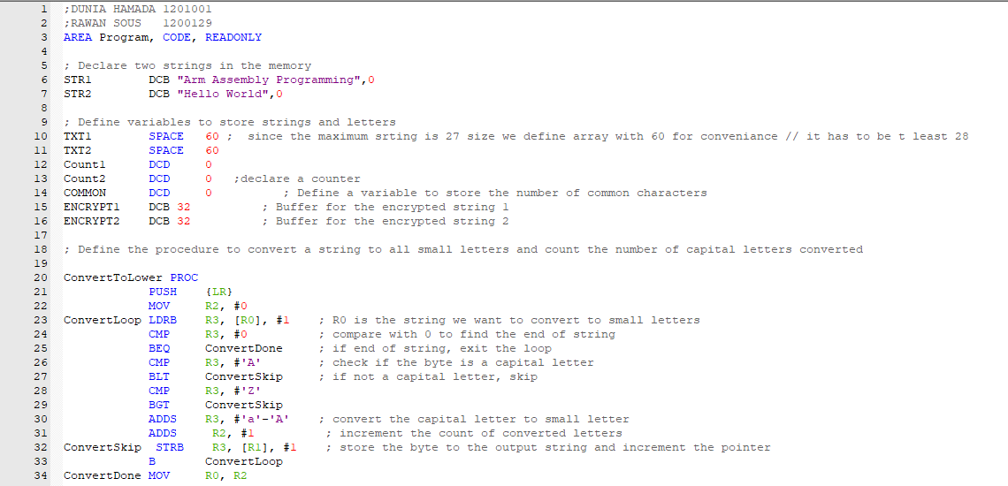

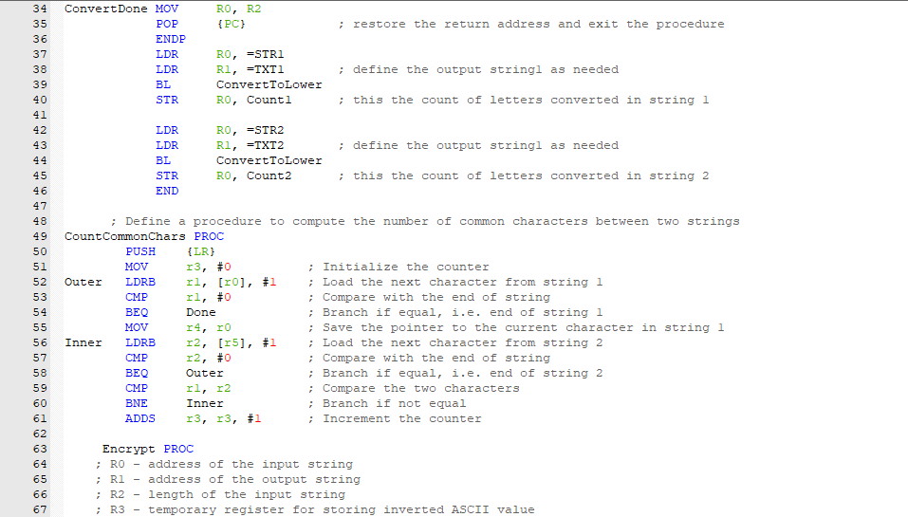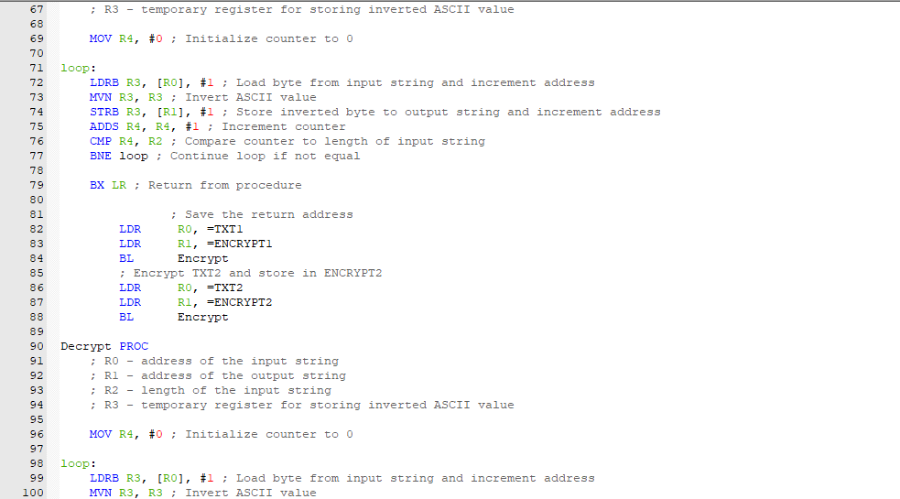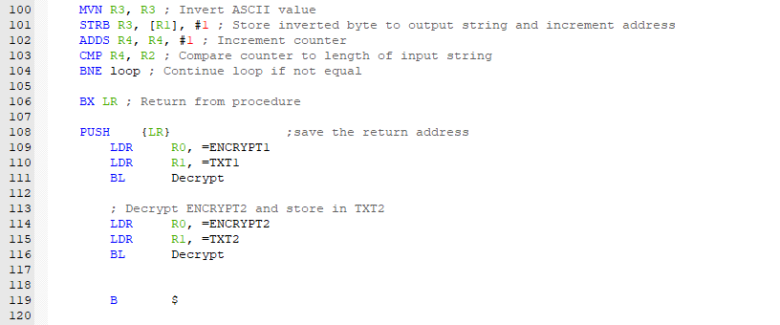

**1) Declare two sentences (two strings) of any length and with a mix of capitals and small letters in the memory, e.g. “ Arm Assembly Programming”.**

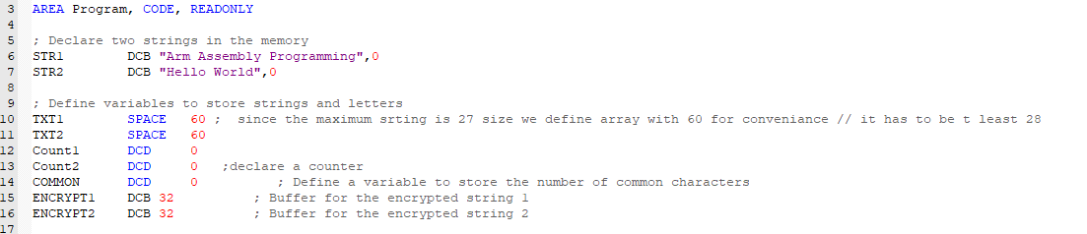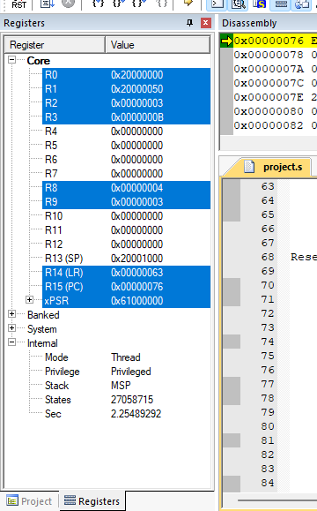

**2) Write a procedure that takes a string and convert all of its characters into small letters. Also, this procedure should count the number of letters which are converted from capital to small letters. The small-letter string should be stored in new array [e.g. TXT1 for string 1 and TXT2 for string 2], and the number converted letters should be stored in Count1 and Count2 in the memory. Use this procedure to convert the two strings into small letters and store them in TXT1 and TXT2. Also, store the number of converted letters [from capital to small] in each string into Count1 and Count 2.**

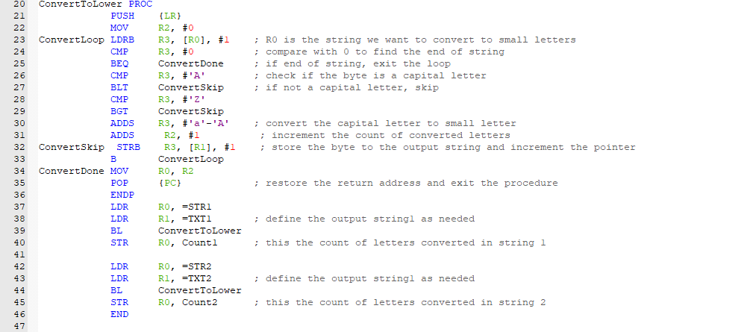

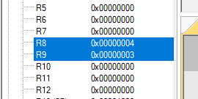

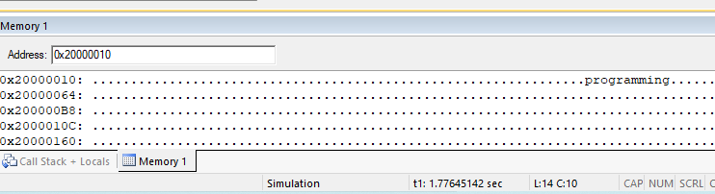

**3) Write a procedure that computes the number of the common characters in two strings, regardless of the letter case (capital or small) and regardless of repetition. Store the number in the memory in a variable called COMMON.**

**For example, if str1 is “Assembly”, and str2 is “Programming”, the number of common characters between them is 2 (‘A’ and ‘m’).**

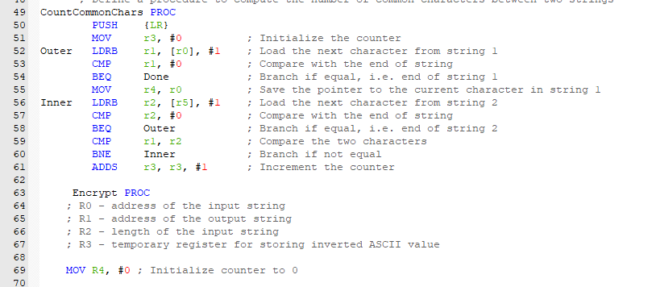

**4) Write a procedure that encrypts a string by inverting all the bits of each character ASCII code. For example, the 8-bit ASCII code of character ‘A’ is 01000001, after encryption it becomes 10111110.**

**The encrypted string should be stored in a new array. Use this procedure to encrypt the two strings and stored their encryption in ENCRYPT1 and ENCRYPT2. The same procedure used for encryption can be used for decryption, i.e. if you apply this procedure at the encrypted string, you will get the original strings. You can do this to make sure that your encryption implementation works correctly**

