I completed this lab remotely.

CNT4703C – LAB 6

Configuration of Static Routes

Objective:

In this lab several of the concepts that were previously covered will be combined to configure static routes between a group of networks. In this scenario multiple routers will be configured so that network connectivity is established between workstations across a serial connection. You will use the experience gained in the previous lab assignments to configure workstations, routers, switches, and a physical medium. A requirement for this assignment will be to configure the IP addresses for the appropriate router interfaces and VLANs, including the necessary trunk interfaces for the VLANs. On both networks, gateways of last resort will be used to define network perimeters.

The TA will be available to assist you.

Supporting concepts for Lab 6:

*Lab 1 – Cisco Packet Tracer Training

*Lab 2 – Build Cat5e Patch-Cable / T568B Pinout

*Lab 3 – Connecting to Equipment utilizing Console Interface (Putty/xTerm)

*Lab 4 – Configuring a Switch / Introduction to VLANs

*Lab 5 – Multiple VLANs & Router Sub-Interfaces

Credit for this assignment will require:

1. Cisco Packet Tracer file (attempt to complete prior to Lab)
2. Screen Shots of Workstation(s)
   1. IPv4 Configurations

1. Screenshots of Switch A/B
   1. #show vlan

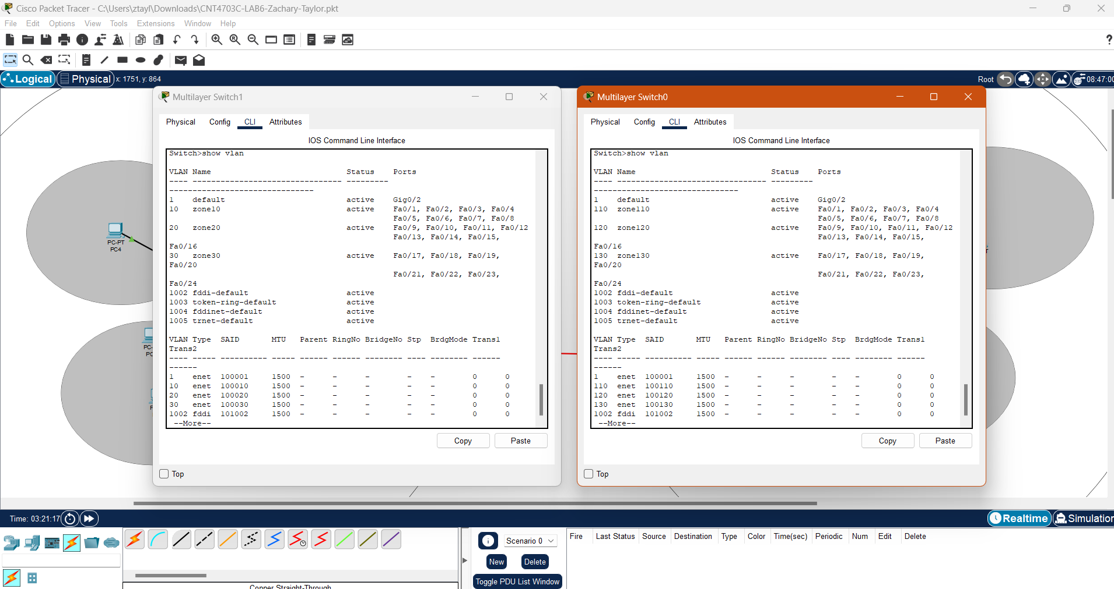

* 1. #show ip interface

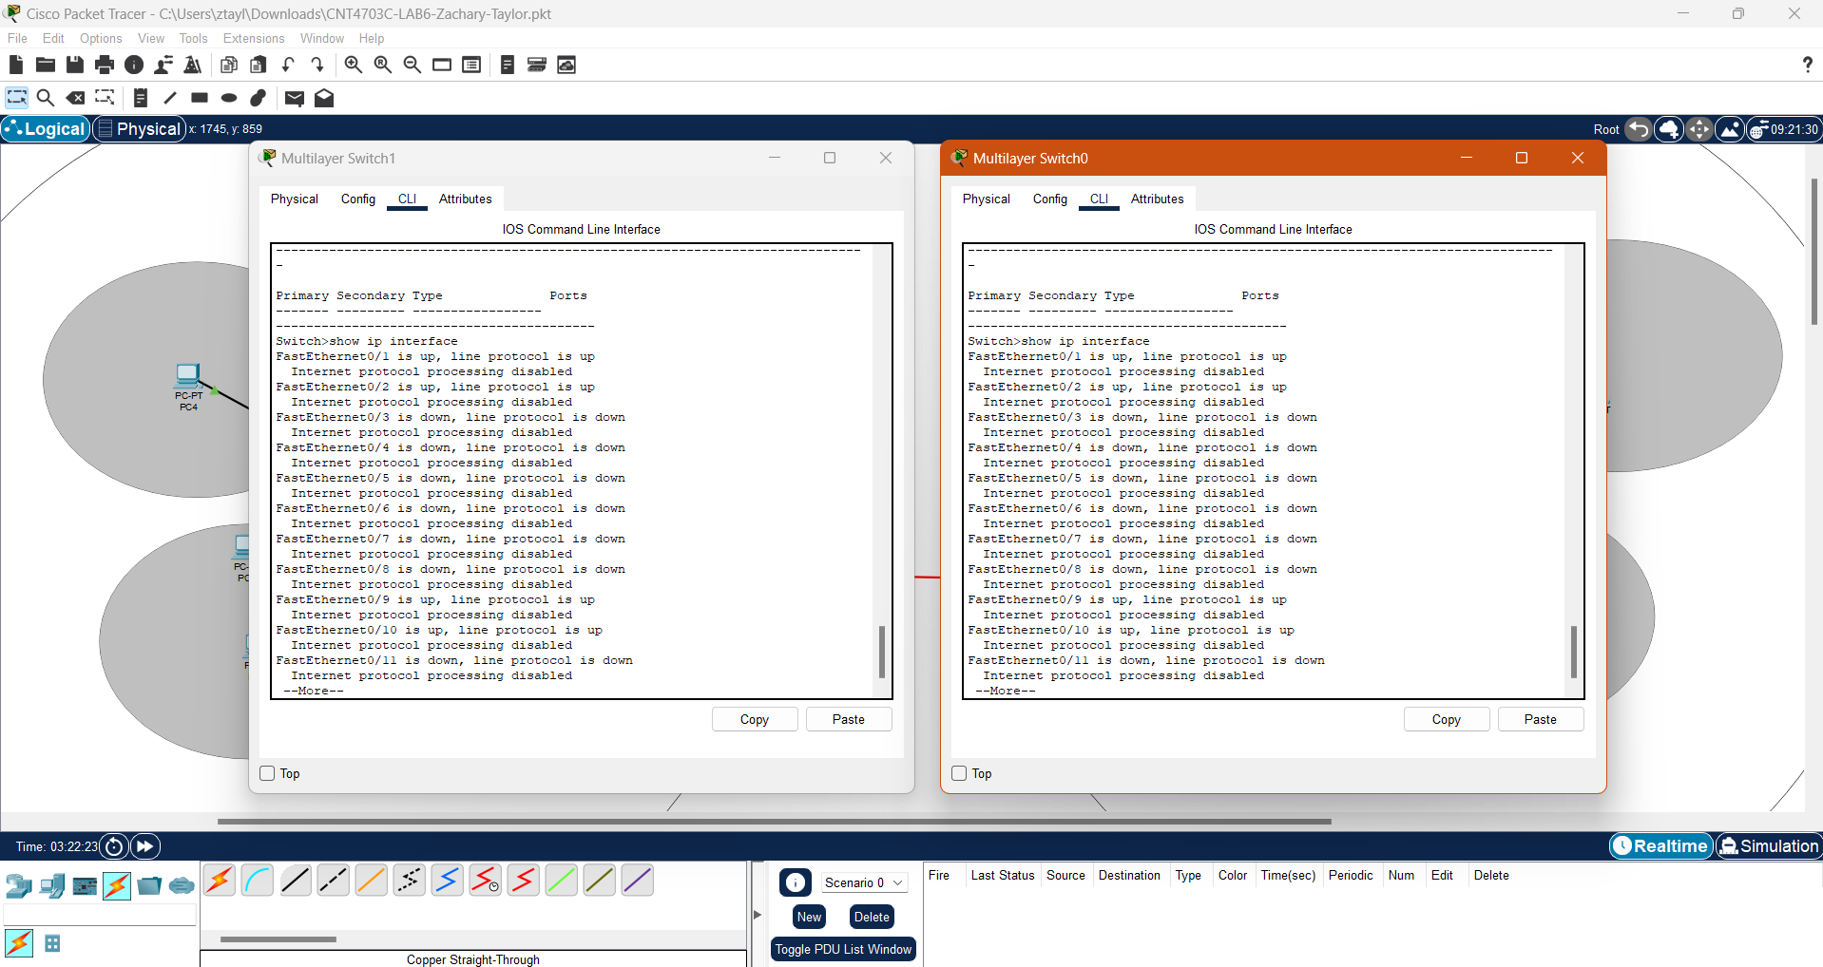

* 1. Front of Switch w/Cables Connected

1. Screenshots of Router A/B
   1. Router 1 & 2: Running Configuration
      1. [host]#show run

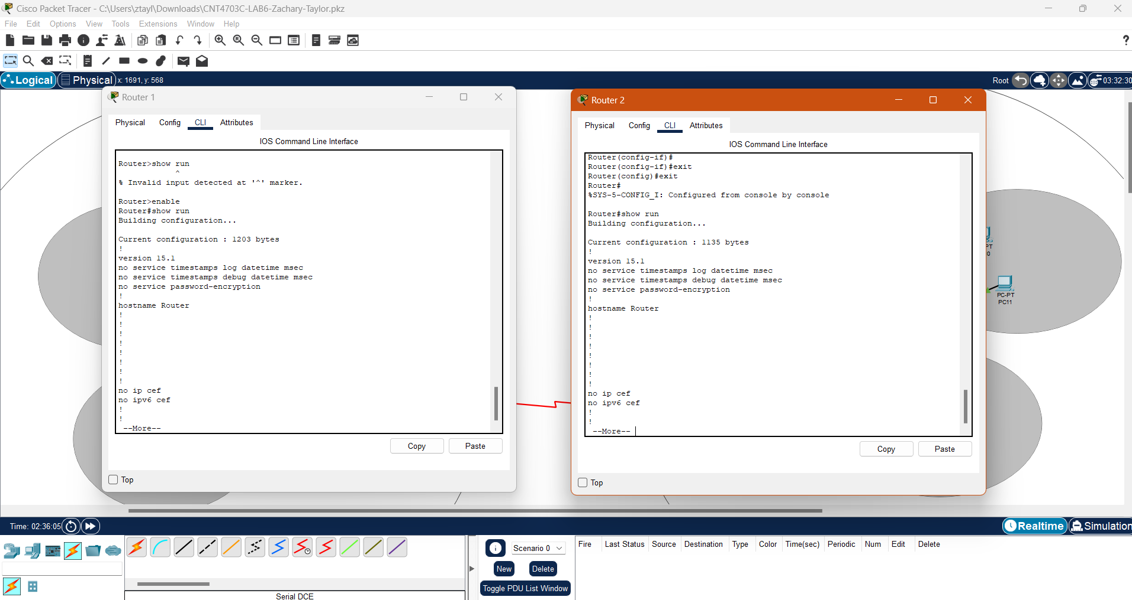

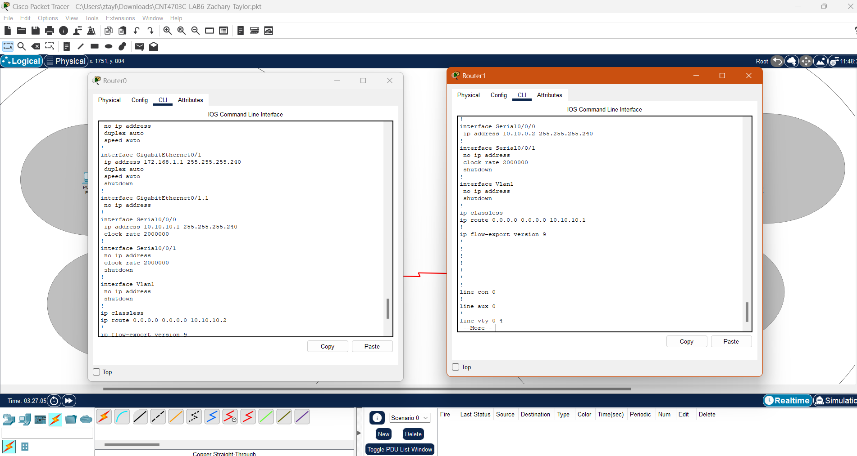

* + 1. [host]#show ip int brief

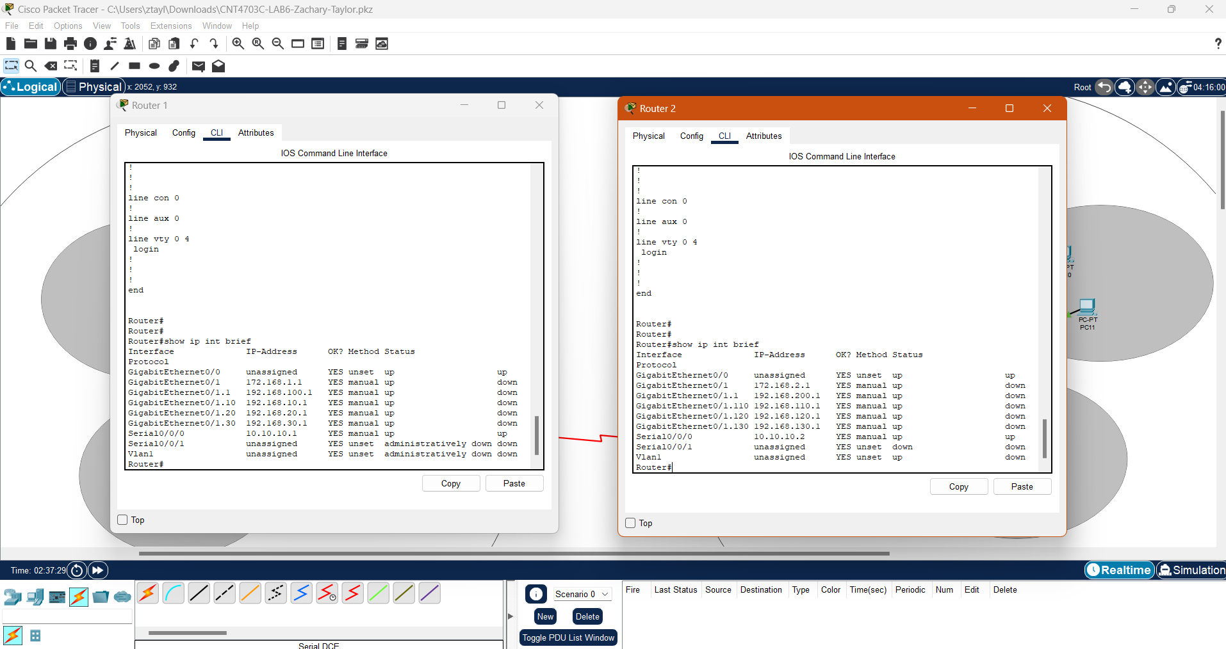

* + 1. [host]#show ip route

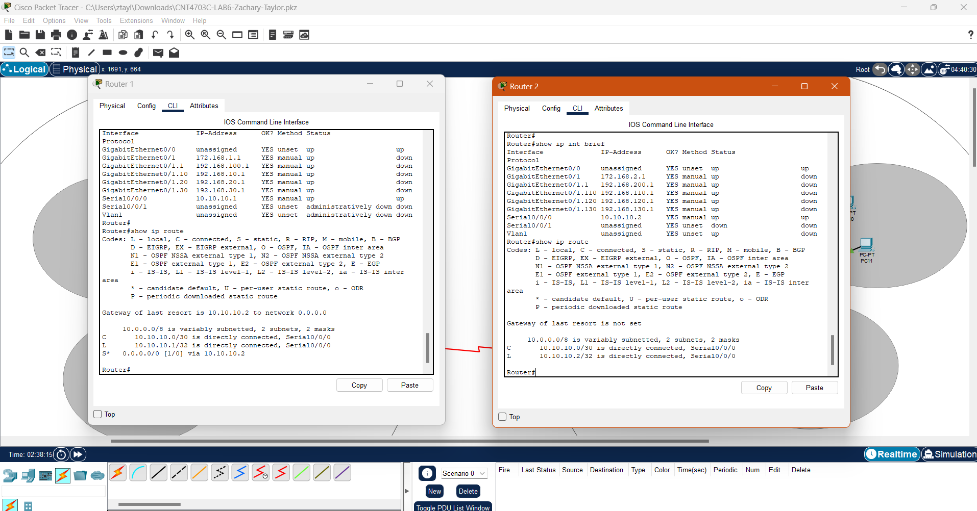

LAB 6 questions:

1. What does TCP/IP stand for?

TCP/IP stands for Transmission Control Protocol/Internet Protocol.

1. What does UDP stand for?

User Datagram Protocol.

1. How does TCP differ from UDP?

TCP is connection oriented and UDP is connectionless.

* 1. How are these protocols similar?

Both protocols are used for communication.

* 1. List some characteristics of both.

TCP was designed with error checking in mind, it is slower than UDP in general; but is better for secure uses such as emails and file sending. UDP can’t check for errors and is fast. It works by continuously sending regardless of whether the target is receiving or not. Its use cases are more geared towards TV broadcasts and real-time communication.

1. Explain the use of 0.0.0.0 in setting the static routes in this assignment. (use complete sentences)

0.0.0.0 is what you would use for a locally linked network, and using it means that there is no next-hop capability; each connection is directly linked to the interface.

1. What does the statement “Gateway of last resort is not set” mean?

The gateway of last resort is not set means that there is not a default pathway set for packets lacking a route from the table.

* 1. Why would this matter when sending packets outside a network?

Essentially, external traffic won’t know how to negotiate to the correct route since the network that sent them is not part of the routing table.

FIGURE 1.0 – Installation of Serial Module on CISCO router in Packet Tracer

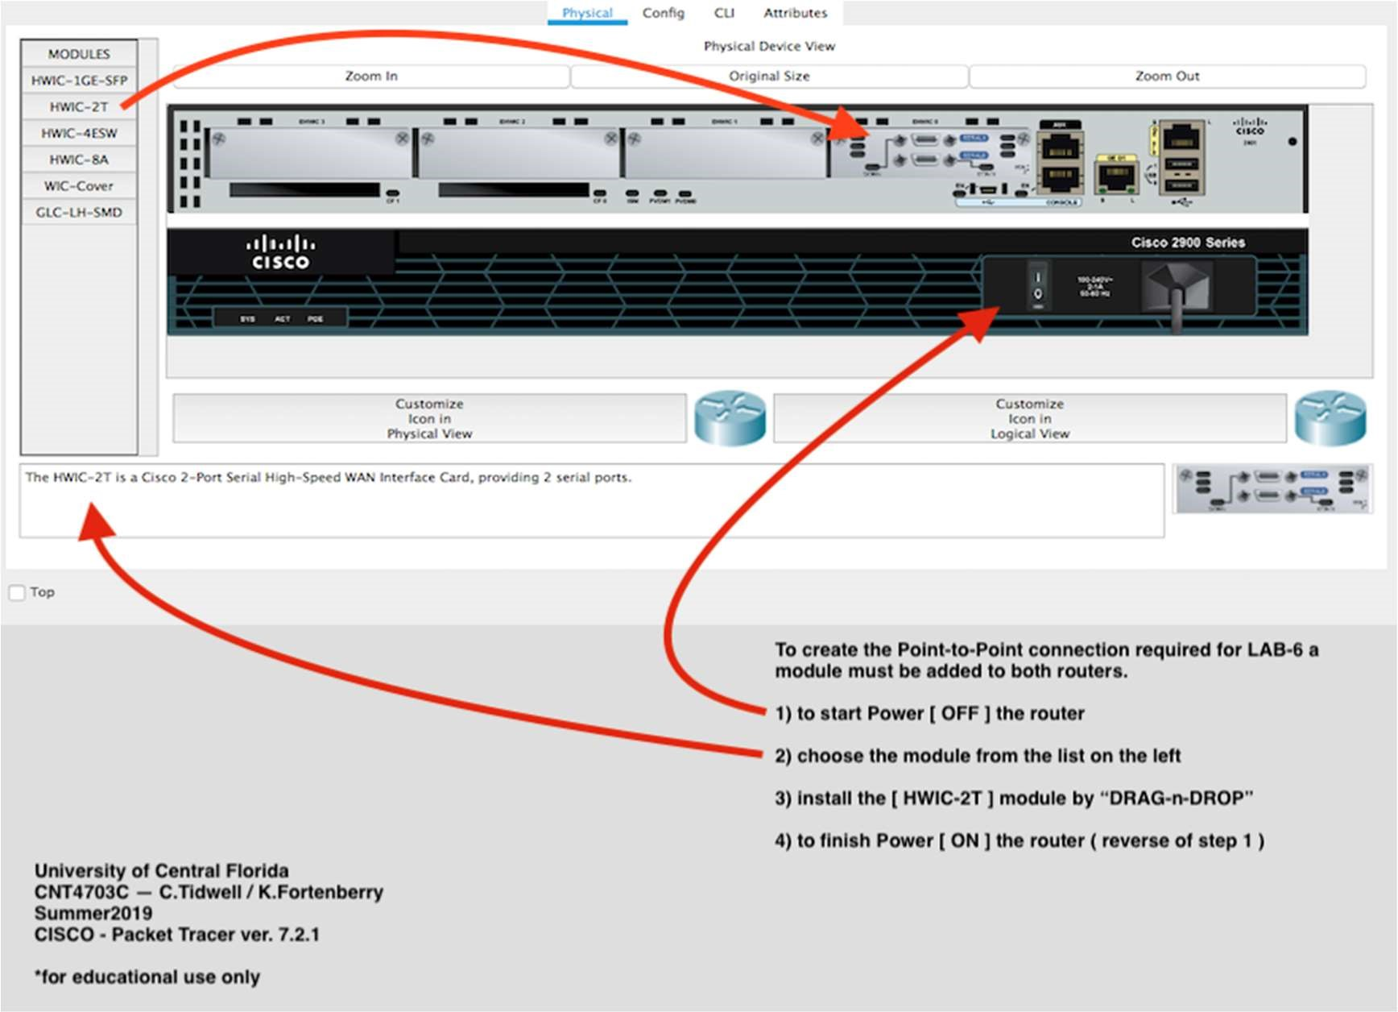

FIGURE 1.1 – CISCO Packet Tracer / Logical Topography

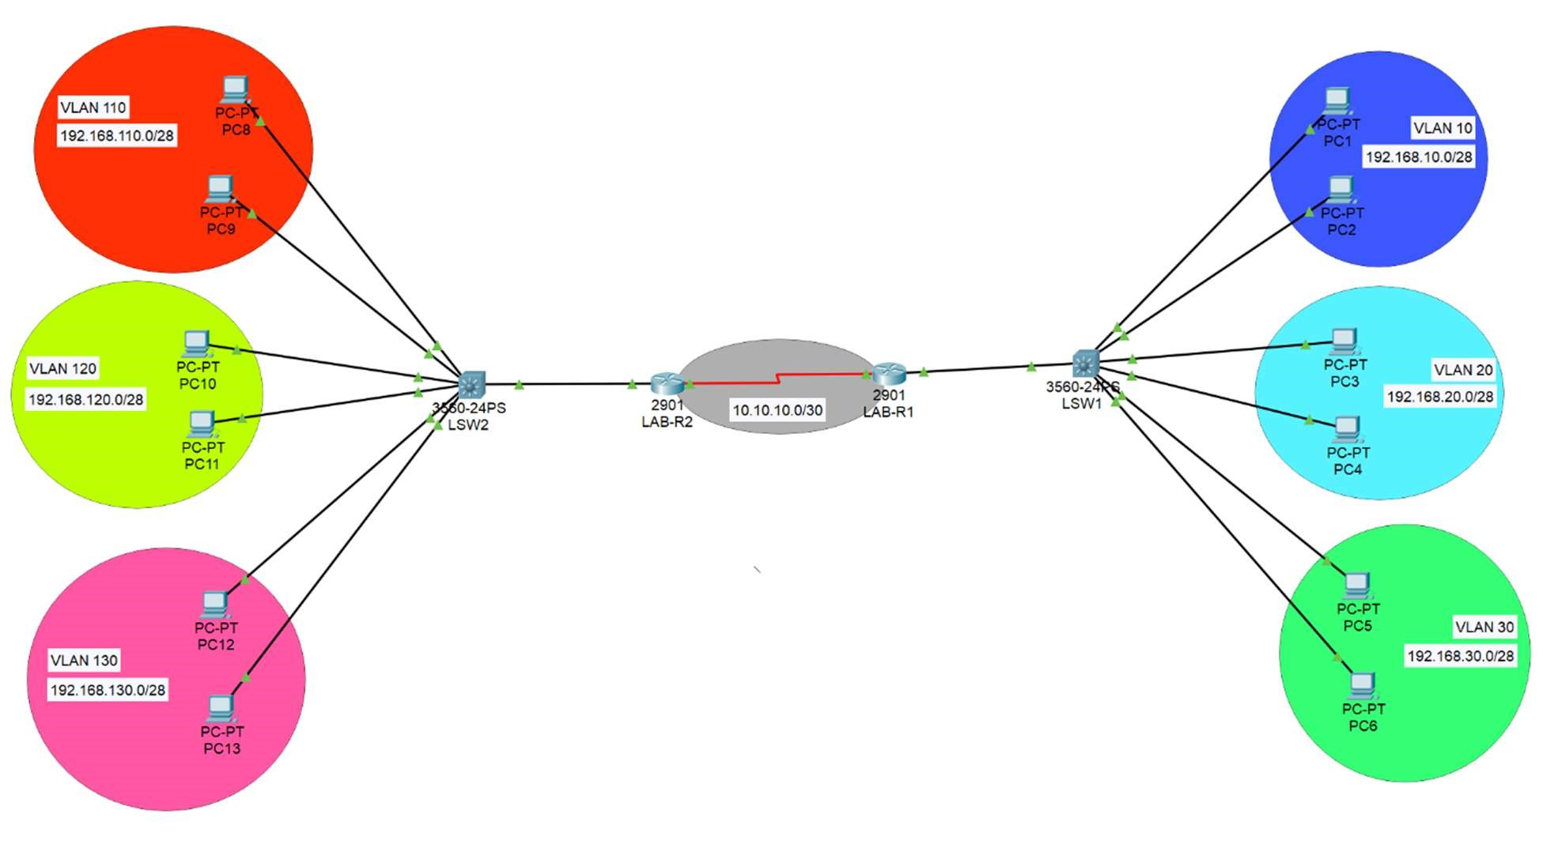

FIGURE 1.2 – Equipment and Interface Reference Chart

|  |  |  |  |  |
| --- | --- | --- | --- | --- |
| Router / LAB-R1 / Interface | IPv4 – Address / Subnet | VLAN | VLAN - Name | Encapsulation Mode |
| Serial 0/0/0 | 10.10.10.1/30 | n/a | n/a | n/a |
| Gi 0/1 | 172.168.1.1/24 | n/a | n/a |  |
| Gi0/1.1 | 192.168.100.1/24 | vlan 1 | default | IEEE 802.1Q |
| Gi0/1.10 | 192.168.10.1/28 | vlan10 | zone10 | IEEE 802.1Q |
| Gi0/1.20 | 192.168.20.1/28 | vlan20 | zone20 | IEEE 802.1Q |
| Gi0/1.30 | 192.168.30.1/28 | vlan30 | zone30 | IEEE 802.1Q |

|  |  |  |  |  |
| --- | --- | --- | --- | --- |
| Router / LAB-R2 / Interface | IPv4 – Address / Subnet | VLAN | VLAN - Name | Encapsulation Mode |
| Serial 0/0/0 | 10.10.10.2/30 | n/a | n/a | n/a |
| Gi 0/1 | 172.168.2.1/24 | n/a | n/a |  |
| Gi0/1.1 | 192.168.200.1/24 | vlan 1 | default | IEEE 802.1Q |
| Gi0/1.110 | 192.168.110.1/28 | vlan110 | zone110 | IEEE 802.1Q |
| Gi0/1.120 | 192.168.120.1/28 | vlan120 | zone120 | IEEE 802.1Q |
| Gi0/1.130 | 192.168.130.1/28 | vlan130 | zone130 | IEEE 802.1Q |

FIGURE 1.3 – Example of Switchport VLAN Assignment

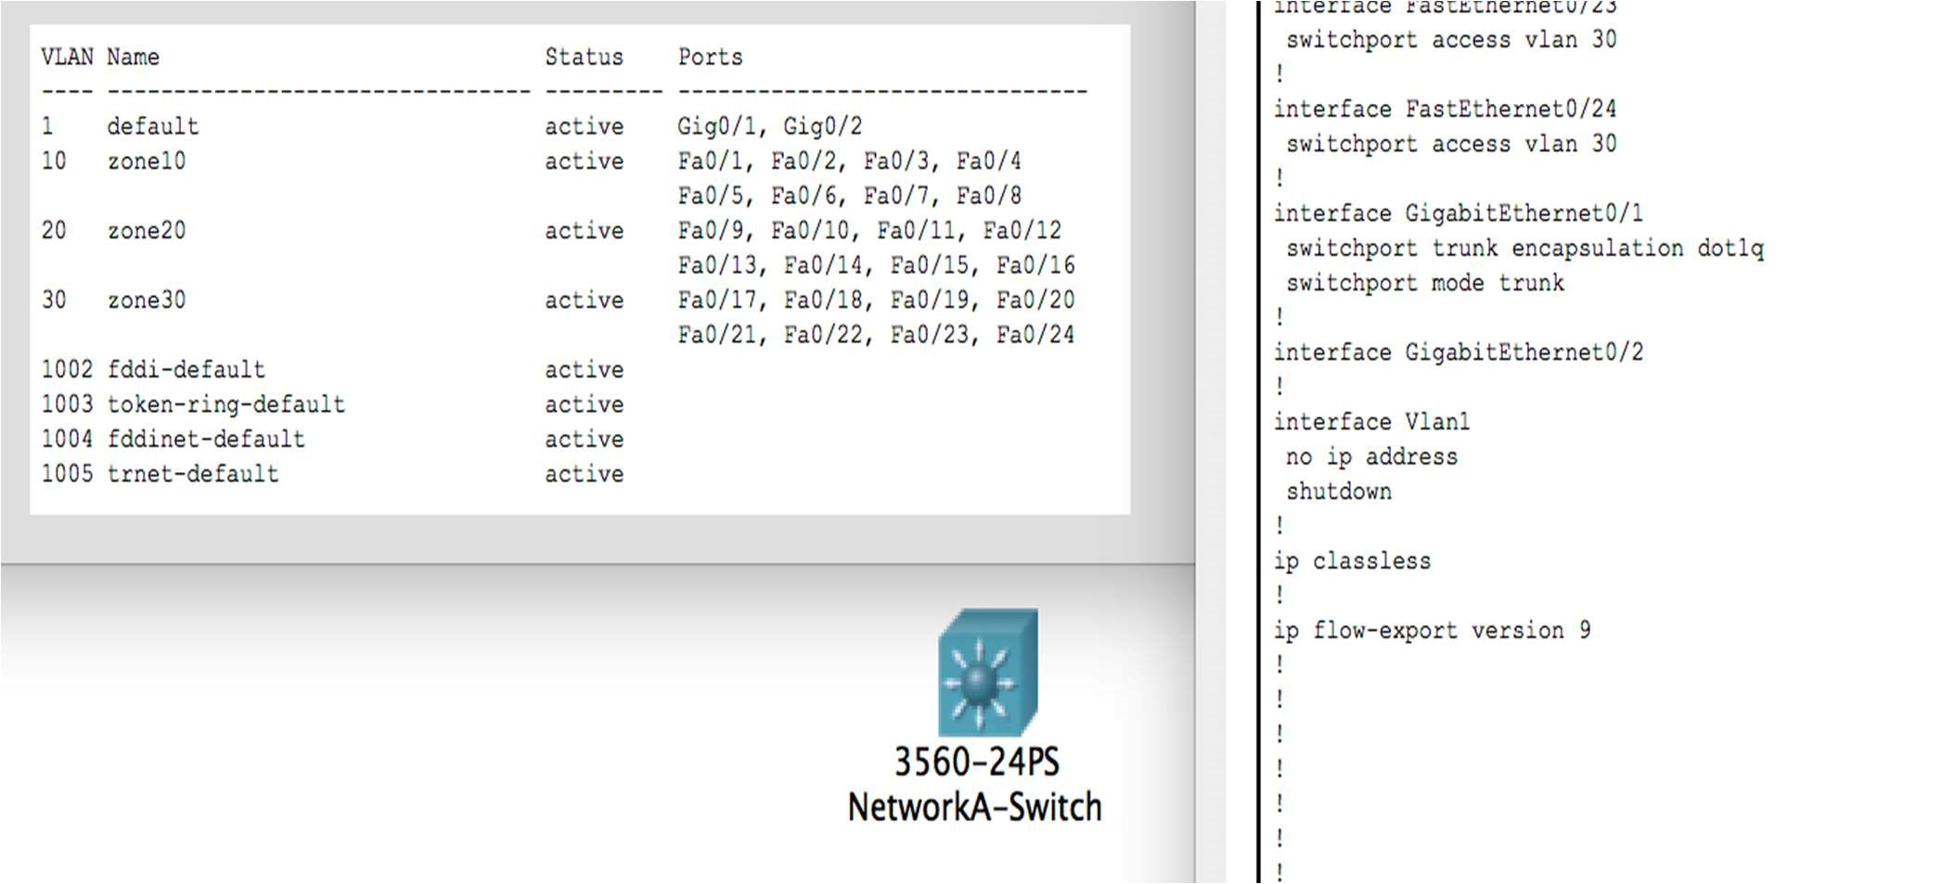

FIGURE 1.4 – Configuration of PC Ethernet Interface (PC2 – VLAN 10)

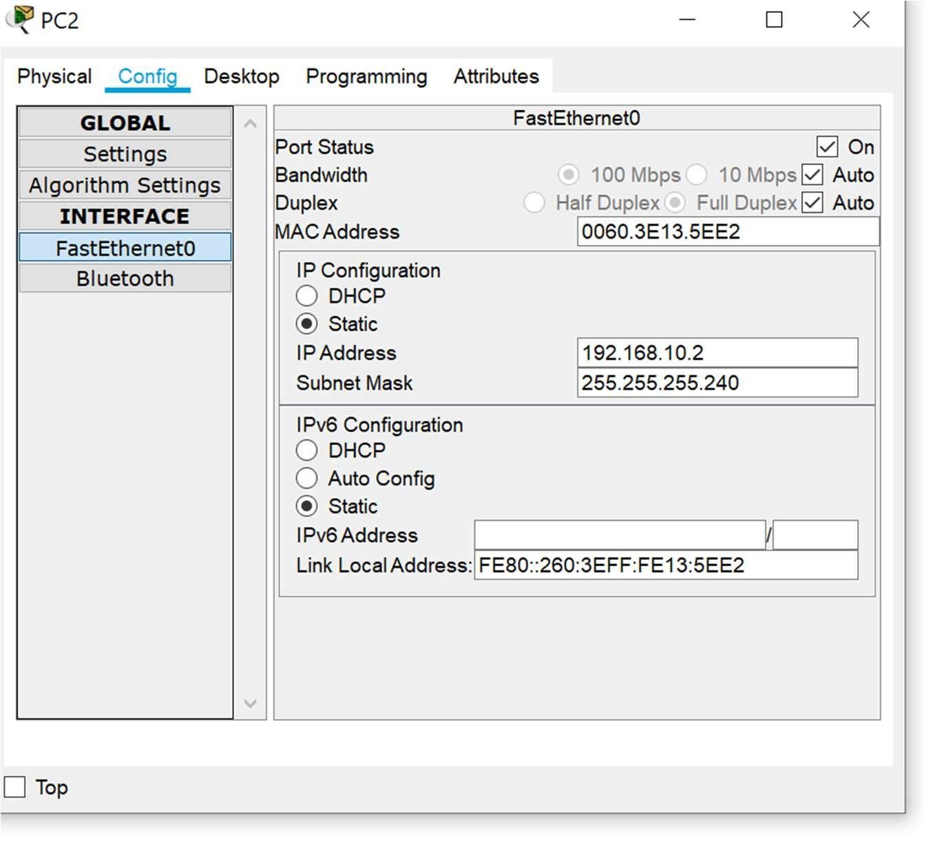

FIGURE 2.0 - Procedure for creation of Packet Tracer network simulation

1. Download and open file <CNT4703C-LAB6-PT-Template>
2. Save file and Rename <CNT4703C-LAB6-PT-[your full name]>
3. Select and create required connections between devices in NETWORK A.
   1. PC to Switch (Ethernet)
   2. Switch to Router (Ethernet)
   3. Router to Router (Serial)

i. Serial adapter will have to be added to both routers. ii. See FIGURE 1.3

* 1. Configure router(s) interfaces.
     + 1. See FIGURE 1.1
       2. FIGURE 2.1
  2. Configure switch(s) VLANs and assign interfaces.

i. See FIGURE 1.2 ii. See FIGURE 2.0

* 1. Configure switch trunk port and default vlan.

i. See FIGURE 2.0

* 1. Configure PC(s) interfaces for each VLAN.

i. See FIGURE 1.4

* + 1. Test network connectivity between devices within each VLAN.
    2. PC to PC

* + - 1. PC to Router

1. Repeat Step 3 for required connections between devices in NETWORK B.
2. Set IP route for all unknown traffic on Router(s) to exit Serial interface(s)
   1. Router 1: Command

i. [host](config)#ip route 0.0.0.0 0.0.0.0 10.10.10.2

* 1. Router 2: Command

i. [host](config)#ip route 0.0.0.0 0.0.0.0 10.10.10.1

1. Test connectivity between Networks
   1. Ping from Router on Network A to Router on Network B
   2. Ping from PC on Network A to PC on Network B