**Databases Laboratory Work Nr.1** Mamaliga Dumitras FAF-191

**Title** Instalarea si configurarea SQL Server 2017

**Prerequisites:** SQL Server 2017 Installation Center and SQL Server Management Studio

**Objectives:** Instalarea SGBD-ului MS SQL Server 2017, gestiunea serviciilor si inregistrarea unui server, lucrul in mediul SQL Server Manangement Studio, precum si administrarea securitatii si accesului la baza de date.

**Tasks:**

1. Sa se instaleze SQL Server 2017, urmarind procedurile descrise in lucrarea data.   
  
2. Sa se inregistreze serverul pe calculatorul disponibil, alegand tipul de autentificare SQL.   
  
3. Sa se creeze trei loginuri de utilizatori care sa posede SQL Autentificarea.   
  
a) Sa se aloce primului utilizator acces la schema HumanResources din baza de date AdventureWorks2017. Utilizatorul dat trebuie sa aiba posibilitatea sa citeasca si sa editeze datele din tabelele schemei respective.   
  
b) Utilizatorul #2 trebuie sa aiba acces numai la citirea datelor din schema Sales din baza de date AdventureWorks2017. in acelsi timp, el trebuie sa aiba posibilitatea sa gestioneze orice obiect si continutul acestui obiect din baza de date Adventure WorksD W2017.   
  
c) Utilizatorul #3 trebuie sa aiba posibilitatea crearii hazel or de date noi si definirii accesului la ele

**Implementation:**

1.

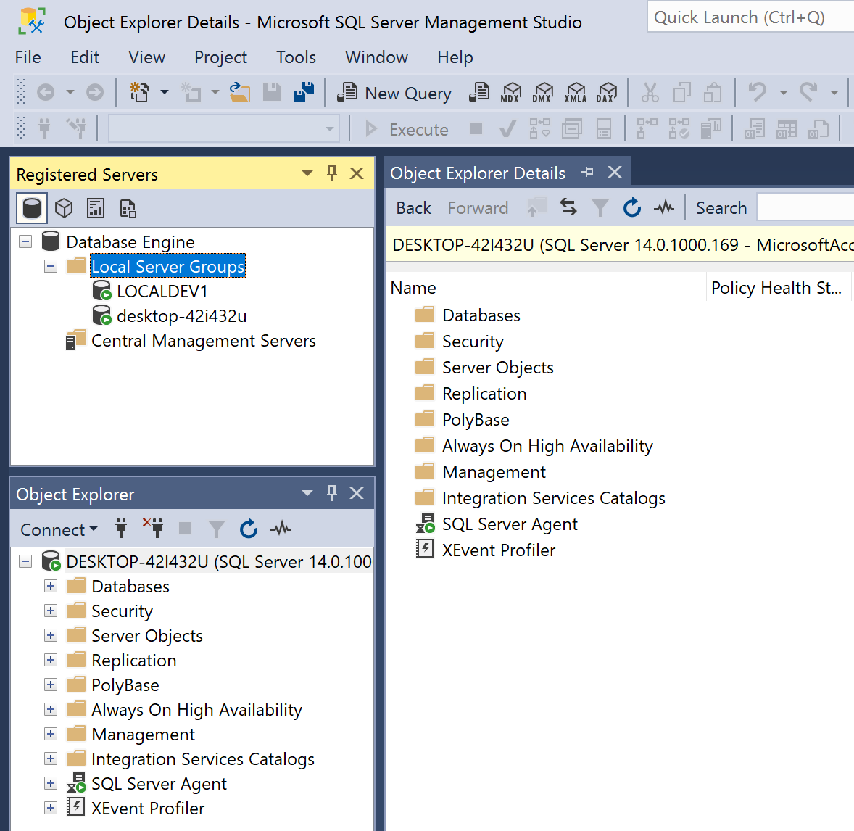

This image shows that I succesfully installed SQL Server 2017 and SQL Server Management Studio and successfully created and configured an SQL Server.

2.

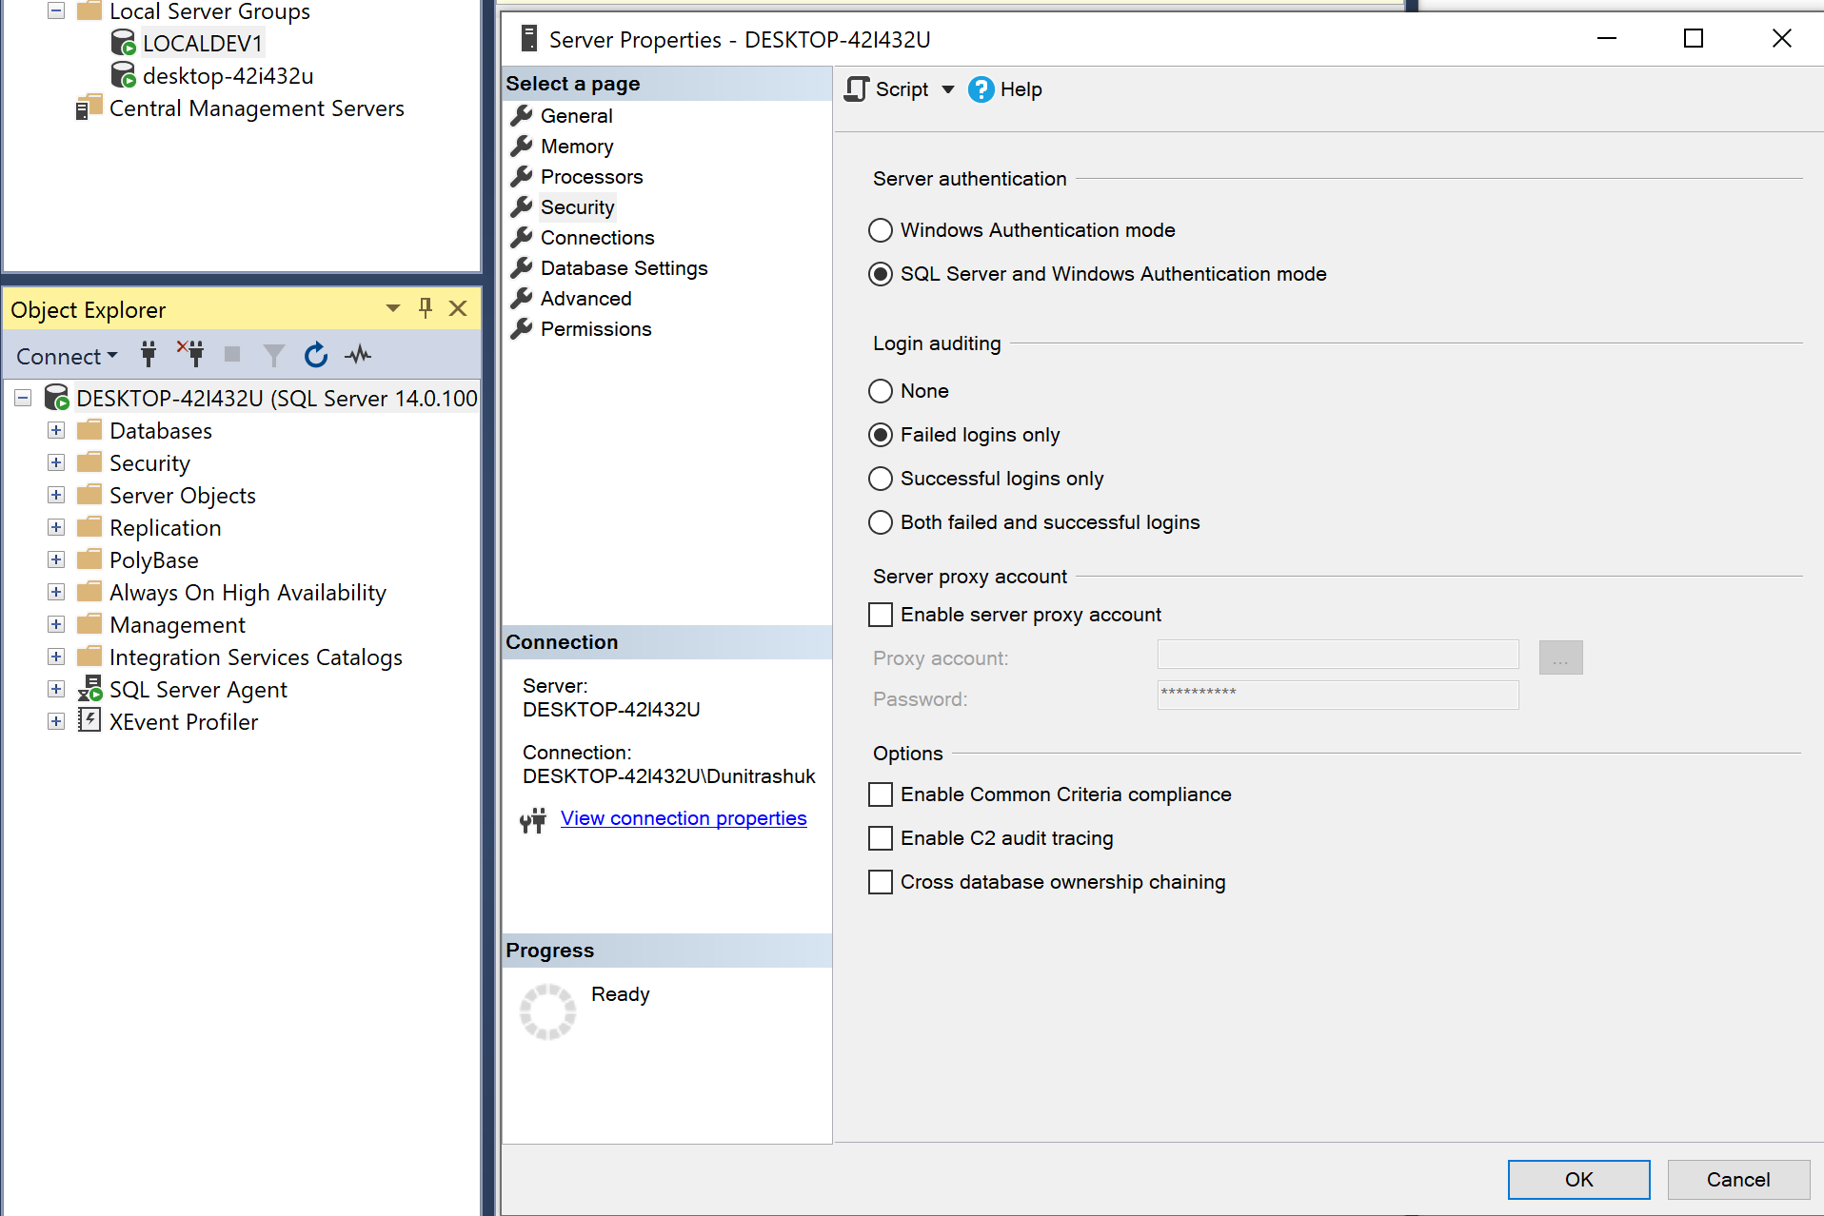

Here I registered the server with SQL Server and Windows Authentication mode

3.

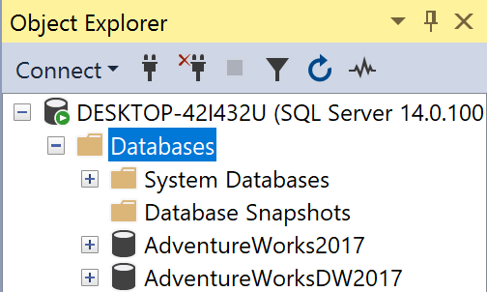

I restored the AdventureWorks2017 and AdventureWorksDW2017 databases

a)

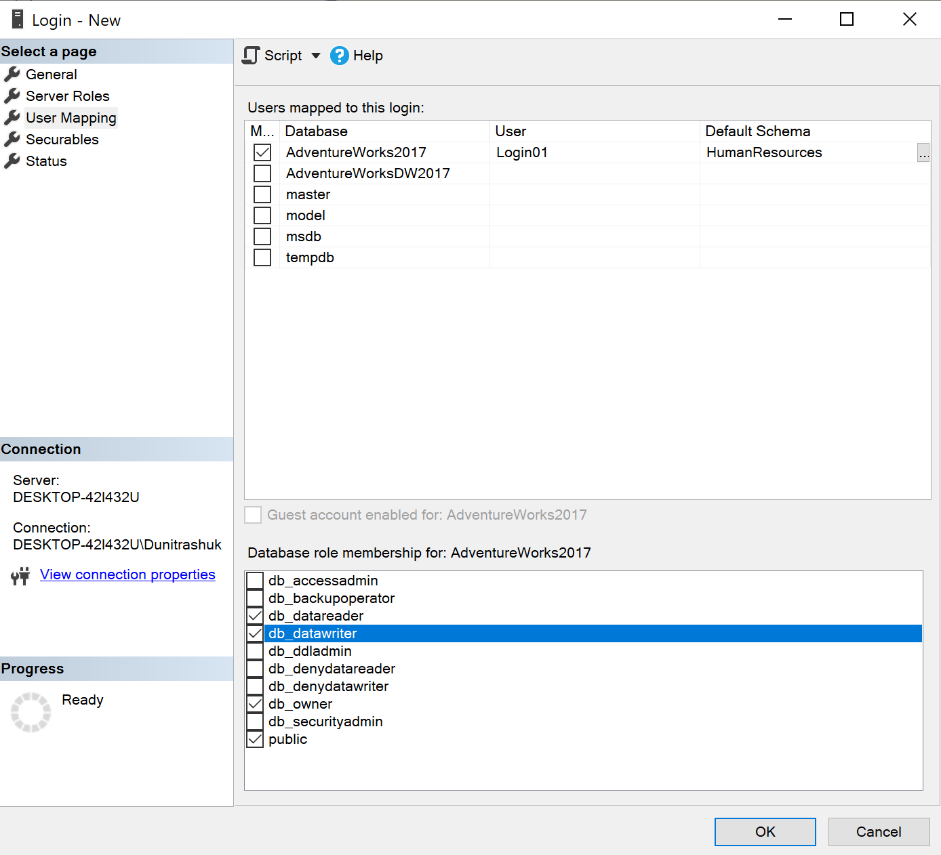

Here I created the user Login01 who has access to HumanResources Schema. He has the ability to write and read.

b)

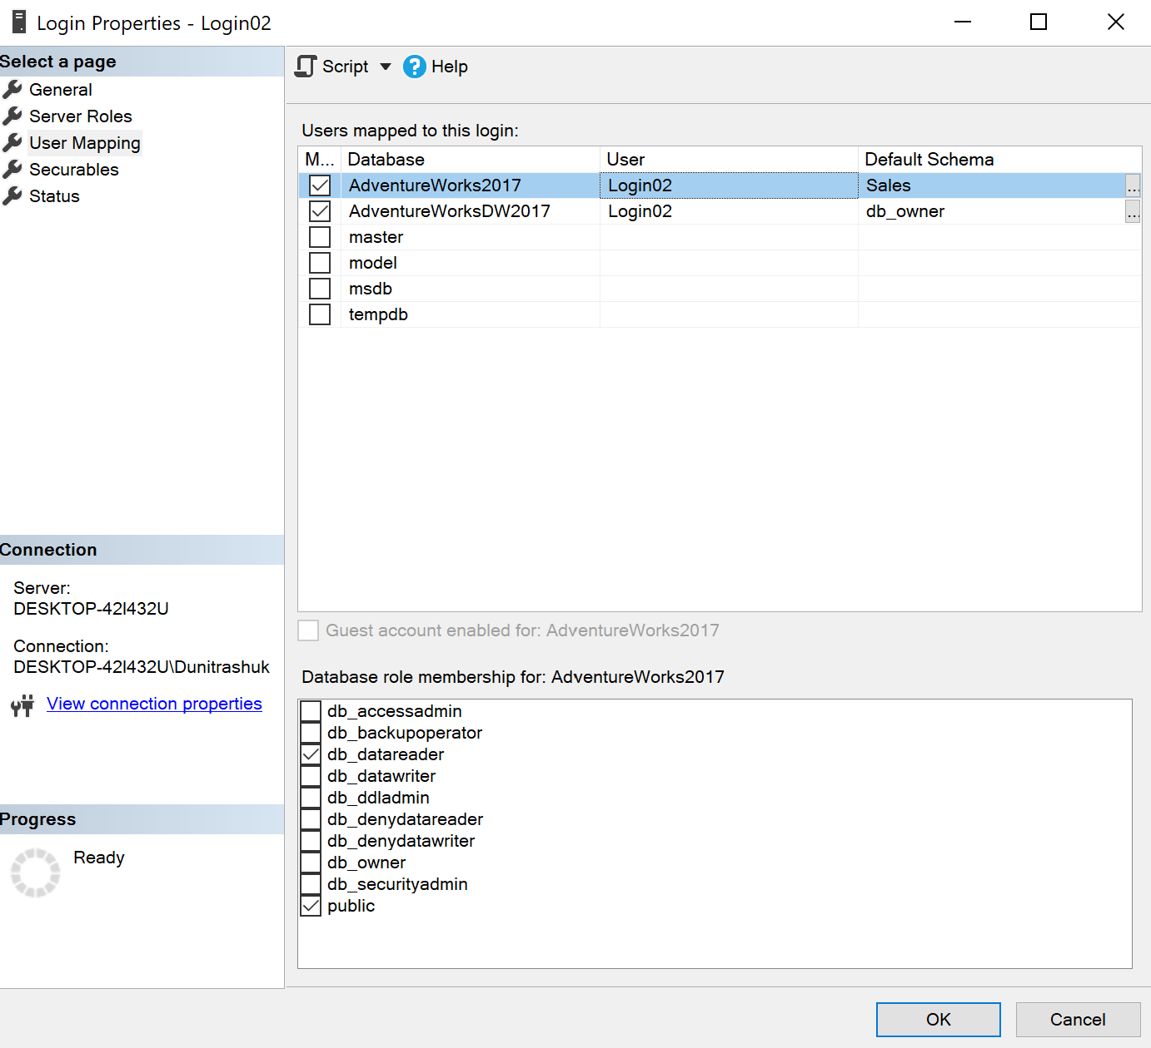

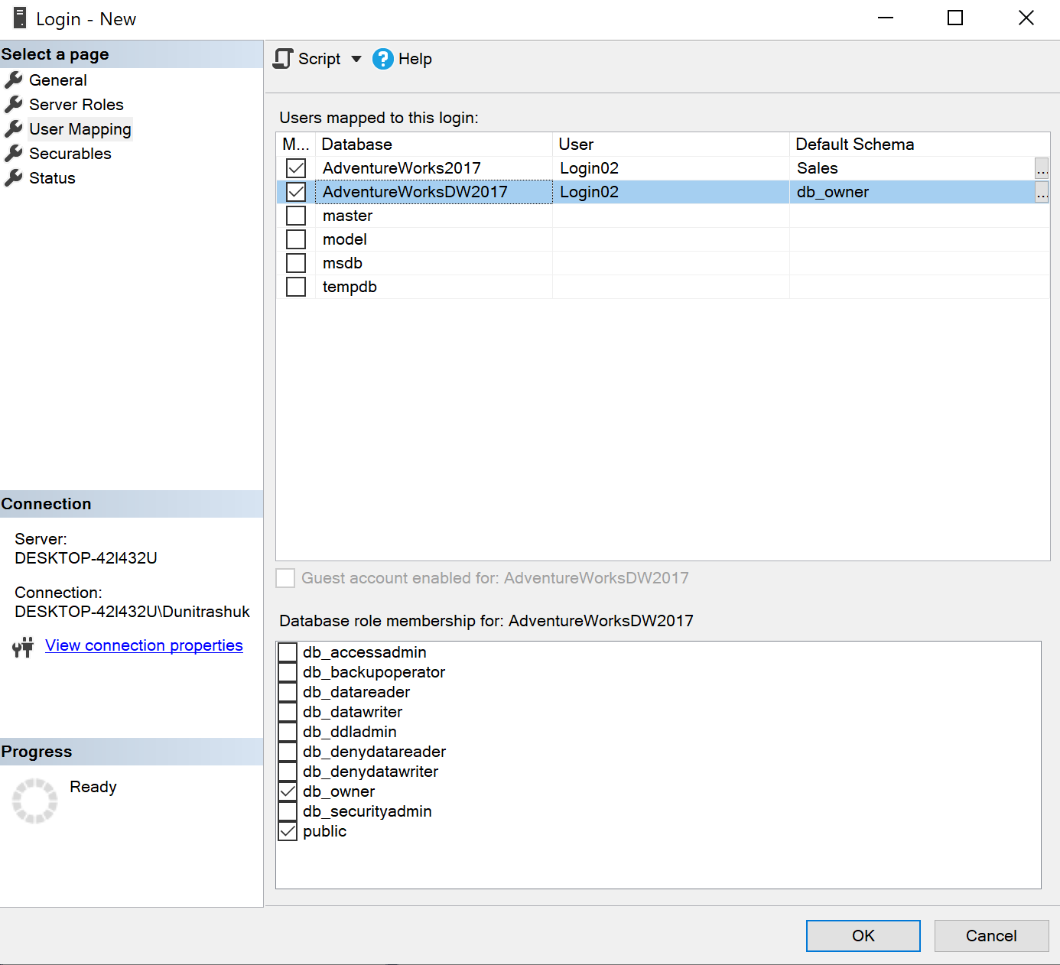

Here I created the Login named Login02 who has access to Sales Schema from AdventureWork2s017 database to only read data and at the same time he has access to the AdventureWorksDW2017 database with the permission to modify every object and content from this database.

c)

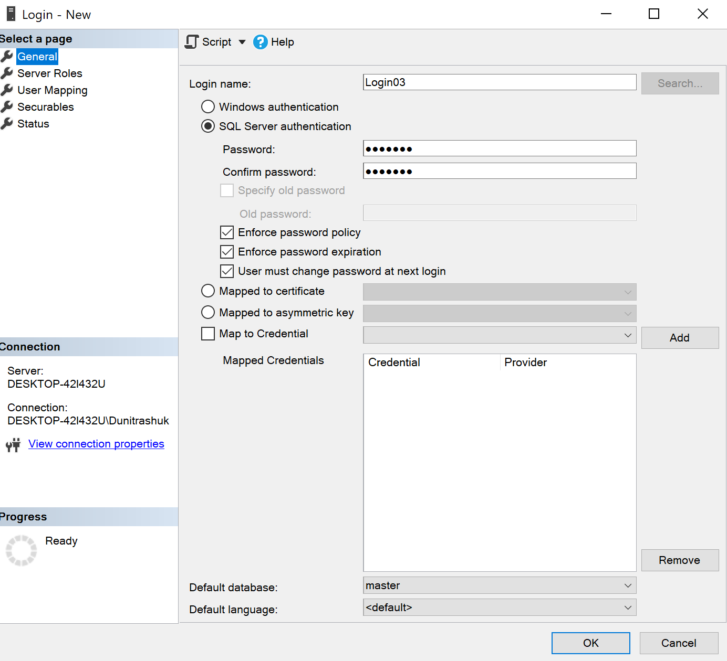

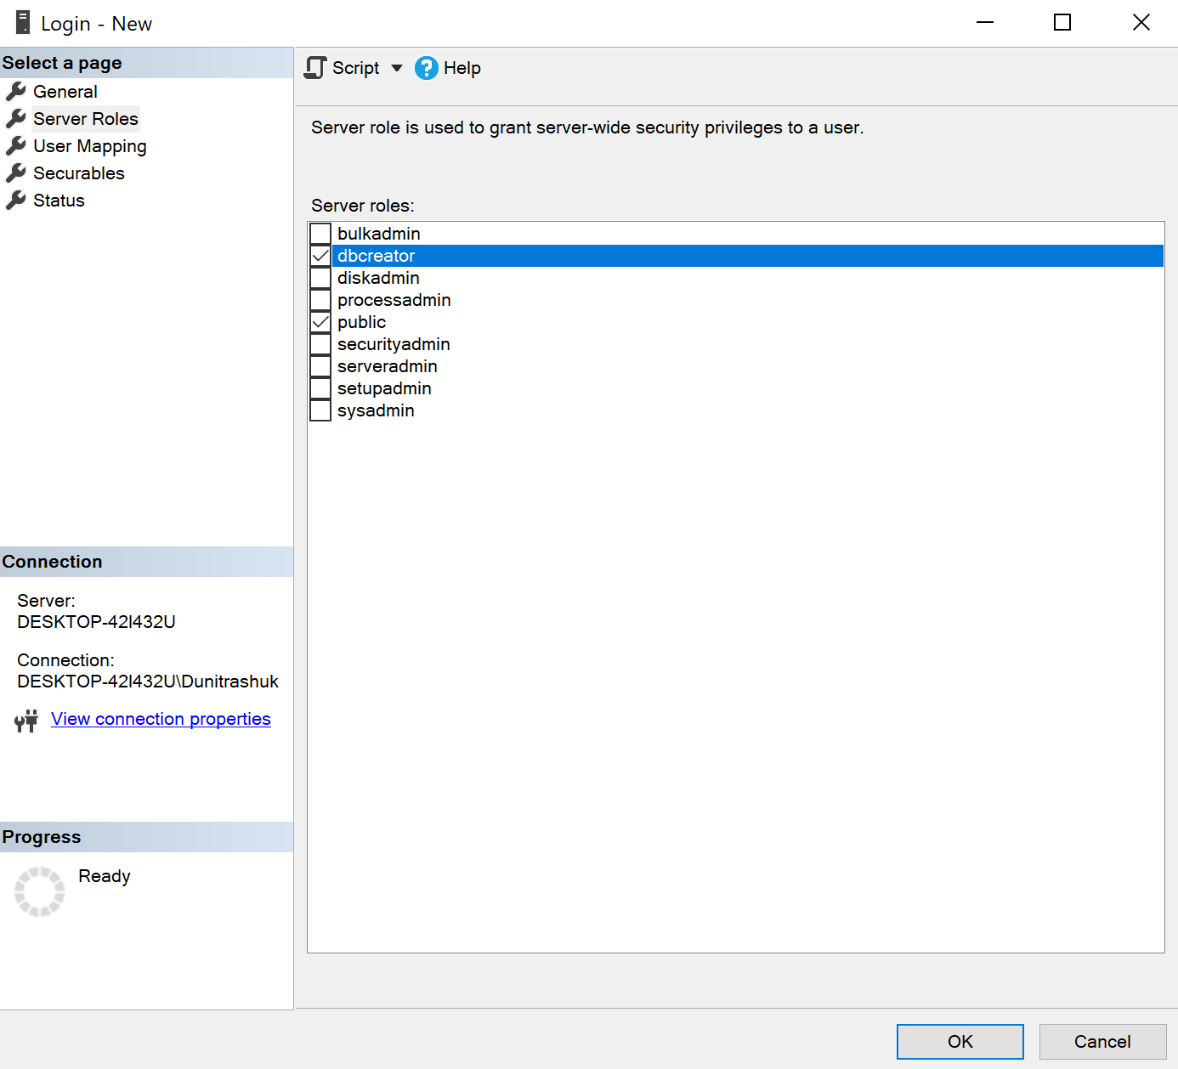

Here I created the Login named Login03 which has the server role (dbcreator).

**Conclusion:**

In this laboratory work I succesfully installed and configured SQL Server 2017. I learned how to create a database server and set a type of authentication. I created three Logins which have different roles and permissions to an specific database (AdventureWorks2017 and AdventureWorksDW2017). This laboratory work introduced us in SQL Server Management and we learned some basic things in order to work with the Graphical Interface and manage the database.