**Databases Laboratory Work Nr.6** Mamaliga Dumitras FAF-191

**Title: CREAREA TABELELOR SI INDECSILOR**

**Prerequisites:** SQL Server Management Studio

**Objectives:** In capitolul de fata sunt tratate structura instructiunilor CREATE, ALTER, INSERT, UPDATE, DELETE utilizate pentru crearea si gestiunea tabelelor. In afara de aceasta, sunt examinate aspectele de creare si administrare a indecsilor, utilizand instructiuni Transact-SQL, precum si in mediul grafic Microsoft SQL Server Management Studio.

**Tasks:**

1.

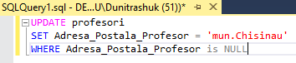

2.

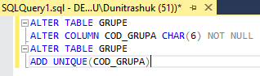

3. a)

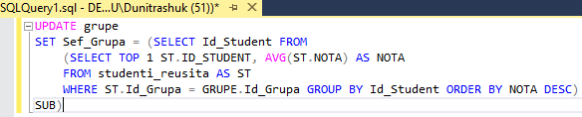

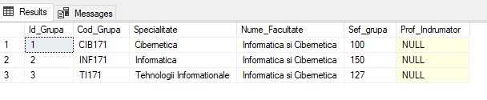

b)

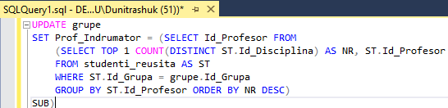

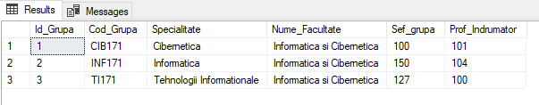

c)

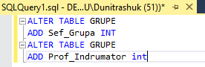

4.

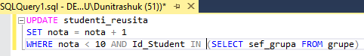

5.

a

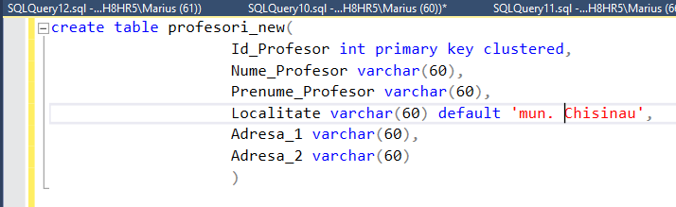

b

6.

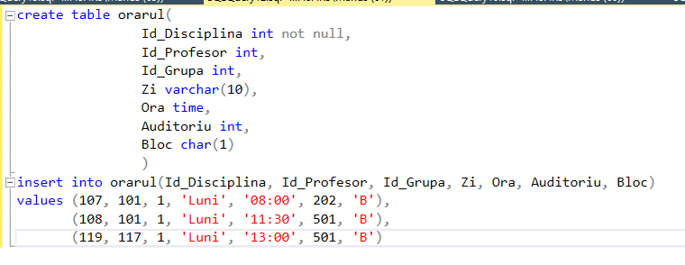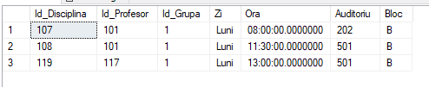

7.

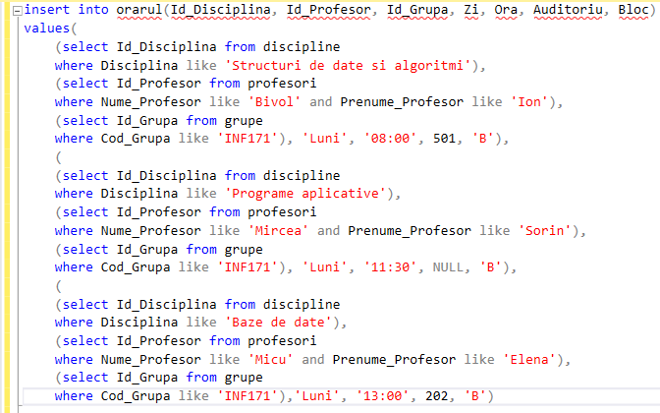



8.

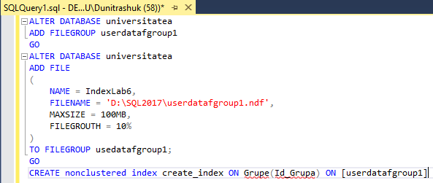

**Conclusion:**

In this laboratory work we learned how to create and maintain tables with some instructions like ALTER, CREATE, UPDATE, INSERT, DELETE. We also learned how to create indexes using Transact-SQL instructions. This laboratory work boosted our knowledge using SQL Server Management Studio.