|  |
| --- |
| Master 1 - ISII |
| Artificial Intelligence |
| Machine Learning Project |

|  |
| --- |
| Team N° 10   * Taleb Mehdi * Sennoun Merouane * Zouai Serine Maria * Aouanouk lmane * Zemmouri Arslane |

Table of Contents

1. Introduction 2

2. Project Descriptions 2

2.1. Regression Problem 2

2.2. Classification Problem 2

3. Real Estate Valuation 3

3.1. Dataset Description 3

3.2. Preprocessing 3

3.3. Linear Regression 5

4. Immunotherapy Treatment Result 6

4.1. Dataset Description 6

4.2. Preprocessing 6

4.2.1 Graphic Representation 7

4.2.2 Pairwise Correlation of the features 7

4.2.3 Missing values 8

4.2.4 Removing Categorical values 8

4.2.5 Detecting Outliers 9

4.2.6 Feature scaling 10

4.3. Logistic Regression 11

4.4 Neural Network 12

4.5 SVM 13

4.6 Decision Trees 14

4.6.1 Train and Test Datasets 14

4.6.2 Building the Decision Tree 14

4.6.3 Text representation of the decision tree 15

4.6.4 Feature importance in the Decision Tree: 15

4.6.5 Graphic representation: 16

# Introduction

The project that we had to undertake is based on a subcategory of machine learning and artificial intelligence, which is Supervised Learning. Essentially, supervised learning is when the computer is taught by example. It learns from past data and applies the learning to present data to predict future events. In this case, both input and desired output data provide help to the prediction of future events.

Supervised learning can also be divided into two subcategories, classification and regression. Which are the two sorts of problems that we had to operate.

We had to apply the specific analysis methods to each category, to solve the two problems and train different models capable of predicting the best possible results.

On the other hand, we also had to comply with specific working methods to solve a machine learning problem. The use of a notebook is therefore essential for this, because it is used to present the analysis process step by step by arranging the code, images, text, output etc. in a step-by-step manner. Jupyter Notebook provides a full set of features that makes it one the best components of Python Machine Learning. Another tool that we used, this time for the arrangement and organization of work in general, is Git and GitHub, such as each member of the group made changes on the part of the notebook that corresponded with a specific part of the project (preprocessing, graphic visualization etc.)

In the following parts, we are going to discuss the achieved tasks in each of the two problems, explaining the dataset content, the different steps of preprocessing realized to improve its quality, and testing and visualizing the obtained results produced from the built models.

# Project Descriptions

## Regression Problem

One of the two problems that we had to process is a regression problem. A regression analysis must be considered when we deal with a problem that requires a prediction of a continuous value. Our regression problem is about valuating real estate properties given certain characteristics about them and their surroundings. Basically, the main task is to predict a house price, which is continuous value, considering a group of numerical/categorical features describing this house.

## Classification Problem

The second problem is a classification problem. This is the kind of problems that require the result of the prediction to be a categorical value. In our case it is a binary classification, for the reason that the model can only predict a 0 or 1 value for a given set of feature values concerning an instance. Our classification problem is about predicting if Immunotherapy, when used for wart treatment, produces a positive or negative result on a patient, given different informations about this one. A prediction of “1” being a result of a successful treatment and “0” of an unsuccessful one.

# Real Estate Valuation

## Dataset Description

The real estate valuation is a regression problem. The market historical data set of real estate valuation are collected from Sindian Dist., New Taipei City, Taiwan.

The data set was randomly split into the training data set (2/3 samples) and the testing data set (1/3 samples).

**Attribute Information:**

The inputs are as follows:  
X1=the transaction date (for example, 2013.250=2013 March, 2013.500=2013 June, etc.)  
X2=the house age (unit: year)  
X3=the distance to the nearest MRT station (unit: meter)  
X4=the number of convenience stores in the living circle on foot (integer)  
X5=the geographic coordinate, latitude. (Unit: degree)  
X6=the geographic coordinate, longitude. (Unit: degree)  
  
The output is as follows:  
Y= house price of unit area (10000 New Taiwan Dollar/Ping, where Ping is a local unit, 1 Ping = 3.3 meter squared)

## Preprocessing

## Linear Regression

# Immunotherapy Treatment Result

## Dataset Description

This dataset contains information about wart treatment results of 90 patients using immunotherapy.

## Preprocessing

The imported dataset df:

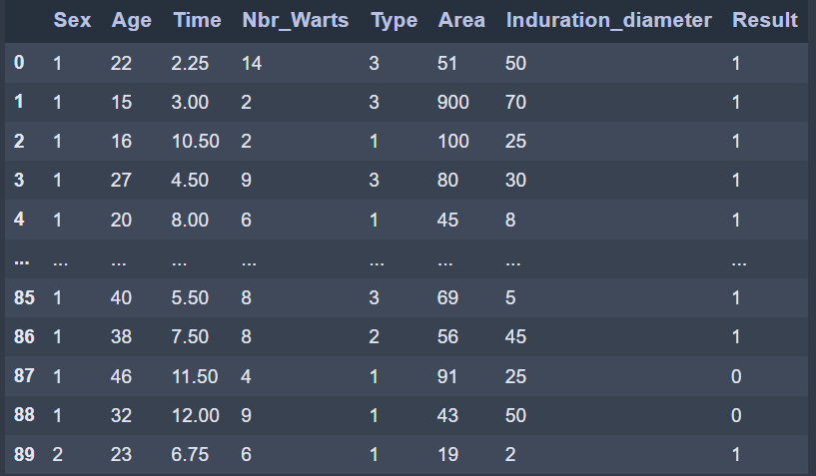

### 4.2.1 Graphic Representation

We represent all the 7 features in comparison to ‘Result’ in 7 subplots:

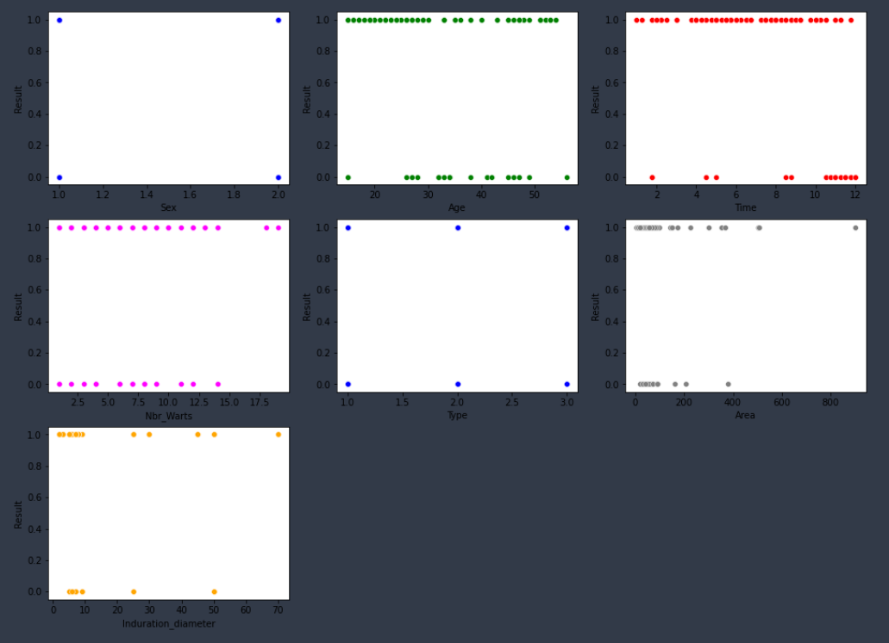

### 4.2.2 Pairwise Correlation of the features

We use df.corr() to show pairwise correlation of all the features:

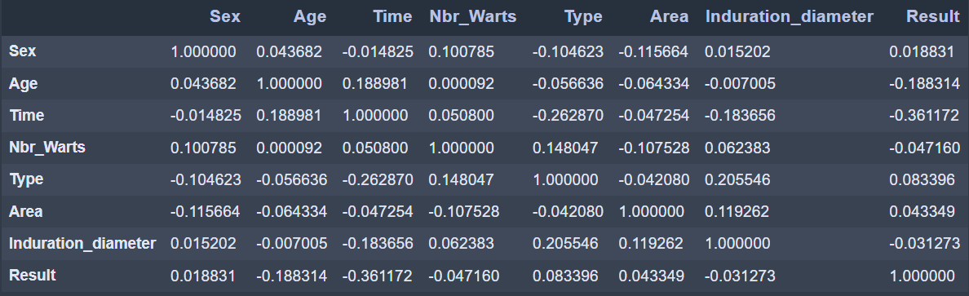

We notice that the features ‘Time’ and ‘Age’ have the strongest correlation to ‘Result’

### 4.2.3 Missing values

We use the command **isna().sum()** to check if there are any missing values

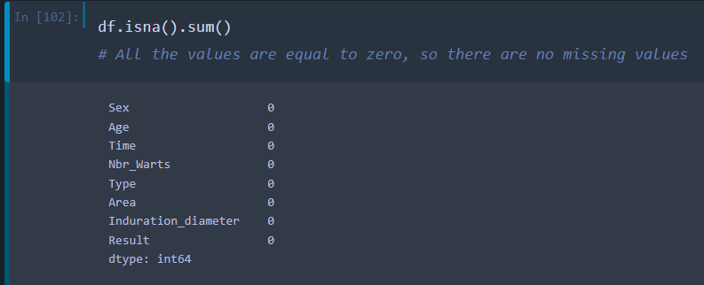

### 4.2.4 Removing Categorical values

The features 'Sex' and 'Type' are of Categorical type, we have to transform them to a numerical type (int) using the 'Dummies' method:

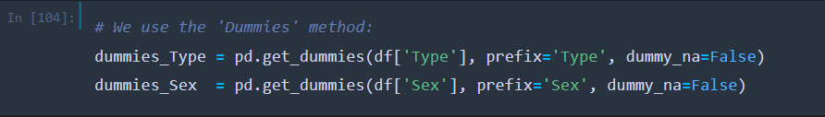

‘Type’ dummies:

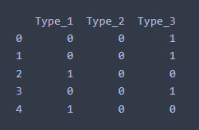

‘Sex’ dummies:

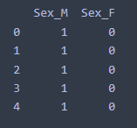

-We remove the features ‘Type’ and ‘Sex’ from the initial dataset df.

-We merge all the features to get our new and processed dataset:

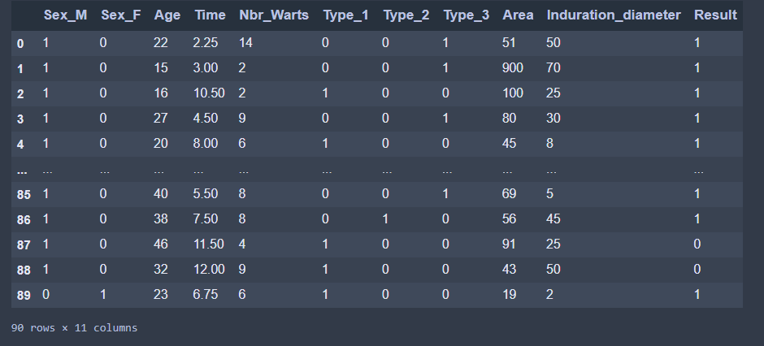

### 4.2.5 Detecting Outliers

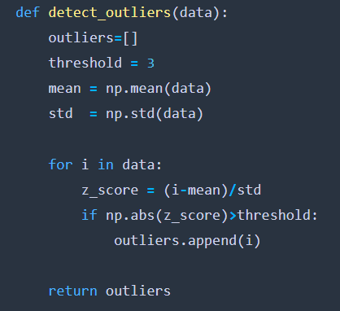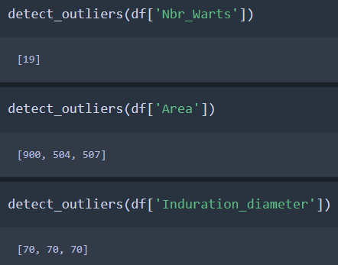We use the **‘z_score’** method to detect the outliers:

**Remark:** we checked all the other features and they don’t contain any outliers.

Table of all the outliers of ‘Nbr_Warts’, ‘Area’ and ‘Induration_diameter’:

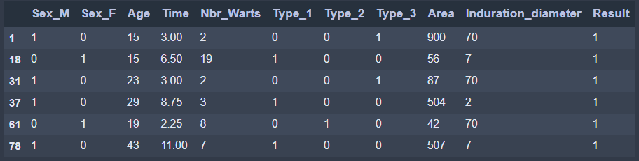

Df after removing the outliers:

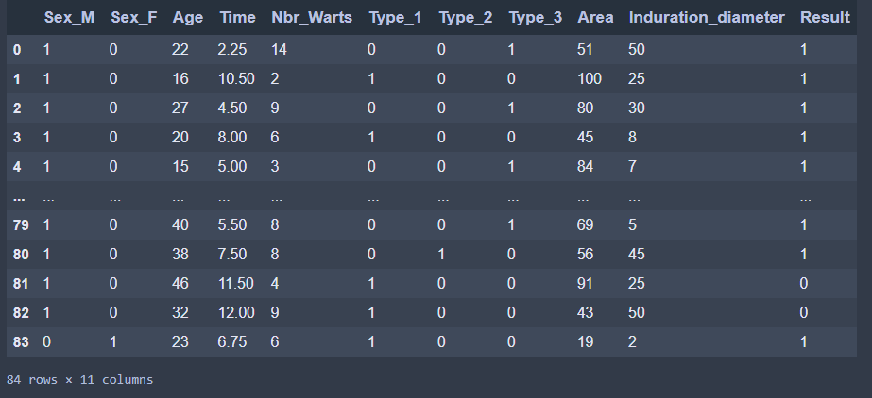

### 4.2.6 Feature scaling

To make all values of features between 0 and 1 we use MinMaxScaler from sklearn.preprocessing

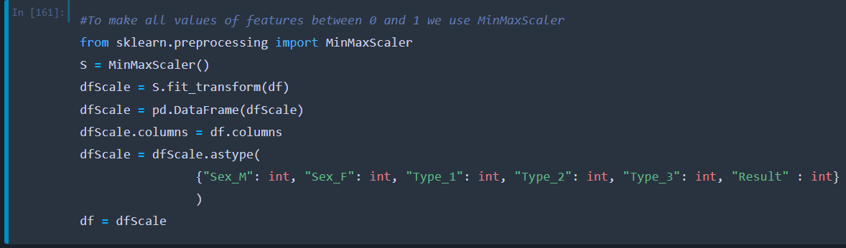

Df after the feature scaling:

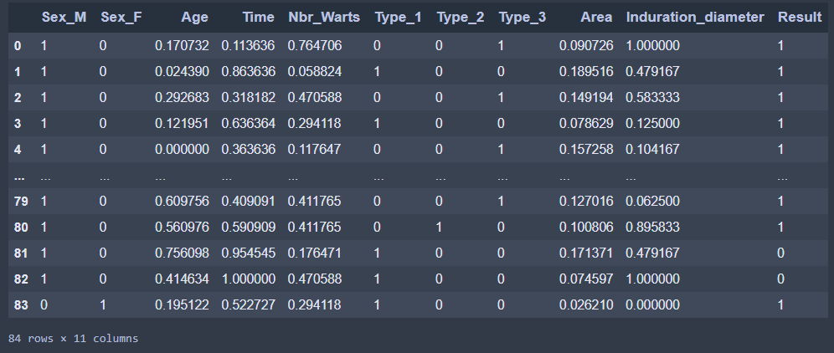

And this is also the final result of all of the pre-processing methods.

## Logistic Regression

## 4.4 Neural Network

## 4.5 SVM

## 4.6 Decision Trees

### 4.6.1 Train and Test Datasets

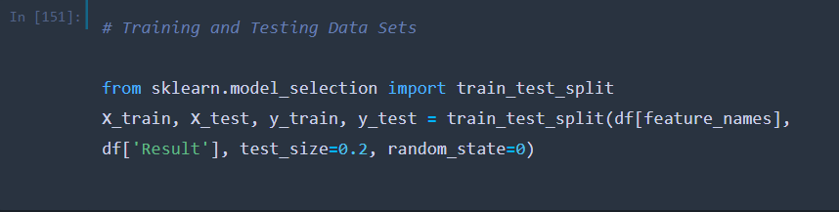

After trying many test-sizes, 0.2 gave the best test accuracy:

|  |  |  |
| --- | --- | --- |
| **Test Size** | **Train Accuracy** | **Test Accuracy** |
| 0.1 | 98.67 % | 88.89 % |
| 0.15 | 98.59 % | 92.31 % |
| 0.2 | 100 % | 94.12 % |
| 0.25 | 100 % | 80.95 % |
| 0.3 | 98.28 % | 92.31 % |
| 0.35 | 98.15 % | 93.33 % |
| 0.4 | 100 % | 91.18 % |

### 4.6.2 Building the Decision Tree

We found that the best max_depth is 6

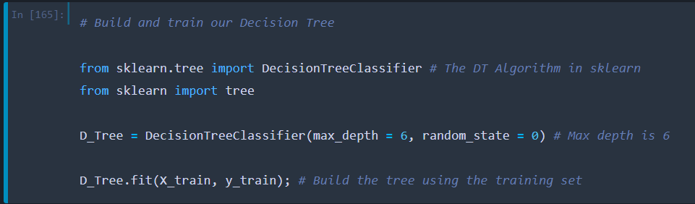

### 4.6.3 Text representation of the decision tree

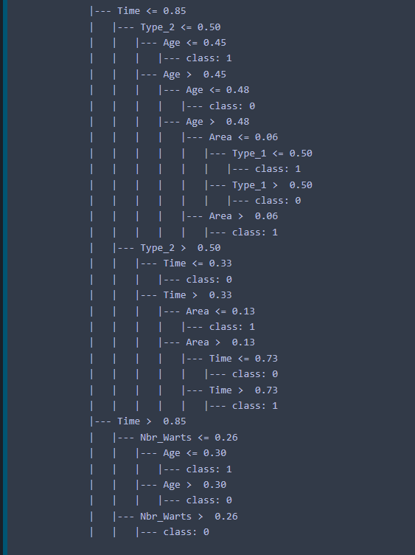

### 4.6.4 Feature importance in the Decision Tree:

We used D_Tree.feature_importances and plt.barh() to create this graph :

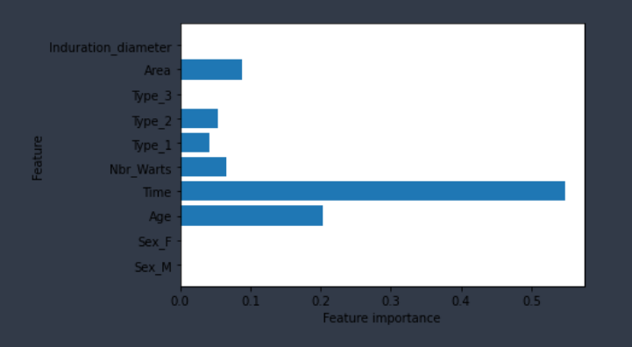

We notice that ‘Time’,’Age’ and ‘Area’ are the most important features, while ‘Sex_F’, ‘Sex_M’ and ‘Type_3’ are not used.

### 4.6.5 Graphic representation:

