C:\Users\Messom\Desktop\Monash.jpg

**FIT5042 Design Report (Major Tasks)**

Banking Enterprise Application

Student Name: Duo Pan

Student ID: 27554074

Tutor Name: ABM Russel

Tutorial Time: Mon 18:00-20:00

Lecturer: Chris Messom

Table of Contents

1. Overview 3

2. Functional diagram 3

3. Core program functionality 3

4. Usability Design Review 5

5. Checklist of site functionality 6

# 1. Overview

This assignment is to build a web-based Java prototype of a Banking Enterprise Application as well as a desktop client application version. Some Java enterprise technologies should be used in the assignment: JSF, RESTful web services, EJB, Persistence API and so on.

The basic function is that users can login in the system by their username and password. System will then redirect the user to the specific page. If the user is a public customer, he/she can view and edit his/her own information, and can view, create, sort, multiple search their transaction records. If it is a bank worker, he/she can view, create, update, delete and search users.

# 2. Functional diagram

When the application is running, it first displays its main page. This page provides a table to display data and some buttons to navigate to other pages. Every other page has a specific function and a button to go back to the main page.

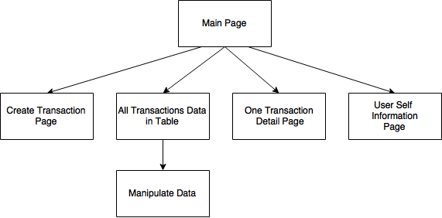

# 3. Core program functionality

Use BootsFaces library to build the page, which is designed for JSF and based on Bootstrap. It provides a table control, and through changing its attributes, I can get functions I need.

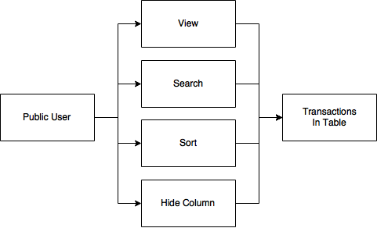

* View all data in table, click view button, can see detail of this transaction record.

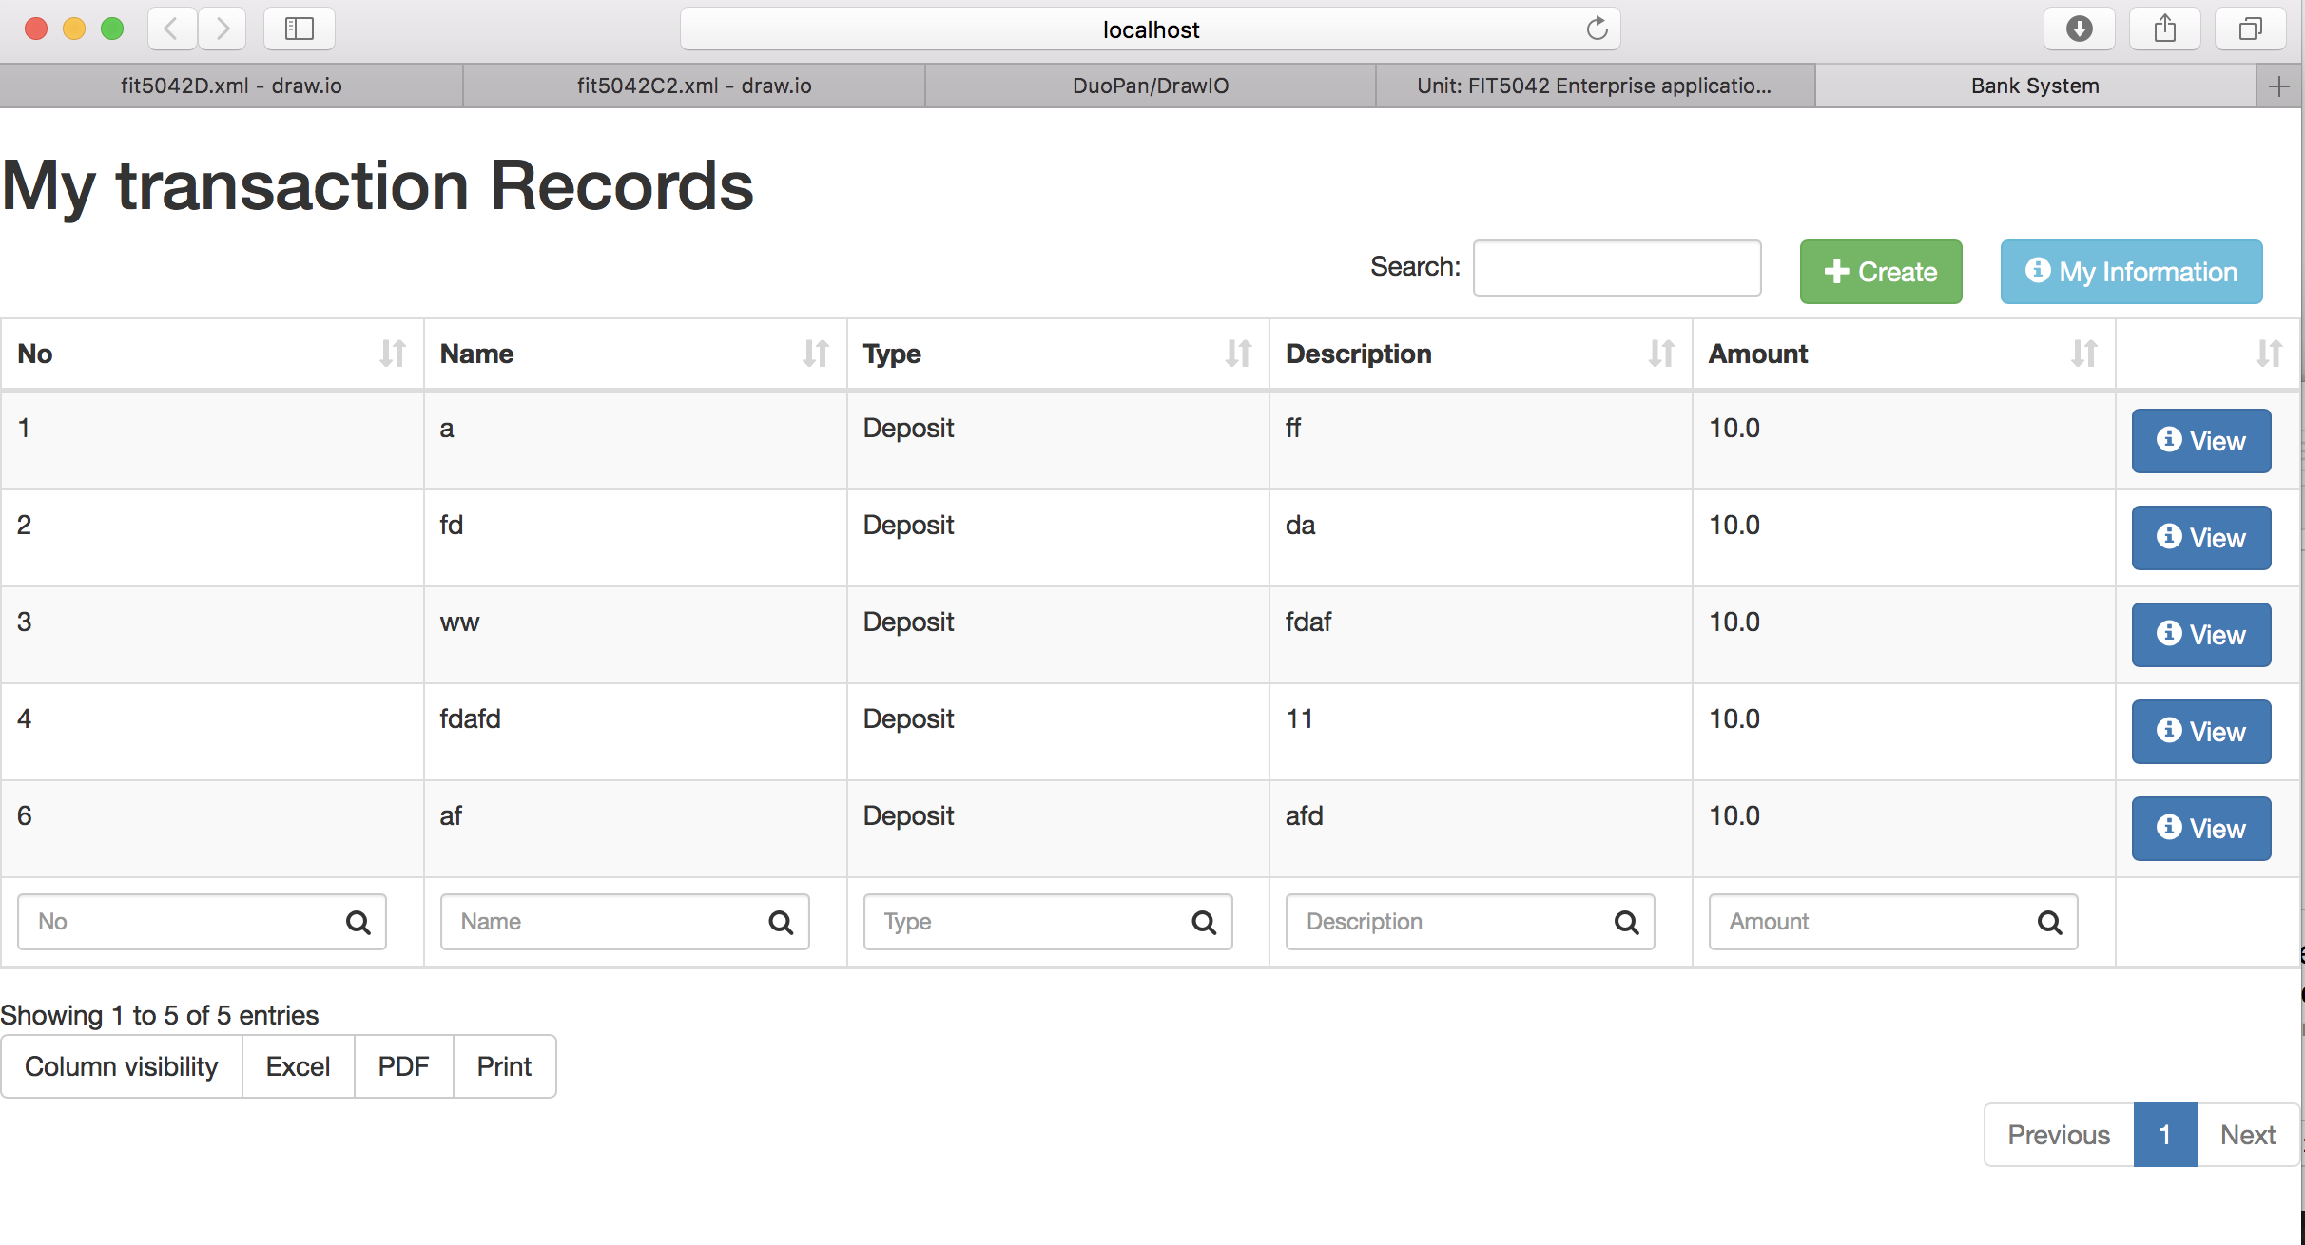

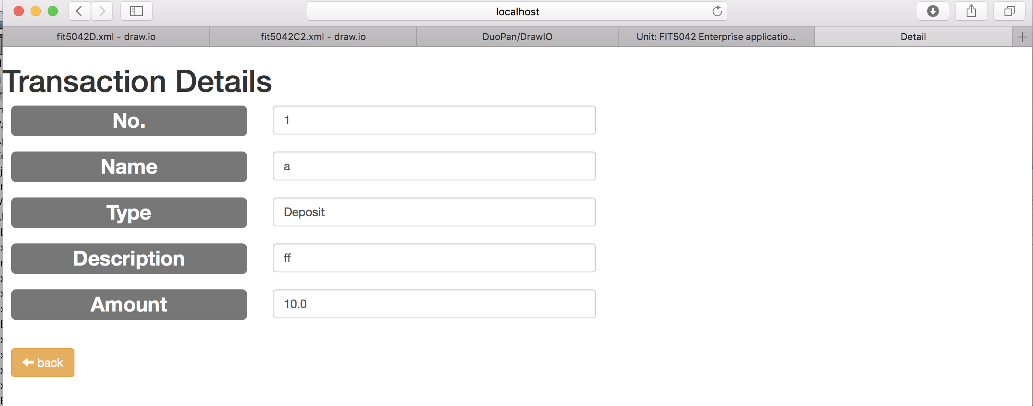

* Can choose which attributes to show on table.

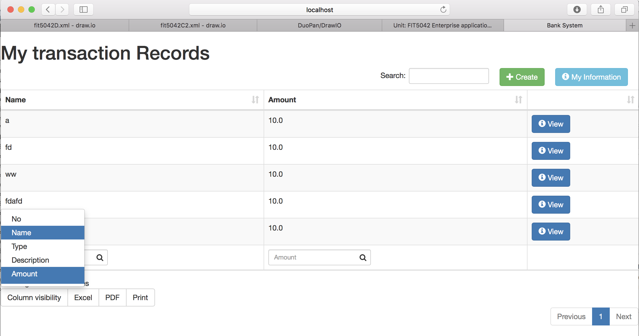

* Multiple search. I put a search textbox under each column, so users can input data in the corresponding search textbox to do multiple search. The example search attributes by both name and amount.

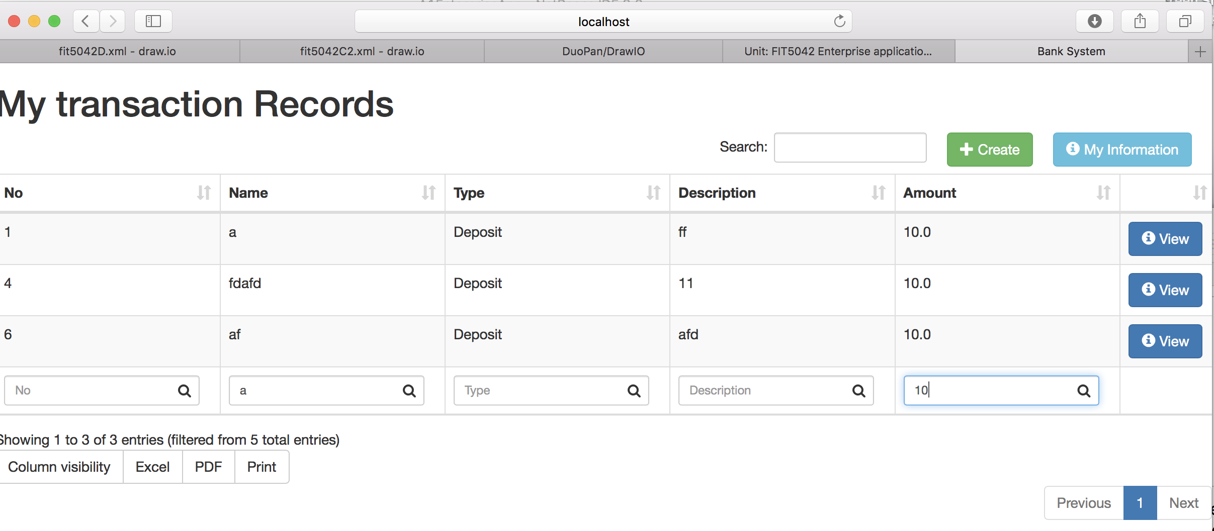

* Navigation: Provide buttons for user to view transaction details and come back to main page.

# 4. Usability Design Review

* Navigation: Each page has good navigation buttons to the other pages, they are colorful and easy to find;
* Familiarity: This web site did not adopt any strange layout, so it is familiar with most people;
* Consistency: This web application can run at different browsers.
* Error Prevention: User inputs are check before store into the database;
* Feedback: When mouse moves over table rows, it will highlight.
* Visual Clarity: Data table makes the web site easy to read and use. Red color on delete button also remains user be careful when clicking. The whole page is clear and tidy.
* Flexibility: Many buttons in a page, so that user can easily go to a page they want. All the pages are connected in graph structure instead of linear.

# 5. Checklist of site functionality

|  |  |
| --- | --- |
| **1. Credit Functionality** |  |
| Search for Transaction by | ✔️ |
| Transaction Name, | ✔️ |
| Transaction No | ✔️ |
| Transaction Type | ✔️ |
| Results with tabular format with heading. | ✔️ |
| Option to view the full details | ✔️ |
|  |  |
|  |  |
| **2. Technical Requirements** | ✔️ |
| **Credit** | ✔️ |
| JSF web clients | ✔️ |
| Persistence API | ✔️ |
| Application managed entity manager or container managed entity manager. | ✔️ |
|  |  |
| **Audit** | ✔️ |
| No breaking of copyright | ✔️ |