From Fragmentation to Systematization: A Standardized Quality Selection and Systematic Reconstruction Approach for RISC-V Courses

Fuyuan Zhang, and Yunxiang Luo

Institute of Software, Chinese Academy of Sciences (ISCAS)

# Abstract

The development of RISC-V technology faces challenges such as the existence of low-quality online courses, fragmented content, a lack of hierarchical and systematic course series, insufficient online experimental practice environments, and limited channels for learning Q&A. The paper sets out to develop a standardized model for assessing the quality of RISC-V courses. In addition, it puts forward a reconstruction method based on course classification tags, organized the individual video into a structured course series. The solution integrates a online RISC-V lab with offline community activities, thereby establishing an integrated online-offline practical teaching environment. This project has produced over 1,000 original RISC-V lecture videos, with total views exceeding 1.3 million. The experimental results demonstrate that the systematically organized course collections generated by this method significantly improve viewership and user engagement, providing a systematic solution for the development of the RISC-V education ecosystem.

# Motivation

RISC-V is an open instruction set architecture that has rapidly developed in recent years, garnering widespread attention due to its flexibility and openness. However, despite the rapid expansion of its ecosystem, the courses available for beginners and developers face numerous challenges, hindering both technology dissemination and talent cultivation. Firstly, the quality of instruction is often substandard, partly because many university instructors lack hands-on development experience in RISC-V. Secondly, the learning content remains highly fragmented—most lectures are isolated, lack continuity, and do not form a structured curriculum that builds progressively from fundamentals to advanced applications. This fragmentation severely impacts learning coherence, especially for novices. Moreover, existing course evaluation systems typically rely on end-of-term assessments, which provide delayed and insufficient feedback for iterative content improvement.[1] Finally, the absence of online experimental environments and interactive Q&A mechanisms further limits learners’ opportunities for hands-on engagement and timely support.

# Methods

To address these challenges, our research establishes a tripartite quality assurance framework combining quantitative engagement metrics, qualitative expert assessment (The quality assessment model of RISC-V courses) , and systematic content reorganization. The initial filtration phase leverages Bilibili.com's native analytics to monitor three key performance indicators: aggregate view counts as a measure of content reach, like/dislike ratios reflecting satisfaction levels, and comment density (minimum 5 substantive comments per 500 views) indicating active engagement. This data-driven approach ensures that only the top 30% of lectures demonstrating genuine learner value progress to subsequent evaluation stages.

The standardized model for assessing the quality of RISC-V courses, referencing Table 1, comprising both academic experts and industry engineers—employs a weighted scoring matrix assessing five critical dimensions. Technical accuracy (25% weighting) evaluates conceptual precision against the latest RISC-V specifications, while pedagogical structure (25%) examines logical sequencing and cognitive scaffolding. Practical relevance (25%) measures alignment with real-world development scenarios, and experimental completeness (25%) verifies the availability of executable code samples and simulation exercises.

**Table1. The quality assessment model of RISC-V courses**

|  |  |  |
| --- | --- | --- |
| Criterion | Weight (%) | Description |
| Technical Accuracy | 25 | Correctness and depth of RISC-V concepts. |
| Pedagogical Structure | 25 | Logical progression, clarity, and learner accessibility. |
| Practical Relevance | 25 | Applicability to real-world RISC-V development. |
| Experimental Completeness | 25 | Availability and effectiveness of hands-on exercises. |

To transform fragmented RISC-V lectures into a structured curriculum, we propose a tag-based systematic reconstruction method. This approach, referencing Table 2, leverages metadata tagging to classify courses by topics, difficulty level, experimental requirements, and timeliness, enabling automated generation of logically sequenced course series. The methodology ensures that learners receive a coherent, progressive, and practice-oriented educational experience.

**Table2. The tags of RISC-V Lectures**

|  |  |  |
| --- | --- | --- |
| **Tag** | **Category Values** | **Purpose** |
| Theme | RISC-V CPU Design, | Groups courses by technical domain. |
| Difficulty | Beginner/Intermediate/Advanced | Ensures hierarchical progression. |
| Has Experiment | Yes/No | Filters out non-practical content. |
| Release Time | Year (2019–2024) | Prioritizes recent content (<5 years old). |

Our framework, referencing Figure 1, addresses this challenge through a five-phase reconstruction pipeline leveraging granular metadata(classification tags) annotation and algorithmic sequencing. Initial preprocessing applies temporal and practical filters, discarding videos exceeding five years antiquity (to maintain technical relevance) and those lacking experimental components (ensuring hands-on competency development). This selective filtration, applied to our corpus of 1,000+ Bilibili-hosted lectures, typically retains 60-70% of content while eliminating outdated or purely theoretical material.

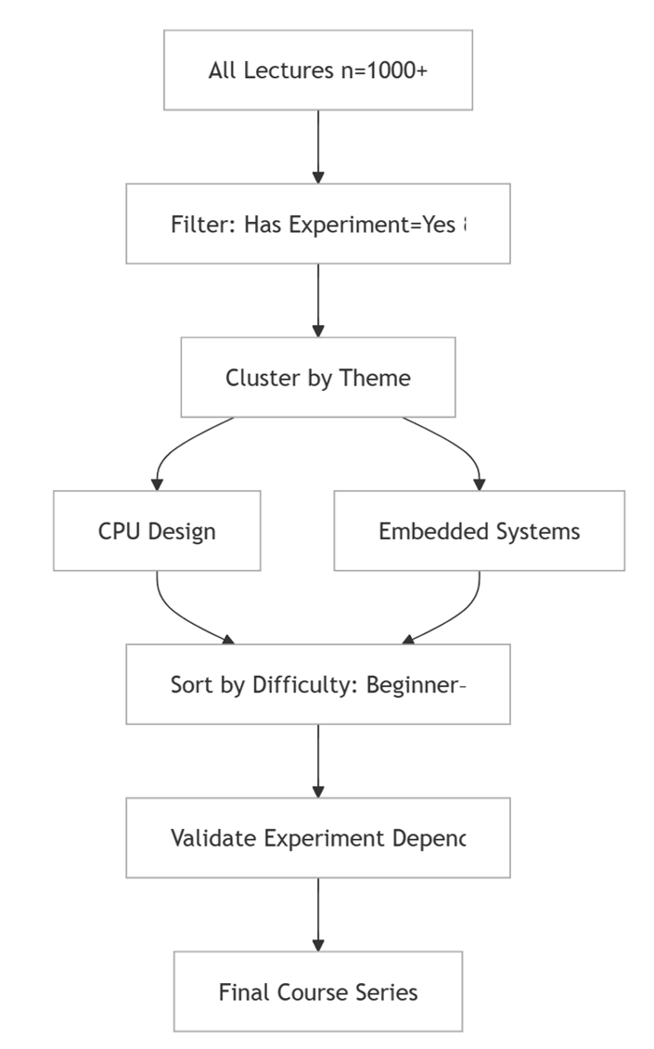

**Figure 1. Reconstruction pipeline leveraging granular classification tags**

Following filtration, thematic clustering employs domain-specific tags (e.g., "RISC-V CPU Architecture", "RISC-V Compiler") to establish coherent subject trajectories. Each cluster undergoes tripartite difficulty stratification—beginner courses introducing foundational ISA concepts precede intermediate pipeline optimization techniques, culminating in advanced multicore synchronization topics. Crucially, experimental continuity validation ensures laboratory exercises progress from QEMU-based emulation or RISC-V boards.

To mitigate RISC-V laboratory infrastructure accessibility barriers, a distributed remote lab environment was established across Beijing, Nanjing, and Shanghai, referencing Figure 2, Key components include multi-region RISC-V boards integration, access architecture, and Operating System support. The physical RISC-V development boards (e.g., HiFive Unmatched, Licheepi4A) are pooled from our labs and community contributors, enabling shared access via remote protocols. Users connect through SSH and VNC protocols, facilitated by a jump server for secure authentication. Smart power outlets enable remote power cycling, while SD Mux devices automate firmware flashing (e.g., using SDWireC for unattended SD card programming). A compatibility RISC-V Operating System Matrix, offering 56 types of RISC-V boards and 41 types of operating systems, ensures seamless integration of diverse RISC-V boards with Linux distributions (e.g., Fedora RISC-V, Debian) and real-time operating systems (e.g., FreeRTOS).

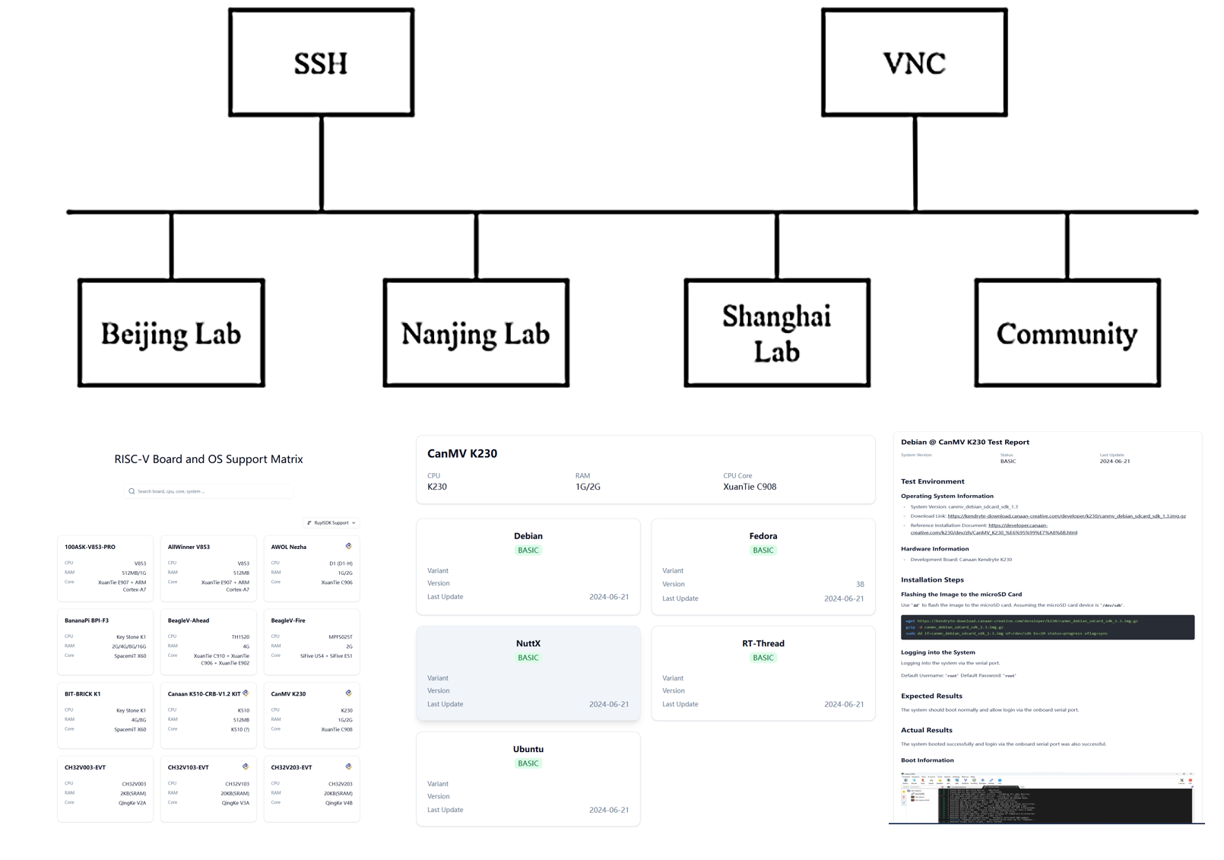

**Figure 2. Online RISC-V Lab**

To foster collaboration and engagement, a hybrid online-offline community was cultivated. The community has Bilibili and WeChat as platforms with a large number of participants, offering tutorials, Q&A forums, and live coding sessions. Offline workshops and annual RISC-V programming competitions provide training and job opportunities.

#### **Results**

The success of this initiative is evident from the engagement metrics on platforms such as Bilibili.com, referencing Table 3. The primary channel, comprising 787 videos, has garnered 1.34 million views, 38,000 likes, and 25,000 followers. Notable series include "RISC-V Software Porting and Optimization Championships," "KSCO's Hands-on RISC-V High-Performance Simulator," and "From Scratch: Writing a RISC-V Compiler." A second channel, comprising 131 videos, has garnered 54,000 views, 2,168 likes, and 595 followers, featuring series such as "RISC-V Computing Floating Bridge" and "WiringX for Milk-V Duo.”

**Table3. Data from our two Bilibili.com channels**

|  |  |  |  |
| --- | --- | --- | --- |
| **Metric** | **Primary Channel** | **Secondary Channel** | **Total** |
| **Number of Videos** | 787 | 131 | 918 |
| **Total Views** | 1.34 million | 54,000 | 1,394,000 |
| **Total Likes** | 38,000 | 2168 | 40,168 |
| **Total Followers** | 25,000 | 595 | 25,595 |

To quantitatively evaluate the efficacy of our systematic reconstruction approach, a comparative study was conducted by deploying two parallel learning tracks, one utilizing the original fragmented video collection and another featuring our structurally optimized course series to demographically matched learner cohorts. The experimental results demonstrate statistically significant improvements across all key performance indicators.

# References

[1] Z. Liu, D. Li, and G. Zeng, “Research and Practice on Course Evaluation Mode for 'Programmable Controllers Applications and Practice',” in Proc. 43rd Chinese Control Conf., 2024, pp. 9096–9101.