MVC4

# PAGing

Add more a package

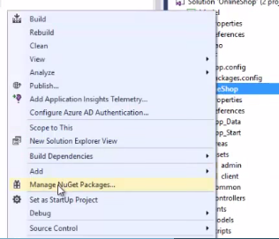

# using the layout temlate

Create an Assets folder

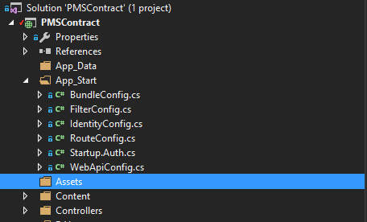

Copy source AdminLTE2 into Assets folder

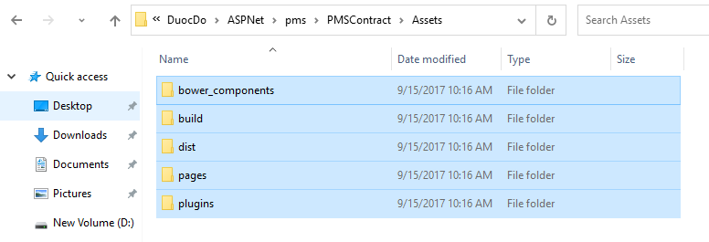

Create a _LayoutAdminLTE.cshtml on Views folder

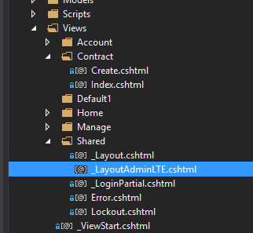

And then copy all source html into _LayhoutAdminLTE.cshtml and change something about links

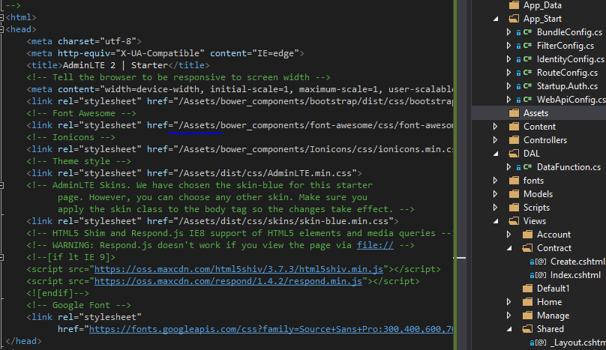

@RenderBody() // On master page

@RenderSection(“Varible_Name”,True or False) // On master page.

@section Varible_Name { HTML code in here …} // On children page, can put it anywhere.

# PAGing

Add more a package

# PAGing

Add more a package

# PAGing

Add more a package

# PAGing

Add more a package

# PAGing

Add more a package

# PAGing

Add more a package

# PAGing

Add more a package

# PAGing

sfssdfdsfsfssdssf

# PAGing

Add more a package