The plug-ins are all collected and integrated by myself and make tutorials. If there is any infringement or any problem when you using, please contact me .

=====================================================================

According to this tutorial , there is no problem in pro-testing . If you encounter problems, please let me know.

=====================================================================

It is recommended to turn off the antivirus software when starting the game with the graphics patch injector before / after starting the operation . If the file is intercepted/deleted by antivirus software during operation , it is recommended to restart the operation to ensure nothing goes wrong.

=====================================================================

After the operation is completed, it is recommended to add a whitelist to all files in the image quality patch in the antivirus to prevent the antivirus from intercepting / deleting files

=====================================================================

After the operation is completed, Mod will generate some files in the folder

(It's not the root directory of the game) , please don't delete it!

=====================================================================

I don't recommend that you run this mod on the official HoyoVerse server, although it will work fine on the official server. In fact, no matter which mod you install, it may be detected and banned account by HoyoVerse. If you are really afraid of being banned account by HoyoVerse, please set up your own private server. If you choose to run this mod on the official server, please be responsible for the consequences of your actions.

=====================================================================

by the way.CN Servers Genshin Impact started on version 2.8 and connected to the Tencent Anti cheating. This means any mod(s) are easier detection. Well......if you want to use any mod on CN Servers Genshin Impact,emm,Good Luck XD

=====================================================================

Download the ZIP from: https://github.com/DuolaD/Reshade_For_HoyoVerse_Games

and unzip it.

Open the folder and follow this tutorial

~~(when you can see this tutorial, it means that you have already done this step)~~

Open folder

Launch the launcher in the language you are familiar with (double-click to open, do not use administrator privileges).

Chinese Simplified：

English：

traditional：

For private servers, please see whether you are using the Global Server client or the CNServer client

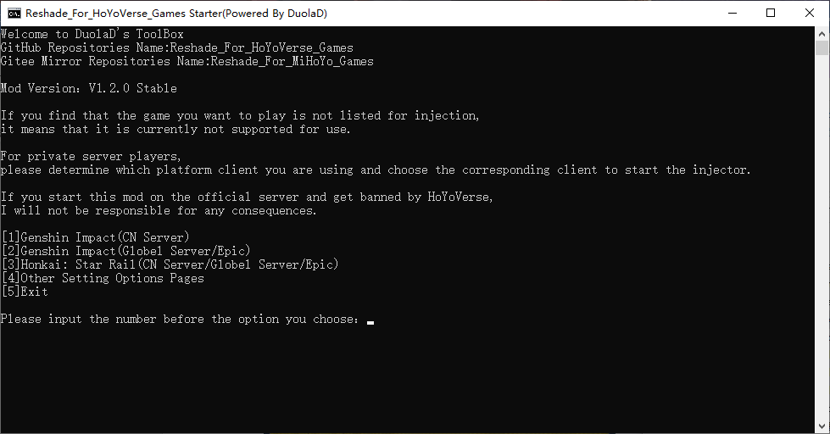

Please select the number of the game client you want to play and press Enter to confirm.



If this prompt pops up, type A in uppercase and press Enter

Next, it will pop up requesting administrator permission to run the program, agree

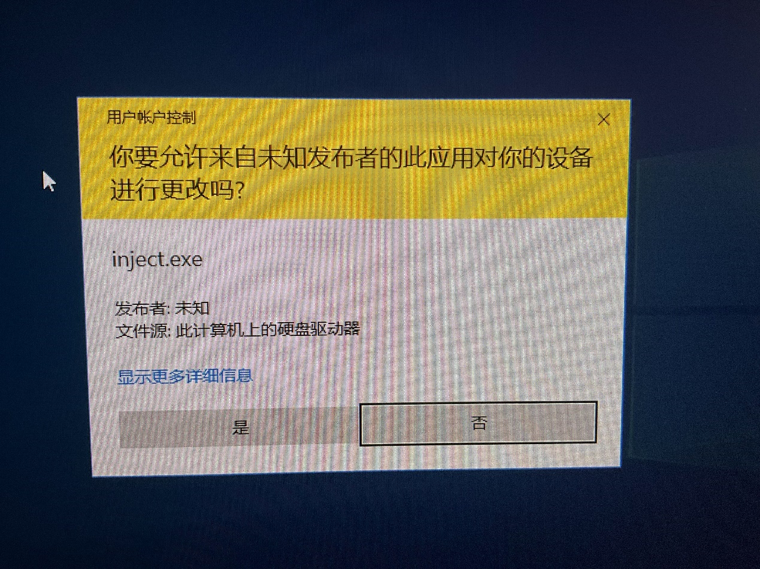

Then a window will open, don't close it! Follow the steps to continue

Next launch the game using the official launcher

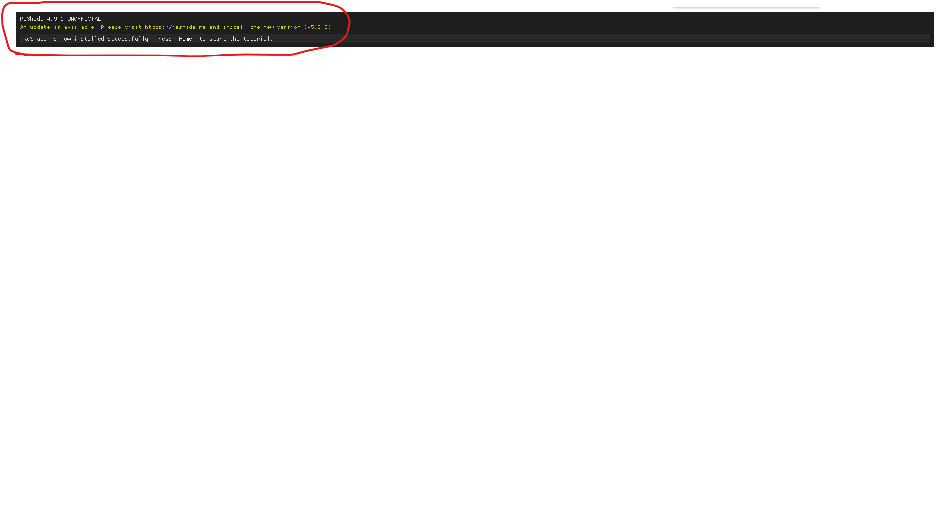

If there is this prompt at the top of the game screen after opening, it means half of the success

Click the ‘Home’ button on keyboard.

Double click on " reshade -shaders " - click on " Shader " - "Select"

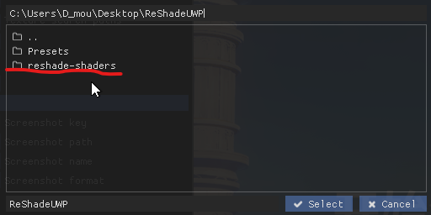

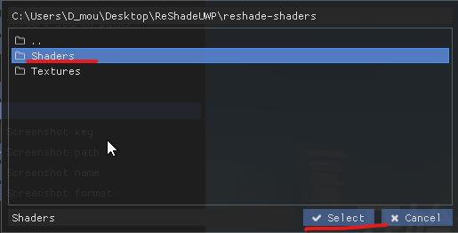

Then select the plus sign for " Texture search paths "

Double click on " reshade -shaders " - click on " Textures " - "Select"



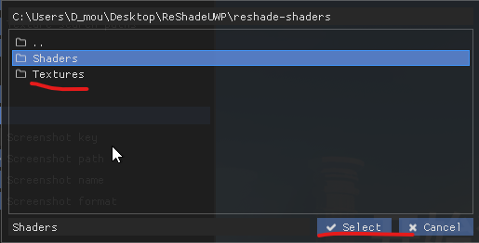

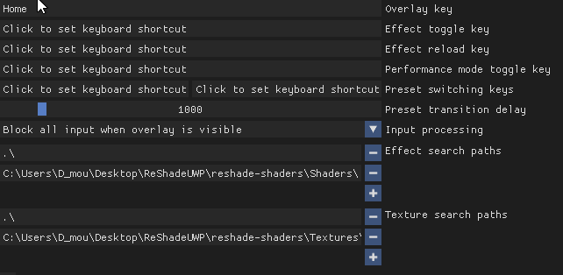

That's all right~

configuration preset when reloading will be varying degrees of unresponsiveness.

Wait for the loading to complete and return to the normal response.

If you need to reload in multiplayer, it's best to go back to the main city first.

In single-player mode, it is best to call out the emergency food before operating.

Select ReshadePreset

图形用户界面

Double-click Presets

There are a lot of configuration files here, choose to play by yourself

My videos/photos is using Film Night present and RTX Presets1.

When loading the Re configuration file, select the INI preset file in the folder , and then click Select

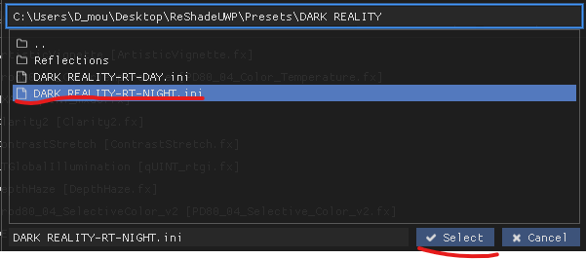

You can also download Reshade presets yourself and use.

Reshade is not unfamiliar to some people who often make Graphics mods for 3A games

If you mess up, after re-following the steps, click Reload below on the Home interface

Press ‘HOME’ on the keyboard to exit the Reshade operation panel

Have Fun XD~

For some Reshade presets(like Some present are used ADOF),you need to use ‘Hide UI’ Mod to get better display because some effect will limit by reshade.

I suggest you to check out this mod：<https://gamebanana.com/mods/424034>

FAQ:

1. I no longer want to use this mod. How do I uninstall it?

The mod is an injectable mod and will not leave any files in your game's root directory. In other words, if you no longer want to use this mod, simply launch the game using the official game launcher.

2. I have followed the tutorial steps, and if I want to continue using this mod, what should I do?

After initializing the mod for the first time, the configuration file will be saved in the mod's root directory. The next time you start the game, simply run the specified injection program, and make sure that there is a program prompt at the top of the game launcher.

The mod will automatically save your settings when you exit the game, and the next time you start the game, it will use the settings and presets that were saved when you last exited the game.

3. Can this mod be used simultaneously with GIMI, SRMI, FPS unlocker, or other cheats?

Yes, you can. Just start the injection program for the other mod while waiting for the XX game to be injected, and leave the other mod's injection program on the waiting page. Once all mods prompt that they are waiting for XX injection, use the official launcher to start the game. Please note that the more mods and injectors you have, the slower the game loading and in-game teleportation will be.