Translations are not necessarily 100% accurate

User Agreement:

Writer：哆啦D夢|DuolaD

From this release onwards, if you continue to use this mod (regardless of which version of the mod you use), you are deemed to have agreed to this user agreement and are aware that the use of mods may result in the banning of your MiHoYo/HoYoVerse game account or other consequences. It is also acknowledged that the mod developer and all of its secondary developers shall not be responsible for any consequences arising from any consequences.

If you do not agree to this User Agreement, please stop using this Mod.

=====================================================================

Follow this tutorial to do a personal test without problems, and if you encounter problems, remember to let me know

=====================================================================

It is recommended to turn off the antivirus software when launching the game with the image quality patch injector before/after the operation. If the file is intercepted/deleted by the killing software during the operation, it is recommended to start the operation again to ensure that nothing goes wrong.

=====================================================================

If you have to do the operation with the anti-software enabled operation, please add the folder you unzipped to the whitelist, and allow the operation to continue when the operation is intercepted/deleted by the anti-software file

=====================================================================

After the operation is completed, it is recommended to add a whitelist to all files in the image quality patch in the anti-software to prevent the anti-software from intercepting/deleting the files

=====================================================================

Once this is done, the mod will generate some files in the folder

(not the game root directory there ha), please don't delete!

=====================================================================

HoYoVerse has a vague attitude towards mods, and it is forbidden on the surface, in fact, as long as it is not a plug-in/face jumping after installing a mod, the official will basically not care about you, and your account will be fine. My video was recorded on my Asian trumpet, and it was completely fine. The mod is also only a second change to Reshade, so that it can run after breaking through the HoYoVerse blockade. Title self-care!Title self-care!Title self-care!

=====================================================================

Download the latest version of HoYoShade from the HoYoShade Release interface

Then unzip it

Open the folder and follow this tutorial

~~(However, when you can see this tutorial, you already have this step)~~

Open the mods folder

Choose a language you're familiar with to launch the launcher (double-click to open it, don't use administrator privileges)

Simplified Chinese:

English:

Traditional Chinese:

The first launch generates ReShade.ini to the mod root.

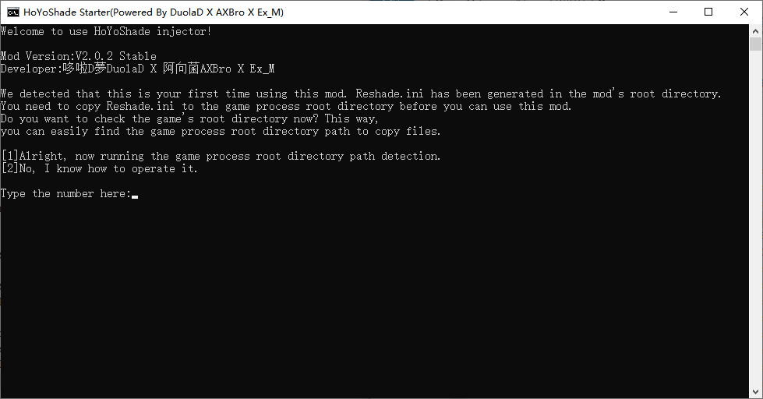

Copy the ReShade.ini generated in the root directory of the mod to the root directory of the game process

You can use the injector's game process directory detection feature, or you can go to the launcher to see the path.

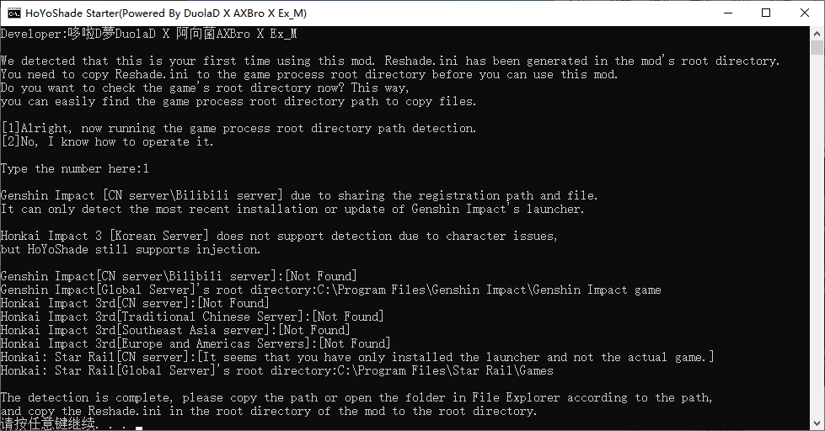

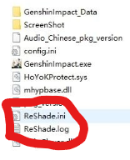If there is ReShade.ini and/or ReShade.log in the root directory of the game process, delete it first. If the mod is updated, you also need to delete the old version of ReShade.ini and/or ReShade.log first, and then copy the ReShade.ini of the new version of HoYoShade to the root of the game process.

After copying, tap any key in the injector to go to the main interface

Select the number of the client of the game you want to play and press enter to confirm

Next, a pop-up will pop up asking for administrator permission to run the program, agree

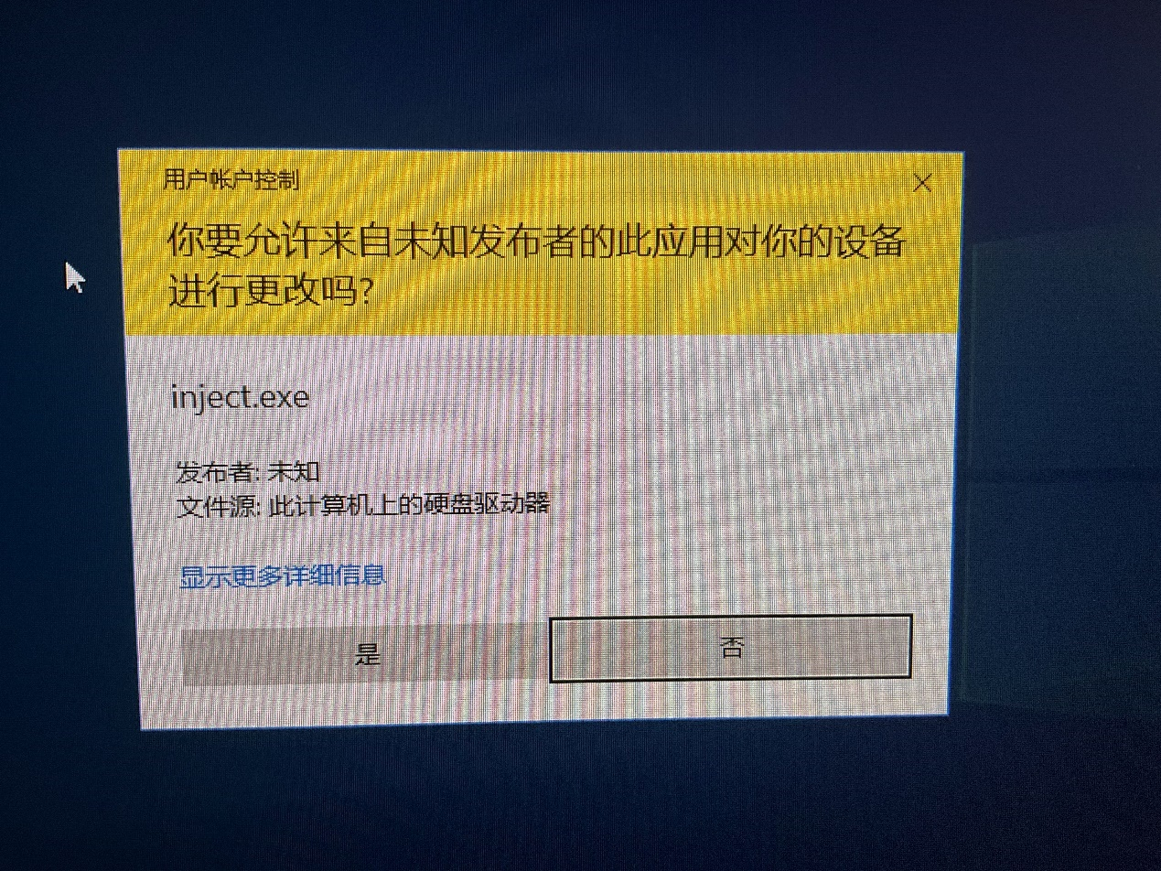

Then a window will open, don't close!

text

The description is automatically generated

HoYoShade is fully compatible with all major mods/injectors, you can open other mods/injectors in this interface, and wait until all mods/injectors are prompted to wait for the game to start before launching the game.

It should be noted that there may be incompatibility issues between other mods/injectors, not HoYoShade issues.

If one of your mods/injectors will automatically launch the game, please launch the mod/injector last, or set it to inject when the game is launched manually (if any) (e.g. Ex_M drone)

Next, launch the game (if you don't have any other mods/injectors that you want to launch at the same time after launching Ho YoShade, it is recommended to use the official launcher to launch the game, which has a high success rate).

A screenshot of your phone's screen

Medium confidence descriptions are automatically generated

In this way, it means that you have succeeded~ (the content of the pop-up window may be slightly different)

Click on "Home" (not the Home button on your keyboard!).

Select 'Mod OFF'



There are a lot of profiles here that you can choose to play

There is text on the photo of the computer screen

The description is automatically generated

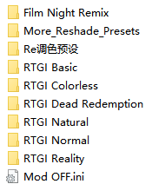

When loading the Re profile, select the INI preset file in the Chinese folder, and then click Select

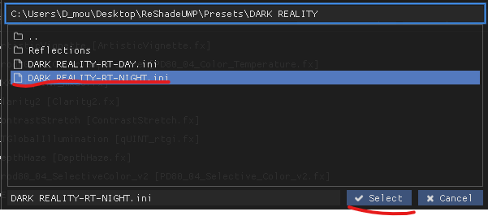

You can also download the Reshade presets and use them yourself, or you can make your own.

Reshade is no stranger to some people who often patch and mod triple-A games

Note: The game may load differently depending on the PC configuration/configuration preset

There will be varying degrees of unresponsiveness

Wait for the load to complete and resume normal response.

It is recommended that you pause the game before proceeding

Then you can press HOME on your keyboard to exit the Reshade control panel

For some Reshade presets, such as those that use ADOF (Auto Bokeh), you will need to use the Hide UI mod to get a better display due to the limitations of Reshade itself.

FAQ (Frequently Asked Questions):

1: I don't want to play this mod anymore, how do I uninstall it?

Mods are injected mods, they do not leave files in the root directory of your game, and the Re Shade .ini that remains in the root directory of the game process will not load if you normally enter the game without mods/use other mods that are not based on Reshade.

In other words, if you don't want to play this mod anymore, you can use it normally as you normally would.

2: I've followed the steps of this tutorial, what should I do if I still want to play this mod.

The mod will automatically save the configuration file in the ReShade .ini file in the root directory of the game process.

The next time you start the game, just run the injector.

Make sure there is a prompt at the top of the game when you start the game.

The mod will automatically save your settings this time when you close the game,

The next time you start the game, you'll inherit the settings and presets you saved the last time you closed the game.

3: I encountered a prompt similar to the one in the following figure after injection, how should I fix this problem?

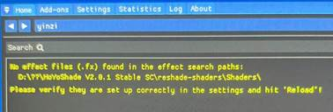

If you don't have ReShade.ini in the right place, open the directory shown in the prompt in Explorer and copy ReShade.ini into it. Once the copy is complete, go back to the in-game console and click the Reload button below to reload

4: What should I do if I open the game after copying the file and it prompts "The data is abnormal, please completely uninstall the game and re-download it from the official channel"?

Check if there is a ReShade .dll in the root directory of the game process, if it exists, please delete the file with the game closed, and then re-inject/start normally.