**Serious exercises**

1. **Calculate BMI**

height = int(input('Nhap chieu cao '))

weight = int(input('Nhap khoi luong '))

BMI = weight / (height/100 * height/100)

a = BMI

if a < 16:

print('Severely underweight')

elif a < 18.5:

print('Underweight')

elif a < 25:

print('Normal')

elif a < 30:

print('Overweight')

else:

print('Obese')

1. **Write a program that Asks users enter a number and then calculates factorial of n: (1 * 2 * 3 *... *n)**

n = int(input('Nhap so '))

tich = 1

for i in range(1,n+1):

tich = tich * i

print(tich)

1. **Study how to print without moving to a new line**

print("Hello", end = '')

print(",my name", end = ' ')

print("is B-max")

1. **Print out the following patterns, remember that the number of columns and rows can be changed later, so try to write programs that can scale**
2. **20 x 1 stars:**

* * * * * * * * * * * * * * * * * * * *

print(20*'*')

1. **n stars (n is entered by users)**

Enter a number: 17

* * * * * * * * * * * * * * * * *

n = int(input('Nhap so '))

print(n*'*')

1. 9 stars and xs **in total**

x * x * x * x * x

print('x*'*4, end = '')

print('x')

1. n stars and xs **in total** (n is entered by users)

Enter a number: 13

x * x * x * x * x * x * x

n = int(input('Nhap so n '))

a = int((n-1)/2)

print('x*'*a, end = '')

print('x')

1. **You can use print(), (yes, print with nothing inside the parentheses ()) to move to a new line, try it**

**print(end = '')**

1. **7 * 3 stars**

**\* * * * * * \***

**\* * * * * * \***

**\* * * * * * \***

for i in range(1,4):

print(7*'*')

1. **n x m stars (n, m are entered by users)**

Enter n: 5

Enter m: 3

* * * * *

* * * * *

* * * * *

m = int(input('Nhap so ')) # So sao

n = int(input('Nhap so')) # So lan in

for i in range(1,n+1):

print(m*'*')

***Turtle exercises***

1. Hình 1:

import turtle

screen = turtle.Screen() # create screen

duong = turtle.Turtle() # create a turtle assign it to duong

for num in range(2): # loop 2 times

duong.left(60)

duong.forward(100)

duong.left(120)

duong.forward(100)

duong.left(60)

duong.forward(100)

for num in range(3): # loop 3 times

duong.left(30)

duong.forward(100)

duong.left(60)

duong.forward(100)

duong.left(120)

duong.forward(100)

duong.left(60)

duong.forward(100)

1. Hình 2:

import turtle

screen = turtle.Screen() # create screen

duong = turtle.Turtle() # create a turtle assign it to duong

for num in range(3): # loop 3 times

duong.forward(100)

duong.left(120)

duong.color("blue")

for num in range(4): # loop 4 times

duong.forward(100)

duong.left(90)

duong.color("red")

for num in range(5): # loop 5 times

duong.forward(100)

duong.left(72)

duong.color("blue")

for num in range(6): # loop 6 times

duong.forward(100)

duong.left(60)

duong.color("red")

screen.mainloop()

**STUDY**

1. What is Boolean? Write down 3 different expression that results a Boolean type (i.e. 5 == 6)

A Boolean value is either true or false.

Write down 3 different expression that results a Boolean type

1 == 2 False

1 !=2 True

‘he’ + ‘he’ == ‘hehe’ True

1. What is a flow chart? Draw flow chart for the following code snippet
   * What is a flow chart?

A flowchart is a type of diagram that represents an algorithm, workflow or process. The flowchart shows the steps as boxes of various kinds, and their order by connecting the boxes with arrows. This diagrammatic representation illustrates a solution model to a given problem. Flowcharts are used in analyzing, designing, documenting or managing a process or program in various fields.

The two most common types of boxes in a flowchart are:

* a processing step, usually called activity, and denoted as a rectangular box
* a decision, usually denoted as a diamond.

Illustration:

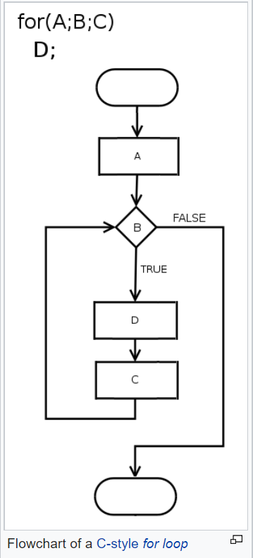

* + Draw flow chart for the following code snippet

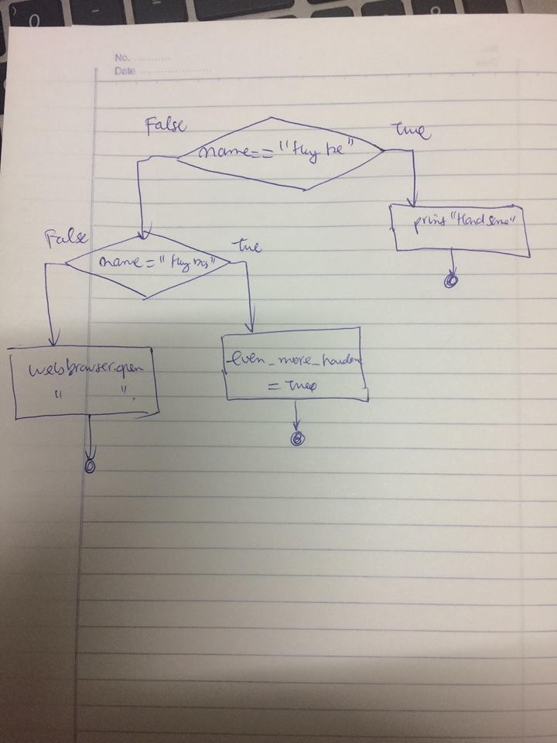

1. What is nested conditionals? Write a piece of code that uses nested conditionals
   * Nested conditional are conditional statements means that you can use one if or else if statement inside another if or else if statement(s).
   * Write a piece of code that uses nested conditionals

a = input('What is your name ')

b = int(input('age '))

if a == 'Zeus':

print('Oh My God')

if b == 1000:

print('Welcome to beautiful world')

else:

print('Welcome to Hell')

elif a == 'Hades':

print('You are so powerful')

else:

print('Nothing')