Week 2
Assignment 1

#Laboratory Exercise 3, Home Assignment 1

addi $s1,$zero,3
addi $s2,$zero,5
addi $t1,$zero,7
addi $t2,$zero,8
addi $t3,$zero,9
start:
slt $t0,$s2,$s1 #j<i
bne $t0,$zero,else #branch to else if j<i
addi $t1,$t1,1 #then part: x=x+1
addi $t3,$zero,1 #z=1
j endif #skip “else” part
else: addi $t2,$t2,-1 #begin else part: y=y-1
add $t3,$t3,$t3 #z=2*z
endif:

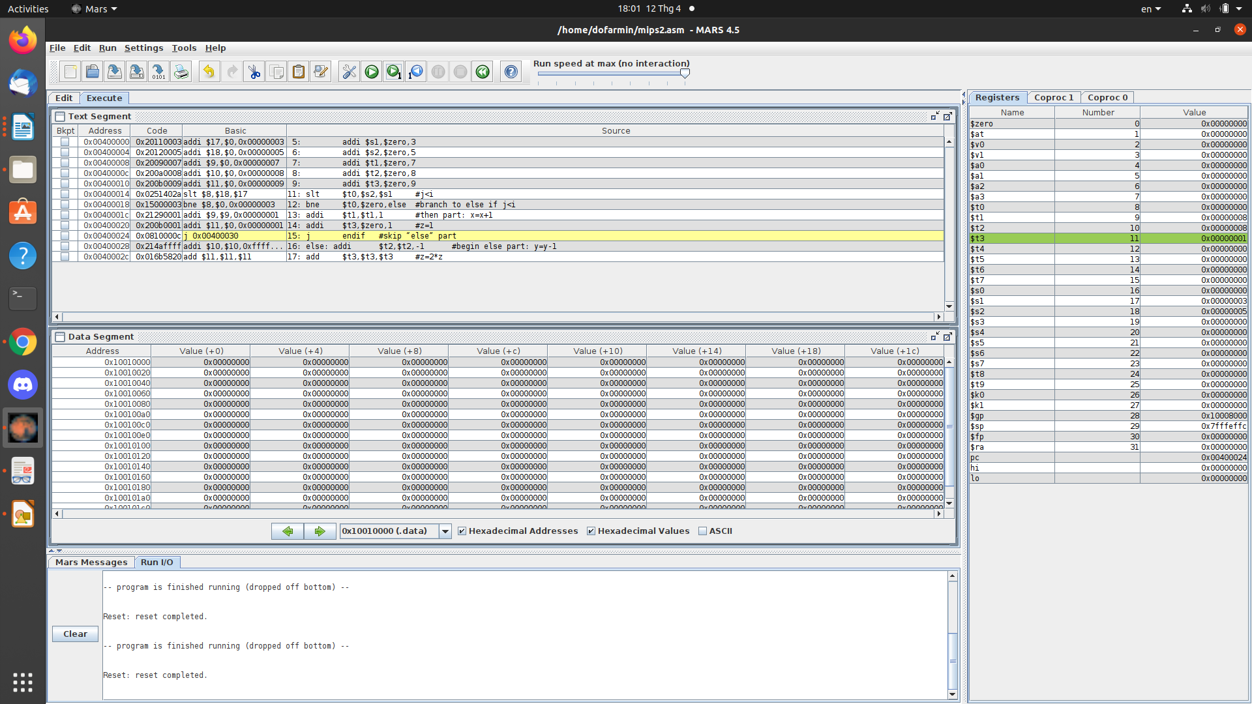

Assignment 2

#Laboratory 3, Home Assigment 2

.data

i: .word 2

n: .word 5

step: .word 9

sum: .word 4

A: .word 1,2,3,4

.text

la $t7, i

lw $s1, 0($t7)

la $s2, A

la $t7, n

lw $s3, 0($t7)

la $t7, step

lw $s4,0($t7)

la $t7, sum

lw $s5,0($t7)

loop:

add $s1,$s1,$s4 #i=i+step

add $t1,$s1,$s1 #t1=2*s1

add $t1,$t1,$t1 #t1=4*s1

add $t1,$t1,$s2 #t1 store the address of A[i]

lw $t0,0($t1) #load value of A[i] in$t0

add $s5,$s5,$t0 #sum=sum+A[i]

bne $s1,$s3,loop #if i != n, goto loop
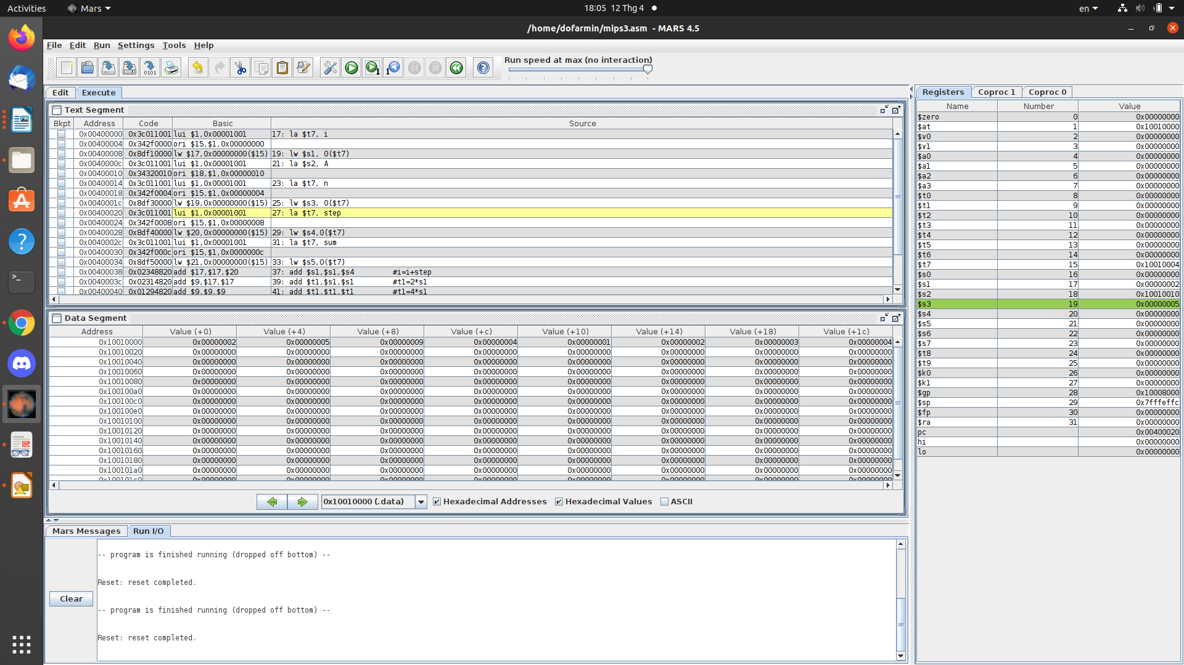

Assignment 3

#Laboratory Exercise 3, Home Assignment 3

.data

test: .word 2

a: .word 7

b: .word 2

.text

la $t7, a

lw $s2, 0($t7)

la $t7, b

lw $s3, 0($t7)

la $s0,test #load the address of test variable

lw $s1,0($s0) #load the value of test to register$t1

li $t0,0 #load value for test case

li $t1,1

li $t2,2

beq $s1,$t0,case_0

beq $s1,$t1,case_1

beq $s1,$t2,case_2

j default

case_0:

addi $s2,$s2,1 #a=a+1

j continue

case_1:

sub $s2,$s2,$t1 #a=a-1

j continue

case_2:

add $s3,$s3,$s3 #b=2*b

j continue

default:

continue:

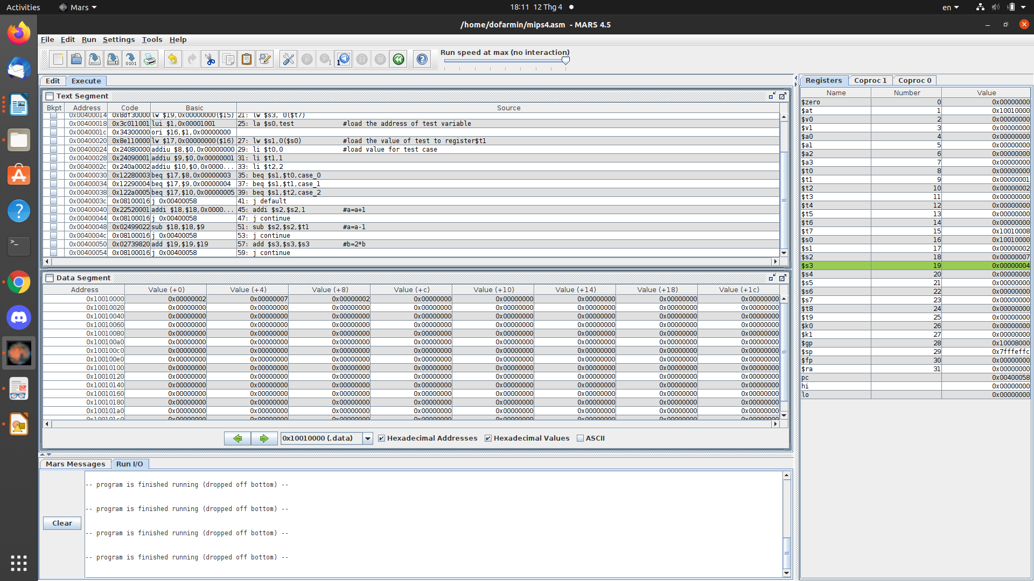
Assignment 4
a.

#Assignment 4a - Lab 03

.data

i: .word 3

j: .word 5

x: .word 7

y: .word 8

z: .word 9

.text

la $t6, i #load address of i to register $t6

lw $s1, 0($t6) #load value of i ($t6) to $s1

la $t7, j #load address of j to register $t7

lw $s2, 0($t7) #load value of j ($t7) to $s2

la $t5, x #load address of x to register $t5

lw $t1, 0($t5) #load value of x ($t5) to $t1

la $t5, y #load address of y to register $t5

lw $t2, 0($t5) #load value of y($t5) to $t2

la $t5, z #load address of z to register $t5

lw $t3, 0($t5) #load value of z ($t5) to $t3

start:

slt $t0, $s1, $s2 # i < j => t0 = 1

beq $t0, $0, else # if i < j (t0 = 1) continue executing else i >= j (t0 = 0) jumping to else

addi $t1, $t1, 1 # x += 1

addi $t3, $0, 1 # z = 1

j endif # jump to branch endif

else:

addi $t2, $t2, -1 # y -= 1

add $t3, $t3, $t3 # z *= 2

endif:

syscall

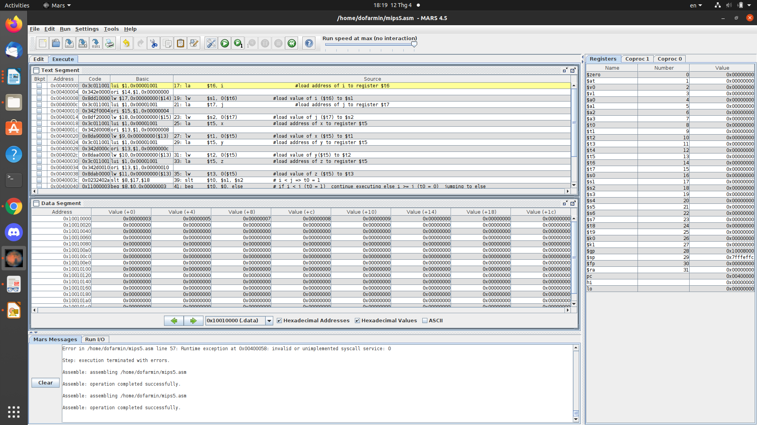
x
b.
#Assignment 4b - Lab 03

.data

i: .word 3

j: .word 5

x: .word 7

y: .word 8

z: .word 9

.text

la $t6, i #load address of i to register $t6

lw $s1, 0($t6) #load value of i ($t6) to $s1

la $t7, j #load address of j to register $t7

lw $s2, 0($t7) #load value of j ($t7) to $s2

la $t5, x #load address of x to register $t5

lw $t1, 0($t5) #load value of x ($t5) to $t1

la $t5, y #load address of y to register $t5

lw $t2, 0($t5) #load value of y($t5) to $t2

la $t5, z #load address of z to register $t5

lw $t3, 0($t5) #load value of z ($t5) to $t3

start:

slt $t0, $s1, $s2 # i < j => t0 = 1 <=> ( i >= j => t0 = 0)

bne $t0, $0, else # if i >= j (t0 == 0) continue executing else i < j (t0 == 1 != 0) jumping to else

addi $t1, $t1, 1 # x += 1

addi $t3, $0, 1 # z = 1

j endif # jump to branch endif

else:

addi $t2, $t2, -1 # y -= 1

add $t3, $t3, $t3 # z *= 2

endif:

syscall

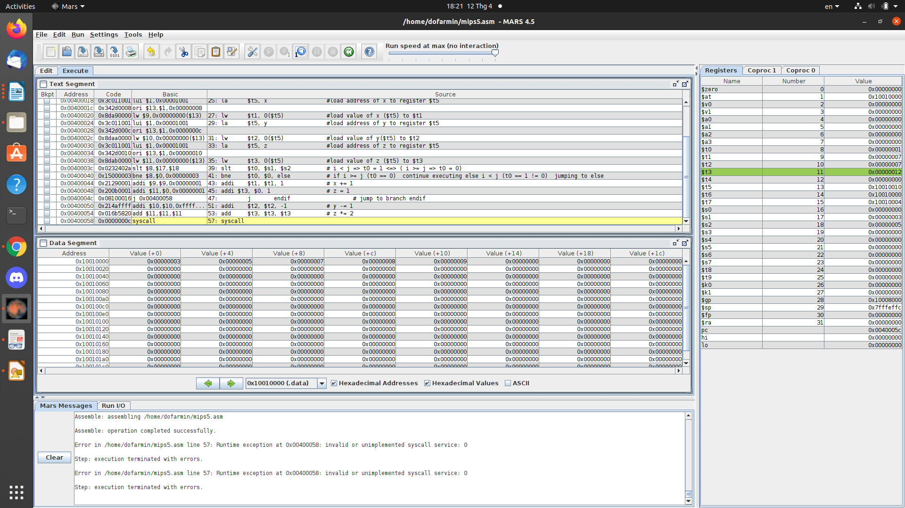
c.
#Assignment 4c - Lab 03

.data

i: .word 3

j: .word 5

x: .word 7

y: .word 8

z: .word 9

.text

la $t6, i #load address of i to register $t6

lw $s1, 0($t6) #load value of i ($t6) to $s1

la $t7, j #load address of hj to register $t7

lw $s2, 0($t7) #load value of j ($t7) to $s2

la $t5, x #load address of x to register $t5

lw $t1, 0($t5) #load value of x ($t5) to $t1

la $t5, y #load address of y to register $t5

lw $t2, 0($t5) #load value of y($t5) to $t2

la $t5, z #load address of z to register $t5

lw $t3, 0($t5) #load value of z ($t5) to $t3

start:

add $t4, $s1, $s2 # t4 = i + j

slt $t0, $0, $t4 # 0 < (i + j) then t0 = 1 else (i + j) <= 0 then t0 = 0

bne $t0, $0, else # if (i + j) <= 0 (t0 = 0) continue executing else (i + j) > 0 (t0 = 1 != 0) jumping to else

addi $t1, $t1, 1 # x += 1

addi $t3, $0, 1 # z = 1

j endif # jump to branch endif

else:

addi $t2, $t2, -1 # y -= 1

add $t3, $t3, $t3 # z *= 2

endif:

syscall

