Question 1: [5]
Given a JSP page:
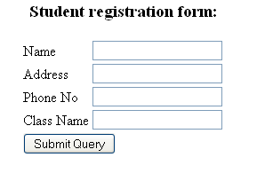
Using JSP/Servlet to develop a program with the below requirement:
When user clicks the button, all information of student are stored and displayed on the other page. It means that you must store student information in cookie, and then display them in the other page. You must validate all textbox as required. If any of them is not inputted, please display a message on the right of corresponding textbox.

Question 2: [15]
With the support of any Database, create a table named as TblEmployee to store information of employee with below fields:
Name | Type
EmployeeNo | Varchar(20), primary key
EmployeeName | Varchar(30)
PlaceOfWork | Varchar(30)
PhoneNo | Varchar(10)

Develop a JSP/Servlet web application to do the Adding, Deleting, Getting All employee. You should create each JSP page for each operation.
The web application must meet the below requirements:
a)Employee list form: used to show all employees. [4]
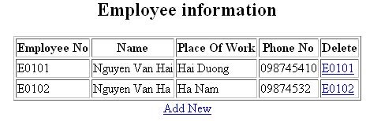
b) Delete employee by the selected employee number(no). [4]
c)Add New employee: you must validate all textbox as required. If all data inputted, you must validate the existing employee. It means you should check whether employee existed or not. If it is existed, please display a message, otherwise, add employee information into database and back to the employee list page [7]
