SWR302 - Software Requirements
Assignment 2 - UML models
Topic 1 - Online Shopping for Baking Ingredients System (Gia Hoa Phat Bakery Supply)
Item | Value
Group | GroupX
Student | [Full name of member 3] - [Roll number]
File | Ass2_GroupX_Member3.docx
My sequence diagrams | SD07 (UC05 Place an order and pay), SD08 (UC06 Track an order), SD09 (UC10 Process orders)
Based on | SRS_BakeCraft_v1.0 (15 use cases UC01-UC15, business rules BR-01 to BR-09)
Date | 08/11/2026

Contents
- Part A - Group diagrams: 1. Use case diagram, 2. Class diagram (full diagram and three package views).
- Part B - My sequence diagrams (Ordering and fulfilment): SD07, SD08, SD09.

Sequence diagrams of the group
Every member draws three sequence diagrams; together they cover all 15 use cases once, so no two members draw the same diagram.
Member | Part | Sequence diagrams
Member1 | Account and access | SD01 UC01 Register an account, SD02 UC08 Log in, SD03 UC07 Manage personal account
Member2 | Browsing and cart | SD04 UC02 Search and view products, SD05 UC03 View recipe combos, SD06 UC04 Manage shopping cart
Member3 | Ordering and fulfilment | SD07 UC05 Place an order and pay, SD08 UC06 Track an order, SD09 UC10 Process orders
Member4 | Catalogue, stock and promotions | SD10 UC11 Manage products and categories, SD11 UC12 Manage stock and expiry, SD12 UC13 Manage promotions
Member5 | Reports, customers and staff | SD13 UC09 View dashboard and reports, SD14 UC14 Manage customers, SD15 UC15 Manage staff and settings

Part A - Group diagrams

1. Use case diagram
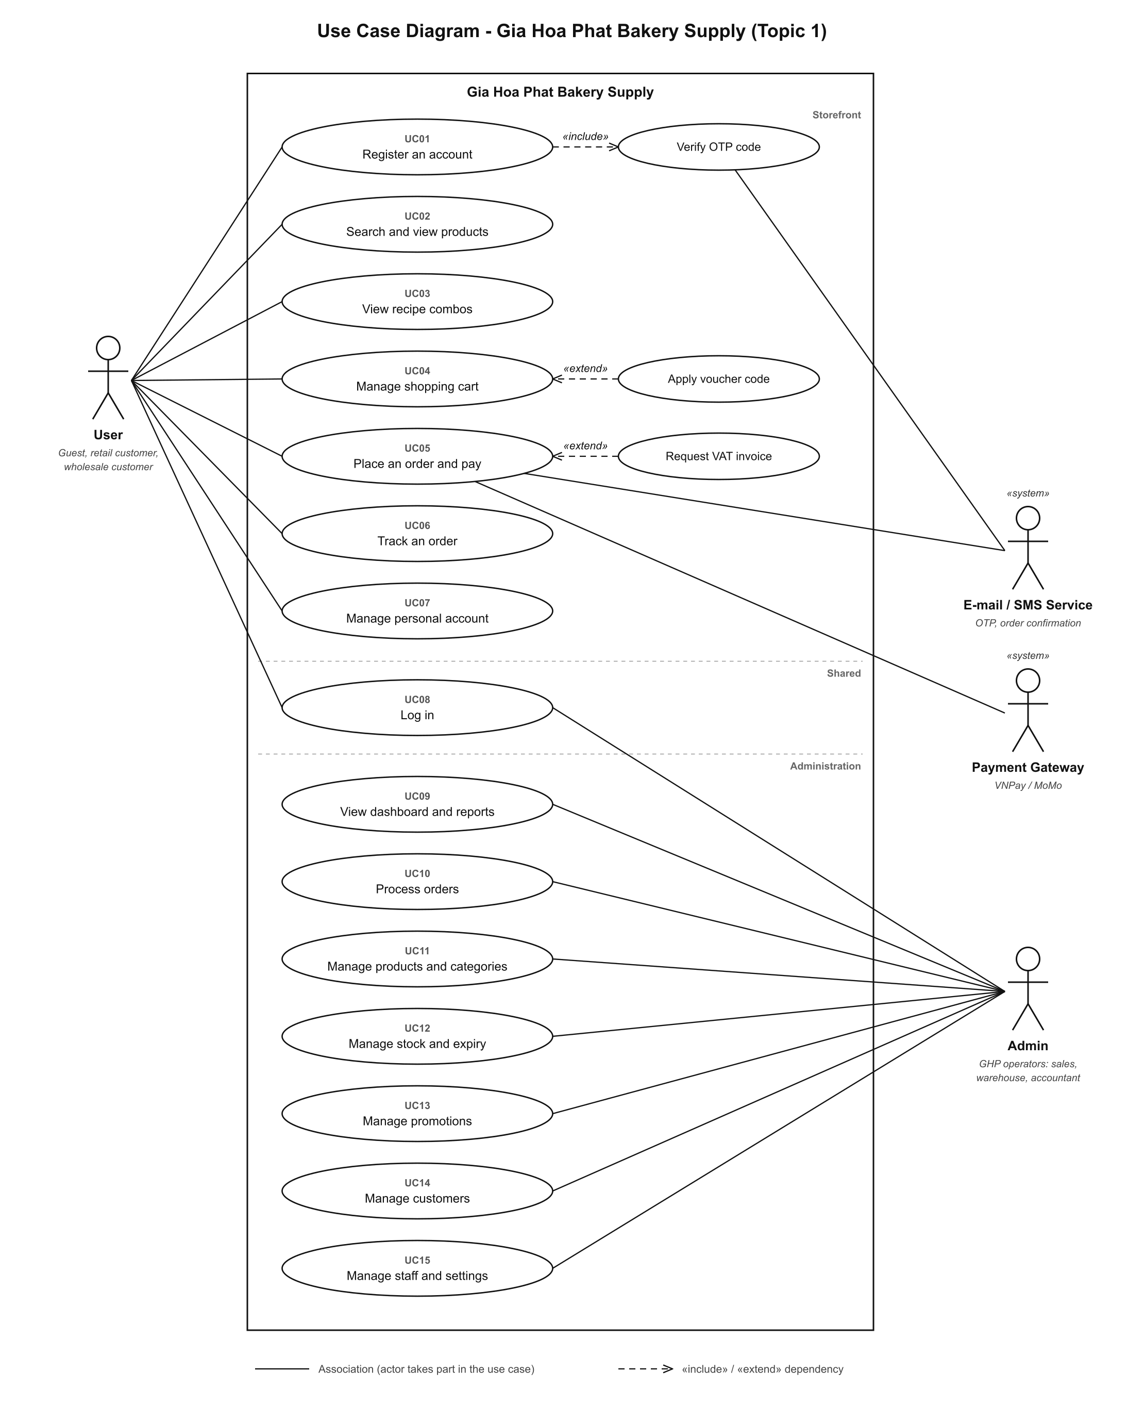
Figure 1 - Use case diagram (2 primary actors, 15 use cases)

1.1 Actors
Actor | Type | Description
User | Primary | Guest, retail customer and wholesale customer (approved business account). Cart, checkout and personal account need a logged-in user.
Admin | Primary | All GHP operators: sales and customer care, warehouse and cold-chain staff, accountant, system administrator. Their rights are set in the permission matrix (UC15).
Payment Gateway (VNPay / MoMo) | Secondary, external system | Creates the QR payment and returns the result (UC05).
E-mail / SMS Service | Secondary, external system | Sends the OTP code (Verify OTP code) and the order confirmation (UC05).

1.2 Use cases
ID | Use case | Primary actor | Secondary actor
UC01 | Register an account | User (Guest) | E-mail / SMS Service (through Verify OTP code)
UC02 | Search and view products | User | -
UC03 | View recipe combos | User | -
UC04 | Manage shopping cart | User (logged in) | -
UC05 | Place an order and pay | User (logged in) | Payment Gateway, E-mail / SMS Service
UC06 | Track an order | User | -
UC07 | Manage personal account | User (logged in) | -
UC08 | Log in | User, Admin | -
UC09 | View dashboard and reports | Admin | -
UC10 | Process orders | Admin | -
UC11 | Manage products and categories | Admin | -
UC12 | Manage stock and expiry | Admin | -
UC13 | Manage promotions | Admin | -
UC14 | Manage customers | Admin | -
UC15 | Manage staff and settings | Admin | -

1.3 Relationships between use cases
- UC01 Register an account «include» Verify OTP code: every registration sends and checks a 6-digit OTP (BR-03).
- Apply voucher code «extend» UC04 Manage shopping cart: only when the user enters a voucher code (BR-05).
- Request VAT invoice «extend» UC05 Place an order and pay: only when the user asks for a VAT invoice; pre-filled for a wholesale customer.

2. Class diagram
Analysis-level class diagram of the domain. Attribute names follow the data model of the prototype (client/src/types and client/src/mocks). The full diagram is on this page; the three package views on the next pages show the same classes larger.
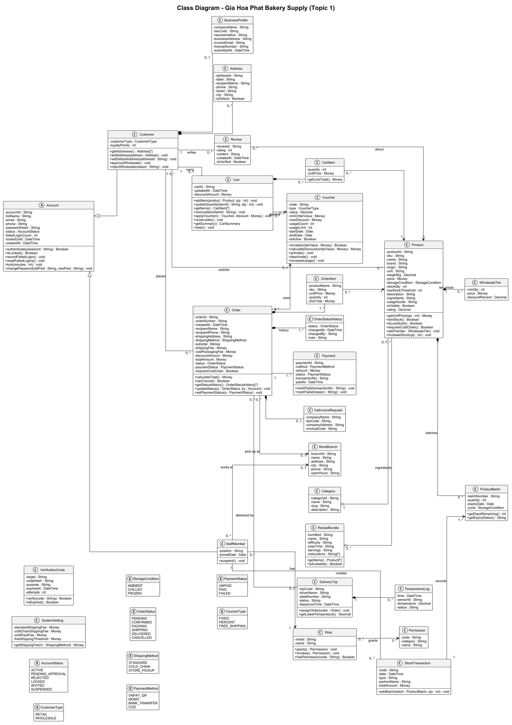
Figure 2 - Class diagram (full)

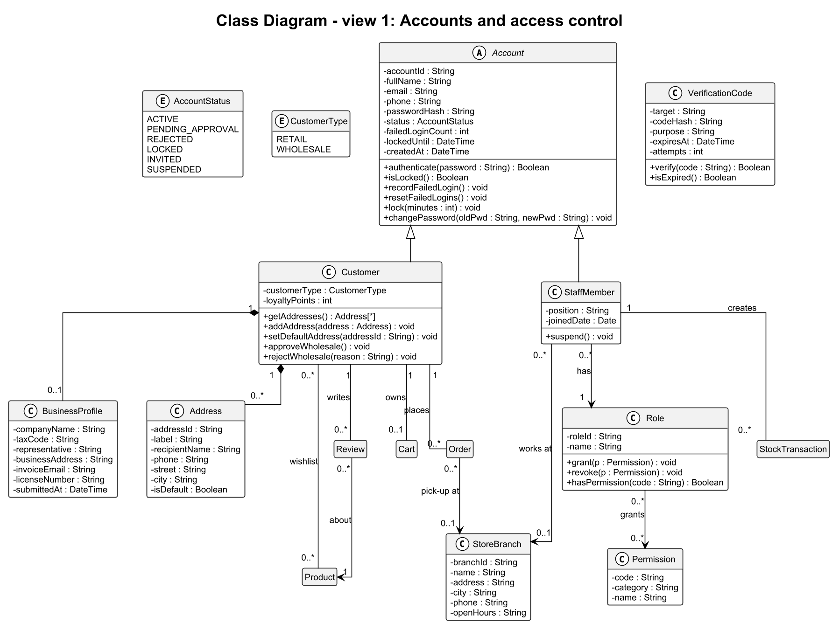
Figure 3 - View 1: accounts and access control
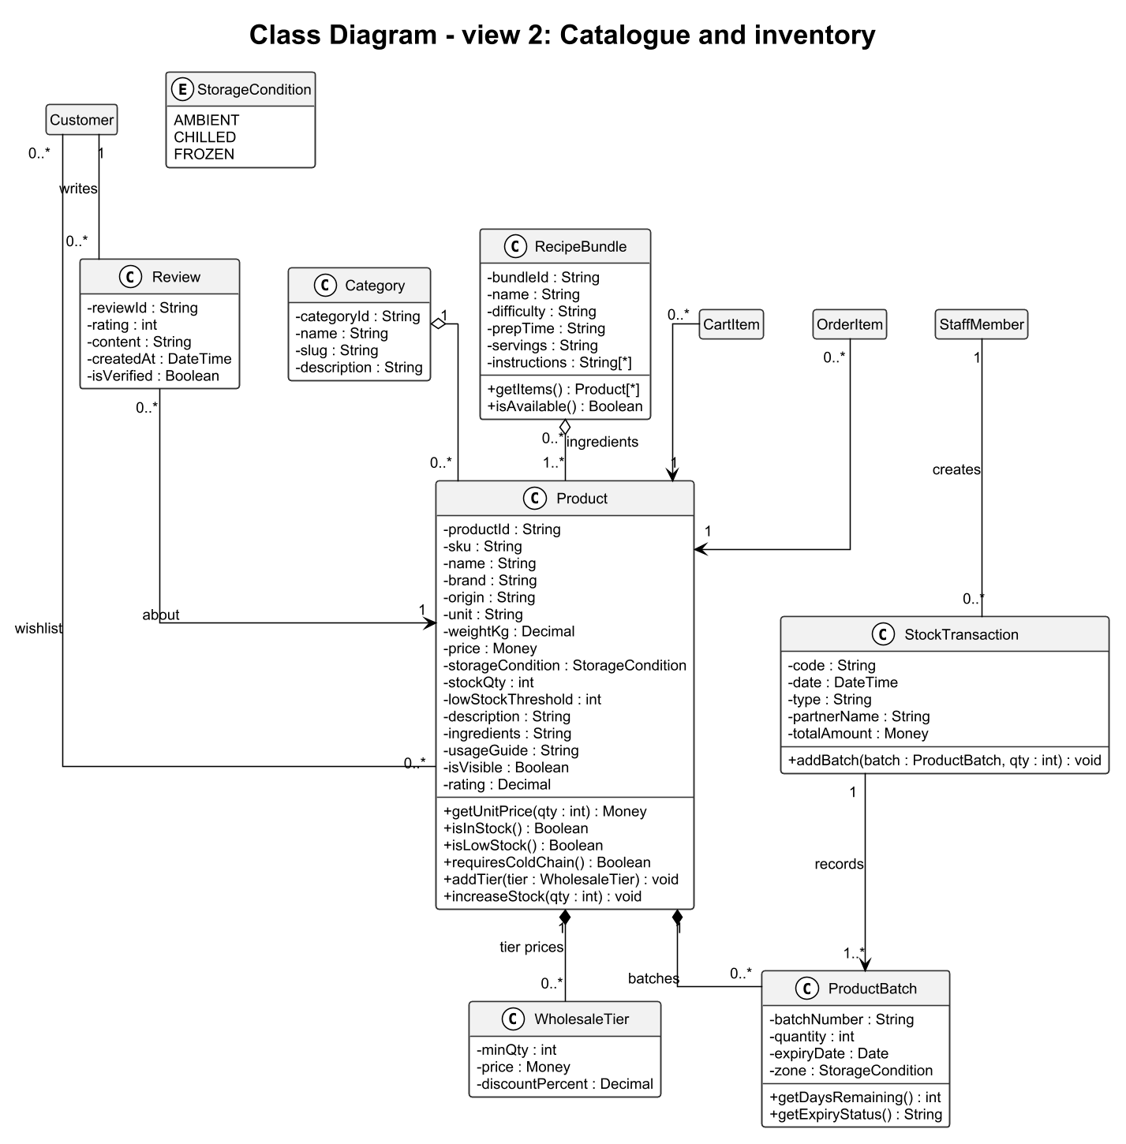
Figure 4 - View 2: catalogue and inventory

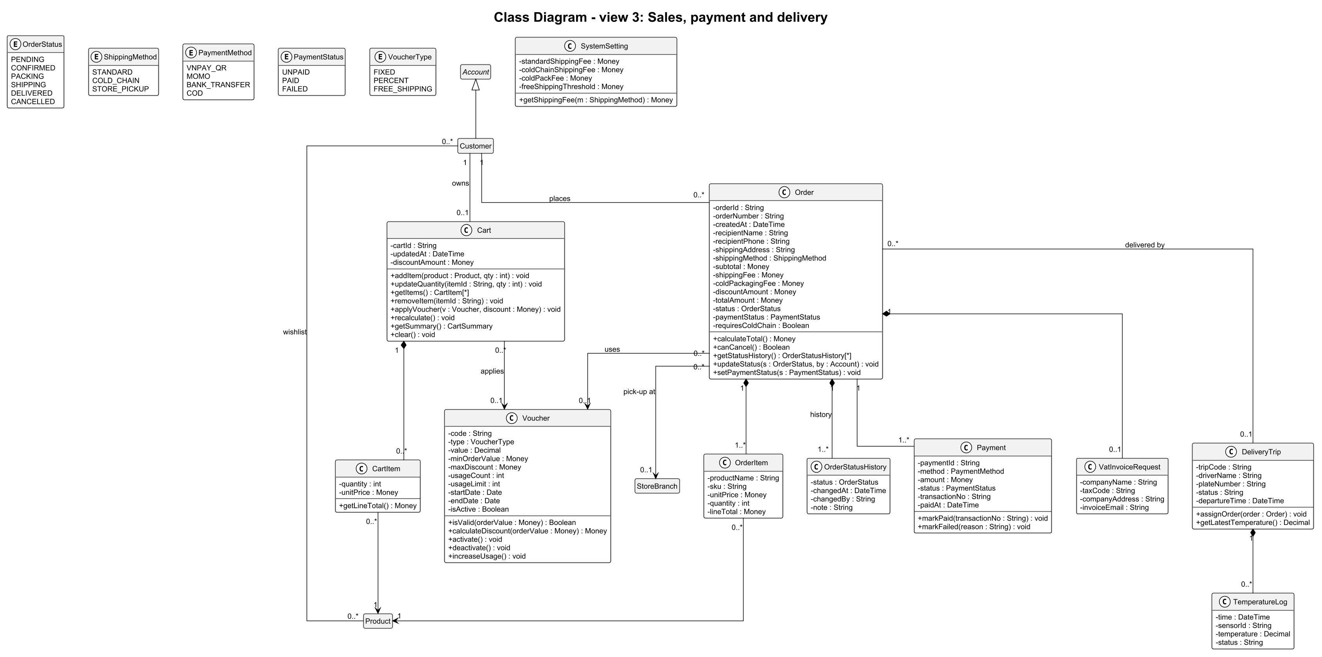
Figure 5 - View 3: sales, payment and delivery

2.1 Main design decisions
- Account is abstract and generalises Customer and StaffMember, so login data and the lock rule (5 wrong passwords, 15 minutes, BR-03) are defined once.
- A Customer owns 0..* Address and 0..1 BusinessProfile (composition). The business profile and approveWholesale() / rejectWholesale() realise the wholesale account rule (BR-04).
- Product is composed of WholesaleTier (tier prices, BR-02, used by getUnitPrice(qty)) and ProductBatch (batch number, expiry date, FEFO alerts, BR-09). A Category aggregates its products; a RecipeBundle aggregates 1..* products and isAvailable() checks BR-06.
- Cart is composed of CartItem; Order is composed of OrderItem, OrderStatusHistory and an optional VatInvoiceRequest. OrderItem copies name, SKU and unit price so that past orders do not change when a product is edited.
- An Order has 1..* Payment (a failed online payment can be retried with another method) and may be delivered by a DeliveryTrip, which keeps the TemperatureLog of the cold box (BR-01, alert above 8 °C).
- StaffMember has one Role; a Role grants 0..* Permission (permission matrix of UC15).
- Enumerations hold the allowed values: OrderStatus follows BR-08 (PENDING > CONFIRMED > PACKING > SHIPPING > DELIVERED, CANCELLED only from PENDING or CONFIRMED).

2.2 Business rules in the model
Business rule (SRS) | Where it lives in the class diagram
BR-01 Cold chain | Product.requiresColdChain(), Cart.recalculate() (cold-pack fee), Order.coldPackagingFee, DeliveryTrip / TemperatureLog
BR-02 Wholesale tier price | WholesaleTier, Product.getUnitPrice(qty)
BR-03 OTP and account lock | VerificationCode.verify(), Account.recordFailedLogin(), Account.lock()
BR-04 Wholesale account | BusinessProfile, Customer.approveWholesale() / rejectWholesale()
BR-05 Voucher | Voucher.isValid(orderValue), Voucher.calculateDiscount()
BR-06 Recipe combo availability | RecipeBundle.isAvailable()
BR-08 Order status flow | OrderStatus, Order.canCancel(), Order.updateStatus(), OrderStatusHistory
BR-09 FEFO and alerts | ProductBatch.getDaysRemaining(), ProductBatch.getExpiryStatus()

Part B - My sequence diagrams (Ordering and fulfilment)

Notation
- Lifelines follow the Boundary-Control-Entity pattern: «boundary» is a screen of the prototype (screen IDs SCR-xx from the SRS), «control» is the controller that runs the use case, «entity» is a class of the class diagram, «system» is an external system.
- Messages are numbered. A solid arrow is a call, a dashed arrow is a return, an open arrowhead is an asynchronous message. create(...) creates a new object (its lifeline starts at that message).
- Messages named find..., search..., exists..., count... or sum... are class-level queries that read stored objects; they are not repeated in the class diagram.
- Fragments: alt = alternatives (A1, A2, ... are the alternative flows of the SRS), opt = optional part, loop = repetition, group «include» = the included use case.

3.1 SD07 - UC05 Place an order and pay
Item | Value
Use case | UC05 Place an order and pay
Actors | User (logged in); Payment Gateway; E-mail / SMS Service
Scenario | Three-step checkout with cold-chain delivery and VNPay QR payment, including «extend» Request VAT invoice.
Alternative flows shown | A1 missing field, A2 payment failed or cancelled.
Business rules | BR-01, BR-05

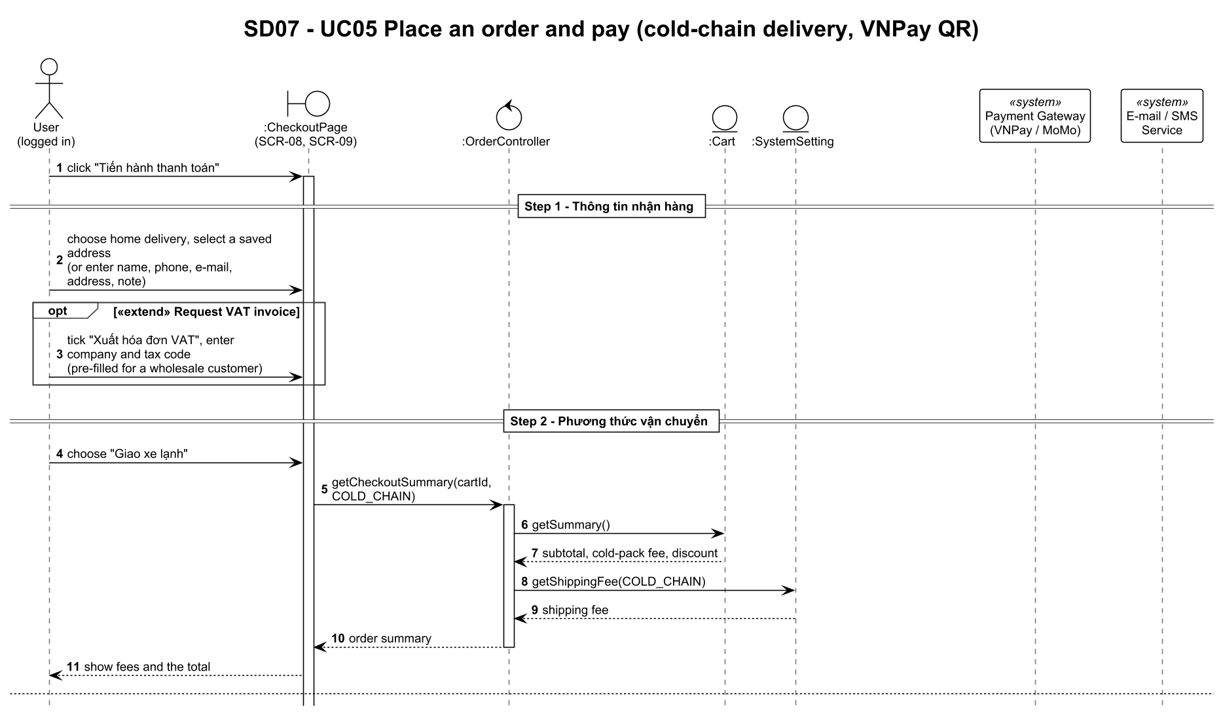
Figure 6 - SD07 UC05 Place an order and pay (part 1 of 2)

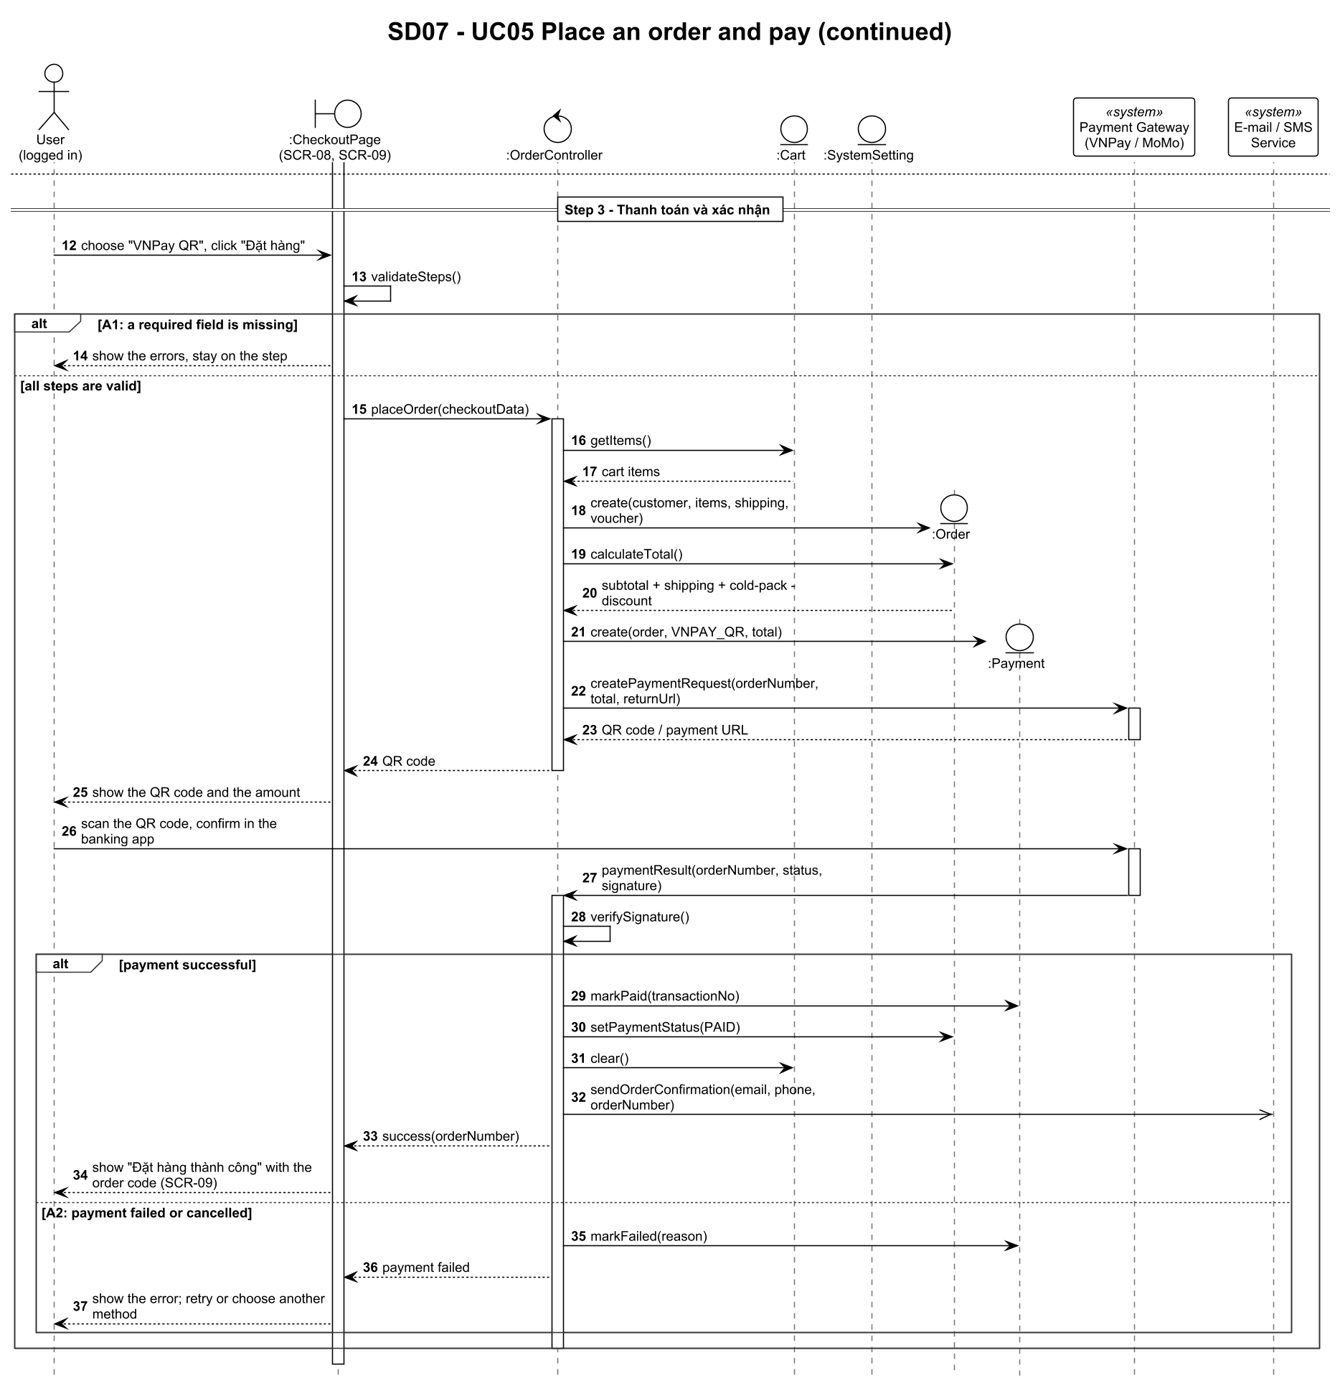
Figure 6 - SD07 UC05 Place an order and pay (part 2 of 2)

3.2 SD08 - UC06 Track an order
Item | Value
Use case | UC06 Track an order
Actors | User (Guest)
Scenario | A guest looks up an order with code and phone, follows the journey and cold-box temperature, and cancels the order.
Alternative flows shown | A1 order not found, A2 order can no longer be cancelled.
Business rules | BR-08

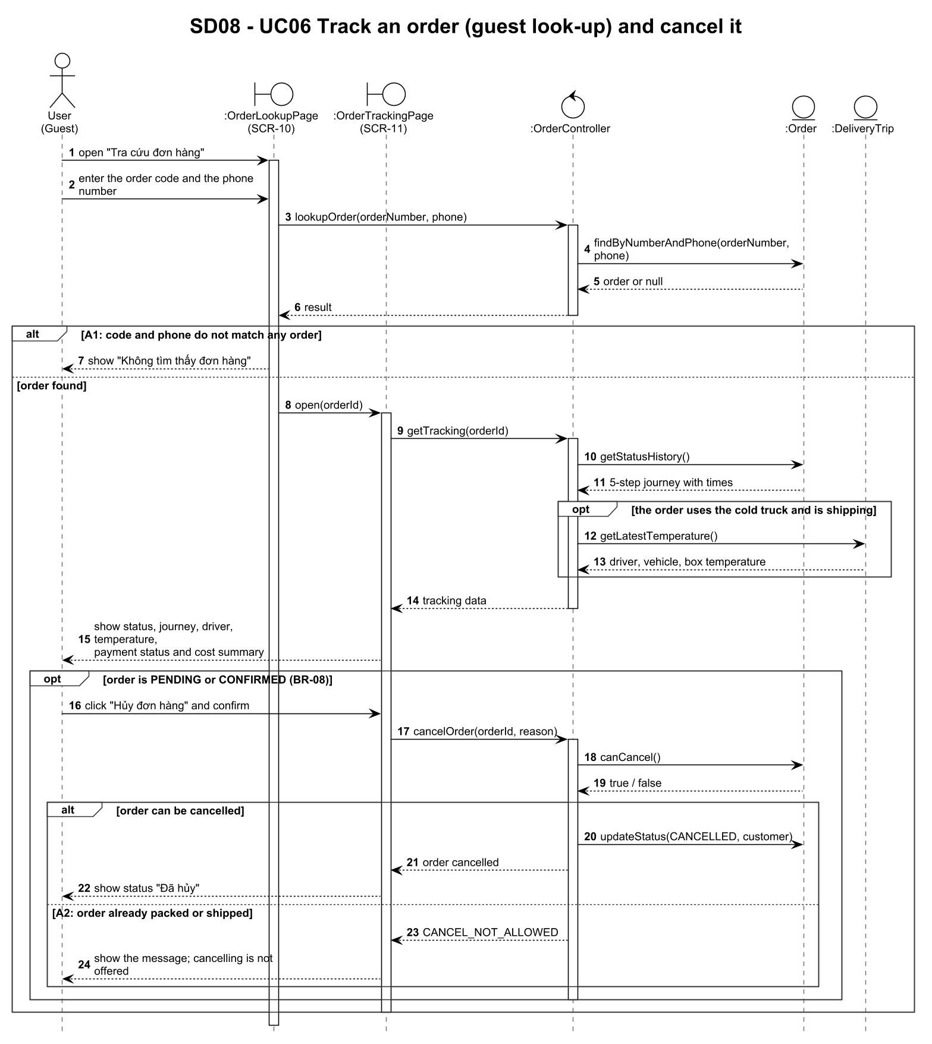
Figure 7 - SD08 UC06 Track an order

3.3 SD09 - UC10 Process orders
Item | Value
Use case | UC10 Process orders
Actors | Admin
Scenario | The Admin filters orders, opens one, ticks the cold-pack checklist and advances the status until delivery.
Alternative flows shown | Loop ends on DELIVERED or CANCELLED (A1).
Business rules | BR-01, BR-08

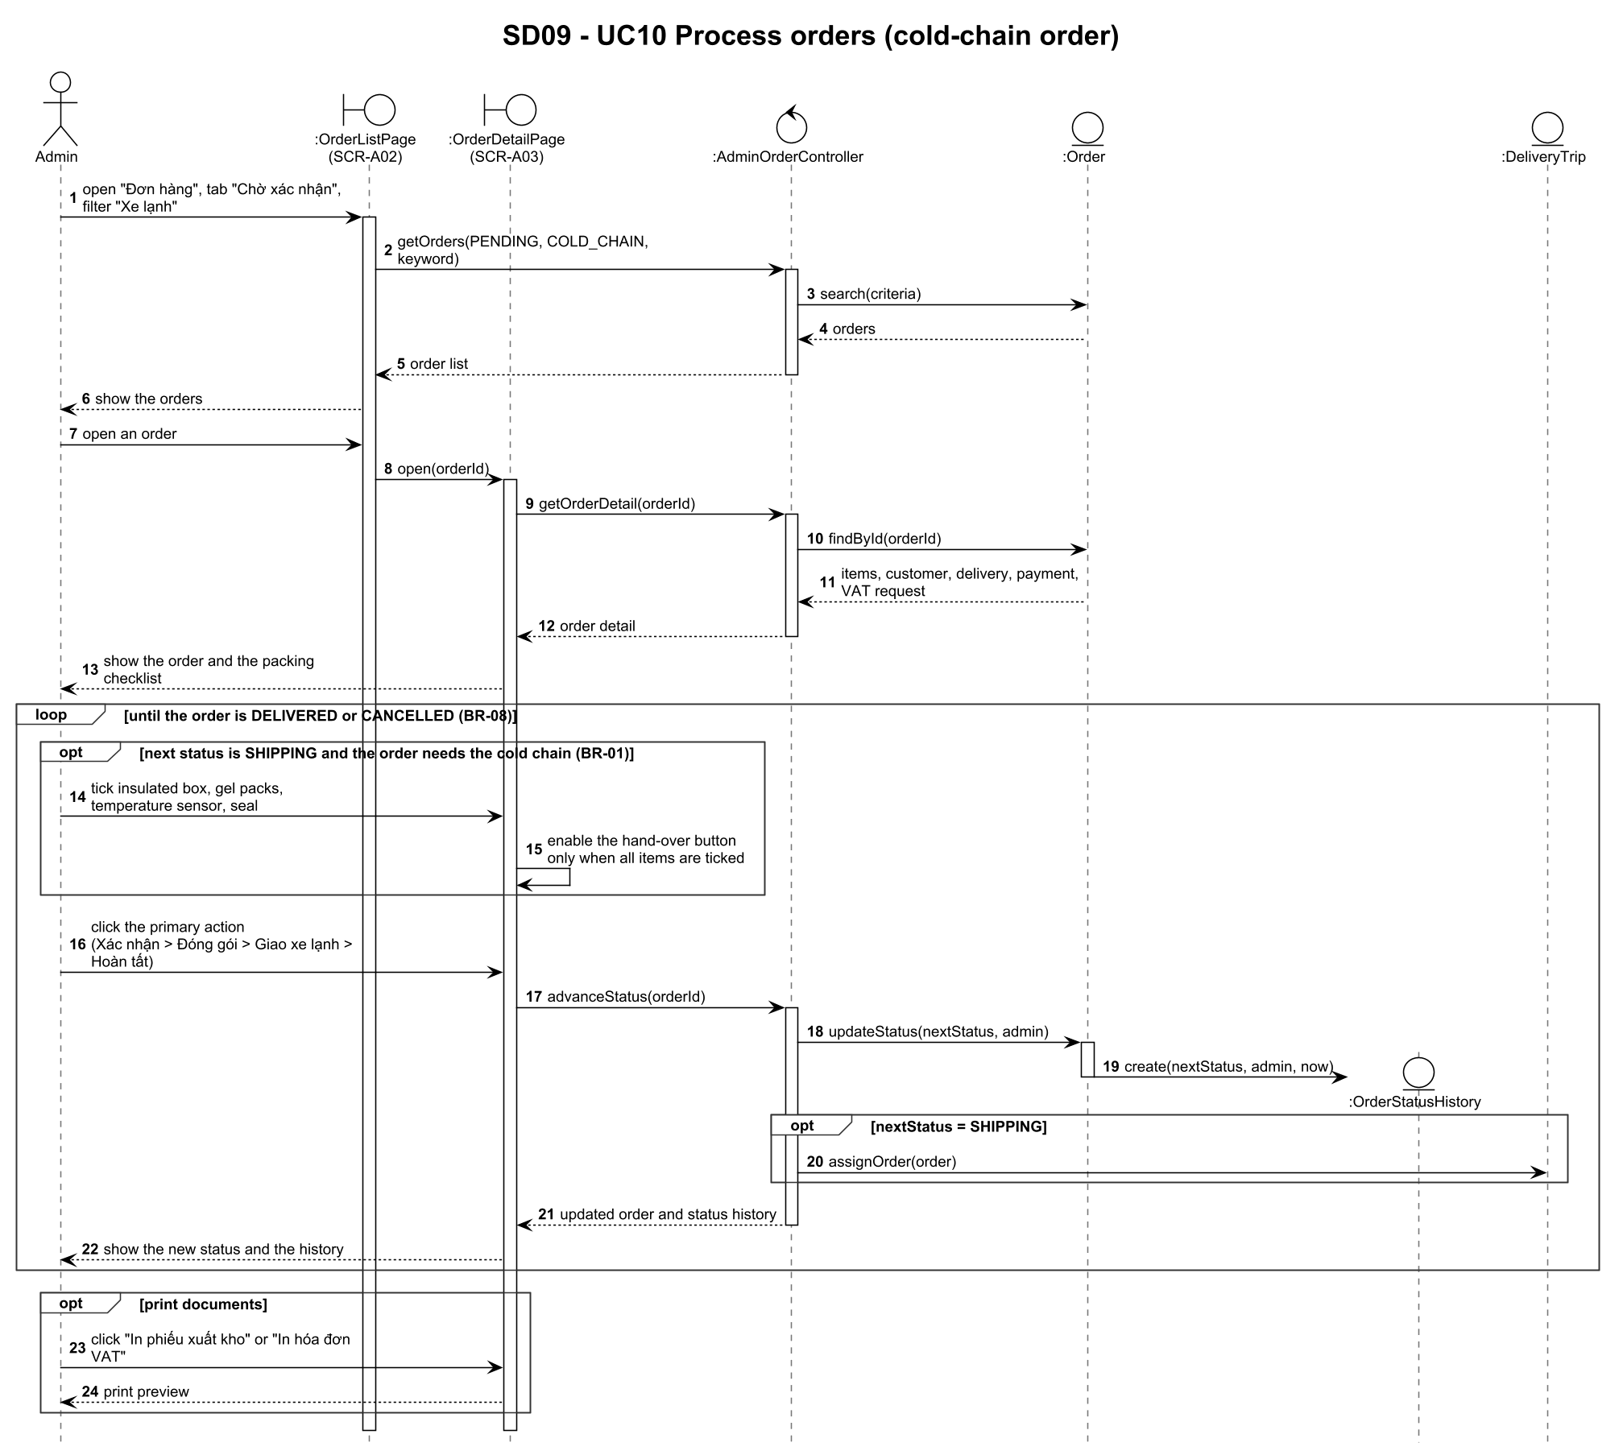
Figure 8 - SD09 UC10 Process orders

