**Setup Jenkins container and Tomcat container on  
the single EC2 instance**

**Running containers:**



**Pipeline status:**

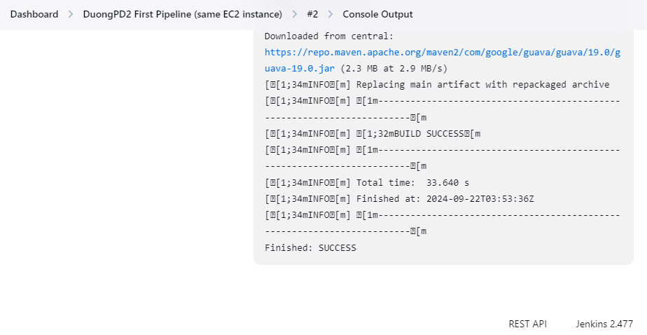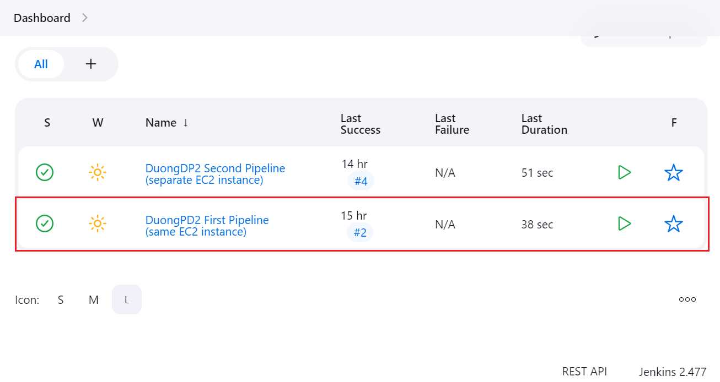

**Pipeline config:**

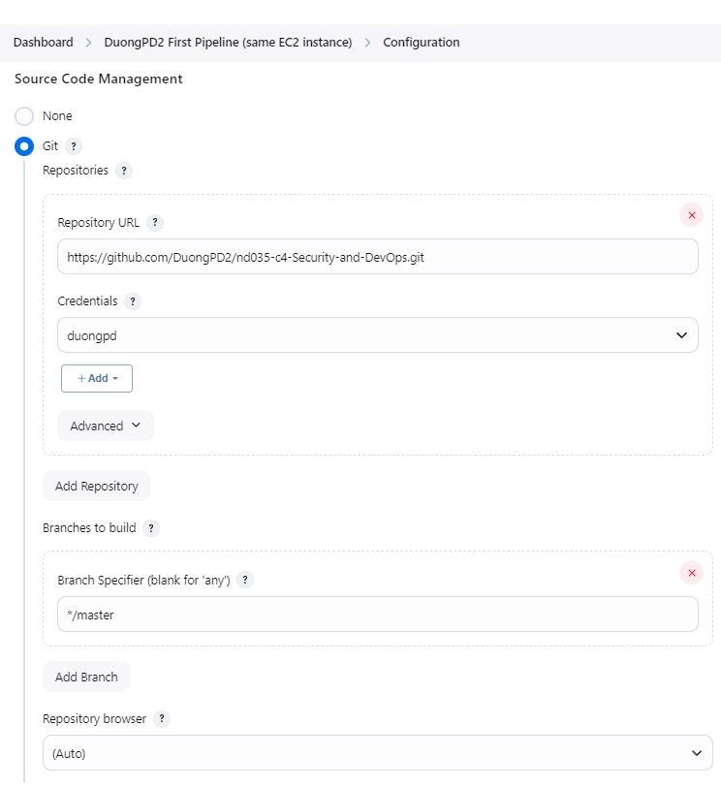

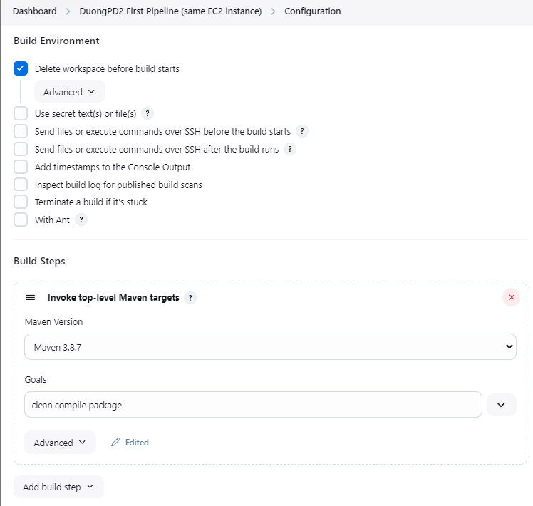

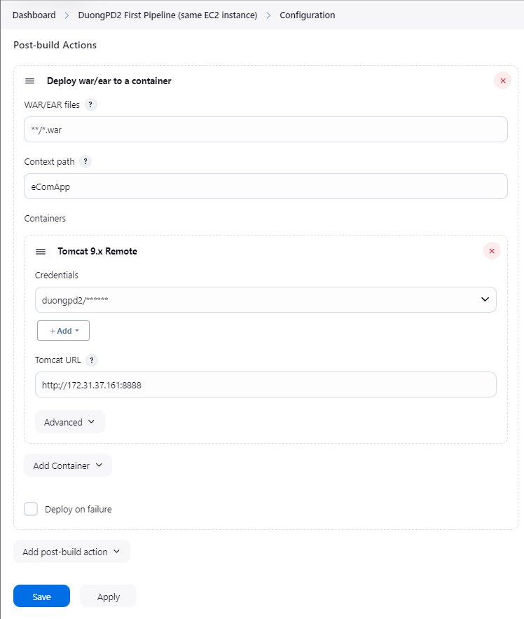

**Tomcat server:**

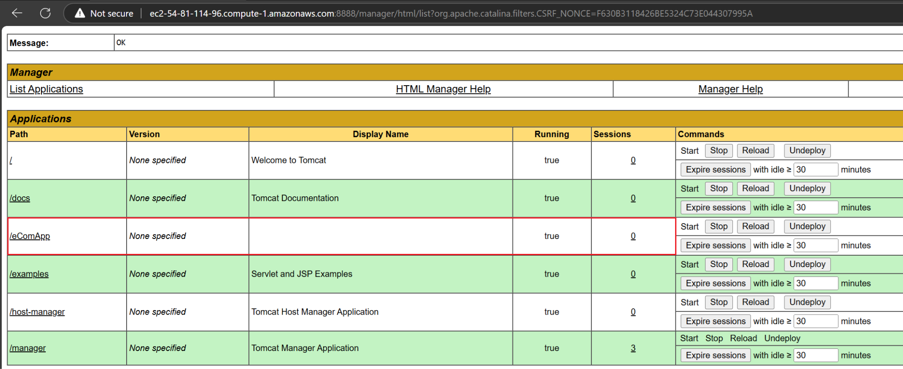

**Try to call eComApp:**

