**Set up separate Jenkins and Tomcat containers on two different EC2 instances.**

**Dockerfile:**

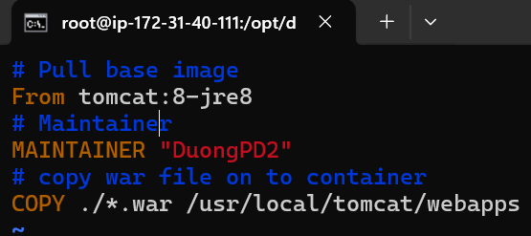

**Pipeline status:**

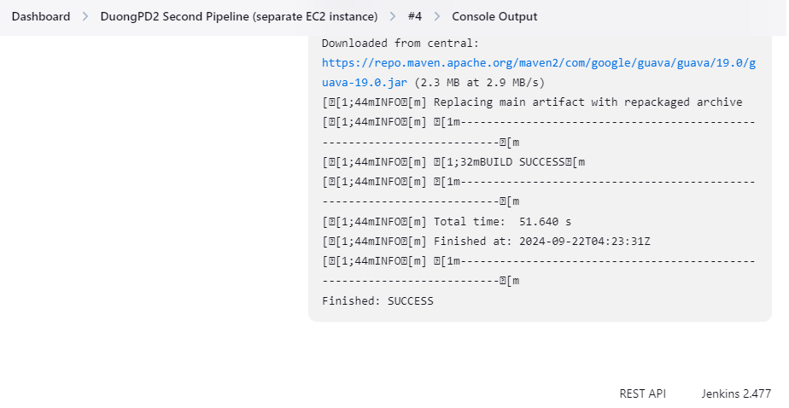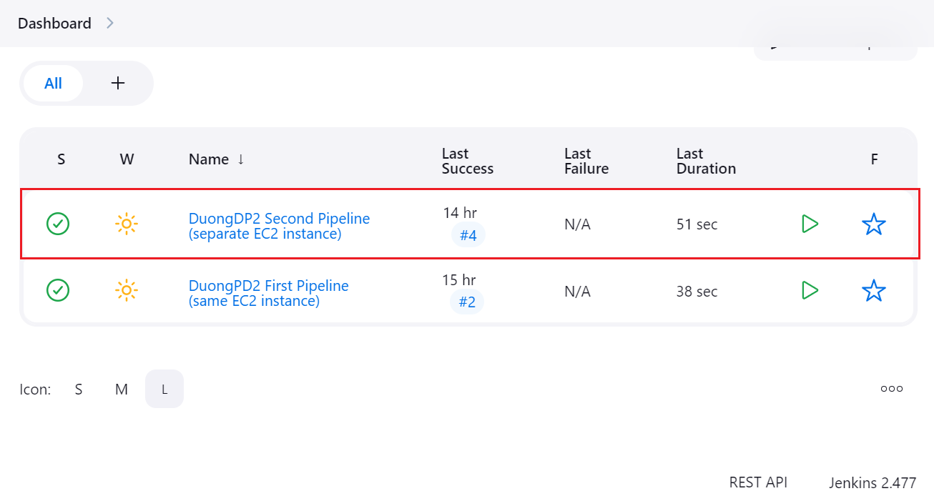

**Pipeline config:**

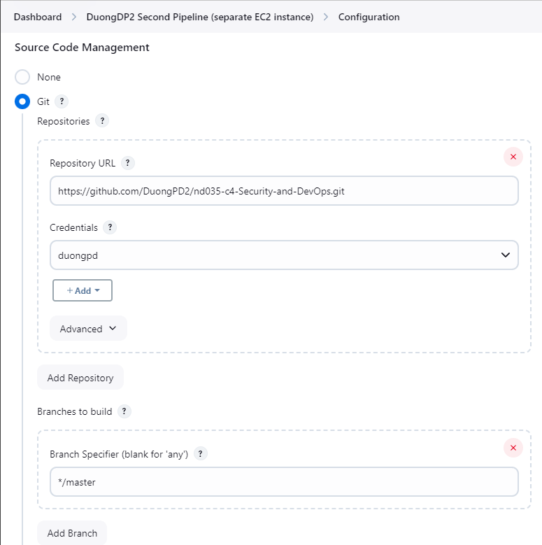

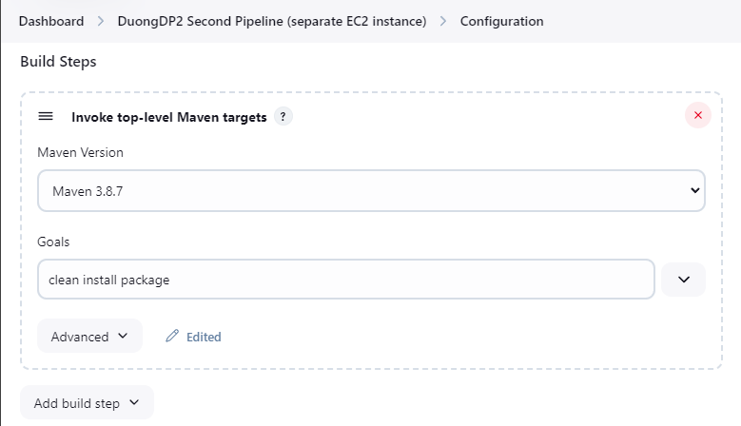

**Transfer set 1:**

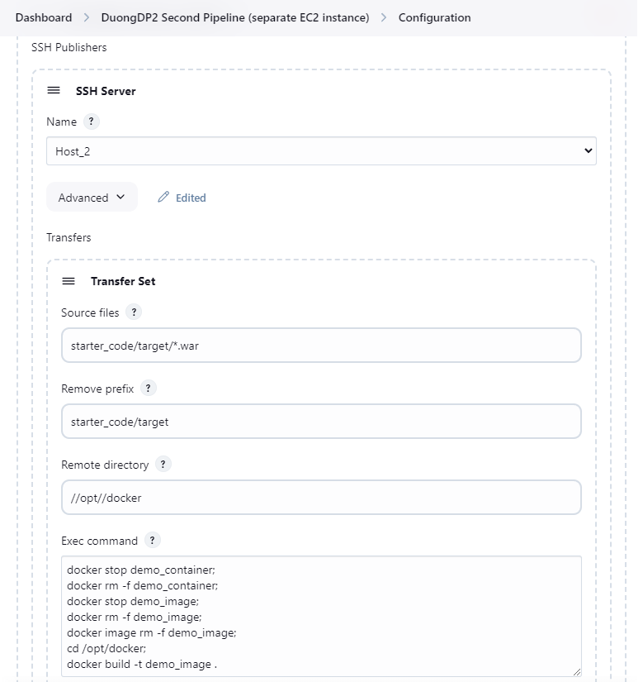

**Transfer set 2:**

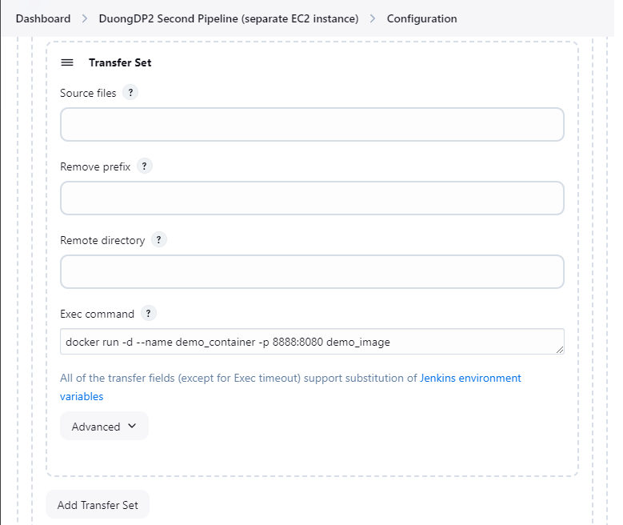

**Jenkins - instance 1 copy WAR, create image and container for Tomcat in instance 2:**

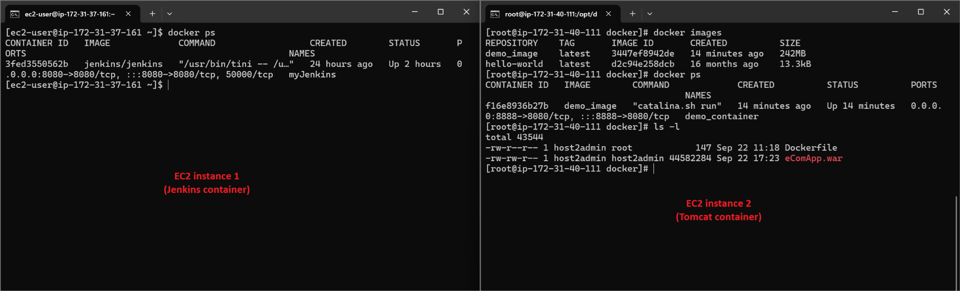

**Try to call eComApp:**

