

Capstone Project Report
Report 6 - Software User Guides

- Hanoi, April 2026 -
Table of Contents
I. Record of Changes 3
II. Release Package & User Guides 4
1. Deliverable Package 4
2. Installation Guides 4
2.1 System Requirements 4
2.2 Installation Instruction 5
3. User Manual 7
3.1 Overview 7
3.2 Challenge Management Lifecycle (Admin/Challenge Writer) 7
3.3. Guideline for writing Challenge 15
3.4. Guideline for Contestant 30

I. Record of Changes
Date | A*  M, D | In charge | Change Description
 | A | DucDM | 1, 2. Installation Guides
 | A | TrungTM | 3.3 Guideline for writing Challenge
 | A | NhatKA | 3.2 Challenge Management, 3.4 Guideline for Contestant
 | A | KienHT | 2.2 Installation Instruction
*A - Added M - Modified D - Deleted

II. Release Package & User Guides

1. Deliverable Package
[The section will list all source programs, scripts, documents with version number in this release. You can see the example following table for reference, can customize or delete if not using belong to each project characteristics]
No. | Deliverable Item | Description
1 | Project Schedule/Tracking
2 | Project Backlog
3 | Source Codes
4 | Database Script(s)
5 | Final Report Document
6 | Test Cases Document
7 | Defects List
8 | Issues List
9 | Slide
Table 1: Deliverable Items

2. Installation Guides

2.1 System Requirements

2.1.1 Hardware Requirement:
The deployment environment requires two virtual machines forming a lightweight Kubernetes cluster using K3s. The cluster is composed of a control plane node responsible for cluster orchestration and a worker node dedicated to running application workloads.
VM1 – Control Plane Node:
- Role: K3s Server (Control Plane)
- CPU: ≥ 8 cores
- RAM: ≥ 16 GB
- Operating System: Ubuntu 22.04 LTS
- Disk Capacity: ≥ 200 GiB (SSD)
- Required Open Ports (Inbound):
  - 80 - HTTP
  - 443 - HTTPS
  - 6443 - Kubernetes API Server
  - 30037, 30038 - NodePort services (may vary depending on deployment configuration)
VM2 – Worker Node:
- Role: K3s Agent (Worker Node)
- CPU: ≥ 8 cores
- RAM: ≥ 32 GB
- Operating System: Ubuntu 22.04 LTS
- Disk Capacity: ≥ 200 GiB (SSD)

2.1.2 Network Requirement:
Both virtual machines must:
- Be located within the same subnet (private network)
- Have private IP addresses and be able to communicate directly with each other
- Be able to ping each other (ICMP) and maintain stable TCP connectivity
- Allow full-mesh connectivity between nodes (each node can reach every other node)
- Have stable and unique private IP addresses that do not change after cluster initialization
Mandatory requirements for network range (network isolation):
- The private IP range of the VMs must not overlap with:
  - Pod CIDR (default K3s: 10.42.0.0/16)
  - Service CIDR (default K3s: 10.43.0.0/16)
- Recommendation:
  - Use a dedicated infrastructure range, for example: 192.168.x.x or 172.16.x.x
- If the 10.x.x.x range must be used:
  - The Pod CIDR and Service CIDR must be reconfigured during cluster initialization to avoid conflicts
Additional requirements for Calico VXLAN networking:
- UDP port 4789 must be open between all cluster nodes for VXLAN encapsulation
- The underlying network must support MTU ≥ 1450 to accommodate VXLAN overhead
- Internal firewalls or security groups must not block or filter encapsulated UDP traffic
- Reverse path filtering must be configured in permissive mode on all nodes
- IP forwarding must be enabled on all nodes
System-level networking requirements:
- Required Linux kernel modules must be available: overlay, br_netfilter, vxlan, ip_tables, ip_set
- Bridge network traffic must be processed by iptables
- Nodes must have outbound internet access to download installation packages and container images
- Swap must be disabled on all nodes
The network environment must also satisfy the following conditions:
- Low latency between cluster nodes.
- Stable internal bandwidth to support container communication.
- No NAT or firewall rules should block internal traffic between cluster nodes.
- Ports must be opened between nodes (internal network):
  - TCP: 111, 179, 2049, 2379, 2380, 5001, 5473, 6443, 10250
  - UDP: 111, 2049, 4789, 8472, 51820, 51821

2.2 Installation Instruction
Prerequisites
git clone <repo-url> FCTF
cd FCTF
chmod +x manage.sh

Step 1 (Mandatory): Update Domains and Ips Based on the Target Deployment Environment
When deploying to a new environment, update the following:
- registry0.fctf.site → <your-domain>
- admin0.fctf.site → <your-domain>
- api0.fctf.site → <your-domain>
- argo0.fctf.site → <your-domain>
- contestant0.fctf.site → <your-domain>
- grafana0.fctf.site → <your-domain>
- rabbitmq0.fctf.site → <your-domain>
- rancher0.fctf.site → <your-domain>
- challenge0.fctf.site → <your-domain>
Replace infrastructure Ips:
- 10.148.0.2 → your actual private IP of NFS / K3s master
Files That Must Be Updated
- Ingress (host + TLS SAN):
  - prod/ingress/nginx/*.yaml
  - prod/ingress/certificate/*.yaml
- Registry references (images, secrets, configs):
  - prod/app/*/deployment.yaml
  - prod/argo-workflows/**
  - prod/env/configmap/*.yaml
  - prod/env/secret/docker-secret.yaml
- Helm values (domain-related):
  - prod/helm/registry/harbor-values.yaml
  - prod/helm/rancher/rancher-values.yaml
- Storage (NFS server IP):
  - prod/storage/pv/*.yaml
- Bootstrap / setup scripts:
  - setup-worker.sh
  - setup-harbor.sh
  - cicd-setup.sh
Pre-Deployment Checklist
- No remaining references to:
  - registry0.fctf.site, admin0.fctf.site, api0.fctf.site, etc.
- No outdated Ips such as 10.13.2.3
- All Ingress hosts match their corresponding TLS certificates
- Registry domain is consistent across:
  - Harbor values
  - Docker registry secrets
  - Image paths in deployments
Step 2: Set up Master Node
In Master Node:
Run:
./manage.sh
Select: 1) Setup master
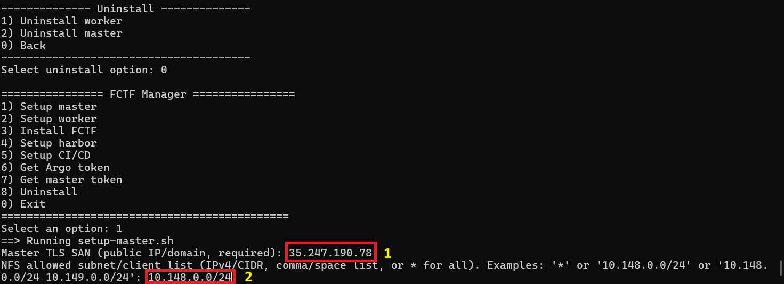
Figure 1: Setup master
1) Input your master TLS SAN (public IP or domain of master)
Example: 35.247.198.78 or api3.fctf.site
2) Input your NFS allowed IP (IPv4/CIDR, comma-separated, or * for all)
Example: 10.240.0.0/24
After completing the setup, get your worker join token:
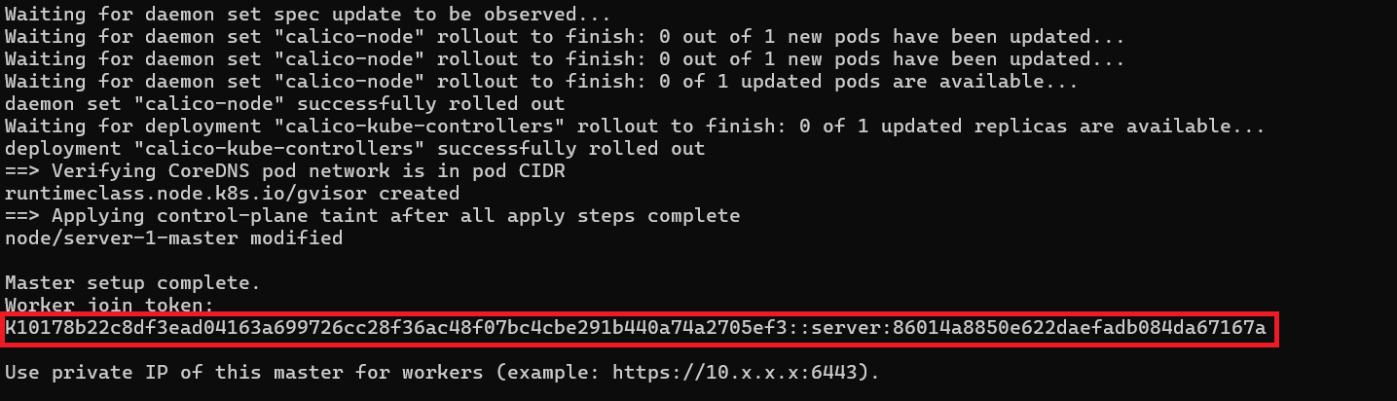
Figure 2
Step 3: Set up Worker Node
In Worker Node
Select: 2) Setup worker
You need to input your token from previous step to join cluster:
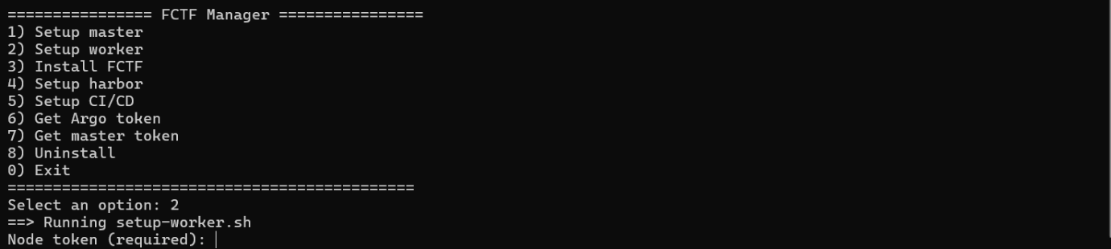
Figure 3
After setup completed, you will see these following messages:
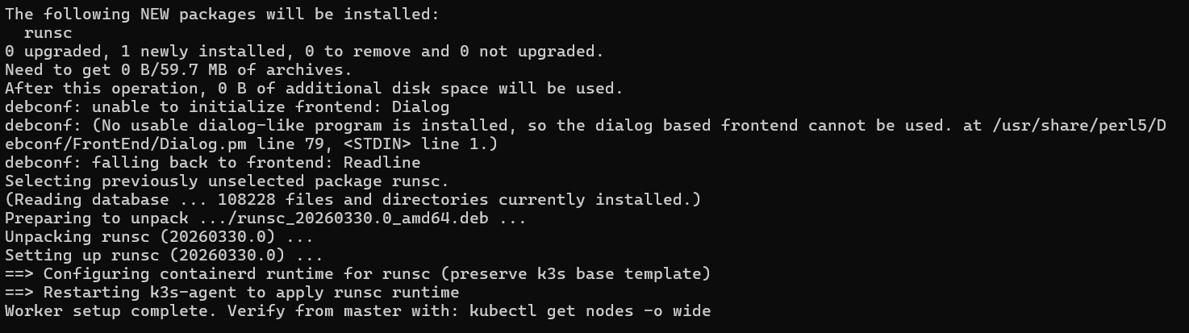
Figure 4
Step 4: Setup FCTF
In Master Node:
Select: 3) Install FCTF
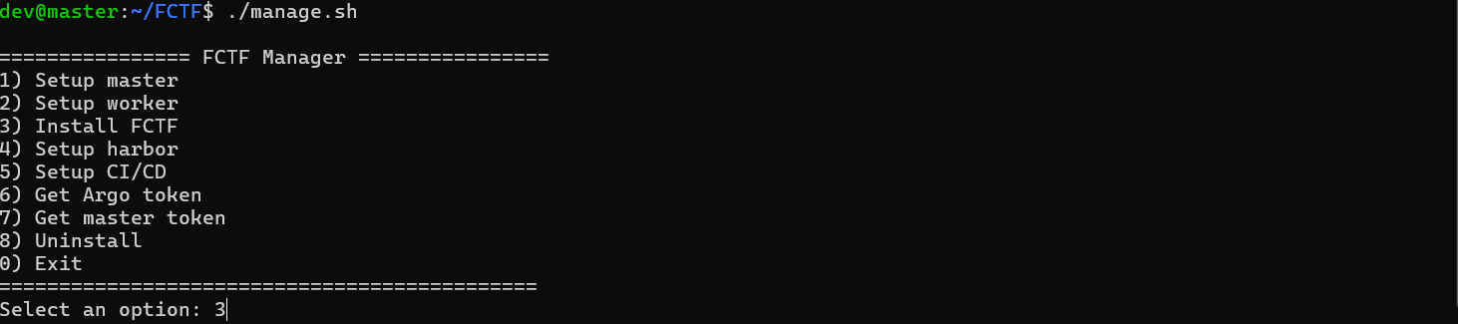
Figure 5
After setup completed:
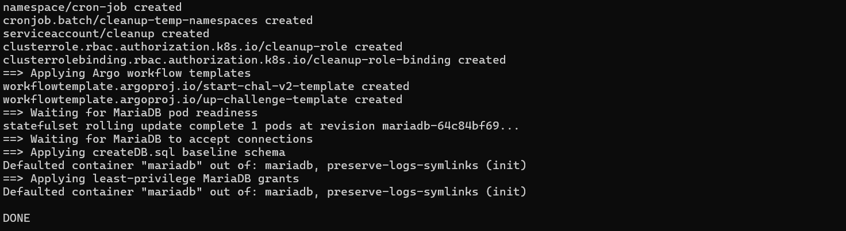
Figure 6
Default admin credentials:
Service | Username | Password
Harbor Registry | admin | FCTF@2025
Rancher | admin | Ab@123456789
Grafana | admin | Fctf2025@
RabbitMQ | rabbit-admin | Fctf2025@admin

Step 5: Setup harbor
In Master Node:
Select: 4) Setup harbor
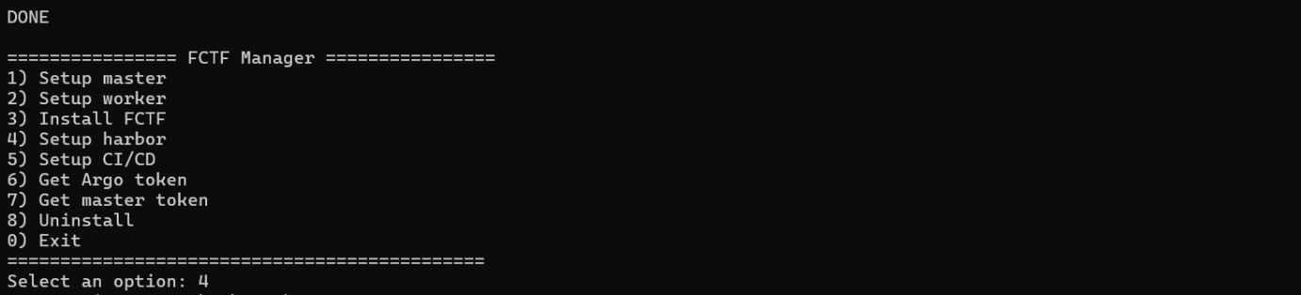
Figure 7
After choosing option 4), you can see the steps required to set up Harbor manually:
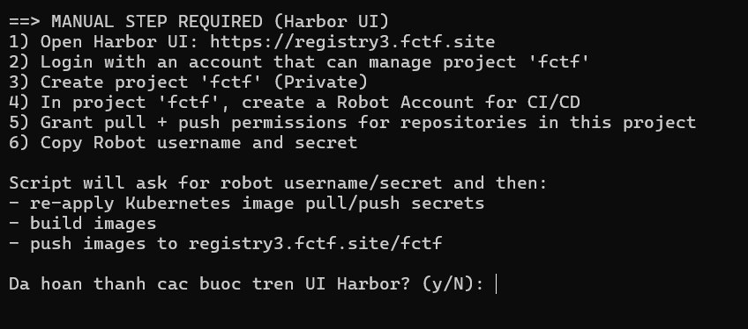
Figure 8
Following step below to finish setup of Harbor:
Open Harbor UI: <your-harbor-domain> and login.
Click new project button to create a new project:
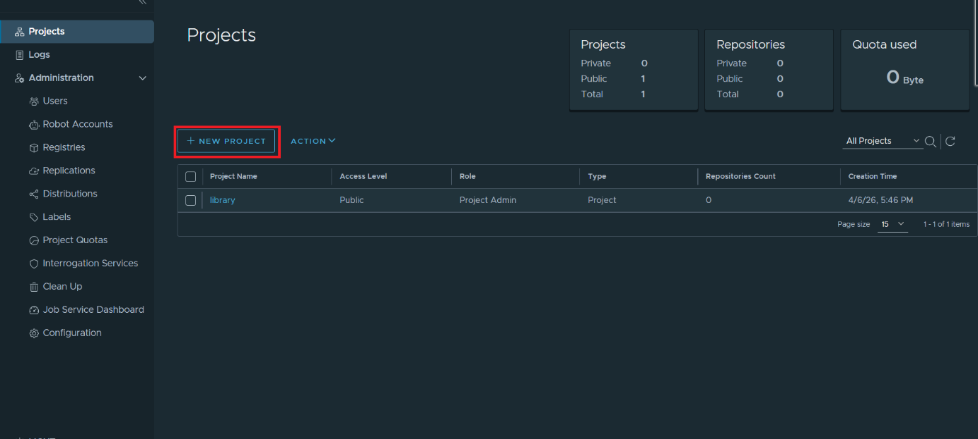
Figure 9:
In field Project Name input field mandatory ‘fctf’ Then click ‘OK’:
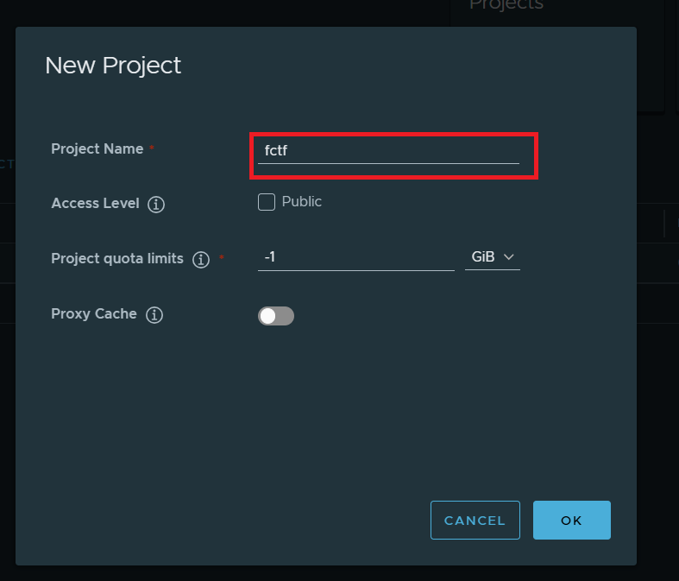
Figure 10
Go to robot accounts sections:
Select New Robot account to create:
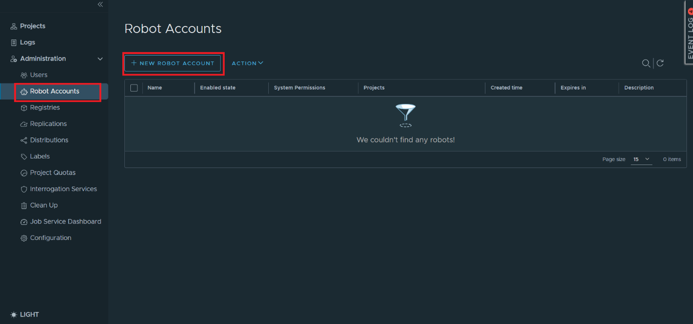
Figure 11
(1) Enter a robot name
(2) Select expiration time
then go next to project permissions (skip 2. Select System Permissions):
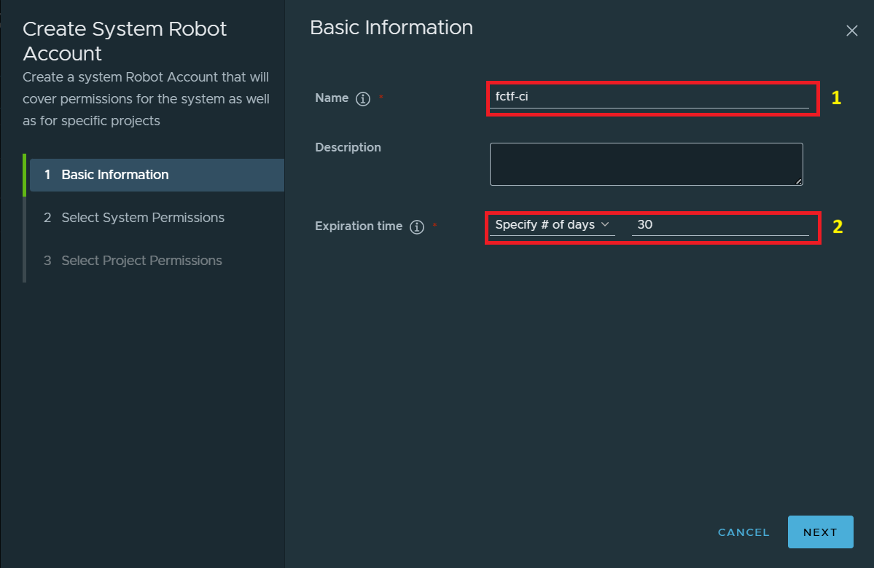
Figure 12
(1) Select ftcf project
(2) Click permission to setup
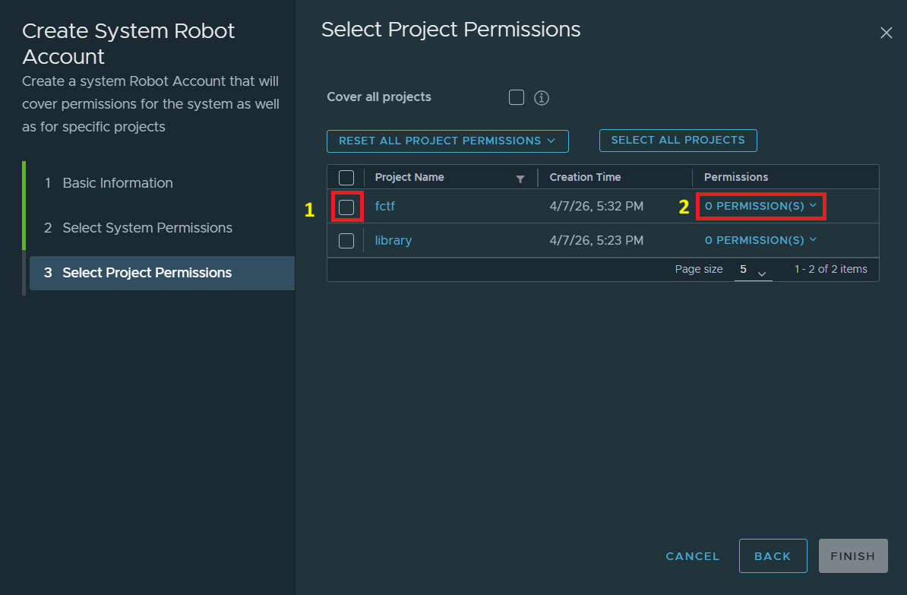
Give robot pull and push permissions as below then finish:
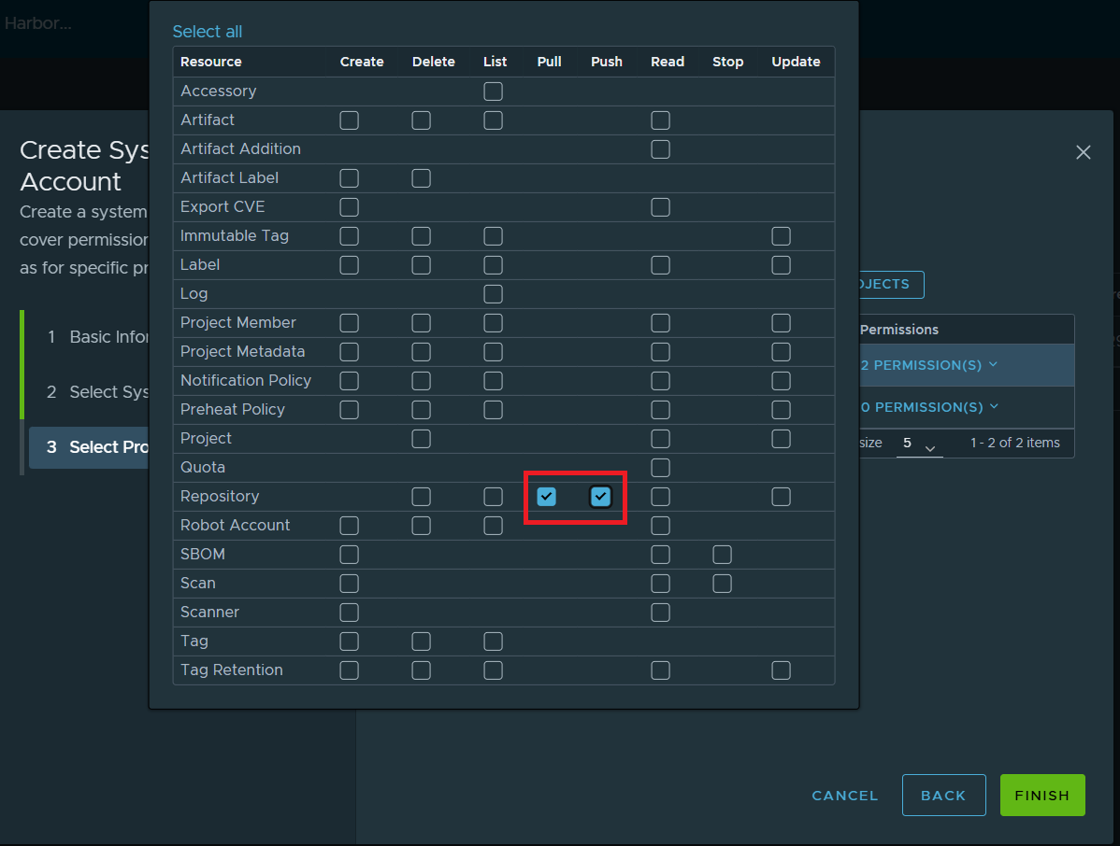
Figure 13
After finishing you can get your robot username and password
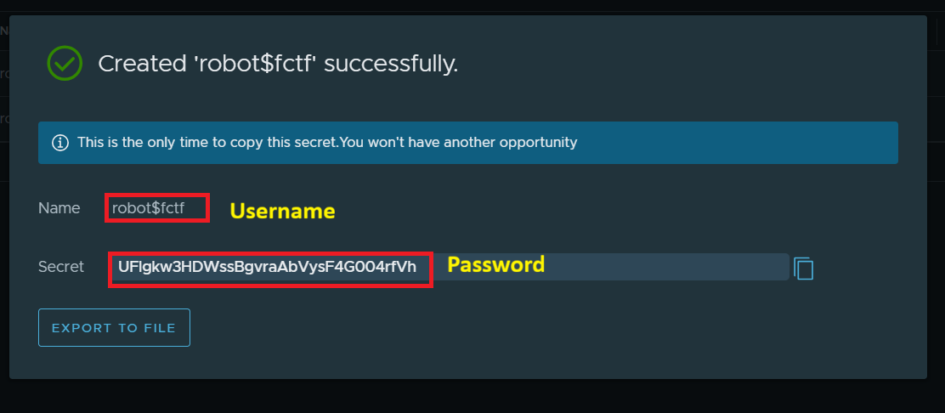
Go back to terminal and input robot username and password
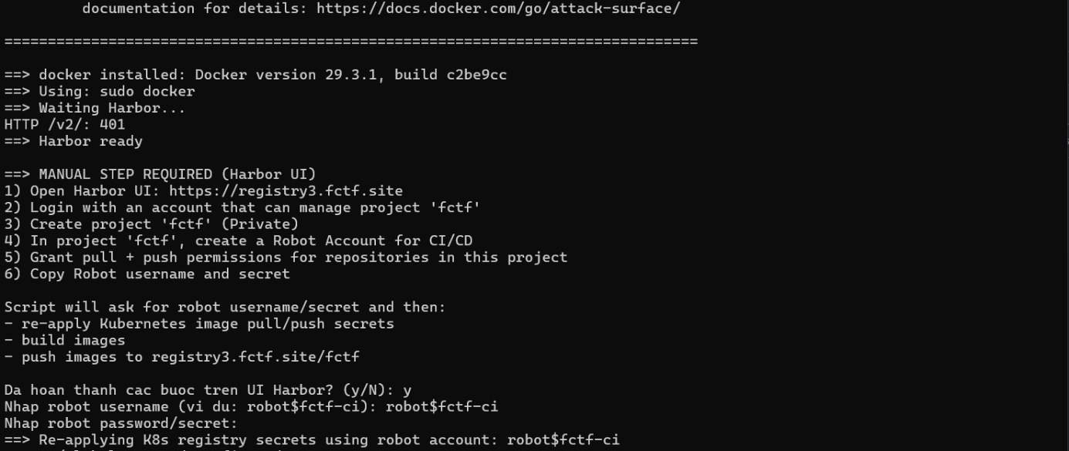
After completing the setup, you will the following messages:
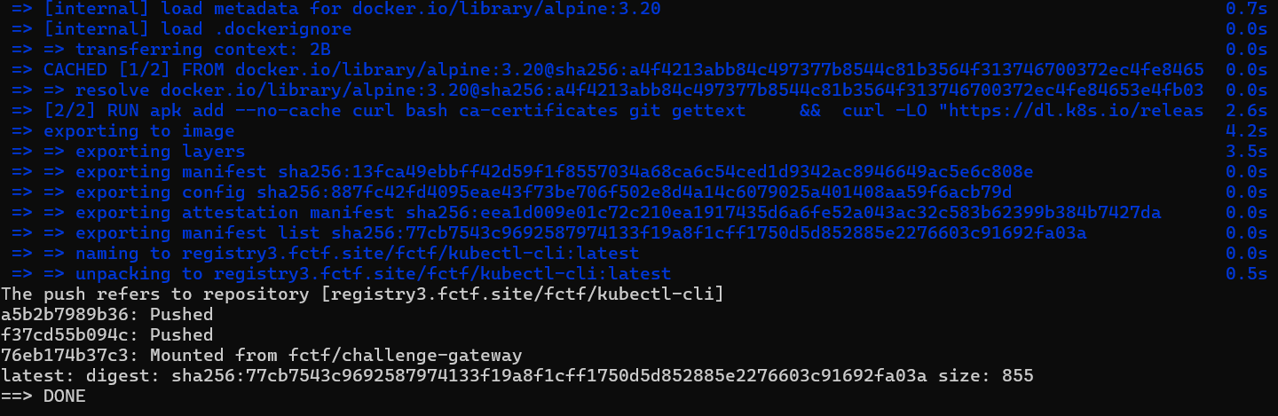

3. User Manual

3.1 Challenge Management (Admin/Challenge Writer)
Purpose: Guide Admin/Challenge Writer through challenge creation, deployment setup, testing and monitoring.
High-level flow: Create Challenge -> Configure Options/Deploy -> Verify Deployment -> View Deploy History -> Preview Challenge -> Start Shared Instance (if enabled) -> Monitor/Stop Instances

3.1.1 Create a new challenge
Step 1: Access Manage Challenges and click [+ Create Challenge] button.
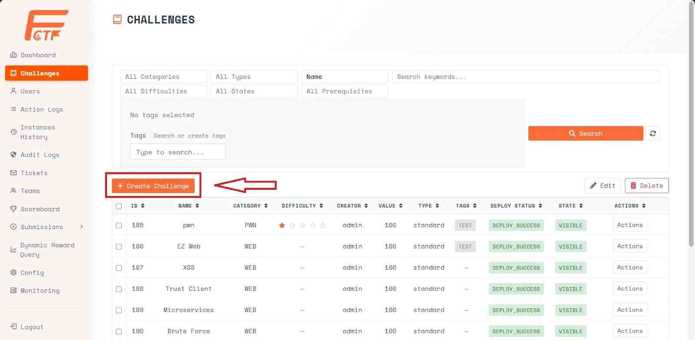
Figure 14: Manage Challenges screen
Step 2: Select a challenge type and fill in the required fields.
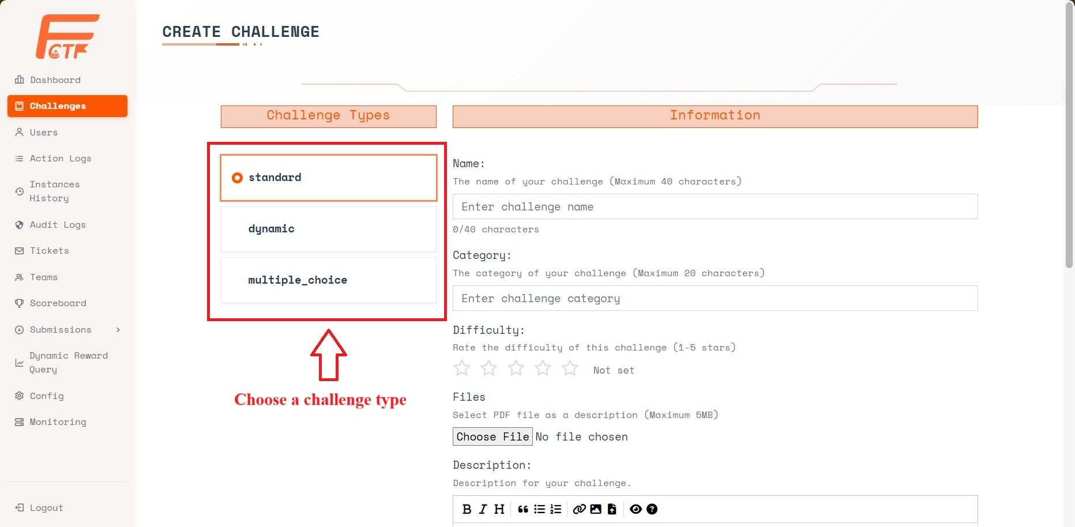
Figure 15: Create Challenge screen
Challenge Type includes:
- Standard:. The score remains fixed regardless of solves.
- Dynamic: The score decreases based on the number of teams that have solved the challenge. The more teams solve it, the lower the received score.
- Multiple choice: Multiple-choice questions where contestants select one correct answer from a list.
Required fields: Name, Category, Value.
Optional fields as needed: Difficulty, Files, Description, Time Limit, Max Attempts, Submission Cooldown.
*For Dynamic challenges, provide Initial Value, Decay Function, Decay, and Minimum Value.
*For Multiple choice challenges, provide answer choices in list format and specify the correct answer.
Step 3: Click [Create] to proceed to the options configuration dialog.
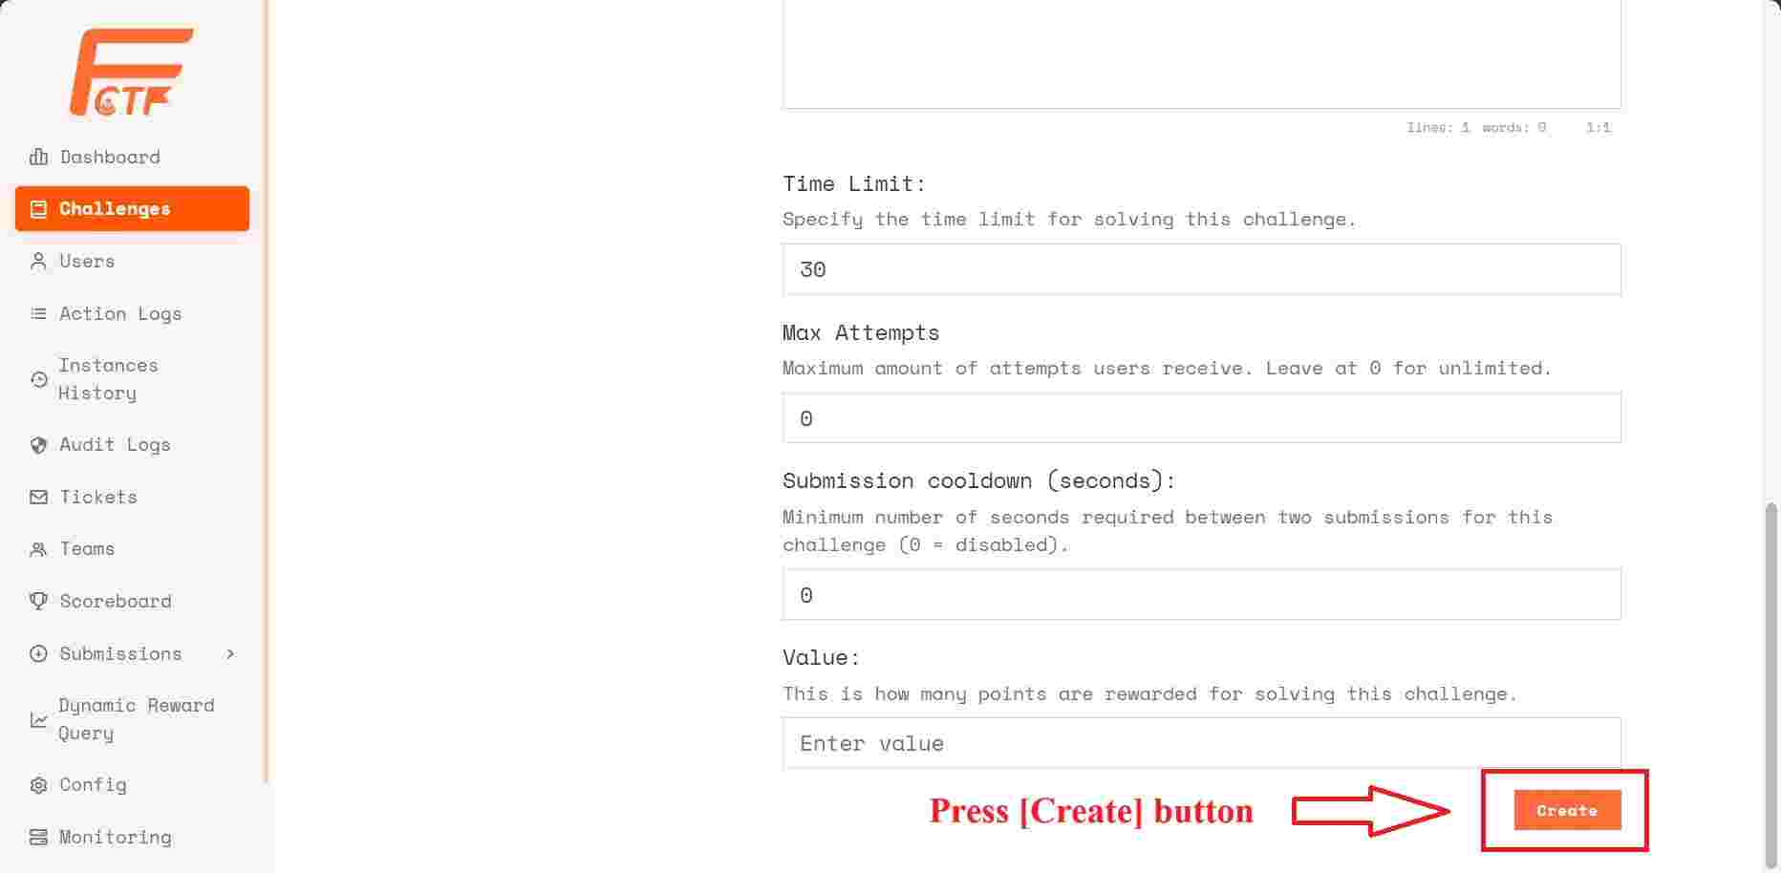
Figure 16: Create Challenge screen
Step 4: Configure challenge options
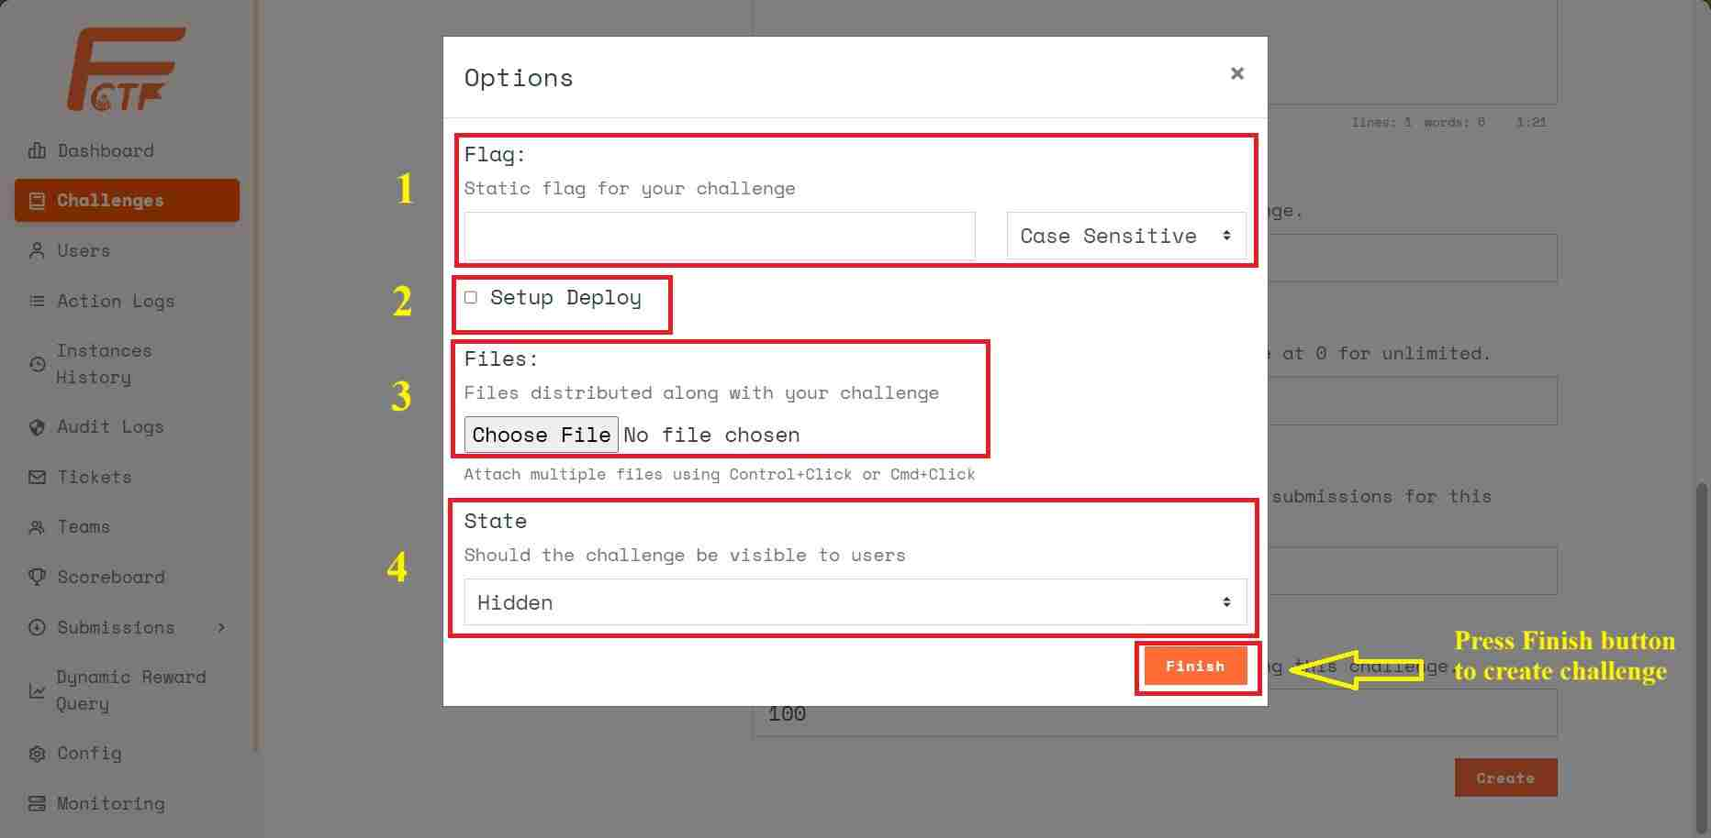
Figure 17: Config challenge option dialog
Box 1: Enter the flag and select whether it is case-sensitive or not (default: static flag).
Box 2: Enable this if the challenge requires deploying a runtime environment.
Box 3: Attached challenge files that contestants can download.
Box 4: The visibility status of the challenge:
Visible: To display it to contestants.
Hidden: To hide it from contestants.
[Finish] button: Click to complete the challenge creation.
*Deployment setup when the [Setup Deploy] checkbox is ticked:
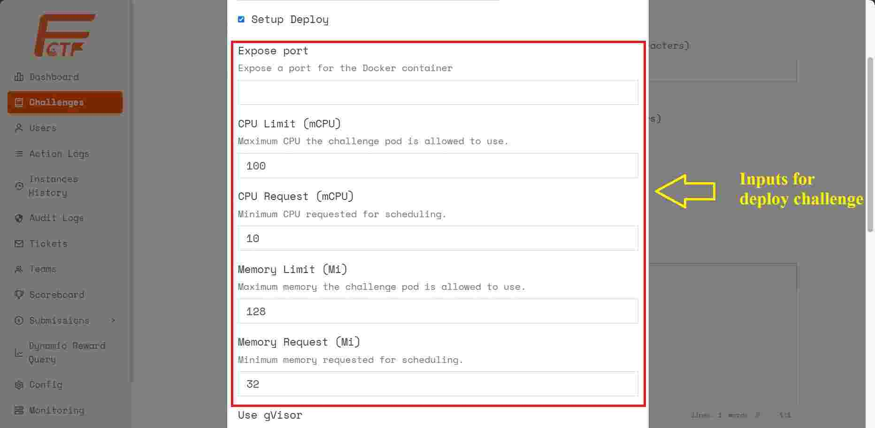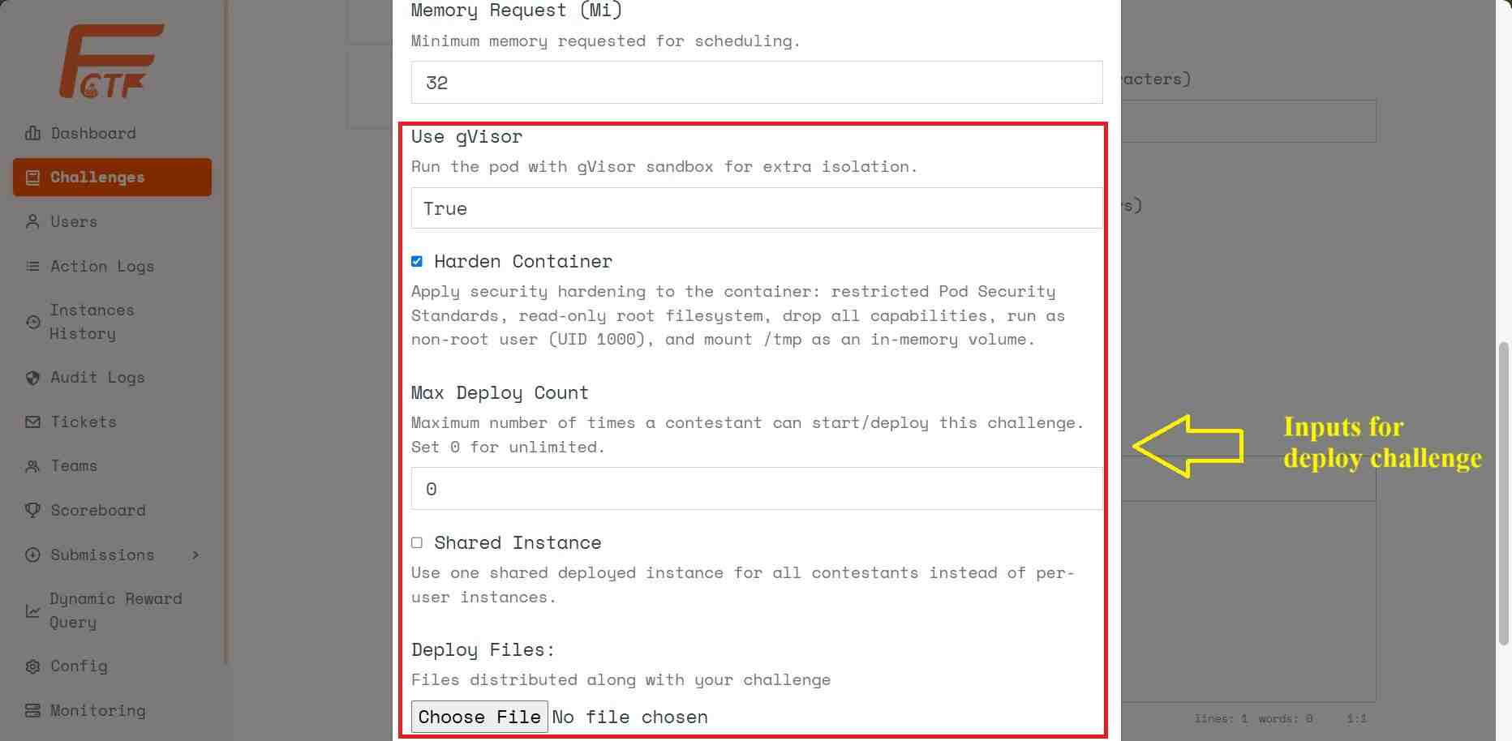
Figure 18: Inputs for Deploy Challenge in options dialog
Required information for deploying a challenge:
- Expose port (Required): The public port that the challenge instance will expose to the outside.
- Connection Protocol: The protocol contestants will use to connect to the challenge instance.
- CPU Limit (mCPU): The maximum amount of CPU the challenge pod is allowed to use.
- CPU Request (mCPU): The minimum amount of CPU required for the scheduler to consider placing the pod.
- Memory Limit (Mi): The maximum amount of RAM the challenge pod can use.
- Memory Request (Mi): The minimum amount of RAM required for the scheduler to place the pod.
- Use gVisor: A dropdown to select the use of the gVisor runtime sandbox to increase kernel isolation for the challenge container.
- Harden Container: Enable the application of enhanced security measures for the container.
- Max Deploy Count: The limit on how many times a player can start an instance for this challenge (set = 0 for unlimited).
- Shared Instance: A checkbox to enable the mode where a single deployed instance is shared among all contestants instead of creating a separate instance for each user.
- Deploy File (required): The zip file containing the source code to build/deploy the challenge instance.
Step 5: After completing Step 4, the system redirects to the Challenge Detail page.
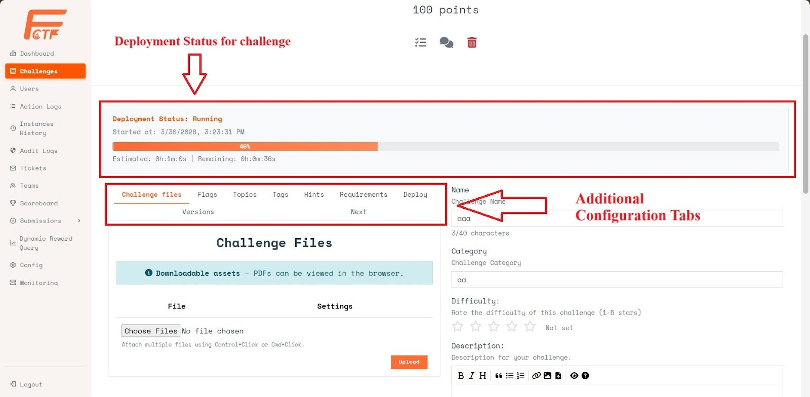
Figure 19: Challenge Detail screen
Configure additional tabs:
- Challenge Files: downloadable files.
- Flags: static/regex flags.
- Topics and Tags: challenge classification.
- Hints: optional hints with point cost and dependencies.
- Requirements: prerequisite challenge and lock behavior (Hidden/Anonymized).
- Deploy: deployment configuration updates.
- Versions: active/old image versions and rollback.
- Next: next challenge recommendation after solve.

3.1.2 View Deploy History
Step 1: Select the newly created challenge from the challenges list to check its deployment history. Click the [Actions] button, then click [History].
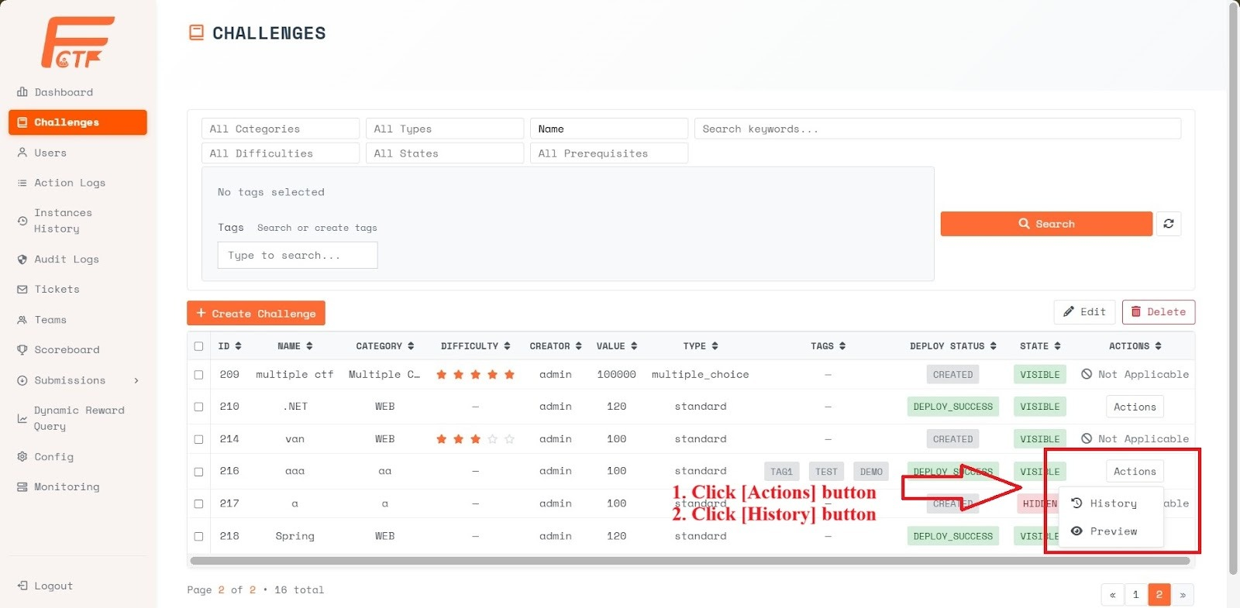
Figure 20: Manage Challenges screen
Step 2: The deployment history list for the challenge will appear. Click [View Details] to see the detailed logs of the deployment workflow.
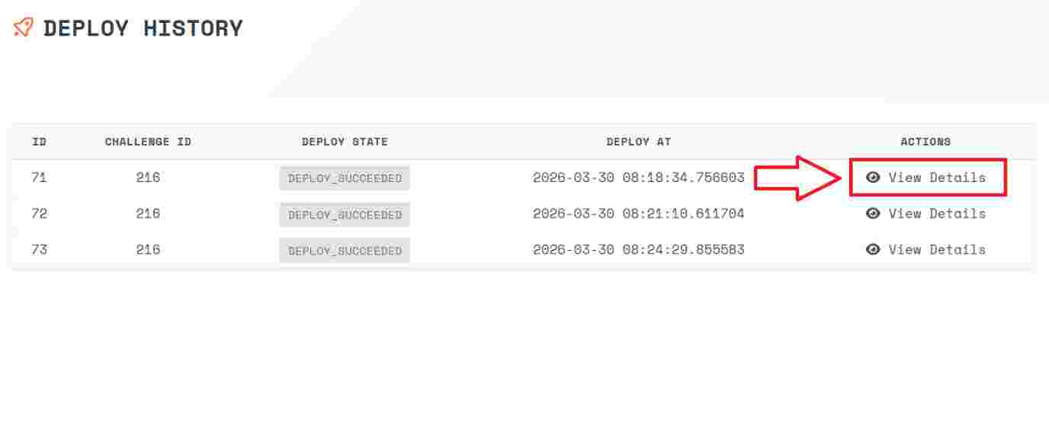
Figure 21: Deploy History Screen
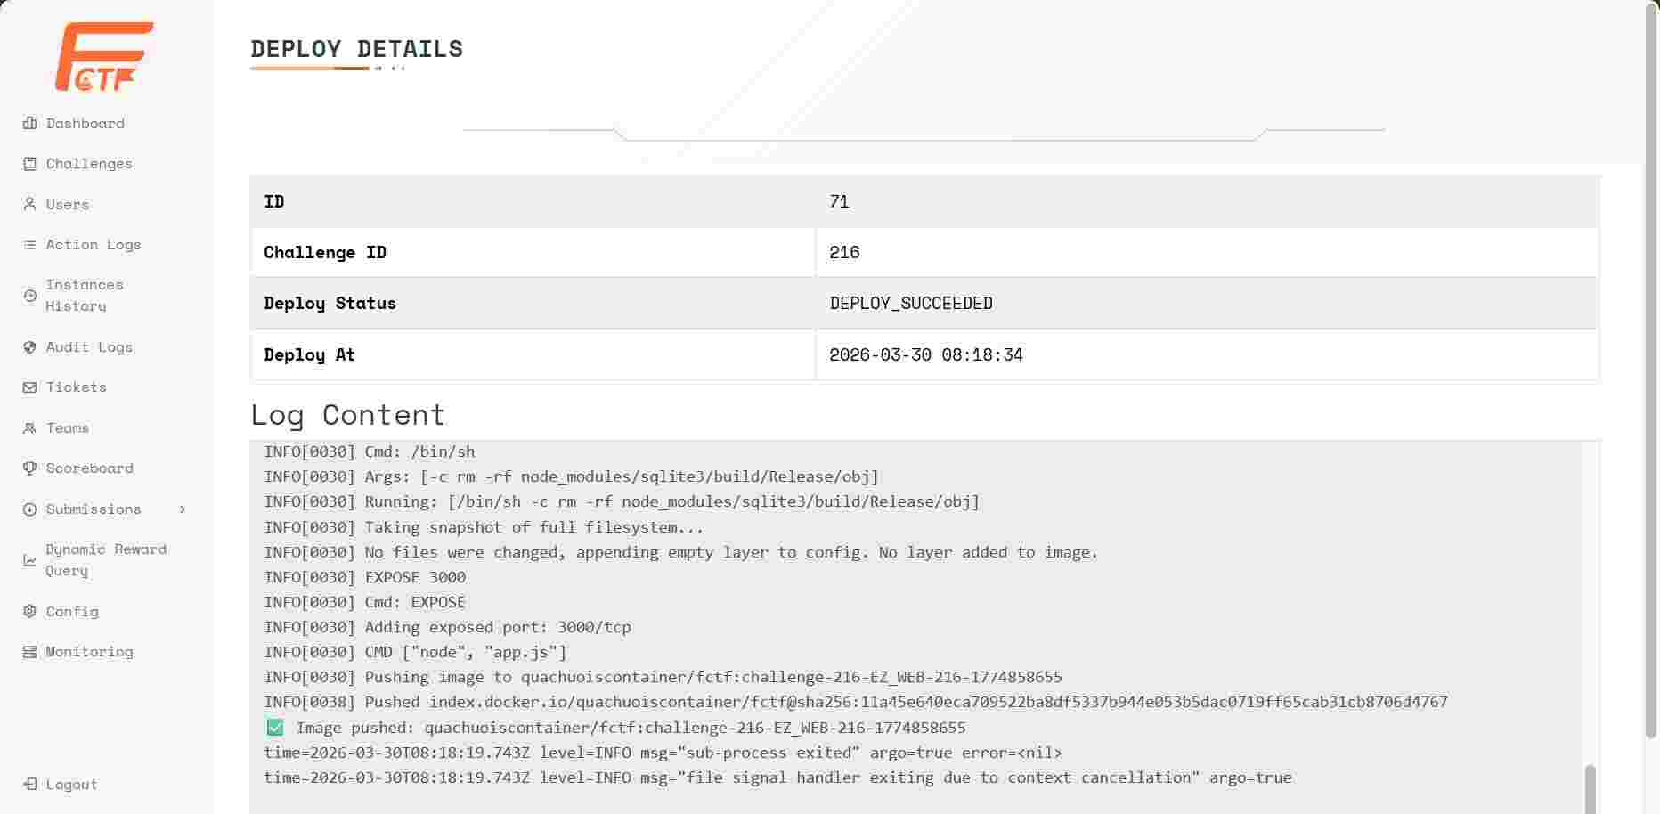
Figure 22: Deploy logs Screen

3.1.3 Preview Challenge
Preview Challenge allows Admins or Challenge Writers to test challenge accuracy and instance deployment without using dummy accounts, avoiding leaderboard impact and unnecessary resource usage during live competitions.
Step 1: Access the Manage Challenges page, click the [Actions] button, then click [Preview].
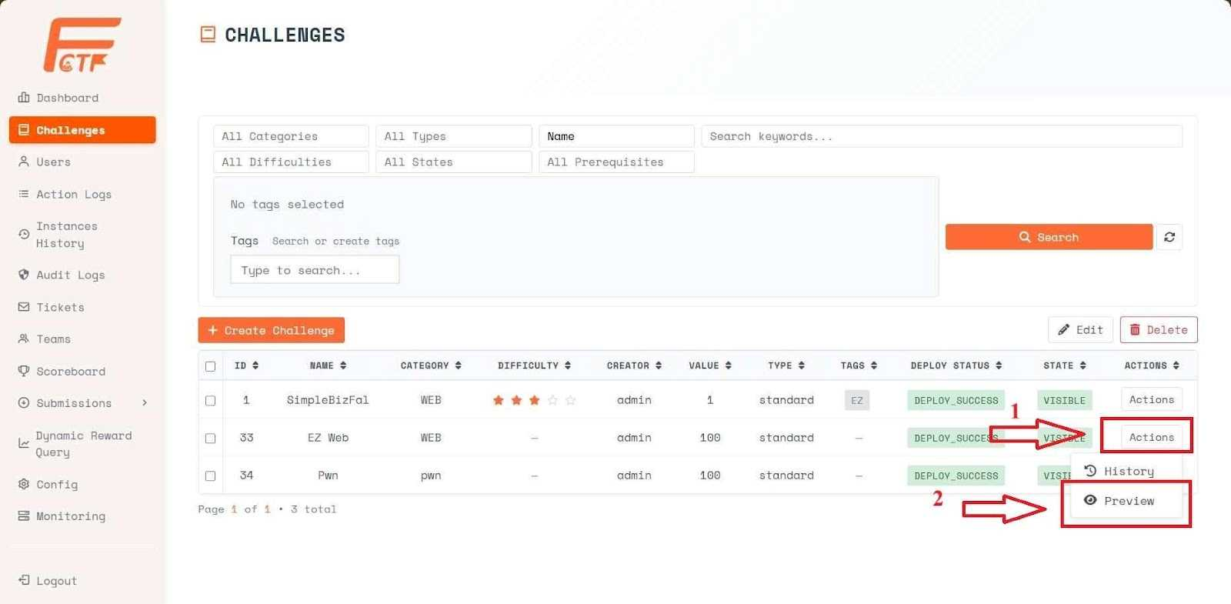
Figure 23: Manage Challenges Screen
Step 2: Access the challenge instance.
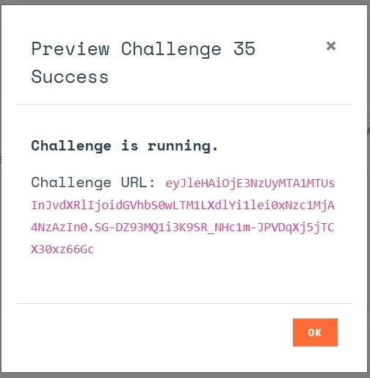
Figure 24: Deploy Status Dialog
Once processing is complete, a success message will be displayed along with the access token for the challenge. Admin can access the challenge instance just like a normal contestant using the provided token.

3.1.4 Start Shared Instance & Monitor/Stop Instances

a, For challenges with the Shared Instance option enabled:
Contestants will not be able to start the challenge themselves. Instead, the Admin must start it manually.
Step 1: Select the challenge where the Shared Instance option was enabled in Step 4 from the challenges list. Click the [Actions] button, then click [Start].
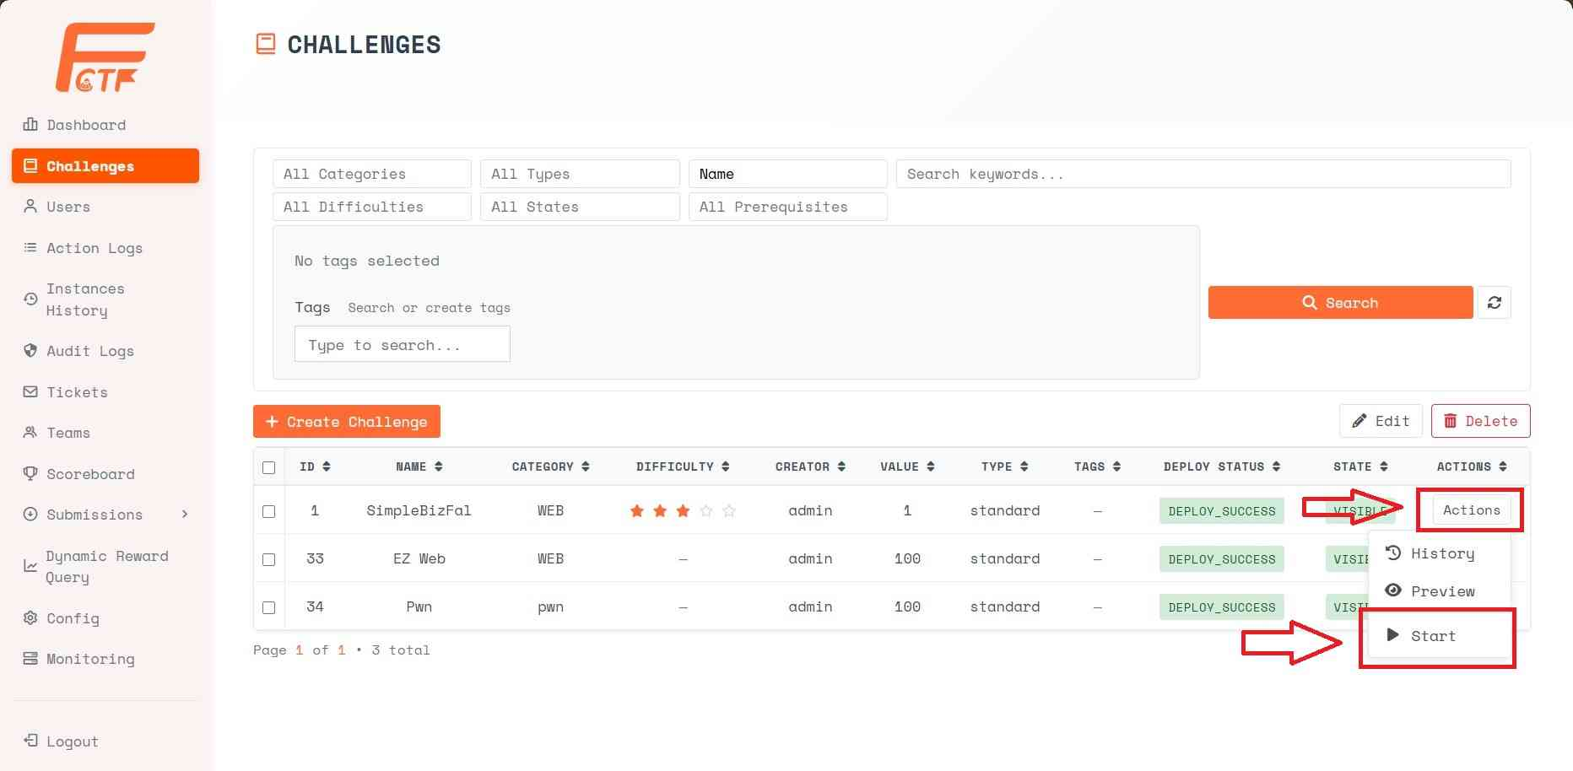
Figure 25: Manage Challenges screen
After the challenge instance is successfully initialized, contestants accessing the challenge will see the connection information as shown below:
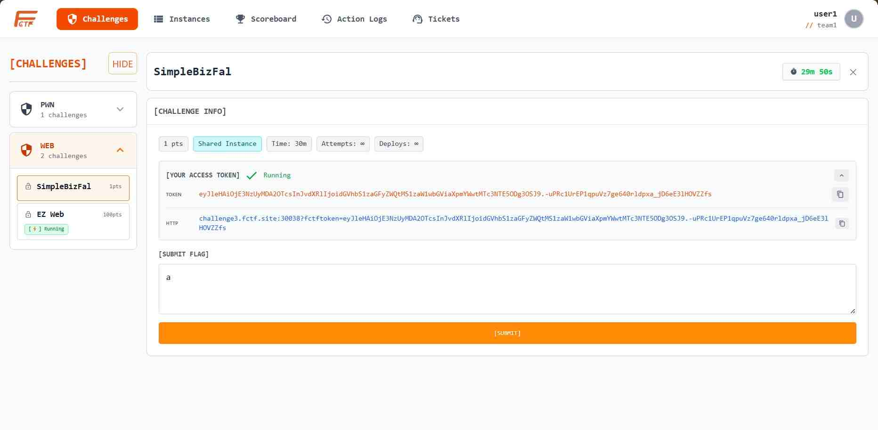
Figure 26: Contestant Challenge Detail screen
b. Monitoring Screen:
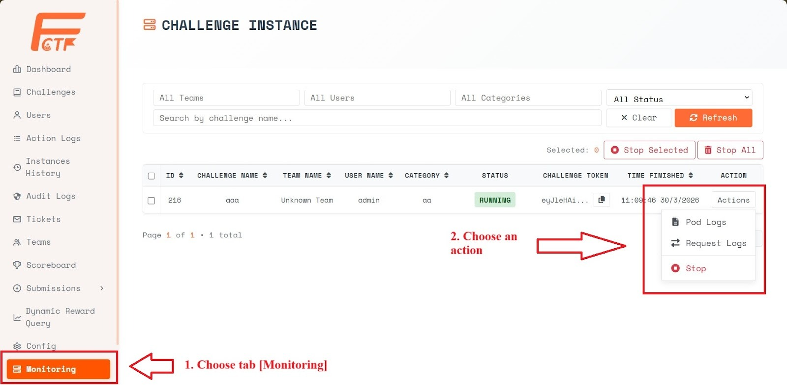
Figure 27: Monitoring screen
Admins can perform management operations on challenge instances on the Monitoring page. The available management options for a challenge instance are:
- Pod Logs: View the live logs of the Pod (container instance) running the challenge.
- Request Logs: Track the Proxy Request system logs exchanged between the contestant and the challenge.
- Stop: Immediately shut down the currently running challenge instance of the contestant.

3.2 Guideline for writing Challenge

3.2.1 Challenge Folder Structure
Each challenge must be packaged in a separate folder containing all the source code and resources required to build and run the challenge. Inside this folder, a Dockerfile must be placed at the root directory. The system will use this Dockerfile to build the container image for the challenge.
All other files and directories within the challenge folder can be defined by the challenge author. These may include source code, libraries, configuration files, or any additional resources required for the challenge to function properly. The entire folder will be used as the build context when building the container image.
Example folder structure:
challenge-name/
├── Dockerfile
└── (other files and folders defined by the challenge author)
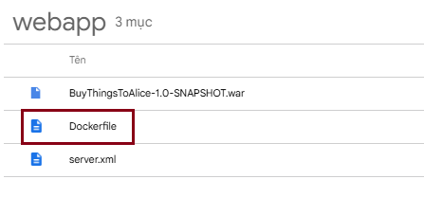
Figure 0-28: Challenge Folder Structure
After preparing the challenge folder, compress it into a .zip file so it can be uploaded to the F-CTF system following the Create Challenge guideline.

3.2.2 Dockerfile Guideline
If the Harden Container option is not enabled, the Dockerfile only needs to ensure that the challenge runs correctly inside the container, and there are no additional security requirements. However, enabling the Harden Container option is recommended to improve the security of the challenge environment.
The following section provides recommended Dockerfile practices for challenges using the Harden Container option, helping authors design containers that comply with these security constraints while maintaining proper functionality.

3.2.2.1 Mandatory Requirements
All challenge Dockerfiles must strictly comply with the following constraints.
Violation of any requirement may cause the container to be rejected or crash when deployed in the Kubernetes environment.
Requirement | Description
USER 1000 | The container must run with UID = 1000. The Dockerfile must end with USER 1000.
Read-only root filesystem | The root filesystem is mounted read-only at runtime. The application must not require write access to the root filesystem.
Write only to /tmp | The container must not write outside /tmp. Writing to /data, /var, /etc, /home, or other directories is not allowed. All temporary storage must use /tmp (mounted as tmpfs).
Logs → stdout/stderr | File-based logging is not allowed. All logs must be written to stdout or stderr so that Kubernetes can collect them.
Single port only | The container must expose and listen on exactly one port, as defined in the challenge specification.
No Linux capabilities | The container must not require additional Linux capabilities. Do not use setcap, privileged mode, or add extra capabilities.
Mandatory runtime test | The container must successfully run with the following command before submission: docker run --read-only --tmpfs /tmp --user 1000 <image>
Table 3: Mandatory Requirements for Dockerfile

3.2.2.2 Dockerfile Design Strategy
- Keep the runtime immutable: everything in the root filesystem must be read-only.
- Use /tmp symlinks for all runtime files that require write access (logs, temp files, working directories).
- Standardize the runtime user by either using a base image with UID 1000 or explicitly creating a user with adduser -u 1000.
- Separate build-time and runtime tasks whenever possible. For example, extract artifacts (WAR/JAR) during the build stage.
- Ensure all necessary files and directories are owned by UID 1000 before switching to the runtime user.
Step | Action
1 | Choose a suitable base image (Alpine is preferred due to its small size).
2 | Create or configure a user with UID 1000.
3 | Install required dependencies during the build stage.
4 | Copy the source code or application artifact into the image.
5 | Create symlinks to /tmp for any directories that require write access at runtime.
6 | Set ownership for the application directory: chown -R 1000:1000.
7 | Switch to the runtime user using USER 1000.
8 | Define the startup command, typically: CMD mkdir -p /tmp/... && exec <server>
Table 4: Steps to write a Dockerfile
Note: A key design pattern is that symlinks must be created during the build stage, when the filesystem is still writable. At runtime, the container should only need to create directories under /tmp, typically using: `mkdir -p /tmp/<target>` inside the CMD or entrypoint before starting the application.

3.2.2.3 Detailed Templates by Workload Type
Each workload type below provides a ready-to-use Dockerfile template. The templates use placeholders in the format <>, simply replace them with your actual values (application name, paths, ports, etc.) before using them. Each template is followed by a fully filled example to illustrate how it should be applied in practice.
How to Use Templates: All fields written as <> are placeholders. Replace them with your actual values before building the image.
Example:
<PORT> => 8080
<APP_USER> => appuser
<SRC_DIR> => ./html

3.2.2.3.1 Static Server - Nginx
By default, Nginx writes logs and PID files outside /tmp, which violates the hardened container constraints. Therefore, the template uses sed to directly modify the existing nginx.conf inside the image, eliminating the need to provide a custom configuration file.
TEMPLATE
FROM nginx:alpine

# [CUSTOMIZABLE] 1. Declare User and Port (can also be overridden via --build-arg)
ARG APP_USER=appuser
ARG PORT=8080

RUN adduser -D -u 1000 $APP_USER

# 2. Remove default configuration
RUN rm -rf /etc/nginx/conf.d/default.conf

# [CUSTOMIZABLE] 3. Create new server configuration
# You may change the root directory or index file here if necessary
RUN echo "server { \
listen ${PORT}; \
location / { \
root /usr/share/nginx/html; \
index index.html; \
try_files \$uri \$uri/ =404; \
} \
}" > /etc/nginx/conf.d/default.conf

# 4. Force Nginx to use /tmp for ALL writable paths
RUN sed -i 's|pid .*|pid /tmp/nginx.pid;|' /etc/nginx/nginx.conf \
&& sed -i 's|access_log .*|access_log /dev/stdout;|' /etc/nginx/nginx.conf \
&& sed -i 's|error_log .*|error_log /dev/stderr;|' /etc/nginx/nginx.conf \
&& sed -i "/http {/a \ client_body_temp_path /tmp/client_temp;\n proxy_temp_path /tmp/proxy_temp;\n fastcgi_temp_path /tmp/fastcgi_temp;\n uwsgi_temp_path /tmp/uwsgi_temp;\n scgi_temp_path /tmp/scgi_temp;" /etc/nginx/nginx.conf \
&& sed -i 's/^user/#user/' /etc/nginx/nginx.conf

# [CUSTOMIZABLE] 5. Copy Source Code into the Image
# Replace <SRC_DIR> with your source directory (e.g., ./dist, ./html, ./public)
COPY <SRC_DIR> /usr/share/nginx/html

# 6. Fix permissions (important: avoid chown /var/run to prevent Kaniko/K8s issues)
RUN chown -R 1000:1000 /usr/share/nginx/html /etc/nginx /var/cache/nginx

USER 1000
EXPOSE ${PORT}

# 7. Startup: create temporary directories inside /tmp
CMD ["sh", "-c", "mkdir -p /tmp/client_temp /tmp/proxy_temp /tmp/fastcgi_temp /tmp/uwsgi_temp /tmp/scgi_temp && exec nginx -g 'daemon off;'"]

EXAMPLE - Static HTML, Port 8080
FROM nginx:alpine

# 1. Create a non-root user (UID 1000)
RUN adduser -D -u 1000 appuser

# 2. Remove the default Nginx configuration
RUN rm -rf /etc/nginx/conf.d/default.conf

# 3. Create a new server configuration
RUN echo 'server { \
listen 8080; \
location / { \
root /usr/share/nginx/html; \
index index.html; \
} \
}' > /etc/nginx/conf.d/default.conf

# 4. Modify the main Nginx configuration to force all writable paths into /tmp
# Add uwsgi and scgi temporary paths as well
RUN sed -i 's|pid .*|pid /tmp/nginx.pid;|' /etc/nginx/nginx.conf \
&& sed -i 's|access_log .*|access_log /dev/stdout;|' /etc/nginx/nginx.conf \
&& sed -i 's|error_log .*|error_log /dev/stderr;|' /etc/nginx/nginx.conf \
&& sed -i '/http {/a \ client_body_temp_path /tmp/client_temp;\n proxy_temp_path /tmp/proxy_temp;\n fastcgi_temp_path /tmp/fastcgi_temp;\n uwsgi_temp_path /tmp/uwsgi_temp;\n scgi_temp_path /tmp/scgi_temp;' /etc/nginx/nginx.conf \
&& sed -i 's/^user/#user/' /etc/nginx/nginx.conf

# 5. Copy application files
COPY ./html /usr/share/nginx/html

# 6. Set permissions (avoid touching /var/run to prevent Kaniko/K8s issues)
RUN chown -R 1000:1000 /usr/share/nginx/html /etc/nginx /var/cache/nginx

# Run container as non-root user
USER 1000

# Expose the application port
EXPOSE 8080

# 7. Startup command:
# Create all required temporary directories in /tmp before launching Nginx
CMD ["sh", "-c", "mkdir -p /tmp/client_temp /tmp/proxy_temp /tmp/fastcgi_temp /tmp/uwsgi_temp /tmp/scgi_temp && exec nginx -g 'daemon off;'"]

3.2.2.3.2 Node.js Backend
TEMPLATE
# Debian slim supports building native modules (e.g., sqlite3)
# <NODE_VER> example: 18
FROM node:<NODE_VER>-bullseye-slim

WORKDIR /app

# Optional build dependencies
RUN apt-get update && \
apt-get install -y python3 build-essential --no-install-recommends && \
rm -rf /var/lib/apt/lists/*

# Install production dependencies
COPY package*.json ./
RUN npm install --production

COPY . .

# Redirect writable paths to /tmp
RUN rm -rf <WRITE_PATH_1> && ln -s /tmp/<TMP_NAME_1> <WRITE_PATH_1> || true
RUN rm -rf <WRITE_PATH_2> && ln -s /tmp/<TMP_NAME_2> <WRITE_PATH_2> || true
RUN rm -f <DB_FILE> && ln -s /tmp/<DB_FILE> <DB_FILE> || true

# Create user 1000
RUN groupadd -g 1000 appgroup || true && \
useradd -r -u 1000 -g appgroup -m -d /home/<APP_USER> -s /usr/sbin/nologin <APP_USER> || true

RUN mkdir -p /tmp/<TMP_NAME_1> /tmp/<TMP_NAME_2> && \
chown -R 1000:1000 /tmp /app

ENV PORT=<PORT>
ENV TMPDIR=/tmp
ENV NODE_ENV=production

EXPOSE <PORT>

USER 1000

CMD ["sh","-c","mkdir -p /tmp/<TMP_NAME_1> /tmp/<TMP_NAME_2> && exec node <ENTRY_FILE>"]

EXAMPLE - Express API, logs and uploads
FROM node:18-bullseye-slim
WORKDIR /app
RUN apt-get update && \
apt-get install -y python3 build-essential --no-install-recommends && \
rm -rf /var/lib/apt/lists/*
COPY package*.json ./
RUN npm install --production
COPY . .
RUN rm -rf /app/uploads && ln -s /tmp/uploads /app/uploads || true
RUN rm -f /app/data.db && ln -s /tmp/data.db /app/data.db || true

RUN groupadd -g 1000 appgroup || true && \
useradd -r -u 1000 -g appgroup -m -d /home/appuser -s /usr/sbin/nologin appuser || true
RUN mkdir -p /tmp/uploads && \
chown -R 1000:1000 /tmp /app

ENV PORT=3000
ENV TMPDIR=/tmp
ENV NODE_ENV=production
EXPOSE 3000
USER 1000
CMD ["sh","-c","mkdir -p /tmp/uploads && exec node server.js"]

3.2.2.3.3 Python - Flask & FastAPI
PYTHONUNBUFFERED=1 is mandatory so logs are immediately flushed to stdout/stderr. Gunicorn and Uvicorn already support stdout logging through CLI flags, so the application code does not need modification.
TEMPLATE - Flask + Gunicorn
FROM python:<PYTHON_VER>-alpine

RUN adduser -D -u 1000 <APP_USER>

WORKDIR /app

COPY requirements.txt .
RUN pip install --no-cache-dir -r requirements.txt

COPY . .

RUN rm -f /app/<DB_FILE> && ln -s /tmp/<DB_FILE> /app/<DB_FILE> || true
RUN rm -rf /app/<WRITE_PATH> && ln -s /tmp/<TMP_NAME> /app/<WRITE_PATH> || true

RUN chown -R 1000:1000 /app

USER 1000

ENV PYTHONUNBUFFERED=1
ENV PYTHONDONTWRITEBYTECODE=1
ENV TMPDIR=/tmp

EXPOSE <PORT>

CMD ["sh","-c","mkdir -p /tmp/<TMP_NAME> && exec gunicorn <MODULE>:<APP_OBJ> --bind 0.0.0.0:<PORT> --workers 2 --access-logfile -"]

TEMPLATE - FastAPI + Uvicorn
FROM python:<PYTHON_VER>-alpine

RUN adduser -D -u 1000 <APP_USER>

WORKDIR /app

COPY requirements.txt .
RUN pip install --no-cache-dir -r requirements.txt

COPY . .

RUN rm -f /app/<DB_FILE> && ln -s /tmp/<DB_FILE> /app/<DB_FILE> || true
RUN rm -rf /app/<WRITE_PATH> && ln -s /tmp/<TMP_NAME> /app/<WRITE_PATH> || true

RUN chown -R 1000:1000 /app

USER 1000

ENV PYTHONUNBUFFERED=1
ENV PYTHONDONTWRITEBYTECODE=1
ENV TMPDIR=/tmp

EXPOSE <PORT>

CMD ["sh","-c","mkdir -p /tmp/<TMP_NAME> && exec uvicorn <MODULE>:<APP_OBJ> --host 0.0.0.0 --port <PORT> --log-level info"]

Example – Flask with Gunicorn, File Uploads and SQLite (Port 5000)
FROM python:3.11-alpine

# Create non-root user (UID 1000)
RUN adduser -D -u 1000 appuser

WORKDIR /app

# Install Python dependencies
COPY requirements.txt .
RUN pip install --no-cache-dir -r requirements.txt

# Copy application source code
COPY . .

# Redirect writable paths to /tmp
RUN rm -f /app/data.db && ln -s /tmp/data.db /app/data.db
RUN rm -rf /app/uploads && ln -s /tmp/uploads /app/uploads

# Ensure application files are owned by user 1000
RUN chown -R 1000:1000 /app

USER 1000

# Environment configuration
ENV PYTHONUNBUFFERED=1
ENV PYTHONDONTWRITEBYTECODE=1
ENV TMPDIR=/tmp

EXPOSE 5000

# Create runtime directories and start the application
CMD ["sh","-c","mkdir -p /tmp/uploads && exec gunicorn app:app --bind 0.0.0.0:5000 --workers 2 --access-logfile -"]

3.2.2.3.4 Java
a, Java Tomcat
TEMPLATE
Tomcat requires three writable directories: logs, work, temp. These directories must be symlinked to /tmp. WAR files should also be extracted during build time to avoid runtime writes.
# <TOMCAT_VER> example: 10.1.40 | <JDK_VER> example: 21
FROM tomcat:<TOMCAT_VER>-jdk<JDK_VER>

# 1. Redirect Tomcat writable directories to /tmp
# (required for environments with a read-only root filesystem)
RUN rm -rf /usr/local/tomcat/logs && ln -s /tmp/tomcat-logs /usr/local/tomcat/logs && \
rm -rf /usr/local/tomcat/work && ln -s /tmp/tomcat-work /usr/local/tomcat/work && \
rm -rf /usr/local/tomcat/temp && ln -s /tmp/tomcat-temp /usr/local/tomcat/temp

# 2. Redirect Catalina localhost config directory
# (needed if the application writes context XML files)
RUN mkdir -p /usr/local/tomcat/conf/Catalina && \
rm -rf /usr/local/tomcat/conf/Catalina/localhost && \
ln -s /tmp/tomcat-conf-localhost /usr/local/tomcat/conf/Catalina/localhost

# 3. Remove default applications and prepare the webapps directory
RUN rm -rf /usr/local/tomcat/webapps/*

# 4. Copy and extract the WAR file during build time
# <APP_NAME>: WAR filename | <CONTEXT>: application context directory (e.g., ROOT or BuyThingsToAlice)
COPY <APP_NAME>.war /tmp/app.war
RUN mkdir -p /usr/local/tomcat/webapps/<CONTEXT> && \
cd /usr/local/tomcat/webapps/<CONTEXT> && \
jar xf /tmp/app.war && \
rm /tmp/app.war

# 5. SQLite configuration: Redirect data directory and extract native library
# Assume the database directory is WEB-INF/data
# <SQLITE_JAR_NAME> example: sqlite-jdbc-3.47.1.0.jar
RUN rm -rf /usr/local/tomcat/webapps/<CONTEXT>/WEB-INF/data && \
ln -s /tmp/app-data /usr/local/tomcat/webapps/<CONTEXT>/WEB-INF/data

RUN set -eux; \
SQLITE_JAR="/usr/local/tomcat/webapps/<CONTEXT>/WEB-INF/lib/<SQLITE_JAR_NAME>"; \
mkdir -p /usr/local/tomcat/sqlite-native; \
arch="$(uname -m)"; \
case "$arch" in \
x86_64|amd64) lib_path="org/sqlite/native/Linux/x86_64/libsqlitejdbc.so" ;; \
aarch64|arm64) lib_path="org/sqlite/native/Linux/aarch64/libsqlitejdbc.so" ;; \
*) echo "Unsupported architecture: $arch"; exit 1 ;; \
esac; \
cd /tmp; \
jar xf "$SQLITE_JAR" "$lib_path"; \
cp "/tmp/$lib_path" /usr/local/tomcat/sqlite-native/libsqlitejdbc.so; \
rm -rf /tmp/org

# 6. Configure server.xml (change port if necessary or copy a custom config)
# RUN sed -i 's/port="8080"/port="<PORT>"/' /usr/local/tomcat/conf/server.xml
# Or: COPY server.xml /usr/local/tomcat/conf/server.xml

# 7. Environment variables
ENV CATALINA_TMPDIR=/tmp/tomcat-temp
ENV CATALINA_OUT=/dev/stdout

# Specify the native library path for SQLite
ENV JAVA_TOOL_OPTIONS="-Dorg.sqlite.lib.path=/usr/local/tomcat/sqlite-native"

# 8. Set permissions for user 1000
RUN chown -R 1000:1000 /usr/local/tomcat
USER 1000

EXPOSE 8080

# 9. Startup: Create required /tmp directories before starting Tomcat
CMD ["sh", "-c", "mkdir -p /tmp/tomcat-temp /tmp/tomcat-work /tmp/tomcat-logs /tmp/tomcat-conf-localhost /tmp/app-data && exec catalina.sh run -Djava.io.tmpdir=/tmp/tomcat-temp -Dcatalina.base=/usr/local/tomcat"]

EXAMPLE - BuyThingsToAlice.war + Sqlite, port 8080
FROM tomcat:10.1.40-jdk21

RUN rm -rf /usr/local/tomcat/logs && ln -s /tmp/tomcat-logs /usr/local/tomcat/logs && \
rm -rf /usr/local/tomcat/work && ln -s /tmp/tomcat-work /usr/local/tomcat/work && \
rm -rf /usr/local/tomcat/temp && ln -s /tmp/tomcat-temp /usr/local/tomcat/temp

RUN rm -rf /usr/local/tomcat/webapps/*

COPY BuyThingsToAlice.war /tmp/app.war
RUN mkdir -p /usr/local/tomcat/webapps/BuyThingsToAlice && \
cd /usr/local/tomcat/webapps/BuyThingsToAlice && \
jar xf /tmp/app.war && \
rm /tmp/app.war && \
rm -rf /usr/local/tomcat/webapps/BuyThingsToAlice/WEB-INF/data && \
ln -s /tmp/app-data /usr/local/tomcat/webapps/BuyThingsToAlice/WEB-INF/data

COPY server.xml /usr/local/tomcat/conf/server.xml

RUN mkdir -p /usr/local/tomcat/conf/Catalina && \
rm -rf /usr/local/tomcat/conf/Catalina/localhost && \
ln -s /tmp/tomcat-conf-localhost /usr/local/tomcat/conf/Catalina/localhost

RUN set -eux; \
SQLITE_JAR="/usr/local/tomcat/webapps/BuyThingsToAlice/WEB-INF/lib/sqlite-jdbc-3.47.1.0.jar"; \
mkdir -p /usr/local/tomcat/sqlite-native; \
arch="$(uname -m)"; \
case "$arch" in \
x86_64|amd64) lib_path="org/sqlite/native/Linux/x86_64/libsqlitejdbc.so" ;; \
aarch64|arm64) lib_path="org/sqlite/native/Linux/aarch64/libsqlitejdbc.so" ;; \
*) echo "Unsupported architecture: $arch"; exit 1 ;; \
esac; \
cd /tmp; \
jar xf "$SQLITE_JAR" "$lib_path"; \
cp "/tmp/$lib_path" /usr/local/tomcat/sqlite-native/libsqlitejdbc.so; \
rm -rf /tmp/org

ENV CATALINA_TMPDIR=/tmp/tomcat-temp
ENV CATALINA_OUT=/dev/stdout
ENV JAVA_TOOL_OPTIONS="-Dorg.sqlite.lib.path=/usr/local/tomcat/sqlite-native"

RUN chown -R 1000:1000 /usr/local/tomcat

USER 1000

EXPOSE 8080

CMD ["sh", "-c", "mkdir -p /tmp/tomcat-temp /tmp/tomcat-work /tmp/tomcat-logs /tmp/tomcat-conf-localhost /tmp/app-data && catalina.sh run -Djava.io.tmpdir=/tmp/tomcat-temp -Dcatalina.base=/usr/local/tomcat"]

b, Spring Boot
Spring Boot applications should use a multi-stage build:
- Build stage: Use Maven to compile the application.
- Runtime stage: Use a lightweight JRE image to run the application.
If the application depends on native libraries (e.g., SQLite JDBC), these libraries should be extracted from the JAR during the build stage and placed into /usr/lib.
This ensures the JVM can load them without needing to write files to the root filesystem at runtime.
TEMPLATE
# ── Build stage ──────────────────────────────────────────
FROM maven:3.9-eclipse-temurin-<JDK_VER> AS build
WORKDIR /build
COPY pom.xml .
COPY src ./src
RUN mvn -q -DskipTests package

# (Optional) Extract native libraries to avoid runtime writes to /tmp
# Example for sqlite-jdbc - adjust version to match pom.xml
RUN mkdir -p /native && \
jar xf target/*.jar BOOT-INF/lib/<NATIVE_LIB>.jar && \
jar xf BOOT-INF/lib/<NATIVE_LIB>.jar org/sqlite/native/Linux/x86_64/libsqlitejdbc.so && \
mv org/sqlite/native/Linux/x86_64/libsqlitejdbc.so /native/libsqlitejdbc.so

# ── Runtime stage ────────────────────────────────────────
# Use Debian-based JRE to avoid musl libc issues with native libraries
FROM eclipse-temurin:<JDK_VER>-jre

WORKDIR /app

# Copy native libraries (optional)
COPY --from=build /native/libsqlitejdbc.so /usr/lib/libsqlitejdbc.so

COPY --from=build /build/target/*.jar /app/app.jar

USER 1000

ENV JAVA_TOOL_OPTIONS="\
-Djava.io.tmpdir=/tmp \
-Dorg.sqlite.lib.path=/usr/lib \
-Dorg.sqlite.lib.name=libsqlitejdbc.so"

EXPOSE <PORT>

CMD ["java", "-jar", "/app/app.jar", "--server.port=<PORT>"]

EXAMPLE - Spring Boot + SQLite, port 8080
# ── Build stage ──────────────────────────────────────────
FROM maven:3.9-eclipse-temurin-17 AS build
WORKDIR /build
COPY pom.xml .
COPY src ./src
RUN mvn -q -DskipTests package

RUN mkdir -p /native && \
jar xf target/*.jar BOOT-INF/lib/sqlite-jdbc-3.49.1.0.jar && \
jar xf BOOT-INF/lib/sqlite-jdbc-3.49.1.0.jar org/sqlite/native/Linux/x86_64/libsqlitejdbc.so && \
mv org/sqlite/native/Linux/x86_64/libsqlitejdbc.so /native/libsqlitejdbc.so

# ── Runtime stage ────────────────────────────────────────
FROM eclipse-temurin:17-jre

WORKDIR /app

COPY --from=build /native/libsqlitejdbc.so /usr/lib/libsqlitejdbc.so
COPY --from=build /build/target/*.jar /app/app.jar

USER 1000

ENV JAVA_TOOL_OPTIONS="\
-Djava.io.tmpdir=/tmp \
-Dorg.sqlite.lib.path=/usr/lib \
-Dorg.sqlite.lib.name=libsqlitejdbc.so"

EXPOSE 8080

CMD ["java", "-jar", "/app/app.jar", "--server.port=8080"]

3.2.2.3.5 .NET (ASP.NET Core)
ASP.NET Core applications should use a multi-stage build:
- Build stage: Use the .NET SDK image to compile and publish the application.
- Runtime stage: Use the lightweight ASP.NET runtime image to run the application.
If the application uses sessions, cookies, or authentication, the DataProtection key storage must be configured to use a writable location (e.g., /tmp), since the root filesystem is read-only in the challenge environment.
TEMPLATE
# ── Stage 1: Build ──────────────────────────────────────
FROM mcr.microsoft.com/dotnet/sdk:<DOTNET_VER>-alpine AS build
WORKDIR /src

COPY *.csproj ./
RUN dotnet restore

COPY . .
RUN dotnet publish -c Release -o /app/publish \
--self-contained false /p:UseAppHost=false

# ── Stage 2: Runtime ─────────────────────────────────────
FROM mcr.microsoft.com/dotnet/aspnet:<DOTNET_VER>-alpine AS runtime

RUN adduser -D -u 1000 <APP_USER>

WORKDIR /app
COPY --from=build /app/publish .

# Redirect writable paths to /tmp
RUN rm -rf <WRITE_PATH_DATA> && ln -s /tmp/<TMP_DATA> <WRITE_PATH_DATA>
RUN rm -rf <WRITE_PATH_UPLOADS> && ln -s /tmp/<TMP_UPLOADS> <WRITE_PATH_UPLOADS> || true
RUN rm -f /app/app.db && ln -s /tmp/app.db /app/app.db || true

RUN mkdir -p /tmp/<TMP_DATA> /tmp/<TMP_UPLOADS> /tmp/dp-keys

RUN chown -R 1000:1000 /app

USER 1000

ENV ASPNETCORE_URLS=http://+:<PORT>
ENV ASPNETCORE_ENVIRONMENT=Production
ENV TMPDIR=/tmp
ENV ASPNETCORE_DataProtection__KeyRingPath=/tmp/dp-keys

EXPOSE <PORT>

ENTRYPOINT ["dotnet","<DLL_NAME>.dll"]

EXAMPLE - ASP.NET 8, SQLite → /app/data, port 5000
FROM mcr.microsoft.com/dotnet/sdk:8.0-alpine AS build
WORKDIR /src

COPY *.csproj ./
RUN dotnet restore

COPY . .
RUN dotnet publish -c Release -o /app/publish \
--self-contained false /p:UseAppHost=false

FROM mcr.microsoft.com/dotnet/aspnet:8.0-alpine

RUN adduser -D -u 1000 dotnetuser

WORKDIR /app
COPY --from=build /app/publish .

RUN rm -rf /app/data && ln -s /tmp/app-data /app/data
RUN rm -rf /app/uploads && ln -s /tmp/app-uploads /app/uploads
RUN rm -f /app/app.db && ln -s /tmp/app.db /app/app.db

RUN mkdir -p /tmp/app-data /tmp/app-uploads /tmp/dp-keys

RUN chown -R 1000:1000 /app
USER 1000

ENV ASPNETCORE_URLS=http://+:5000
ENV ASPNETCORE_ENVIRONMENT=Production
ENV TMPDIR=/tmp
ENV ASPNETCORE_DataProtection__KeyRingPath=/tmp/dp-keys

EXPOSE 5000

ENTRYPOINT ["dotnet","WebApplication2.dll"]

3.2.2.3.6 PHP (Apache)
It is mandatory to modify both: `ports.conf`, `000-default.conf` to use a port greater than 1024 (for example 8080).
This prevents Permission Denied errors when Apache runs as non-root user (UID 1000) in Kubernetes. Adding ServerName localhost also ensures the container starts faster and with cleaner logs.
TEMPLATE
# 1. Base Image: Choose an appropriate PHP version
# <PHP_VER> examples: 8.2, 8.1, 7.4
FROM php:<PHP_VER>-apache

# 2. Install System Packages (Optional)
# Add any libraries required for the challenge (SQLite, GD, Zip, etc.)
RUN apt-get update && apt-get install -y \
libsqlite3-dev sqlite3 \
&& rm -rf /var/lib/apt/lists/*

# 3. Install PHP Extensions (Optional)
# <EXTENSIONS> examples: pdo_sqlite, pdo_mysql, gd
RUN docker-php-ext-install <EXTENSIONS>

# 4. Configure Port & ServerName (Hardening)
# Replace <PORT> with the desired port (usually 8080 to allow non-root execution)
RUN sed -i 's/Listen 80/Listen <PORT>/' /etc/apache2/ports.conf \
&& sed -i 's/:80/:<PORT>/' /etc/apache2/sites-available/000-default.conf \
&& echo "ServerName localhost" >> /etc/apache2/apache2.conf

# 5. Force Apache to use /tmp for runtime writable paths (via environment variables)
ENV APACHE_RUN_DIR=/tmp/apache-run \
APACHE_PID_FILE=/tmp/apache-run/apache2.pid \
APACHE_LOCK_DIR=/tmp/apache-lock \
APACHE_LOG_DIR=/tmp/apache-logs

# 6. Create a non-root user (UID 1000)
RUN groupadd -g 1000 appgroup || true && \
useradd -r -u 1000 -g appgroup -m -d /home/appuser -s /usr/sbin/nologin appuser || true

# 7. Set permissions for Apache directories
# Allow user 1000 to read configs and write temporary logs
RUN chown -R 1000:1000 /var/www/html /etc/apache2 /var/lib/apache2 /var/log/apache2

WORKDIR /var/www/html

# 8. Copy source code
# <SRC_DIR> examples: ./src or .
COPY <SRC_DIR> .

# 9. Ensure all application files belong to user 1000
RUN chown -R 1000:1000 /var/www/html

USER 1000
EXPOSE <PORT>

# 10. Startup command: create required temporary directories under /tmp
# [Optional] Add database initialization if using SQLite
CMD ["sh", "-c", "mkdir -p $APACHE_RUN_DIR $APACHE_LOCK_DIR $APACHE_LOG_DIR /tmp/uploads && touch /tmp/data.db && exec apache2-foreground"]

EXAMPLE - PHP 8.2 + SQLite, Port 8080
FROM php:8.2-apache

# 1. Install dependencies
RUN apt-get update && apt-get install -y \
libsqlite3-dev sqlite3 && rm -rf /var/lib/apt/lists/*

RUN docker-php-ext-install pdo_sqlite

# 2. Configure Port & ServerName
RUN sed -i 's/Listen 80/Listen 8080/' /etc/apache2/ports.conf \
&& sed -i 's/:80/:8080/' /etc/apache2/sites-available/000-default.conf \
&& echo "ServerName localhost" >> /etc/apache2/apache2.conf

# 3. Apache runtime environment variables
ENV APACHE_RUN_DIR=/tmp/apache-run \
APACHE_PID_FILE=/tmp/apache-run/apache2.pid \
APACHE_LOCK_DIR=/tmp/apache-lock \
APACHE_LOG_DIR=/tmp/apache-logs

# 4. Create non-root user
RUN groupadd -g 1000 appgroup || true && \
useradd -r -u 1000 -g appgroup -m -d /home/appuser -s /usr/sbin/nologin appuser || true

# 5. Set permissions (removed /var/lib/php since it does not exist)
RUN chown -R 1000:1000 /var/www/html /etc/apache2 /var/lib/apache2 /var/log/apache2

WORKDIR /var/www/html
COPY . .

# Ensure all web files belong to user 1000
RUN chown -R 1000:1000 /var/www/html

USER 1000
EXPOSE 8080

# 6. Startup command
CMD ["sh","-c", "mkdir -p $APACHE_RUN_DIR $APACHE_LOCK_DIR $APACHE_LOG_DIR /tmp/uploads && touch /tmp/data.db && exec apache2-foreground"]

3.2.2.4 Anti-Patterns & Debugging
Common Anti-Patterns
Anti-Pattern | Correct Approach
Writing files to /app during runtime | Redirect writable paths to /tmp
Running container as root | Use USER 1000
Creating symlinks in CMD | Create them during build (RUN ln -s)
Logging to files | Use stdout or stderr
Using ports <1024 | Use ports such as 8080, 5000, 3000
Table 5: Anti-Pattern for Hardern Dockerfile
Debugging
If the container crashes immediately after startup, check the logs:
docker logs <container_id>
Common causes include missing /tmp directories or permission issues.
For debugging, run the container interactively:
docker run -it --read-only --tmpfs /tmp --user 1000 <image> sh

Quick Local Test
Before uploading a challenge, test the container locally.
docker build -t challenge-x .
docker run --read-only --tmpfs /tmp --user 1000 -p <PORT>:<PORT> challenge-x
Note that passing this test does not guarantee compatibility with the F-CTF platform. The container should also be verified using the Preview feature before submission.

3.3 Guideline for Contestant
Purpose: Guide contestants from login to challenge solving, instance management, and support ticket handling.
High-level flow:
Login -> Browse Challenges -> Open Challenge -> Start Instance -> Access Service with Token -> Submit Flag -> Manage Instances -> Create/Track Tickets

3.4.1 Challenge Workflow
Step 1: Select a Challenge
- Open Challenges page and choose a category (for example: PWN, Web, Crypto).
- Open the target challenge detail
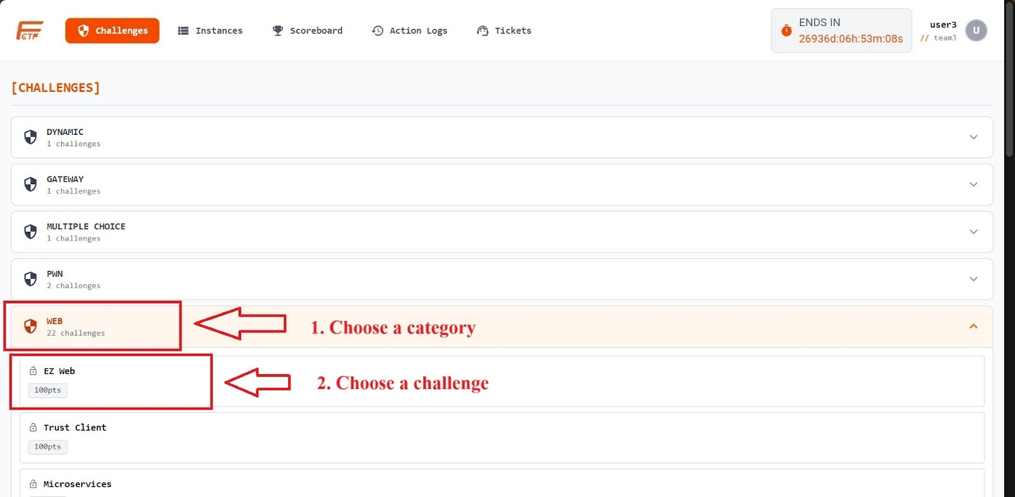
Figure 29 Challenges List for Contestant screen
Step 2: Start challenge instance (for deployable challenges)
Click [+ Start Challenge] to request instance deployment.
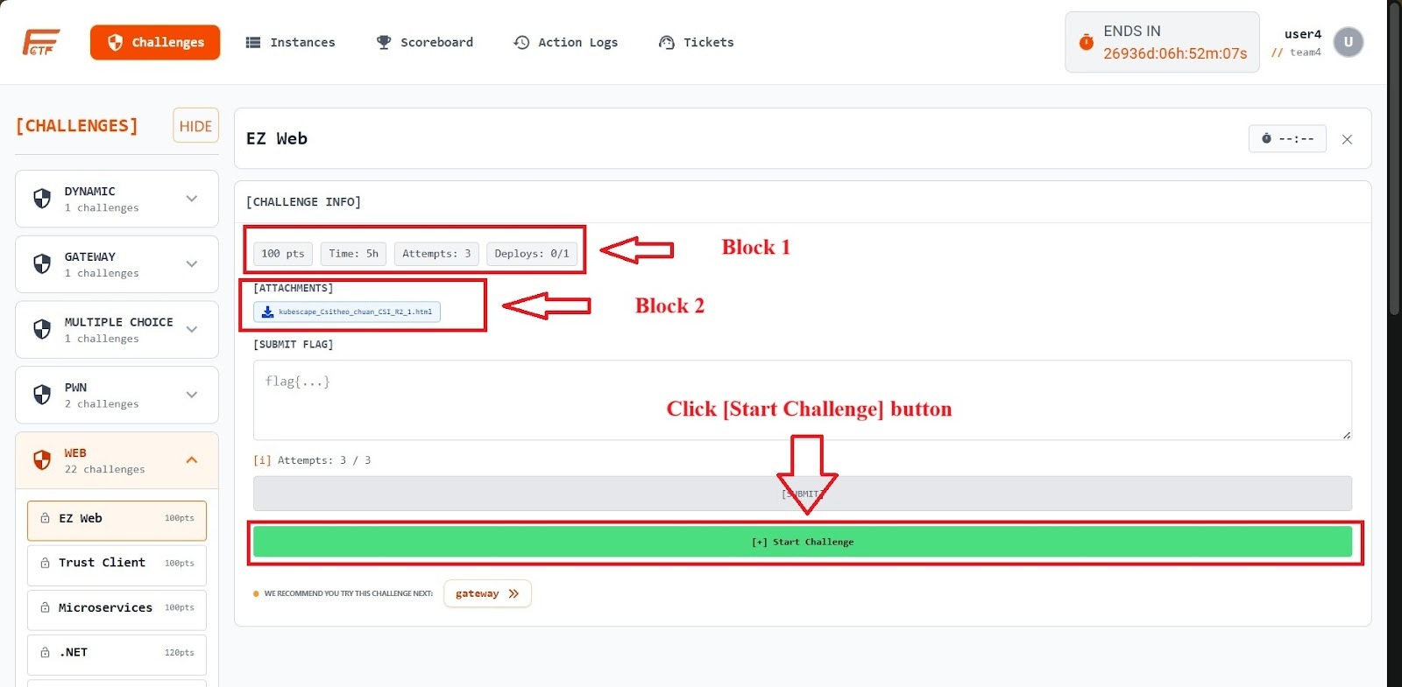
Figure 30: Challenge Detail for Contestant screen
Important information displayed on the challenge card:
Block 1:
- pts: The score awarded for the challenge.
- Time: The time limit to solve the challenge (counted down from when the instance is successfully created).
- Attempts: The maximum number of flag submissions allowed.
- Deploys: Indicates the current number of deployments / maximum allowed deployments.
Example: 0/1 means the contestant has not deployed this challenge yet and can deploy it once.
Block 2 [Attachments]:
- Contains a list of attached files. Contestants can click a file to download it to their local machine.
Step 3: Access challenge instance
After a successful deployment, the system provides an access link or connection details along with a token to access the challenge instance.
a) Access via HTTP
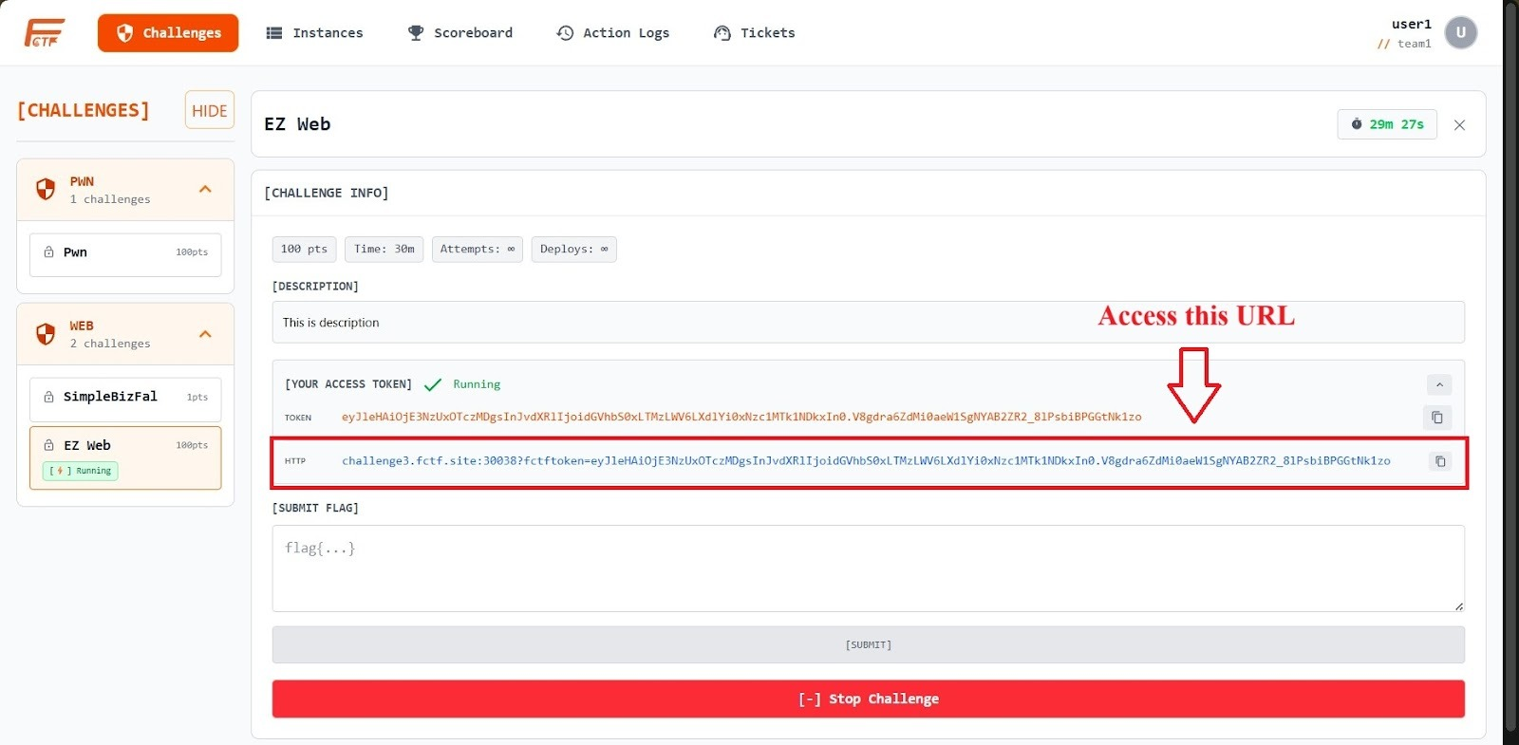
Figure 31: Access challenge instance via HTTP
- Retrieve the token from the [YOUR ACCESS TOKEN] section.
- Access the URL using the following format:
http://<gateway-host>:<http-port>?fctftoken=<YOUR_TOKEN>
b) Access via TCP
- Use a terminal to connect to the TCP gateway
- The system will prompt for a token. Enter the provided token for authentication.
- Once the message “access granted” appears, you can start interacting with the challenge instance.
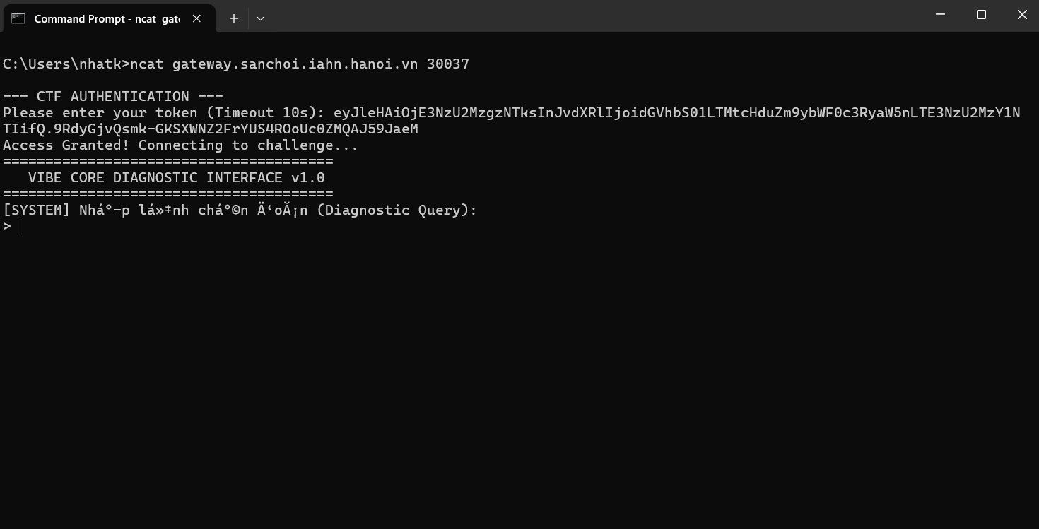
Figure 32: Access instance via TCP

3.4.2 Instance Management
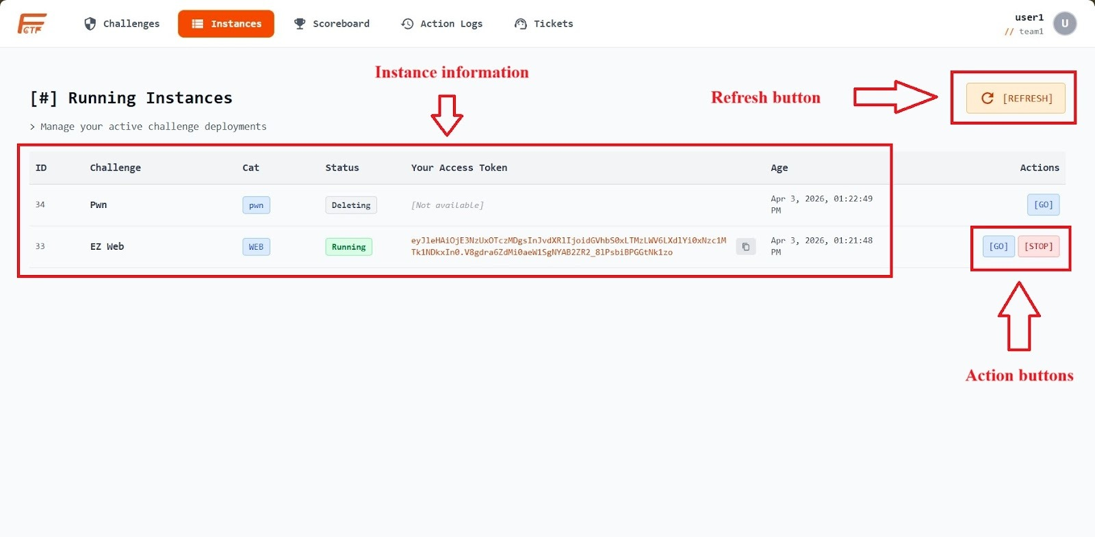
Figure 33: Challenge Instances screen
- How to access: Click the [Instances] section in the menu/sidebar. The screen will display a table of all instances with statuses such as Running, Pending, or Deleting.
- Table information includes: Challenge Name, Category, Access Token, Current Status, and Instance Expiration Time.
- Available actions:
- [GO]: return to challenge detail.
- [STOP]: terminate instance with confirmation.
- [REFRESH]: reload latest status.

3.4.3 Ticket Management
Step 1: View Ticket List
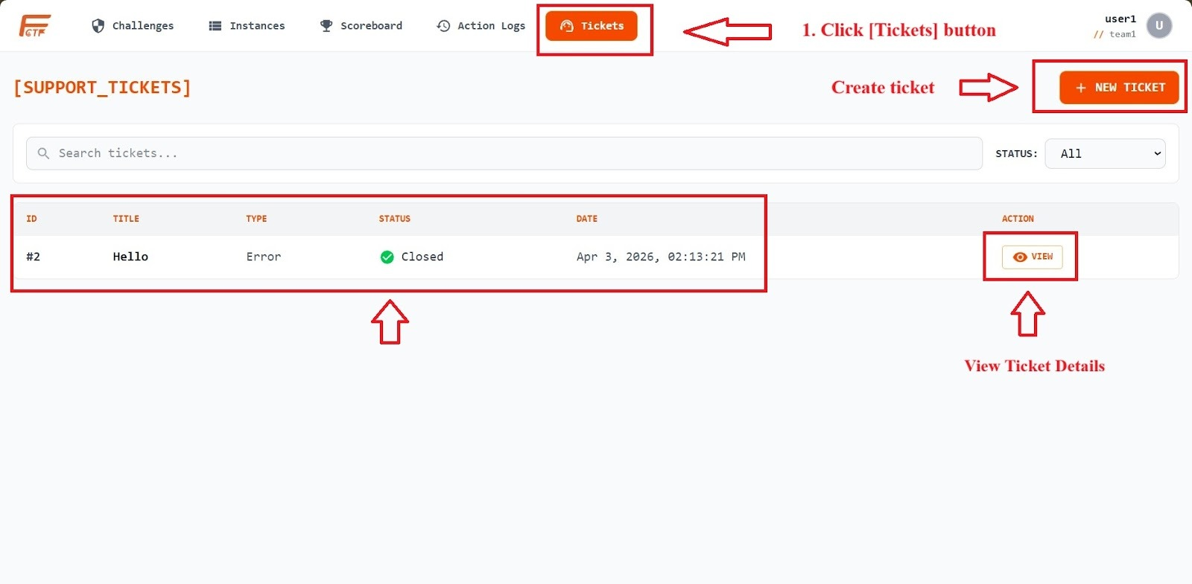
Figure 34: Tickets List screen
- Select the Tickets section from the menu.
- Review reported issues in the table, including ID, Title, Type, Date, Status: Open (in progress) or Closed (resolved).
Step 2: Create a New Ticket
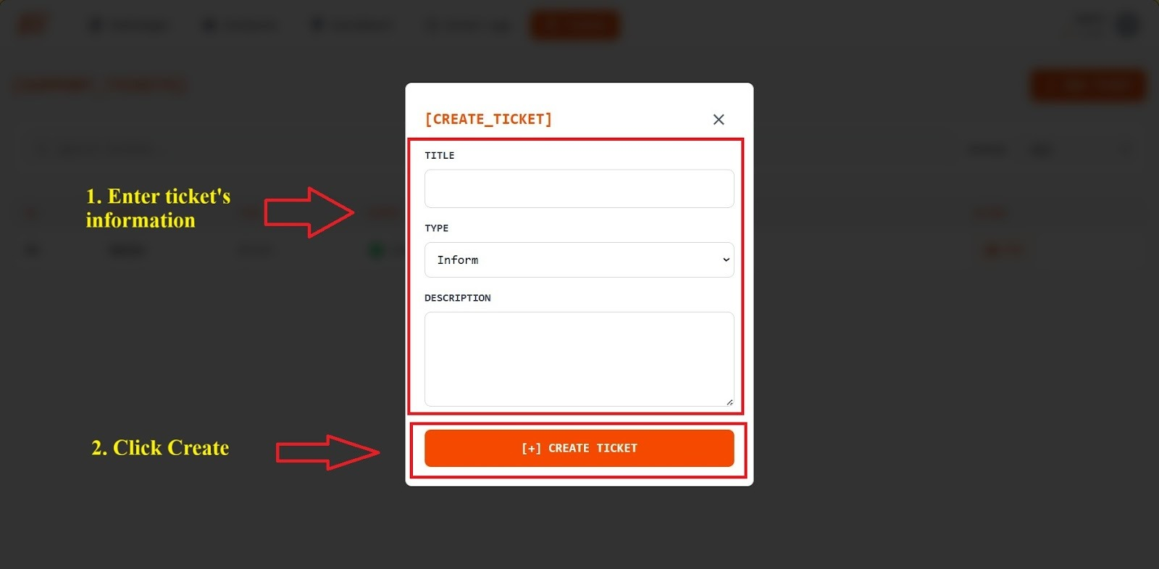
Figure 35: Create new Ticket dialog
To submit a new support request, click [+ NEW TICKET].
Fill in the form fields:
- Title: Provide a concise title that reflects the main issue.
- Type: Select the ticket category (e.g., Question – inquiry, Error – system/technical issue, Inform – urgent notification).
- Description: Provide detailed information about the issue.
Step 3: View Ticket Details / Track Responses
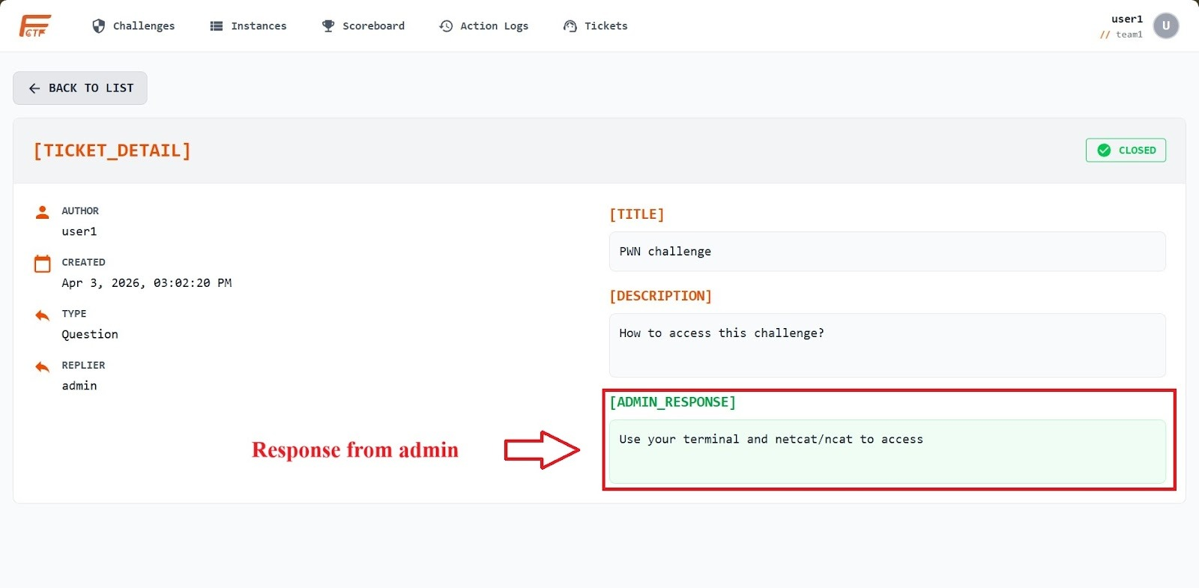
Figure 36: Ticket Details screen
- In the ticket list, click [VIEW] next to the desired ticket.
- On the Ticket Detail page, you can review all content (Title, Description) and responses from the Admin (if any).

