Question 5.9
Which CRUD operation corresponds to the HTTP GET method?
A. read
B. update
C. create
D. delete
Answer: A
Question 5.10
With REST API, which standard HTTP header tells a server which media type is expected by the client?
A. Accept-Encoding: gzip, deflate
B. Accept-Patch: text/example; charset=utf-8
C. Content-Type: application/json; charset=utf-8
D. Accept: application/json
Answer: D
Question 5.21
Which network plane is centralized and manages routing decisions?
A. policy plane
B. control plane
C. management plane
D. data plane
Answer: B
Question 5.34
Refer to the exhibit.
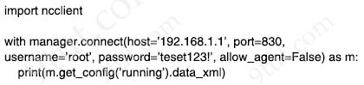
After running the code in the exhibit, which step reduces the amount of data that the NETCONF server returns to the NETCONF client, to only the interface’s configuration?
A. Use the xml library to parse the data returned by the NETCONF server for the interface’s configuration.
B. Create an XML filter as a string and pass it to get_config() method as an argument.
C. Create a JSON filter as a string and pass it to the get_config() method as an argument.
D. Use the JSON library to parse the data returned by the NETCONF server for the interface’s configuration.
Answer: B
Question 5.35
What are two functions of an SDN controller? (Choose two)
A. coordinating VTNs
B. Layer 2 forwarding
C. tracking hosts
D. managing the topology
E. protecting against DDoS attacks
Answer: A D
Question 5.45
What is the purpose of a southbound API in a control based networking architecture?
A. facilities communication between the controller and the applications
B. integrates a controller with other automation and orchestration tools
C. allows application developers to interact with the network
D. facilities communication between the controller and the networking hardware
Answer: D
Question 5.48
Which technology is appropriate for communication between an SDN controller and applications running over the network?
A. OpenFlow
B. Southbound API
C. NETCONF
D. REST API
Answer: D
Question 5.51
Which network action occurs within the data plane?
A. compare the destination IP address to the IP routing table
B. make a configuration change from an incoming NETCONF RPC
C. run routing protocols (OSPF, EIGRP, RIP, BGP)
D. reply to an incoming ICMP echo request
Answer: A
Question 6.1
What are two improvements provided by automation for network management in an SDN environment? (Choose two)
A. Artificial intelligence identifies and prevents potential design failures
B. Data collection and analysis tools establish a baseline for the network
C. New devices are onboarded with minimal effort
D. Machine learning minimizes the overall error rate when automating troubleshooting processes
E. Proprietary Cisco APIs leverage multiple network management tools
Answer: A E
Question 6.5
Which networking function occurs on the data plane?
A. facilitates spanning-tree elections
B. processing inbound SSH management traffic
C. forwarding remote client/server traffic
D. sending and receiving OSPF Hello packets
Answer: C
Question 6.6
What does an SDN controller use as a communication protocol to relay forwarding changes to a southbound API?
A. XML
B. Java
C. REST
D. OpenFlow
Answer: D
Question 6.25
Which JSON data type is an unordered set of attribute-value pairs?
A. array
B. string
C. object
D. Boolean
Answer: C
Question 7.4
Which HTTP status code is returned after a successful REST API request?
A. 200
B. 301
C. 404
D. 500
Answer: A
Question 7.8
What is the function of a controller in controller-based networking?
A. It is a pair of core routers that maintain all routing decisions for a campus
B. It centralizes the data plane for the network
C. It is the card on a core router that maintains all routing decisions for a campus
D. It serves as the centralized management point of an SDN architecture
Answer: D
Question 7.16
What is a function of the Cisco DNA Center Overall Health Dashboard?
A. It summarizes daily and weekly CPU usage for servers and workstations in the network.
B. It provides detailed activity logging for the 10 devices and users on the network.
C. It summarizes the operational status of each wireless device on the network.
D. It provides a summary of the top 10 global issues.
Answer: D
Question 7.18
Where is the interface between the control plane and data plane within the software-defined architecture?
A. application layer and the management layer
B. application layer and the infrastructure layer
C. control layer and the application layer
D. control layer and the infrastructure layer
Answer: D
Question 7.25
Drag and drop the statement about networking from the left into the corresponding networking types on the right. Not all statements are used.
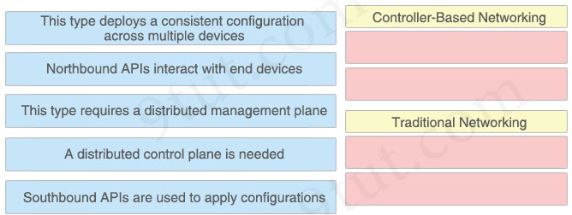
Answer:
Controller-Based Networking:
+ This type deploys a consistent configuration across multiple devices
+ Southbound APIs are used to apply configurations
Traditional Networking:
+ This type requires a distributed management plane
+ A distributed control plane is needed
Question 7.27
Which two components are needed to create an Ansible script that configures a VLAN on a switch? (Choose two)
A. task
B. cookbook
C. recipe
D. model
E. playbook
Answer: A E
Question 7.29
In software-defined architecture, which place handles switching for traffic through a Cisco router?
A. Data
B. Control
C. Management
D. Application
Answer: A
Question 7.37
Which two primary drivers support the need for network automation? (Choose two)
A. Increasing reliance on self-diagnostic and self-healing
B. Eliminating training needs
C. Policy-derived provisioning of resources
D. Reducing hardware footprint
E. Providing a single entry point for resource provisioning
Answer: C E
Question 7.46
Which two events occur automatically when a device is added to Cisco DNA Center? (Choose two)
A. The device is assigned to the Global site.
B. The device is placed into the Unmanaged state.
C. The device is placed into the Provisioned state.
D. The device is placed into the Managed state.
E. The device is assigned to the Local site.
Answer: A D
Question 7.50
Which plane is centralized by an SDN controller?
A. data plane
B. management plane
C. control plane
D. services plane
Answer: C
Question 8.1
Which communication interaction takes place when a southbound API is used?
A. between the SDN controller and PCs on the network
B. between the SDN controller and switches and routers on the network
C. between the SDN controller and services and applications on the network
D. between network applications and switches and routers on the network
Answer: B
Question 8.25
Drag the descriptions of device management from the left onto the types of device management on the right.
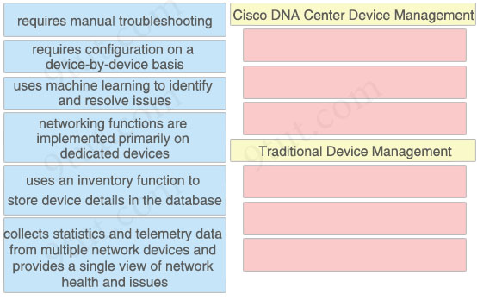
Answer:
Cisco DNA Center Device Management:
+ uses machine learning to identify and resolve issues
+ uses an inventory function to store device details in the database
+ collects statistics and telemetry data from multiple network devices and provides a single view of network health and issues
Traditional Device Management:
+ requires manual troubleshooting
+ requires configuration on a device-by-device basis
+ networking functions are implemented primarily on dedicated devices
Question 8.32
Which type of API allows SDN controllers to dynamically make changes to the network?
A. northbound API
B. southbound API
C. SOAP API
D. REST API
Answer: B
Question 8.63
What is the function of the controller in a software-defined network?
A. forwarding packets
B. making routing decisions
C. multicast replication at the hardware level
D. fragmenting and reassembling packets
Answer: B
Question 8.81
Drag and drop the statements about networking from the left onto the corresponding networking types on the right.
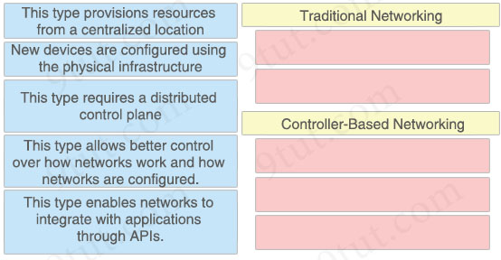
Answer:
Traditional Networking
+ New devices are configured using the physical infrastructure
+ This type requires a distributed control plane
Controller-Based Networking
+ This type provisions resources from a centralized location
+ This type allows better control over how networks work and how networks are configured
+ This type enables networks to integrate with applications through APIs.
Question 9.9
Which action is taken by the data plane within a network device?
A. looks up an egress interface in the forwarding information base
B. constructs a routing table based on a routing protocol
C. provides CLI access to the network device
D. forwards traffic to the next hop
Answer: D
Question 9.20
Which two network actions occur within the data plane? (Choose two)
A. Add or remove an 802.1Q trunking header.
B. Make a configuration change from an incoming NETCONF RPC.
C. Run routing protocols.
D. Reply to an incoming ICMP echo request.
E. Match the destination MAC address to the MAC address table.
Answer: A E
Question 9.53
What is an expected outcome when network management automation is deployed?
A. A distributed management plane must be used.
B. Software upgrades are performed from a central controller
C. Complexity increases when new device configurations are added
D. Custom applications are needed to configure network devices
Answer: B
Question 9.58
Drag and drop the statements about device management from the left onto the corresponding device-management types on the right.
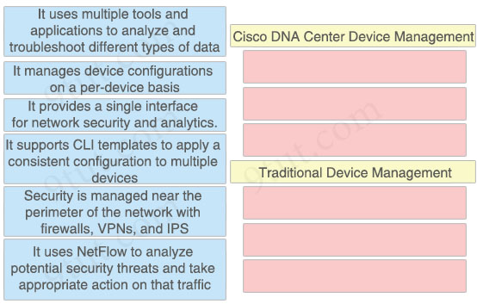
Answer:
Cisco DNA Center Device Management:
+ It provides a single interface for network security and analytics
+ It supports CLI templates to apply a consistent configuration to multiple devices
+ It uses NetFlow to analyze potential security threats and take appropriate action on that traffic
Traditional Device Management:
+ It uses multiple tools and applications to analyze and troubleshoot different types of data
+ It manages device configurations on a per-device basis
+ Security is managed near the perimeter of the network with firewalls, VPNs, and IPS
Question 9.68
What is the role of disaggregation in controller-based networking?
A. It divides the control-plane and data-plane functions.
B. It summarizes the routes between the core and distribution layers of the network topology.
C. It enables a network topology to quickly adjust from a ring network to a star network
D. It streamlines traffic handling by assigning individual devices to perform either Layer 2 or Layer 3 functions.
Answer: A
Question 9.69
Which REST method updates an object in the Cisco DNA Center Intent API?
A. CHANGE
B. UPDATE
C. POST
D. PUT
Answer: D
Question 9.73
What is the function of “off-the-shelf” switches in a controller-based network?
A. Forwarding packets
B. Making routing decision
C. Providing a central view of the deployed network
D. Setting packet-handling policies
Answer: A
Question 9.81
Refer to the exhibit.
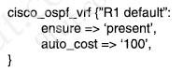
Which type of configuration is represented in the output?
A. Chef
B. JSON
C. Ansible
D. Puppet
Answer: D
Question 9.83
Drag and drop the statements about networking from the left onto the corresponding networking types on the right.
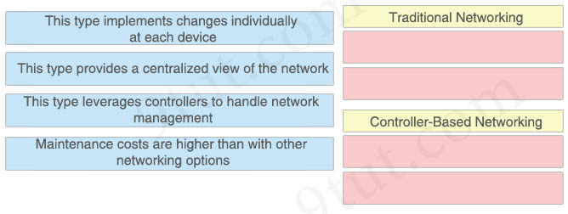
Answer:
Traditional Networking
+ This type implements changes individually at each device.
+ Maintenance costs are higher than with other networking options.
Controller-Based Networking
+ This type provides a centralized view of the network.
+ This type leverages controllers to handle network management.
Question 9.84
Refer to the exhibit.
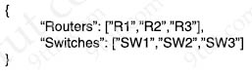
What is represented by “R1” and “SW1” within the JSON output?
A. array
B. object
C. value
D. key
Answer: C
Question 9.94
In an SDN architecture, which function of a network node is centralized on a controller?
A. provides protocol access for remote access devices
B. discards a message due filtering
C. creates the IP routing table
D. makes a routing decision
Answer: D
Question 9.96
Which SDN plane forwards user-generated traffic?
A. policy plane
B. management plane
C. data plane
D. control plane
Answer: C
Question 10.2
Drag and drop the HTTP methods used with REST-Based APIs from the left onto the descriptions on the right.
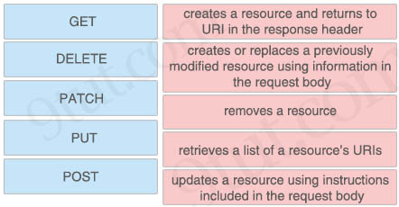
Answer:
+ creates a resource and returns to URI in the response header: POST
+ creates or replaces a previously modified resource using information in the request body: PUT
+ removes a resource: DELETE
+ retrieves a list of a resource’s URIs: GET
+ updates a resource using instructions included in the request body: PATCH
Question 10.15
What is the purpose of the Cisco DNA Center controller?
A. to securely manage and deploy network devices
B. to scan a network and generate a layer 2 network diagram
C. to provide Layer 3 services to autonomous access points
D. to secure physical access to a data center
Answer: A
Question 10.23
Which two REST API status-code classes represent errors? (Choose two)
A. 1XX
B. 2XX
C. 3XX
D. 4XX
E. 5XX
Answer: D E
Question 10.28
What differentiates device management enabled by Cisco DNA Center from traditional campus device management?
A. CLI-oriented device
B. centralized
C. per-device
D. device-by-device hands-on
Answer: B
Question 10.37
Refer to the exhibit.
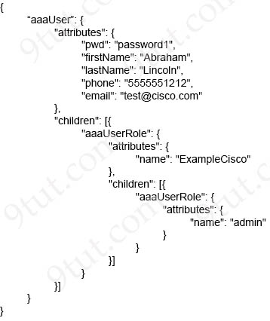
How many objects are present in the given JSON-encoded data?
A. one
B. four
C. seven
D. nine
Answer: D
Question 10.55
Drag and drop the Ansible features from the left to the right. Not all features are used.
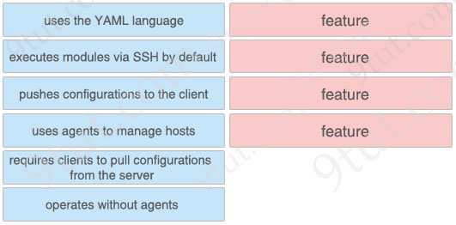
Answer:
uses the YAML language
executes modules via SSH by default
pushes configurations to the client
operates without agents
Question 10.75
Refer to the exhibit.
{
"myCar": {
"name": "thunder",
"wheels": ["good", "good", "pressureLow", "warning"],
"gasLight": false
},
"oldCar": {
"name": "sleepy",
"wheels": ["pressureLow", "pressureLow", "pressureLow", "pressureLow"],
"color": "rust"
"gasLight": true
},
"newCar": {
"name": "lightning",
"wheels": ["pressureLow", "good", "pressureLow", "good"],
"color": "blue"
"gasLight": true
}
}

In which structure does the word “warning” directly reside?
A. array
B. object
C. Boolean
D. string
Answer: A
Question 10.80
A network architect is considering whether to implement Cisco DNA Center to deploy devices on a new network. The organization is focused on reducing the time it currently takes to deploy devices in a traditional campus design. For which reason would Cisco DNA Center be more appropriate than traditional management options?
A. Cisco DNA Center provides zero-touch provisioning to third-party devices.
B. Cisco DNA Center supports deployment with a single pane of glass.
C. Cisco DNA Center minimizes the level of syslog output when reporting on Cisco devices.
D. Cisco DNA Center reduces the need for analytics on third-party access points and devices.
Answer: B
Question 10.83
Which interface type enables an application running on a client to send data over an IP network to a server?
A. southbound interface
B. application programming interface
C. northbound interface
D. Representational State Transfer application programming interface
Answer: B
Question 10.88
Which script paradigm does Puppet use?
A. manifests and modules
B. strings and marionettes
C. recipes and cookbooks
D. playbooks and roles
Answer: A

