Question 5.1
Which two QoS tools are used to guarantee minimum bandwidth to certain traffic? (Choose two)
A. FIFO
B. CBWFQ
C. LLC
D. WFQ
E. RSVP
Answer: B D
Question 5.2
Drag and drop the SNMP manager and agent identifier commands from the left onto the functions on the right.
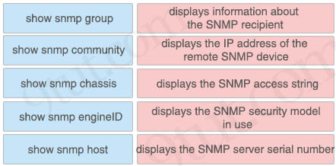
Answer:
+ show snmp group: displays the SNMP security model in use
+ show snmp community: displays the SNMP access string
+ show snmp chassis: displays the SNMP server serial number
+ show snmp engineID: displays the IP address of the remote SNMP device
+ show snmp host: displays information about the SNMP recipient
Question 5.14
A network administrator must enable DHCP services between two sites. What must be configured for the router to pass DHCPDISCOVER messages on to the server?
A. a DHCP Relay Agent
B. DHCP Binding
C. a DHCP Pool
D. DHCP Snooping
Answer: A
Question 5.22
What does a router do when configured with the default DNS lookup settings, and a URL is entered on the CLI?
A. initiates a ping request to the URL
B. prompts the user to specify the desired IP address
C. continuously attempts to resolve the URL until the command is cancelled
D. sends a broadcast message in an attempt to resolve the URL
Answer: D
Question 5.25
Refer to exhibit.
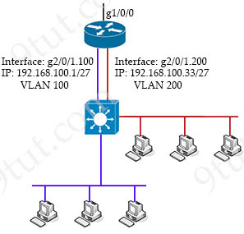
Which configuration must be applied to the router that configures PAT to translate all addresses in VLAN 200 while allowing devices on VLAN 100 to use their own IP addresses?
Option A  Router1(config)#access-list 99 permit 209.165.201.2 0.0.0.0  Router1(config)#ip nat inside source list 99 interface gi1/0/0 overload  Router1(config)#interface gi2/0/1.200  Router1(config)#ip nat inside  Router1(config)#interface gi1/0/0  Router1(config)#ip nat outside | Option B  Router1(config)#access-list 99 permit 209.165.201.2 255.255.255.255  Router1(config)#ip nat inside source list 99 interface gi1/0/0 overload  Router1(config)#interface gi2/0/1.200  Router1(config)#ip nat inside  Router1(config)#interface gi1/0/0  Router1(config)#ip nat outside
Option C  Router1(config)#access-list 99 permit 192.168.100.0 0.0.0.255  Router1(config)#ip nat inside source list 99 interface gi1/0/0 overload  Router1(config)#interface gi2/0/1.200  Router1(config)#ip nat inside  Router1(config)#interface gi1/0/0  Router1(config)#ip nat outside | Option D  Router1(config)#access-list 99 permit 192.168.100.32 0.0.0.31  Router1(config)#ip nat inside source list 99 interface gi1/0/0 overload  Router1(config)#interface gi2/0/1.200  Router1(config)#ip nat inside  Router1(config)#interface gi1/0/0  Router1(config)#ip nat outside
A. Option A
B. Option B
C. Option C
D. Option D
Answer: D
Question 5.28
Which protocol does an IPv4 host use to obtain a dynamically assigned IP address?
A. ARP
B. DNS
C. CDP
D. DHCP
Answer: D
Question 5.30
Which condition must be met before an NMS handles an SNMP trap from an agent?
A. The NMS must be configured on the same router as the SNMP agent
B. The NMS must receive a trap and an inform message from the SNMP agent within a configured interval
C. The NMS software must be loaded with the MIB associated with the trap
D. The NMS must receive the same trap from two different SNMP agents to verify that it is reliable
Answer: C
Question 5.38
Refer to the exhibit.
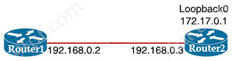
The ntp server 192.168.0.3 command has been configured on Router1 to make it an NTP client of router 2. Which command must be configured on Router2 so that it operates in server-only mode and relies only on its internal clock?
A. Router2(config)#ntp passive
B. Router2(config)#ntp master 4
C. Router2(config)#ntp server 172.17.0.1
D. Router2(config)#ntp server 192.168.0.2
Answer: B
Question 5.41
When DHCP is configured on a router, which command must be entered so the default gateway is automatically distributed?
A. default-router
B. default-gateway
C. ip helper-address
D. dns-server
Answer: A
Question 6.13
When deploying syslog, which severity level logs informational message?
A. 0
B. 2
C. 4
D. 6
Answer: D
Syslog levels are listed below
Level | Keyword | Description
0 | emergencies | System is unusable
1 | alerts | Immediate action is needed
2 | critical | Critical conditions exist
3 | errors | Error conditions exist
4 | warnings | Warning conditions exist
5 | notification | Normal, but significant, conditions exist
6 | informational | Informational messages
7 | debugging | Debugging messages
The highest level is level 0 (emergencies). The lowest level is level 7. By default, the router will send informational messages (level 6). That means it will send all the syslog messages from level 0 to 6.
Question 6.23
Which two QoS tools provides congestion management? (Choose two)
A. FRTS
B. CAR
C. PQ
D. PBR
E. CBWFQ
Answer: C E
Question 6.28
An engineering team asks an implementer to configure syslog for warning conditions and error conditions. Which command does the implementer configure to achieve the desired result?
A. logging trap 2
B. logging trap 3
C. logging trap 4
D. logging trap 5
Answer: C
Question 7.1
Which level of severity must be set to get informational syslogs?
A. alert
B. critical
C. notice
D. debug
Answer: D
Question 7.3
A network analyst is tasked with configured the date and time on a router using EXEC mode. The date must be set to 12:00am. Which command should be used?
A. Clock timezone
B. Clock summer-time-recurring
C. Clock summer-time date
D. Clock set
Answer: D
Question 7.7
Drag and drop the functions of DHCP from the left onto any of the positions on the right. Not all functions are used.
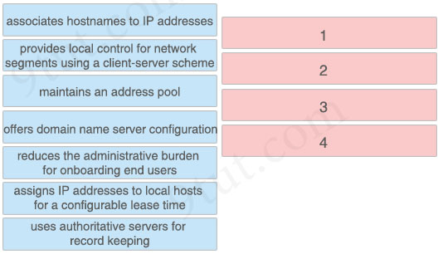
Answer:
1 – maintains an address pool
2 – offers domain name server configuration
3 – reduces the administrative burden for onboarding end users
4 – assigns IP addresses to local hosts for a configurable lease time
Question 7.17
Which protocol requires authentication to transfer a backup configuration file from a router to a remote server?
A. TFTP
B. FTP
C. DTP
D. SMTP
Answer: B
Question 7.31
When a client and server are not on the same physical network, which device is used to forward requests and replies between client and server for DHCP?
A. DHCP relay agent
B. DHCP server
C. DHCPDISCOVER
D. DHCPOFFER
Answer: A
Question 7.34
Which QoS tool can you use to optimize voice traffic on a network that is primarily intended for data traffic?
A. WRED
B. FIFO
C. PQ
D.WFQ
Answer: C
Question 7.35
On workstations running Microsoft Windows, which protocol provides the default gateway for the device?
A. STP
B. DNS
C. SNMP
D. DHCP
Answer: D
Question 7.41
Drag and drop the DNS lookup components from the left onto the functions on the right.
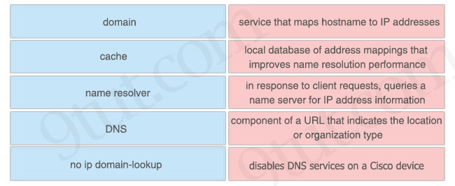
Answer:
+ service that maps hostname to IP addresses: DNS
+ local database of address mappings that improves name resolution performance: cache
+ in response to client requests, queries a name server for IP address information: name resolver
+ component of a URL that indicates the location or organization type: domain
+ disables DNS services on a Cisco device: no ip domain-lookup
Question 7.45
How does QoS optimize voice traffic?
A. reducing bandwidth usage
B. by reducing packet loss
C. by differentiating voice and video traffic
D. by increasing jitter
Answer: C
Question 8.11
In QoS, which prioritization method is appropriate for interactive voice and video?
A. expedited forwarding
B. traffic policing
C. round-robin scheduling
D. low-latency queuing
Answer: D
Question 8.12
An engineer is configuring data and voice services to pass through the same port. The designated switch interface fastethernet0/1 must transmit packets using the same priority for data when they are received from the access port of the IP phone. Which configuration must be used?
A. interface fastethernet0/1
switchport priority extend cos 7
B. interface fastethernet0/1
switchport voice vlan untagged
C. interface fastethernet0/1
switchport voice vlan dot1p
D. interface fastethernet0/1
switchport priority extend trust
Answer: D
Question 8.14
What is a syslog facility?
A. host that is configured for the system to send log messages
B. password that authenticates a Network Management System to receive log messages
C. group of log messages associated with the configured severity level
D. set of values that represent the processes that can generate a log message
Answer: D
Question 8.18
What is a capability of FTP in network management operations?
A. uses separate control and data connections to move files between server and client
B. devices are directly connected and use UDP to pass file information
C. encrypts data before sending between data resources
D. offers proprietary support at the session layer when transferring data
Answer: A
Question 8.33
What is a DNS lookup operation?
A. serves requests over destination port 53
B. DNS server pings the destination to verify that it is available
C. DNS server forwards the client to an alternate IP address when the primary IP is down
D. responds to a request for IP address to domain name resolution to the DNS server
Answer: A
Question 8.36
Refer to the exhibit.
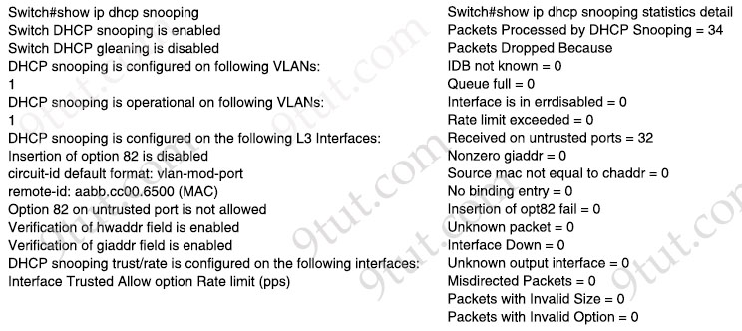
The DHCP server and clients are connected to the same switch. What is the next step to complete the DHCP configuration to allow clients on VLAN 1 to receive addresses from the DHCP server?
A. Configure the ip dhcp snooping trust command on the interface that is connected to the DHCP server
B. Configure the ip dhcp relay information option command on the interface that is connected to the DHCP server
C. Configure the ip dhcp relay information option command on the interface that is connected to the DHCP client
D. Configure the ip dhcp snooping trust command on the interface that is connected to the DHCP client
Answer: A
Question 8.38
A network administrator is setting up a new IPv6 network using the 64-bit address 2001:0EB8:00C1:2200:0001:0000:0000:0331/64. To simplify the configuration, the administrator has decided to compress the address. Which IP address must the administrator configure?
A. ipv6 address 2001:EB8:C1:2200:1:0000:331/64
B. ipv6 address 21:EB8:C1:2200:1::331/64
C. ipv6 address 2001:EB8:C1:22:1::331/64
D. ipv6 address 2001:EB8:C1:2200:1::331/64
Answer: D
Question 8.42
Refer to the exhibit.
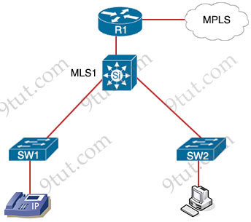
Which plan must be implemented to ensure optimal QoS marking practices on this network?
A. As traffic enters from the access layer on SW1 and SW2, trust all traffic markings
B. Trust the IP phone markings on SW1 and mark traffic entering SW2 at SW2
C. As traffic traverses MLS1 remark the traffic, but trust all markings at the access layer
D. Remark traffic as it traverses R1 and trust all markings at the access layer
Answer: B
Question 8.44
Refer to the exhibit.

interface FastEthernet0/10
description WAN_INTERFACE
ip address 10.0.1.2 255.255.255.252
ip access-group 100 in
!
interface FastEthernet0/1
description LAN INTERFACE
ip address 10.148.2.1 255.255.255.0
duplex auto
speed auto
!
ip forward-protocol nd
!
access-list 100 permit eigrp any any
access-list 100 permit icmp any any
access-list 100 permit tcp 10.149.3.0 0.0.0.255 host 10.0.1.2 eq 22
access-list 100 permit tcp any any eq 80
access-list 100 permit tcp any any eq 443
access-list 100 deny ip any any log
Which configuration enables DHCP addressing for hosts connected to interface FastEthernet0/1 on router R4?
A. interface FastEthernet0/1
ip helper-address 10.0.1.1
!
access-list 100 permit tcp host 10.0.1.1 eq 67 host 10.148.2.1
B. interface FastEthernet0/0
ip helper-address 10.0.1.1
!
access-list 100 permit host 10.0.1.1 host 10.148.2.1 eq bootps
C. interface FastEthernet0/0
ip helper-address 10.0.1.1
!
access-list 100 permit udp host 10.0.1.1 eq bootps host 10.148.2.1
D. interface FastEthernet0/1
ip helper-address 10.0.1.1
!
access-list 100 permit udp host 10.0.1.1 eq bootps host 10.148.2.1
Answer: D
Question 8.74
Refer to the exhibit.
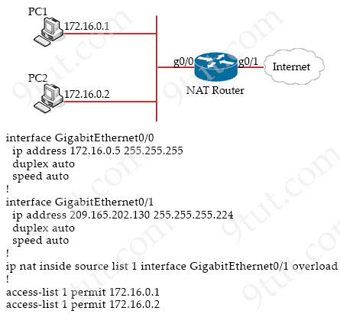
How should the configuration be updated to allow PC1 and PC2 access to the Internet?
A. Modify the configured number of the second access list
B. Remove the overload keyword from the ip nat inside source command
C. Add either the ip nat {inside|outside} command under both interfaces
D. Change the ip nat inside source command to use interface GtgabitEthernet0/0
Answer: C
Question 8.79
What is the purpose of the ip address dhcp command?
A. to configure an interface as a DHCP server
B. to configure an interface as a DHCP relay
C. to configure an interface as a DHCP helper
D. to configure an interface as a DHCP client
Answer: D
Question 8.82
A network engineer is installing an IPv6-only capable device. The client has requested that the device IP address be reachable only from the internal network. Which type of IPv6 address must the engineer assign?
A. unique local address
B. link-local address
C. IPv4-compatibie IPv6 address
D. aggregatable global address
Answer: A
Question 9.10
R1 as an NTP server must have:
* NTP authentication enabled
* NTP packets sourced from Interface loopback 0
* NTP stratum 2
* NTP packets only permitted to client IP 209.165.200.225
How should R1 be configured?
Option A  ntp authenticate  ntp authentication-key 2 sha1 CISCO123  ntp source Loopback0  ntp access-group server-only 10  ntp master 2  !  access-list 10 permit udp host 209.165.200.225 any eq 123 | Option B  ntp authenticate  ntp authentication-key 2 md5 CISCO123  ntp source Loopback0  ntp access-group server-only 10  ntp stratum 2  !  access-list 10 permit udp host 209.165.200.225 any eq 123
Option C  ntp authenticate  ntp authentication-key 2 md5 CISCO123  ntp interface Loopback0  ntp access-group server-only 10  ntp stratum 2  !  access-list 10 permit 209.165.200.225 | Option D  ntp authenticate  ntp authentication-key 2 md5 CISCO123  ntp source Loopback0  ntp access-group server-only 10  ntp master 2  !  access-list 10 permit 209.165.200.225
A. Option A
B. Option B
C. Option C
D. Option D
Answer: D
Question 9.26
Refer to the exhibit.
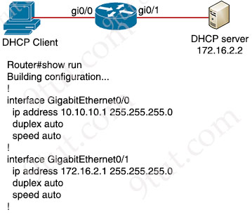
An engineer is configuring a new router on the network and applied this configuration. Which additional configuration allows the PC to obtain its IP address from a DHCP server?
A. Configure the ip dhcp relay information command under interface Gi0/1
B. Configure the ip dhcp smart-relay command globally on the router
C. Configure the ip helper-address 172.16.2.2 command under interface Gi0/0
D. Configure the ip address dhcp command under interface Gi0/0
Answer: C
Question 9.34
Which QoS per-hop behavior changes the value of the ToS field in the IPv4 packet header?
A. shaping
B. marking
C. policing
D. classification
Answer: B
Question 9.44
Refer to the exhibit.
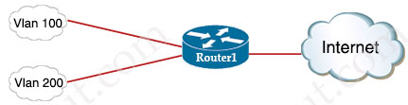
Router1(config)#interface GigabitEthernet0/0
Router1(config-if)#ip address 209.165.200.225 255.255.255.224
Router1(config-if)#ip nat outside
Router1(config)#interface GigabitEthernet0/1
Router1(config-if)#ip nat inside
Router1(config)#interface GigabitEthernet
Router1(config-if)#encapsulation dot1Q 100
Router1(config-if)#ip address 10.10.10.1 255.255.255.0
Router1(config)#interface GigabitEthernet0/1.200
Router1(config-if)#encapsulation dot1Q 200
Router1(config-if)#ip address 10.10.20.1 255.255.255.0
Router1(config)#ip access-list standard NAT_INSIDE_RANGES
Router1(config-std-nacl)#permit 10.10.10.0 0.0.0.255
Router1(config)#ip nat inside source list NAT_INSIDE_RANGES interface GigabitEthernet0/0 overload
Users on existing VLAN 100 can reach sites on the Internet. Which action must the administrator take to establish connectivity to the Internet for users in VLAN 200?
A. Define a NAT pool on the router.
B. Update the NAT_INSIDE_RANGES ACL
C. Configure the ip nat outside command on another interface for VLAN 200
D. Configure static NAT translations for VLAN 200
Answer: B
Question 9.50
Which QoS traffic handling technique retains excess packets in a queue and reschedules these packets for later transmission when the configured maximum bandwidth has been surpassed?
A. traffic shaping
B. traffic policing
C. weighted random early detection
D. traffic prioritization
Answer: A
Question 9.67
Which QoS queuing method discards or marks packets that exceed the desired bit rate of traffic flow?
A. shaping
B. policing
C. CBWFQ
D. LLQ
Answer: B
Question 9.70
Drag and drop the QoS terms from the left onto the descriptions on the right.
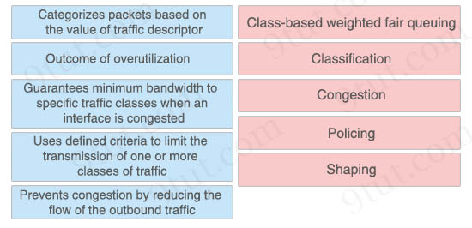
Answer:
Class-based weighted fair queuing: Guarantees minimum bandwidth to specific traffic classes when an interface is congested
Classification: Categorizes packets based on the value of traffic descriptor
Congestion: Outcome of overutilization
Policing: Uses defined criteria to limit the transmission of one or more classes of traffic
Shaping: Prevents congestion by reducing the flow of the outbound traffic
Question 9.82
How does TFTP operate in a network?
A. relies on the well-known TCP port 20 to transmit data
B. requires two separate connections for control and data traffic
C. uses block numbers to identify and mitigate data-transfer errors
D. provides secure data transfer
Answer: C
Question 9.86
An engineer is configuring switch SW1 to act as an NTP server when all upstream NTP server connectivity fails. Which configuration must be used?
A. SW1# config t
SW1(config)#ntp server 192.168.1.1
SW1(config)#ntp access-group server accesslist1
B. SW1# config t
SW1(config)3 ntp peer 192.168.1.1
SW1(config)#ntp access-group peer accesslist1
C. SW1# config t
SW1(config)#ntp backup
SW1(config)#ntp server 192.168.1.1
D. SW1# config t
SW1(config)#ntp master
SW1(config)#ntp server 192.168.1.1
Answer: D
Question 9.99
Drag and drop the traffic types from the left onto the QoS delivery mechanisms on the right.
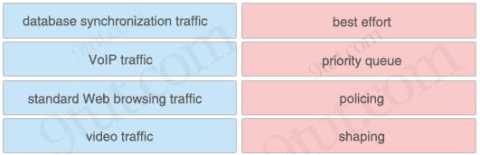
Answer:
+ best effort: standard Web browsing traffic
+ priority queue: VoIP traffic
+ policing: video traffic
+ shaping: database synchronization traffic
Question 9.100
What is a function performed by a web server?
A. provide an application that is transmitted over HTTP
B. send and retrieve email from client devices
C. securely store files for FTP access
D. authenticate and authorize a user’s identity
Answer: A
Question 10.14
Drag and drop the functions of SNMP fault-management from the left onto the definitions on the right.
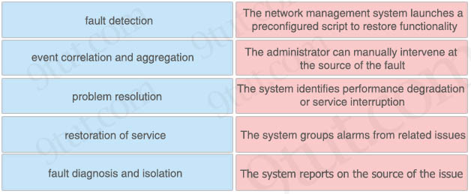
Answer:
+ The network management system launches a preconfigured script to restore functionality: restoration of service
+ The administrator can manually intervene at the source of the fault: problem resolution
+ The system identifies performance degradation or service interruption: fault detection
+ The system groups alarms from related issues: event correlation and aggregation
+ The system reports on the source of the issue: fault diagnosis and isolation
Question 10.19
What is a feature of TFTP?
A. provides secure data transfer
B. relies on the well-known TCP port 20 to transmit data
C. uses two separate connections for control and data traffic
D. offers anonymous user login ability
Answer: D
Question 10.21
Which command creates a static NAT binding for a PC address of 10.1.1.1 to the public routable address 209.165.200.225 assigned to the PC?
A. R1(config)#ip nat outside source static 209.165.200.225 10.1.1.1
B. R1(config)#ip nat inside source static 209.165.200.225 10.1.1.1
C. R1(config)#ip nat outside source static 10.1.1.1 209.165.200.225
D. R1(config)#ip nat inside source static 10.1.1.1 209.165.200.225
Answer: D
Question 10.33
Which command implies the use of SNMPv3?
A. snmp-server community
B. snmp-server host
C. snmp-server enable traps
D. snmp-server user
Answer: D
Question 10.43
What are two features of the DHCP relay agent? (Choose two)
A. minimizes the necessary number of DHCP servers
B. assigns DNS locally and then forwards request to DHCP server
C. is configured under the Layer 3 interface of a router on the client subnet
D. allows only MAC-to-IP reservations to determine the local subnet of a client
E. permits one IP helper command under an individual Layer 3 interface
Answer: A C
Question 10.46
Drag and drop the steps in a standard DNS lookup operation from the left into the order on the right.
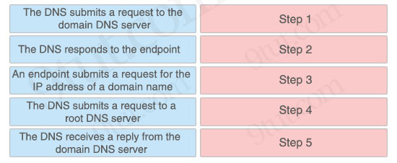
Answer:
Step 1: An endpoint submits a request for the IP address of a domain name
Step 2: The DNS submits a request to a root DNS server
Step 3: The DNS submits a request to the domain DNS server
Step 4: The DNS receives a reply from the domain DNS server
Step 5: The DNS responds to the endpoint
Question 10.72
Refer to the exhibit.
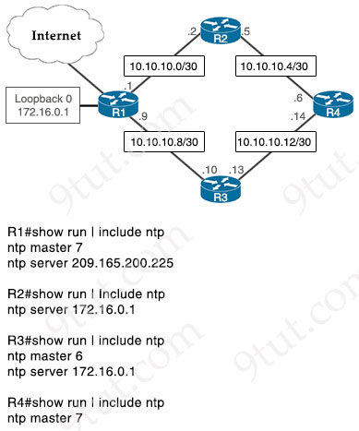
Which router or router group are NTP clients?
A. R1, R2, and R3
B. R1
C. R2 and R3
D R1, R3, and R4
Answer: A
Question 10.78
Refer to the exhibit.
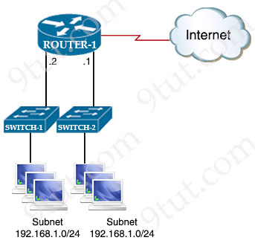
Which command set configures ROUTER-1 to allow Internet access for users on the 192.168.1.0/24 subnet while using 209.165.202.129 for Port Address Translation?
A. ip nat pool CCNA 192.168.0.0 192.168.1.255 netmask 255.255.255.0
access-list 10 permit 192.168.0.0 0.0.0.255
ip nat inside source list 10 pool CCNA overload
B. ip nat pool CCNA 209.165.202.129 209.165.202.129 netmask 255.255.255.255
access-list 10 permit 192.168.1.0 255.255.255.0
ip nat inside source list 10 pool CCNA overload
C. ip nat pool CCNA 192.168.0.0 192.168.1.255 netmask 255.255.255.0
access-list 10 permit 192.168.0.0 255.255.255.0
ip nat inside source list 10 pool CCNA overload
D. ip nat pool CCNA 209.165.202.129 209.165.202.129 netmask 255.255.255.255
access-list 10 permit 192.168.1.0 0.0.0.255
ip nat inside source list 10 pool CCNA overload
Answer: D
Question 10.92
Which two actions are taken as the result of traffic policing? (Choose two)
A. bursting
B. fragmentation
C. dropping
D. remarking
E. buffering
Answer: C D

