Question 5.5
In which situation is private IPv4 addressing appropriate for a new subnet on the network of an organization?
A. There is limited unique address space, and traffic on the new subnet will stay local within the organization.
B. The network has multiple endpoint listeners, and it is desired to limit the number of broadcasts.
C. Traffic on the subnet must traverse a site-to-site VPN to an outside organization.
D. The ISP requires the new subnet to be advertised to the internet for web services.
Answer: A
Question 5.8
How do servers connect to the network in a virtual environment?
A. wireless to an access point that is physically connected to the network
B. a cable connected to a physical switch on the network
C. a virtual switch that links to an access point that is physically connected to the network
D. a software switch on a hypervisor that is physically connected to the network
Answer: D
Question 5.18
What is the maximum bandwidth of a T1 point-to-point connection?
A. 1.544 Mbps
B. 2.048 Mbps
C. 34.368 Mbps
D. 43.7 Mbps
Answer: A
Question 5.31
What is a characteristic of a SOHO network?
A. connects each switch to every other switch in the network
B. enables multiple users to share a single broadband connection
C. provides high throughput access for 1000 or more users
D. includes at least three tiers of devices to provide load balancing and redundancy
Answer: B
Question 5.32
Which resource is able to be shared among virtual machines deployed on the same physical server?
A. applications
B. operating system
C. VM configuration file
D. disk
Answer: D
Question 5.37
Which WAN topology provides a combination of simplicity quality, and availability?
A. partial mesh
B. full mesh
C. point-to-point
D. hub-and-spoke
Answer: C
Question 5.50
What is a characteristic of private IPv4 addressing?
A. used without tracking or registration
B. issued by IANA in conjunction with an autonomous system number
C. traverse the Internet when an outbound ACL is applied
D. composed of up to 65,536 available addresses
Answer: A
Question 6.7
A network engineer must configure the router R1 GigabitEthernet1/1 interface to connect to the router R2 GigabitEthernet1/1 interface. For the configuration to be applied the engineer must compress the address 2001:0db8:0000:0000:0500:000a:400F:583B. Which command must be issued on the interface?
A. ipv6 address 2001:db8::500:a:400F:583B
B. ipv6 address 2001 db8:0::500:a:4F:583B
C. ipv6 address 2001:0db8::5:a:4F:583B
D. ipv6 address 2001::db8:0000::500:a:400F:583B
Answer: A
Question 6.11
What is a similarity between OM3 and OM4 fiber optic cable?
A. Both have a 50 micron core diameter
B. Both have a 9 micron core diameter
C. Both have a 62.5 micron core diameter
D. Both have a 100 micron core diameter
Answer: A
Question 6.16
What describes the operation of virtual machines?
A. Virtual machines are responsible for managing and allocating host hardware resources
B. Virtual machines are operating system instances that are decoupled from server hardware
C. Virtual machines are the physical hardware that support a virtual environment
D. In a virtual machine environment, physical servers must run one operating system at a time
Answer: B
Question 6.18
Refer to the exhibit.
SiteA#show interface TenGigabitEthernet0/1/0
TenGigabitEthernet0/1/0 is up, line protocol is up
Hardware is BUILT-IN-EPA-8x10G, address is aabb.cc00.0100 (bia aabb.cc00.0100)
Description: Connection to SiteB
Internet address is 10.10.10.1/30
MTU 8146 bytes, BW 10000000 Kbit/sec, DLY 10 usec,
reliability 166/255, txload 1/255, rxload 1/255
Full Duplex, 10000Mbps, link type is force-up, media type is SFP-LR
5 minute input rate 265746000 bits/sec, 24343 packets/sec
5 minute output rate 123245000 bits/sec, 12453 packets/sec

SiteB#show interface TenGigabitEthernet0/1/0
TenGigabitEthernet0/1/0 is up, line protocol is up
Hardware is BUILT-IN-EPA-8x10G, address is 0000.0c00.750c (bia 0000.0c00.750c)
Description: Connection to SiteA
Internet address is 10.10.10.2/30
MTU 8146 bytes, BW 10000000 Kbit/sec, DLY 10 usec,
reliability 255/255, txload 1/255, rxload 1/255
Full Duplex, 10000Mbps, link type is force-up, media type is SFP-LR
5 minute input rate 123245000 bits/sec, 15343 packets/sec
5 minute output rate 265746000 bits/sec, 12453 packets/sec

Shortly after SiteA was connected to SiteB over a new single-mode fiber path, users at SiteA report intermittent connectivity issues with applications hosted at SiteB. What is the cause of the intermittent connectivity issue?
A. Interface errors are incrementing
B. An incorrect SFP media type was used at SiteA
C. High usage is causing high latency
D. The sites were connected with the wrong cable type
Answer: A
Question 6.21
Which technology allows for multiple operating systems to be run on a single host computer?
A. virtual device contexts
B. network port ID visualization
C. virtual routing and forwarding
D. server virtualization
Answer: D
Question 6.32
What is the function of a hub-and-spoke WAN topology?
A. supports application optimization
B. provides direct connections between subscribers
C. supports Layer 2 VPNs
D. allows access restrictions to be implemented between subscriber sites
Answer: D
Question 7.2
What is a characteristic of cloud-based network topology?
A. physical workstations are configured to share resources
B. services are provided by a public, private, or hybrid deployment
C. onsite network services are provided with physical Layer 2 and Layer 3 components
D. wireless connections provide the sole access method to services
Answer: B
Question 7.10
Drag and drop the IPv6 address type characteristics from the left to the right.
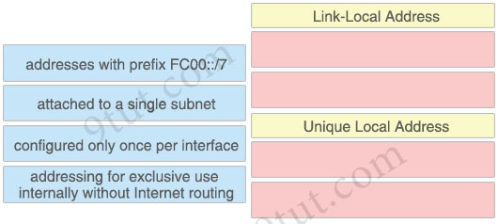
Answer:
Link-Local Address:
+ attached to a single subnet
+ configured only once per interface
Unique Local Address:
+ addresses with prefix FC00::/7
+ addressing for exclusive use internally without Internet routing
Question 7.11
Why was the RFC 1918 address space defined?
A. preserve public IPv6 address space
B. support the NAT protocol
C. reduce instances of overlapping IP addresses
D. conserve public IPv4 addressing
Answer: D
Question 7.19
Which action does the router take as it forwards a packet through the network?
A. The router replaces the source and destination labels with the sending router interface label as a source and the next hop router label as a destination
B. The router encapsulates the source and destination IP addresses with the sending router IP address as the source and the neighbor IP address as the destination
C. The router encapsulates the original packet and then includes a tag that identifies the source router MAC address and transmit transparently to the destination
D. The router replaces the original source and destination MAC addresses with the sending router MAC address as the source and neighbor MAC address as the destination
Answer: D
Question 7.32
An implementer is preparing hardware for virtualization to create virtual machines on a host. What is needed to provide communication between hardware and virtual machines?
A. straight cable
B. router
C. hypervisor
D. switch
Answer: C
Question 7.33
What are two characteristics of the distribution layer in a three-tier network architecture? (Choose two)
A. provides a boundary between Layer 2 and Layer 3 communications
B. designed to meet continuous, redundant uptime requirements
C. serves as the network aggregation point
D. physical connection point for a LAN printer
E. is the backbone for the network topology
Answer: A C
Question 7.38
What is the difference in data transmission delivery and reliability between TCP and UDP?
A. UDP sets up a connection between both devices before transmitting data. TCP uses the three-way handshake to transmit data with a reliable connection.
B. TCP transmits data at a higher rate and ensures packet delivery. UDP retransmits lost data to ensure applications receive the data on the remote end.
C. UDP is used for multicast and broadcast communication. TCP is used for unicast communication and transmits data at a higher rate with error checking.
D. TCP requires the connection to be established before transmitting data. UDP transmits data at a higher rate without ensuring packet delivery.
Answer: D
Question 7.39
What are network endpoints?
A. a threat to the network if they are compromised
B. support inter-VLAN connectivity
C. act as routers to connect a user to the service prowler network
D. enforce policies for campus-wide traffic going to the internet
Answer: A
Question 7.51
What are two similarities between UTP Cat 5e and Cat 6a cabling? (Choose two)
A. Both support runs of up to 100 meters.
B. Both support runs of up to 55 meters.
C. Both operate at a frequency of 500 MHz.
D. Both support speeds of at least 1 Gigabit.
E. Both support speeds up to 10 Gigabit.
Answer: A D
Question 8.2
What is a similarly between 1000BASE-LX and 1000BASE-T standards?
A. Both use the same data-link header and trailer formats
B. Both cable types support LP connectors
C. Both cable types support RJ-45 connectors
D. Both support up to 550 meters between nodes
Answer: A
Question 8.15
What are two characteristics of a public cloud implementation? (Choose two)
A. It is owned and maintained by one party, but it is shared among multiple organizations
B. It enables an organization to fully customize how it deploys network resources
C. It provides services that are accessed over the Internet
D. It is a data center on the public Internet that maintains cloud services for only one company
E. It supports network resources from a centralized third-party provider and privately-owned virtual resources
Answer: A C
Question 8.20
Which type of organization should use a collapsed-core architecture?
A. large and requires a flexible, scalable network design
B. small and needs to reduce networking costs currently
C. large and must minimize downtime when hardware fails
D. small but is expected to grow dramatically in the near future
Answer: B
Question 8.27
An engineer must configure the IPv6 address 2001:0db8:0000:0000:0700:0003:400F:572B on the serial0/0 interface of the HQ router and wants to compress it for easier configuration. Which command must be issued on the router interface?
A. ipv6 address 2001:db8::700:3:400F:572B
B. ipv6 address 2001:db8:0::700:3:4F:572B
C. ipv6 address 2001:Odb8::7:3:4F:572B
D. ipv6 address 2001::db8:0000::700:3:400F:572B
Answer: A
Question 8.28
What is an appropriate use for private IPv4 addressing?
A. on the public-facing interface of a firewall
B. to allow hosts inside to communicate in both directions with hosts outside the organization
C. on internal hosts that stream data solely to external resources
D. on hosts that communicates only with other internal hosts
Answer: D
Question 8.35
Drag and drop the TCP/IP protocols from the left onto their primary transmission protocols on the right.
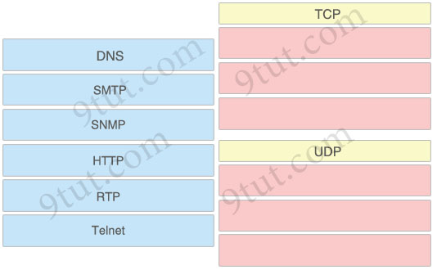
Answer:
TCP:
+ SMTP
+ HTTP
+ Telnet
UDP:
+ DNS
+ SNMP
+ RTP
Question 8.47
Refer to the exhibit.
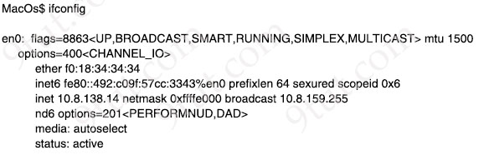
A network engineer must provide configured IP addressing details to investigate a firewall rule issue. Which subnet and mask identify what is configured on the en0 interface?
A. 10.8.0.0/16
B. 10.8.64.0/18
C. 10.8.128.0/19
D. 10.8.138.0/24
Answer: C
Question 8.51
Refer to the exhibit.
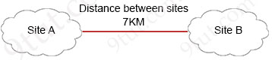
SiteA#show interface TenGigabitEthernet0/1/0
TenGigabitEthernet0/1/0 is up, line protocol is up
Hardware is BUILT-IN-EPA-8x10G, address is aabb.cc00.0100 (bia aabb.cc00.0100)
Description: Connection to SiteB
Internet address is 10.10.10.1/30
MTU 8146 bytes, BW 10000000 Kbit/sec, DLY 10 usec,
reliability 255/255, txload 1/255, rxload 1/255
Full Duplex, 10000Mbps, link type is force-up, media type is SFP-SR
5 minute input rate 264797000 bits/sec, 26672 packets/sec
5 minute output rate 122464000 bits/sec, 15724 packets/sec

SiteB#show interface TenGigabitEthernet0/1/0
TenGigabitEthernet0/1/0 is up, line protocol is up
Hardware is BUILT-IN-EPA-8x10G, address is 0000.0c00.750c (bia 0000.0c00.750c)
Description: Connection to SiteA
Internet address is 10.10.10.2/30
MTU 8146 bytes, BW 10000000 Kbit/sec, DLY 10 usec,
reliability 255/255, txload 1/255, rxload 1/255
Full Duplex, 10000Mbps, link type is force-up, media type is SFP-LR
5 minute input rate 123245000 bits/sec, 15343 packets/sec
5 minute output rate 265746000 bits/sec, 12453 packets/sec

Shortly after SiteA was connected to SiteB over a new single-mode fiber path, users at SiteA report intermittent connectivity issues with applications hosted at SiteB. What is the cause of the intermittent connectivity issue?
A. An incorrect type of transceiver has been inserted into a device on the link.
B. The wrong cable type was used to make the connection.
C. Heavy usage is causing high latency.
D. Physical network errors are being transmitted between the two sites.
Answer: A
Question 8.62
Drag and drop the TCP or UDP details from the left onto their corresponding protocols on the right.
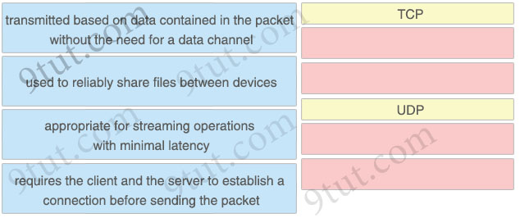
Answer:
TCP
+ used to reliably share files between devices
+ requires the client and the server to establish a connection before sending the packet
UDP
+ transmitted based on data contained in the packet without the need for a data channel
+ appropriate for streaming operations with minimal latency
Question 8.71
What is a characteristic or private IPv4 addressing?
A. composed of up to 65,536 available addresses
B. issued by IANA in conjunction with an autonomous system number
C. used without tracking or registration
D. traverse the Internet when an outbound ACL is applied
Answer: C
Question 8.73
A network engineer must implement an IPv6 configuration on the vlan 2000 interface to create a routable locally-unique unicast address that is blocked from being advertised to the internet. Which configuration must the engineer apply?
A. interface vlan 2000
ipv6 address ff00:0000:aaaa::1234:2343/64
B. interlace vlan 2000
ipv6 address fd00::1234:2343/64
C. interface vlan 2000
ipv6 address fc00:0000:aaaa:a15d:1234:2343:8aca/64
D. interface vlan 2000
ipv6 address fe80:0000:aaaa::1234:2343/64
Answer: B
Question 8.80
What is a function of an endpoint on a network?
A. allows users to record data and transmit to a file server
B. connects server and client devices to a network
C. provides wireless services to users in a building
D. forwards traffic between VLANs on a network
Answer: A
Question 9.2
Which type of IPv6 address is similar to a unicast address but is assigned to multiple devices on the same network at the same time?
A. global unicast address
B. anycast address
C. multicast address
D. link-local address
Answer: B
Question 9.7
What is the difference between IPv6 unicast and anycast addressing?
A. An individual IPv6 unicast address is supported on a single interface on one node but an IPv6 anycast address is assigned to a group of interfaces on multiple nodes.
B. IPv6 unicast nodes must be explicitly configured to recognize the unicast address, but IPv6 anycast nodes require no special configuration
C. IPv6 anycast nodes must be explicitly configured to recognize the anycast address, but IPv6 unicast nodes require no special configuration
D. Unlike an IPv6 anycast address, an IPv6 unicast address is assigned to a group of interfaces on multiple nodes
Answer: A
Question 9.17
Refer to the exhibit.
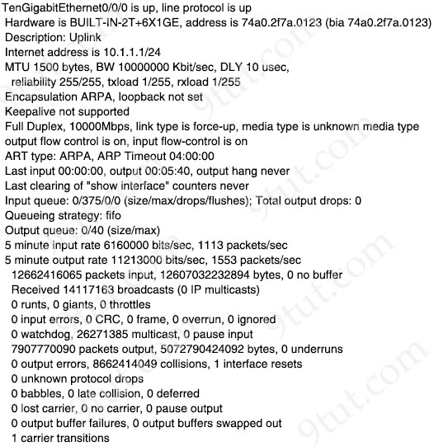
Traffic that is flowing over interface TenGigabitEthernet0/0 experiences slow transfer speeds. What is the reason for the issue?
A. heavy traffic congestion
B. queuing drops
C. a speed conflict
D. a duplex incompatibility
Answer: D
Question 9.25
Refer to the exhibit.
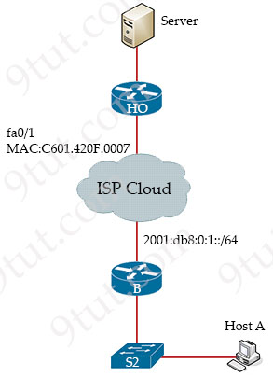
An engineer is configuring the HO router. Which IPv6 address configuration must be applied to the router fa0/1 interface for the router to assign a unique 64-bit IPv6 address to itself?
A. ipv6 address 2001:DB8:0:1:C601:42FF:FE0F:7/64
B. ipv6 address 2001:DB8:0:1:C601:42FE:800F:7/64
C. ipv6 address 2001:DB8:0:1:FFFF:C601:420F:7/64
D. ipv6 address 2001:DB8:0:1:FE80:C601:420F:7/64
Answer: A
Question 9.32
Refer to the exhibit.
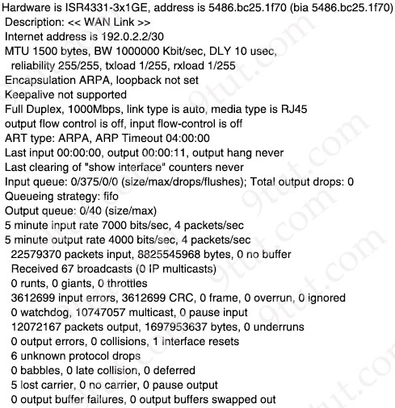
What is a reason for poor performance on the network interface?
A. The interface is receiving excessive broadcast traffic.
B. The cable connection between the two devices is faulty.
C. The interface is operating at a different speed than the connected device.
D. The bandwidth setting of the interface is misconfigured
Answer: B
Question 9.57
How do UTP and STP cables compare?
A. STP cables are cheaper to produre and easier to install and UTP cables are more expensive and harder to install.
B. UTP cables are less prone to crosstalk and interference and STP cables are more prone to crosstalk and interference.
C. UTP cables provide faster and more reliable data transfer rates and STP cables are slower and less reliable.
D. STP cables are shielded and protect against electromagnetic interference and UTP lacks the same protection against electromagnetic interference.
Answer: D
Question 9.63
Drag and drop the IPv6 address details from the left onto the corresponding types on the right.
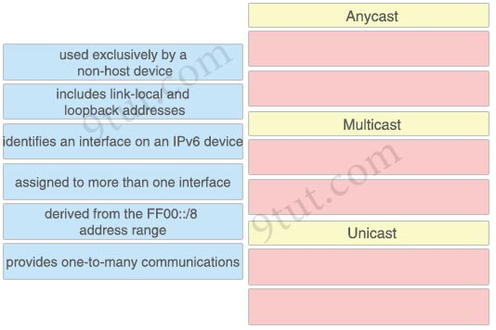
Answer:
Anycast:
+ used exclusively by a non-host device
+ assigned to more than one interface
Multicast:
+ derived from the FF00::/8 address range
+ provides one-to-many communications
Unicast:
+ includes link-local and loopback addresses
+ identifies an interface on an IPv6 device
Question 9.77
Which WAN topology has the highest degree of reliability?
A. router-on-a-stick
B. Point-to-point
C. hub-and-spoke
D. full mesh
Answer: D
Question 9.80
Refer to the exhibit.
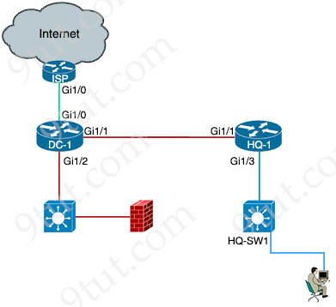
The IP address configurations must be completed on the DC-1 and HQ-1 routers based on these requirements.
DC-1 Gi1/0 must be the last usable address on a /30
DC-1 Gi1/1 must be the first usable address on a /29
DC-1 Gi1/2 must be the last usable address on a /28
HQ-1 Gi1/3 must be the last usable address on a /29
Drag and drop the commands from the left onto the destination interfaces on the right. Not all commands are used.
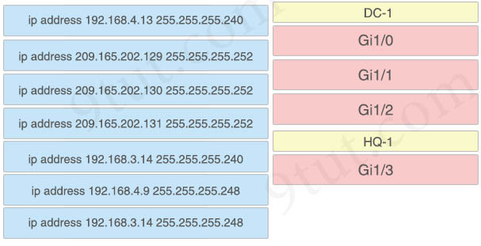
Answer:
DC-1:
+ ip address 209.165.202.130 255.255.255.252
+ ip address 192.168.4.9 255.255.255.248
+ ip address 192.168.3.14 255.255.255.240
HQ-1:
+ ip address 192.168.3.14 255.255.255.248
Question 9.93
What is a benefit for external users who consume public cloud resources?
A. implemented over a dedicated WAN
B. located in the same data center as the users
C. all hosted on physical servers
D. accessed over the Internet
Answer: D
Question 9.97
When should an engineer implement a collapsed-core architecture?
A. for large networks that are connected to multiple remote sites
B. the access and distribution layers must be on the same device
C. only when using VSS technology
D. for small networks with minimal need for growth
Answer: D
Question 9.106
What is the difference between 1000BASE-LX/LH and 1000BASE-ZX interfaces?
A. 1000BASE-LX/LH interoperates with multimode and single-mode fiber, and 1000BASE-ZX needs a conditioning patch cable with a multimode.
B. 1000BASE-ZX is supported on links up to 1000km, and 1000BASE-LX/LH operates over links up to 70 km.
C. 1000BASE-ZX interoperates with dual-rate 100M/1G 10Km SFP over multimode fiber, and 1000BASE-LX/LH supports only single-rate.
D. 1000BASE-LX/LH is supported on links up to 10km, and 1000BASE-ZX operates over links up to 70 km.
Answer: D
Question 9.108
Refer to the exhibit.
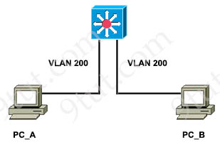
What is expected when PC_A sends data to PC_B after their initial communication?
A. The source and destination MAC addresses remain the same
B. The switch rewrites the source and destination MAC addresses with its own
C. The source MAC address is changed
D. The destination MAC address is replaced with ffff.ffff.ffff
Answer: A
Question 10.3
What is the collapsed layer in collapsed core architectures?
A. core and WAN
B. access and WAN
C. distribution and access
D. core and distribution
Answer: D
Question 10.5
Drag and drop the IPv6 addresses from the left onto the corresponding address types on the right.
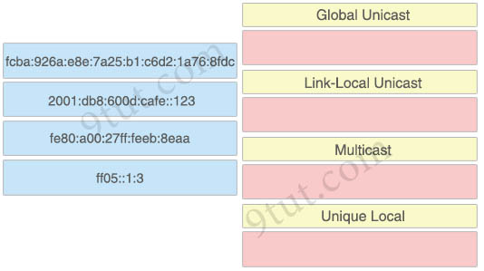
Answer:
Global unicast: 2001:db8:600d:cafe::123
Link-Local unicast: fe80:a00:27ff:feeb:8eaa
Multicast: ff05::1:3
Unique Local: fcba:926a:e8e:7a25:b1:c6d2:1a76:8fdc
Question 10.18
Refer to the exhibit.
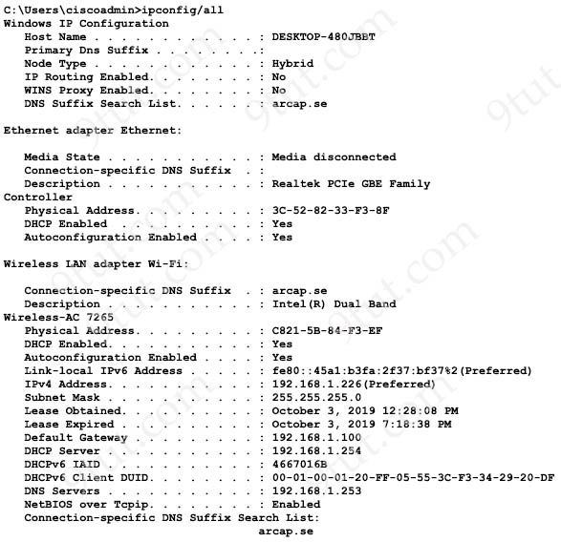
The given Windows PC is requesting the IP address of the host at www.cisco.com. To which IP address is the request sent?
A. 192.168.1.226
B. 192.168.1.253
C. 192.168.1.100
D. 192.168.1.254
Answer: B
Question 10.41
What is a function of an endpoint?
A. It passes unicast communication between hosts in a network
B. It is used directly by an individual user to access network services
C. It provides security between trusted and untrusted sections of the network
D. It transmits broadcast traffic between devices in the same VLAN
Answer: B
Question 10.45
In a cloud-computing environment, what is rapid elasticity?
A. automatic adjustment of capacity based on need
B. control and monitoring of resource consumption by the tenant
C. pooling resources in a multitenant model based on need
D. self-service of computing resources by the tenant
Answer: A
Question 10.49
Which two IPv6 addresses are used to provide connectivity between two routers on a shared link? (Choose two)
A. 2002::512:1204b:1111::1/64
B. ff06:bb43:cc13:dd16:1bb:ff14:7545:234d
C. FF02::0001:FF00:0000/104
D. 2001:701:104b:1111::1/64
E. ::ffff:10.14.101.1/96
Answer: D E (?)
Question 10.60
Refer to the exhibit.
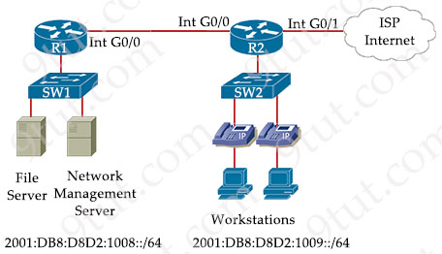
A public IPv6 address must be configured for internet access. Which command must be configured on the R2 WAN interface to the service provider?
A. ipv6 address fe80::260:3EFF:FE11:6770 link-local
B. ipv6 address fe80: :/10
C. ipv6 address 2001:db8:433:47:4620:ffff:ffff:ffff/64 anycast
D. ipv6 address 2001:db8:123:45::4/64
Answer: D
Question 10.69
Refer to the exhibit.
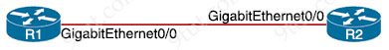
A network engineer must configure the link with these requirements:
• Consume as few IP addresses as possible.
• Leave at least two additional useable IP addresses for future growth.
Which set of configurations must be applied?
A. R1(config-if)#ip address 10.10.10.1 255.255.255.248
R2(config-if)#ip address 10.10.10.4 255.255.255.248
B. R1(config-if)#ip address 10.10.10.1 255.255.255.240
R2(config-if)#ip address 10.10.10.12 255.255.255.240
C. R1 (config-if)#ip address 10.10.10.1 255.255.255.252
R2(config-if)#ip address 10.10.10.2 255.255.255.252
D. R1 (config-if)#ip address 10.10.10.1 255.255.255.0
R2(config-if)#ip address 10.10.10.5 255.255.255.0
Answer: A
Question 10.71
Refer to the exhibit.
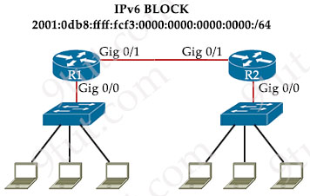
IPv6 is being implemented within the enterprise. The command ipv6 unicast-routing is configured. Interface Gig0/0 on R1 must be configured to provide a dynamic assignment using the assigned IPv6 block. Which command accomplishes this task?
A. ipv6 address 2001:DB8:FFFF:FCF3::/64 eui-64
B. ipv6 address 2001:DB8:FFFF:FCF3::/64 link-local
C. ipv6 address 2001:0B8:FFFF:FCF3::1/64
D. ipv6 address autoconfig 2001:DB8:FFFF:FCF2::/64
Answer: A
Question 10.81
How do TCP and UDP fit into a query-response model?
A. TCP avoids using sequencing, and UDP avoids using acknowledgments.
B. TCP uses error detection for packets, and UDP uses error recovery.
C. TCP establishes a connection prior to sending data, and UDP sends immediately.
D. TCP encourages out-of-order packet delivery, and UDP prevents re-ordering.
Answer: C
Question 10.86
What are two reasons to implement IPv4 private addressing on a network? (Choose two)
A. to expand the routing table on the router
B. to facilitate renumbering when merging networks
C. to enable internal applications to treat the private IPv4 addresses as unique
D. to conserve global unique IPv4 addresses
E. to provide protection from external denial-of-service attacks
Answer: D E

