Question 5.3
Which type of security program is violated when a group of employees enters a building using the ID badge of only one person?
A. intrusion detection
B. user awareness
C. physical access control
D. network authorization
Answer: C
Question 5.11
Which device tracks the state of active connections in order to make a decision to forward a packet through?
A. firewall
B. wireless access point
C. router
D. wireless LAN controller
Answer: A
Question 5.13
Refer to the exhibit. A network administrator has been tasked with securing VTY access to a router. Which access-list entry accomplishes this task?
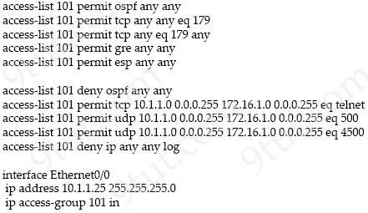
A. access-list 101 permit tcp 10.1.1.0 0.0.0.255 172.16.1.0 0.0.0.255 eq ssh
B. access-list 101 permit tcp 10.1.1.0 0.0.0.255 172.16.1.0 0.0.0.255 eq scp
C. access-list 101 permit tcp 10.1.1.0 0.0.0.255 172.16.1.0 0.0.0.255 eq telnet
D. access-list 101 permit tcp 10.1.1.0 0.0.0.255 172.16.1.0 0.0.0.255 eq https
Answer: A
Question 5.29
Refer to the exhibit.
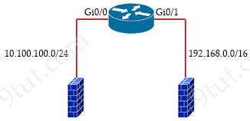
Option A  ip access-list standard 99  permit 10.100.100.0 0.0.0.255  deny 192.168.0.0 0.0.255.255 | Option B  ip access-list standard 99  permit 10.100.100.0 0.0.0.255  deny 192.168.0.0 0.255.255.255
Option C  ip access-list standard 100  permit 10.100.100.0 0.0.0.255  deny 192.168.0.0 0.255.255.255 | Option D  ip access-list standard 199  permit 10.100.100.0 0.0.0.255  deny 192.168.0.0 0.0.255.255
An access list is required to permit traffic from any host on interface G0/0 and deny traffic from interface Gi0/1. Which access list must be applied?
A. Option A
B. Option B
C. Option C
D. Option D
Answer: A
Question 5.33
Which implementation provides the strongest encryption combination for the wireless environment?
A. WPA2 + AES
B. WPA + AES
C. WEP
D. WPA + TKIP
Answer: A
Question 5.42
What is a network appliance that checks the state of a packet to determine whether the packet is legitimate?
A. Layer 2 switch
B. LAN controller
C. load balancer
D. firewall
Answer: D
Question 5.47
What causes a port to be placed in the err-disabled state?
A. latency
B. nothing plugged into the port
C. shutdown command issued on the port
D. port security violation
Answer: D
Question 5.49
Which security program element involves installing badge readers on data-center doors to allow workers to enter and exit based on their job roles?
A. physical access control
B. biometrics
C. role-based access control
D. multifactor authentication
Answer: A
Question 6.2
A network administrator must to configure SSH for remote access to router R1. The requirement is to use a public and private key pair to encrypt management traffic to and from the connecting client. Which configuration, when applied, meets the requirements?
A.
R1#enable
R1#configure terminal
R1(config)#ip domain-name cisco.com
R1(config)#crypto key generate ec keysize 1024
B.
R1#enable
R1#configure terminal
R1(config)#ip domain-name cisco.com
R1(config)#crypto key generate rsa modulus 1024
C.
R1#enable
R1#configure terminal
R1(config)#ip domain-name cisco.com
R1(config)#crypto key generate ec keysize 2048
D.
R1#enable
R1#configure terminal
R1(config)#ip domain-name cisco.com
R1(config)#crypto key encrypt rsa name myKey
A. Option A
B. Option B
C. Option C
D. Option D
Answer: B
Question 6.4
When a WLAN with WPA2 PSK is configured in the Wireless LAN Controller GUI which format is supported?
A. Unicode
B. base64
C. ASCII
D. decimal
Answer: C
Question 6.30
Which two protocols are supported on service-port interfaces? (Choose two)
A. RADIUS
B. TACACS+
C. Telnet
D. SCP
E. SSH
Answer: C E
Question 6.33
Which global command encrypts all passwords in the running configuration?
A. enable secret
B. enable password-encryption
C. service password-encryption
D. password-encrypt
Answer: C
Question 7.14
An engineer is configuring an encrypted password for the enable command on a router where the local user database has already been configured. Drag and drop the configuration commands from the left into the correct sequence on the right. Not all commands are used.
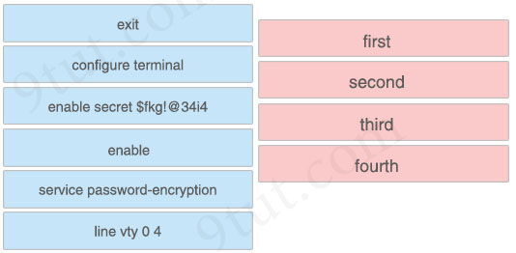
Answer:
+ first: enable
+ second: configure terminal
+ third: enable secret $fkg!@34i4
+ fourth: exit
Question 7.20
When a site-to-site VPN is configured, which IPsec mode provides encapsulation and encryption of the entire original IP packet?
A. IPsec tunnel mode with AH
B. IPsec transport mode with AH
C. IPsec tunnel mode with ESP
D. IPsec transport mode with ESP
Answer: C
Question 7.22
What is the role of a firewall in an enterprise network?
A. determines which packets are allowed to cross from unsecured to secured networks
B. processes unauthorized packets and allows passage to less secure segments of the network
C. forwards packets based on stateless packet inspection
D. explicitly denies all packets from entering an administrative domain
Answer: A
Question 7.24
How are VLAN hopping attacks mitigated?
A. manually implement trunk ports and disable DTP
B. configure extended VLANs
C. activate all ports and place in the default VLAN
D. enable dynamic ARP inspection
Answer: A
Question 7.30
Which two protocols must be disabled to increase security for management connections to a Wireless LAN Controller? (Choose two)
A. Telnet
B. SSH
C. HTTP
D. HTTPS
E. TFTP
Answer: A C
Question 7.40
What does physical access control regulate?
A. access to specific networks based on business function
B. access to servers to prevent malicious activity
C. access to computer networks and file systems
D. access to networking equipment and facilities
Answer: D
Question 7.49
Which function is performed by DHCP snooping?
A. rate-limits certain traffic
B. listens to multicast traffic for packet forwarding
C. provides DDoS mitigation
D. propagates VLAN information between switches
Answer: A
Question 7.54
Drag and drop the AAA terms from the left onto the description on the right.
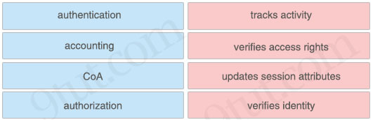
Answer:
+ tracks activity: accounting
+ verifies access rights: authorization
+ updates session attributes: CoA
+ verifies identity: authentication
Question 7.55
Which access layer threat-mitigation technique provides security based on identity?
A. using a non-default native VLAN
B. Dynamic ARP Inspection
C. DHCP snooping
D. 802.1x
Answer: D
Question 8.3
How does WPA3 improve security?
A. It uses SAE for authentication.
B. It uses a 4-way handshake for authentication.
C. It uses RC4 for encryption.
D. It uses TKIP for encryption.
Answer: A
Question 8.16
Which type of traffic is sent with pure IPsec?
A. broadcast packets from a switch that is attempting to locate a MAC address at one of several remote sites
B. multicast traffic from a server at one site to hosts at another location
C. spanning-tree updates between switches that are at two different sites
D. unicast messages from a host at a remote site to a server at headquarters
Answer: D
Question 8.24
Which device permits or denies network traffic based on a set of rules?
A. access point
B. switch
C. wireless controller
D. firewall
Answer: D
Question 8.34
Refer to the exhibit.
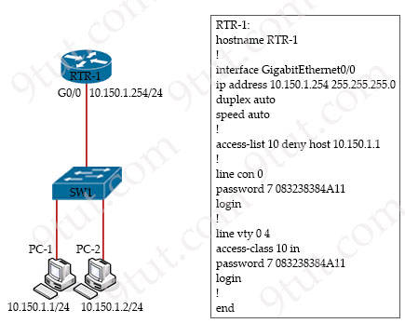
Refer to the exhibit. The access list denies Telnet access from PC-1 to RTR-1 and should allow it from other hosts. PC-2 gets “% Connection refused by remote host” when trying to Telnet. Without permitting Telnet from PC-1, what must be done to allow the traffic?
A. Add the access-list 10 permit any command to the configuration
B. Remove the access-class 10 in command from line vty 0 4.
C. Add the ip access-group 10 out command to interface g0/0.
D. Remove the password command from line vty 0 4.
Answer: A
Question 8.37
Which two components comprise part of a PKI? (Choose two)
A. RSA token
B. clear-text password that authenticates connections
C. one of more CRLs
D. preshared key that authenticates connections
E. CA that grants certificates
Answer: C E
Question 8.46
Which wireless security protocol relies on Perfect Forward Secrecy?
A. WPA
B. WPA3
C. WPA2
D. WEP
Answer: B
Question 8.55
Refer to the exhibit.
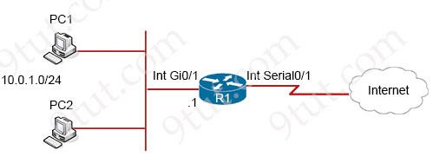
Which two commands must be configured on router R1 to enable the router to accept secure remote-access connections? (Choose two)
A. transport input telnet
B. username cisco password 0 cisco
C. login console
D. ip ssh pubkey-chain
E. crypto key generate rsa
Answer: B E
Question 8.59
An engineer must configure R1 for a new user account. The account must meet these requirements:
* It must be configured in the local database.
* The username is engineer2
* It must use the strongest password configurable.
Which command must the engineer configure on the router?
A. R1(config)# username engineer2 algorithm-type scrypt secret test2021
B. R1(config)# username engineer2 secret 5 password $1$bUu$kZbBS1Pyh4QzwXyZ
C. R1(config)# username engineer2 privilege 1 password 7 test2021
D. R1(config)# username engineer2 secret 4 $1Sb1Ju$kZbBSlFyh4QxwXyZ
Answer: A
Question 8.61
Drag and drop the descriptions or AAA services from the left onto the corresponding services on the right.
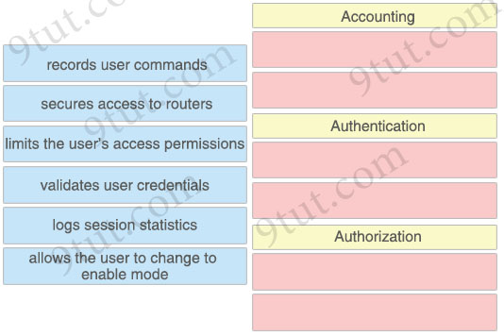
Answer:
Accounting
+ records user commands
+ logs session statistics
Authentication
+ secures access to routers
+ validates user credentials
Authorization
+ limits the user’s access permissions
+ allows the user to change to enable mode
Question 8.69
An engineer is configuring remote access to a router from IP subnet 10.139.58.0/28. The domain name, crypto keys, and SSH have been configured. Which configuration enables the traffic on the destination router?
A. interface FastEthernet0/0
ip address 10.122.49.1 255.255.255.252
ip access-group 10 in
!
ip access-list standard 10
permit udp 10.139.58.0 0.0.0.7 host 10.122.49.1 eq 22
B. line vty 0 15
access-class 120 in
!
ip access-list extended 120
permit tcp 10.139.58.0 0.0.0.15 any eq 22
C. line vty 0 15
access-group 120 in
!
ip access-list extended 120
permit tcp 10.139.58.0 0.0.0.15 any eq 22
D. interface FastEthernet0/0
ip address 10.122.49.1 255.255.255.252
ip access-group 110 in
!
ip access-list standard 110
permit tcp 10.139.58.0 0.0.0.15 eq 22 host 10.122.49.1
Answer: B
Question 8.70
Which protocol is used for secure remote CLI access?
A. HTTP
B. Telnet
C. SSH
D. HTTPS
Answer: C
Question 8.77
A Cisco engineer is configuring a factory-default router with these three passwords:
* The user EXEC password for console access is p4ssw0rd1.
* The user EXEC password for Telnet access is s3cr3t2.
* The password for privileged EXEC mode is priv4t3p4ss.
Which command sequence must the engineer configure?
Option A  enable secret priv4t3p4ss  !  line con 0  password p4ssw0rd1  login  !  line vty 0 15  password s3cr3t2  login | Option B  enable secret privilege 15 priv4t3p4ss  !  line con 0  password p4ssw0rdi  login  !  line vty 0 15  password s3cr3t2  login
Option C  enable secret priv413p4ss  !  line con 0  password login p4ssw0rd1  !  line vty 0 15  password login s3cr3t2  login | Option D  enable secret priv4t3p4ss  !  line con 0  password p4ssw0rd1  !  line vty 0 15  password s3cr3t2
A. Option A
B. Option B
C. Option C
D. Option D
Answer: A
Question 9.3
Which field within the access-request packet is encrypted by RADIUS?
A. authorized services
B. authenticator
C. username
D. password
Answer: D
Question 9.6
What is a function of a Next-Generation IPS?
A. makes forwarding decisions based on learned MAC addresses
B. serves as a controller within a controller-based network
C. integrates with a RADIUS server to enforce Layer 2 device authentication rules
D. correlates user activity with network events
Answer: D
Question 9.8
Refer to the exhibit.
Which two commands must be added to update the configuration of router R1 so that it accepts only encrypted connections? (Choose two)
A. username CNAC secret R!41!4319115@
B. crypto key generate rsa 1024
C. ip ssh version 2
D. line vty 0 4
E. transport input ssh
Answer: B E
Question 9.13
Which WLC management connection type is vulnerable to man-in-the-middle attacks?
A. SSH
B. HTTPS
C. Telnet
D. console
Answer: C
Question 9.15
Which characteristic differentiates the concept of authentication from authorization and accounting?
A. user-activity logging
B. service limitations
C. consumption-based billing
D. identity verification
Answer: D
Question 9.18
Which type of network attack overwhelms the target server by sending multiple packets to a port until the half-open TCP resources of the target are exhausted?
A. SYN flood
B. reflection
C. teardrop
D. amplification
Answer: A
Question 9.28
What is a function of Opportunistic Wireless Encryption in an environment?
A. offer compression
B. increase security by using a WEP connection
C. provide authentication
D. protect traffic on open networks
Answer: D
Question 9.30
Which action implements physical access control as part of the security program of an organization?
A. setting up IP cameras to monitor key infrastructure
B. backing up syslogs at a remote location
C. configuring enable passwords on network devices
D. configuring a password for the console port
Answer: A
Question 9.40
Refer to the exhibit.
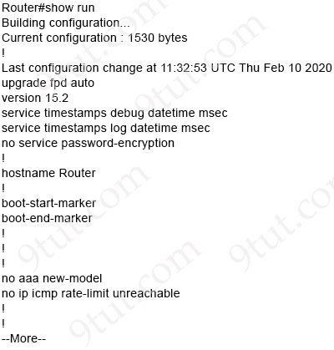
Which minimum configuration items are needed to enable Secure Shell version 2 access to R15?
A. Router(config)#hostname R15
R15(config)#crypto key generate rsa general-keys modulus 1024
R15(config-line)#line vty 0 15
R15(config-line)# transport input ssh
R15(config)#ip ssh source-interface Fa0/0
R15(config)#ip ssh stricthostkeycheck
B. Router(config)#ip domain-name cisco.com
Router(config)#crypto key generate rsa general-keys modulus 1024
Router(config)#ip ssh version 2
Router(config-line)#line vty 0 15
Router(config-line)# transport input all
Router(config)#ip ssh logging events
C. Router(config)#hostname R15
R15(config)#ip domain-name cisco.com
R15(config)#crypto key generate rsa general-keys modulus 1024
R15(config)#ip ssh version 2
R15(config-line)#line vty 0 15
R15(config-line)# transport input ssh
D. Router(config)#crypto key generate rsa general-keys modulus 1024
Router(config)#ip ssh version 2
Router(config-line)#line vty 0 15
Router(config-line)# transport input ssh
Router(config)#ip ssh logging events
R15(config)#ip ssh stricthostkeycheck
Answer: C
Question 9.45
Which protocol uses the SSL?
A. HTTP
B. HTTPS
C. SSH
D. Telnet
Answer: B
Question 9.48
A network engineer is configuring a switch so that it is remotely reachable via SSH. The engineer has already configured the host name on the router. Which additional command must the engineer configure before entering the command to generate the RSA key?
A. password password
B. crypto key generate rsa modulus 1024
C. ip domain-name domain
D. ip ssh authentication-retries 2
Answer: C
Question 9.62
Refer to the exhibit. What must be configured to enable 802.11w on the WLAN?
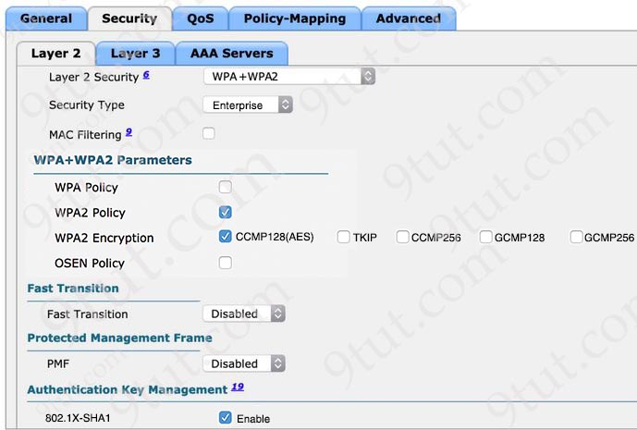
A. Set PMF to Required
B. Enable MAC Filtering
C. Enable WPA Policy
D. Set Fast Transition to Enabled
Answer: A
Question 9.64
Drag and drop the elements of a security program from the left onto the corresponding descriptions on the right.
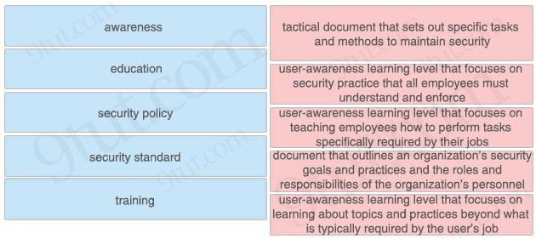
Answer:
+ awareness: user-awareness learning level that focuses on security practice that all employees must understand and enforce
+ education: user-awareness learning level that focuses on learning about topics and practices beyond what is typically required by the user’s job
+ security policy: document that outlines an organization’s security goals and practices and the roles and responsibilities of the organization’s personnel
+ security standard: tactical document that sets out specific tasks and methods to maintain security
+ training: user-awareness learning level that focuses on teaching employees how to perform tasks specifically required by their jobs
Question 9.66
Refer to the exhibit.
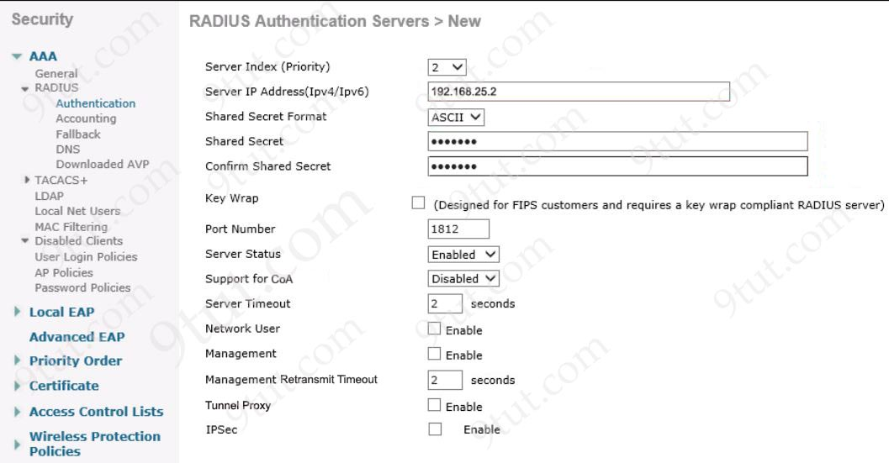
A network engineer configures the Cisco WLC to authenticate local wireless clients against a RADIUS server. Which task must be performed to complete the process?
A. Disable the Server Status option
B. Enable the Management option
C. Enable the Network User option
D. Enable the Support for CoA option
Answer: C
Question 9.71
What is the function of Cisco Advanced Malware protection for next-generation IPS?
A. authorizing potentially compromised wireless traffic
B. URL filtering
C. authenticating end users
D. inspecting specific files and files types for malware
Answer: D
Question 9.72
An administrator must use the password complexity not manufacturer-name command to prevent users from adding “cisco” as a password. Which command must be issued before this command?
A. Password complexity enable
B. confreg 0x2142
C. login authentication my-auth-list
D. service password-encryption
Answer: A
Question 9.74
Which two practices are recommended for an acceptable security posture in a network? (Choose two)
A. Maintain network equipment in a secure location
B. Backup device configurations to encrypted USB drives for secure retrieval
C. Use a cryptographic keychain to authenticate to network devices
D. Place internal email and file servers in a designated DMZ
E. Disable unused or unnecessary ports, interfaces and services
Answer: A E
Question 9.75
Refer to the exhibit.
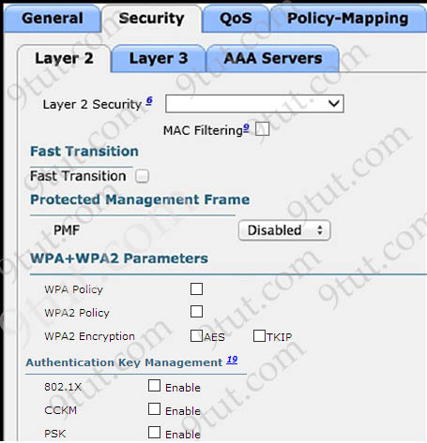
What are the two steps an engineer must take to provide the highest encryption and authentication using domain credentials from LDAP? (Choose two)
A. Select WPA policy with TKIP Encryption
B. Select WPA + WPA2 on layer 2 security
C. Select PSK under authentication key management
D. Select Static-WEP + 802.1x on Layer 2 security
E. Select 802.1x from under authentication key management
Answer: B E
Question 9.78
What is a feature of WPA?
A. 802.1x authentication
B. preshared key
C. TKIP/MIC encryption
D. small Wi-Fi application
Answer: C
Question 9.88
How does authentication differ from authorization?
A. Authentication verifies the identity of a person accessing a network, and authorization determines what resource a user can access.
B. Authentication is used to determine what resources a user is allowed to access, and authorization is used to track what equipment is allowed access to the network
C. Authentication is used to verify a person’s identity, and authorization is used to create syslog messages for logins
D. Authentication is used to record what resource a user accesses, and authorization is used to determine what resources a user can access
Answer: A
Question 9.90
Refer to the exhibit.
ip arp inspection vlan 5-10
interface fastethernet0/1
switchport mode access
switchport access vlan 5

What is the effect of this configuration?
A. Egress traffic is passed only if the destination is a DHCP server.
B. All ingress and egress traffic is dropped because the interface is untrusted.
C. All ARP packets are dropped by the switch.
D. The switch discards all ingress ARP traffic with invalid MAC-to-IP address bindings.
Answer: D
Question 9.101
Drag and drop the functions of AAA supporting protocols from the left onto the protocols on the right.
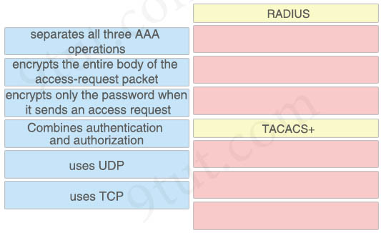
Answer:
RADIUS
+ encrypts only the password when it sends an access request
+ combines authentication and authorization
+ uses UDP
TACACS+
+ separates all three AAA operations
+ encrypts the entire body of the access-request packet
+ uses TCP
Question 9.102
Which two wireless security standards use Counter Mode Cipher Block Chaining Message Authentication Code Protocol for encryption and data integrity? (Choose two)
A. WPA2
B. WPA3
C. WEP
D. WPA
E. Wi-Fi 6
Answer: A B
Question 9.103
What is a practice that protects a network from VLAN hopping attacks?
A. Implement port security on internet-facing VLANs.
B. Configure an ACL to prevent traffic from changing VLANs.
C. Assign all access ports to VLANs other than the native VLAN.
D. Enable dynamic ARP inspection.
Answer: C
Question 10.24
An engineer has configured the domain name, user name, and password on the local router. What is the next step to complete the configuration for a Secure Shell access RSA key?
A. crypto key generate rsa
B. crypto key pubkey-chain rsa
C. crypto key import rsa pem
D. crypto key zeroize rsa
Answer: A
Question 10.25
Which encryption method is used by WPA3?
A. TKIP
B. SAE
C. PSK
D. AES
Answer: D
Question 10.26
An engineer is configuring remote access to a router from IP subnet 10.139.58.0/28. The domain name, crypto keys, and SSH have been configured. Which configuration enables the traffic on the destination router?
A. interface FastEthernet0/0
ip address 10.122.49.1 255.255.255.248
ip access-group 10 in
ip access-list standard 10
permit udp 10.139.58.0 0.0.0.7 host 10.122.49.1 eq 22
B. interface FastEthernet0/0
ip address 10.122.49.1 255.255.255.252
ip access-group 105 in
ip access-list standard 105
permit tcp 10.139.58.0 0.0.0.7 eq 22 host 10.122.49.1
C. interface FastEthernet0/0
ip address 10.122.49.1 255.255.255.252
ip access-group 110 in
ip access-list extended 110
permit tcp 10.139.58.0 0.0.0.15 host 10.122.49.1 eq 22
D. interface FastEthernet0/0
ip address 10.122.49.1 255.255.255.240
access-group 120 in
ip access-list extended 120
permit tcp 10.139.58.0 255.255.255.248 any eq 22
Answer: C
Question 10.31
What is a zero-day exploit?
A. It is when an attacker inserts malicious code into a SQL server.
B. It is when a new network vulnerability is discovered before a fix is available.
C. It is when the perpetrator inserts itself in a conversation between two parties and captures or alters data.
D. It is when the network is saturated with malicious traffic that overloads resources and bandwidth.
Answer: B
Question 10.32
After a recent security breach and a RADIUS failure, an engineer must secure the console port of each enterprise router with a local username and password. Which configuration must the engineer apply to accomplish this task?
Option A  aaa new-model  aaa authorization exec default local  aaa authentication login default radius  username localuser privilege 15 secret plaintextpassword | Option B  username localuser secret plaintextpassword  line con 0  login authentication default  privilege level 15
Option C  username localuser secret plaintextpassword  line con 0  no login local  privilege level 15 | Option D  aaa new-model  line con 0  password plaintextpassword  privilege level 15
A. Option A
B. Option B
C. Option C
D. Option D
Answer: B (?)
Question 10.36
What is the default port-security behavior on a trunk link?
A. It causes a network loop when a violation occurs.
B. It disables the native VLAN configuration as soon as port security is enabled.
C. It places the port in the err-disabled state if it learns more than one MAC address.
D. It places the port in the err-disabled state after 10 MAC addresses are statically configured.
Answer: C
Question 10.38
What are two examples of multifactor authentication? (Choose two)
A. single sign-on
B. unique user knowledge
C. passwords that expire
D. soft tokens
E. shared password responsibility
Answer: B D
Question 10.42
Refer to the exhibit.
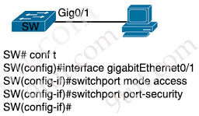
A network engineer started to configure port security on a new switch. These requirements must be met:
– MAC addresses must be learned dynamically.
– Log messages must be generated without disabling the interface when unwanted traffic is seen.
Which two commands must be configured to complete this task? (Choose two)
A. SW(config-if)#switchport port-security mac-address 0010.7B84.45E6
B. SW(config-if)#switchport port-security maximum 2
C. SW(config-if)#switchport port-security mac-address sticky
D. SW(config-if)#switchport port-security violation shutdown
E. SW(config-if)#switchport port-security violation restrict
Answer: B E
Question 10.57
Refer to the exhibit.
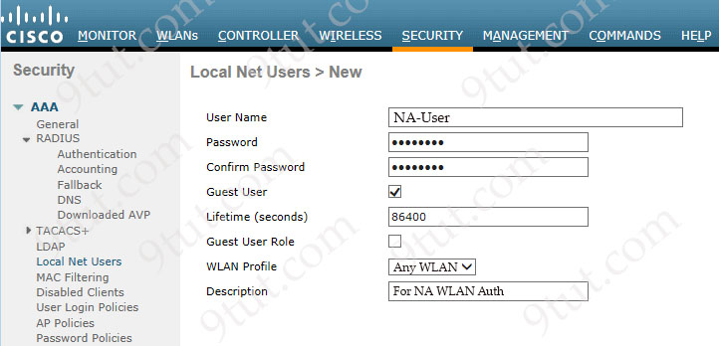
Wireless LAN access must be set up to force all clients from the NA WLAN to authenticate against the local database. The WLAN is configured for local EAP authentication. The time that users access the network must not be limited. Which action completes this configuration?
A. Check the Guest User Role check box
B. Clear the Lifetime (seconds) value
C. Set the Lifetime (seconds) value to 0
D. Uncheck the Guest User check box
Answer: D
Question 10.58
Which remote access protocol provides unsecured remote CLI access?
A. Telnet
B. SSH
C. console
D. Bash
Answer: A
Question 10.59
Refer to the exhibit.
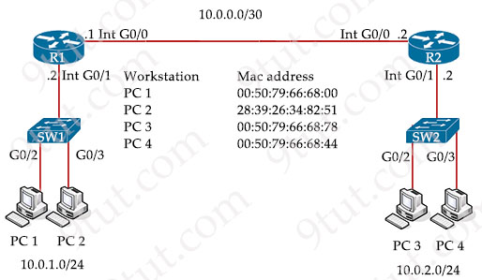
An engineer must configure the interface that connects to PC1 and secure it in a way that only PC1 is allowed to use the port. No VLAN tagging can be used except for a voice VLAN. Which command sequence must be entered to configure the switch?
A. SW1(config-if)#switchport mode nonegotiate
SW1(config-if)#switchport port-security
SW1(config-if)#switchport port-security maximum 1
B. SW1(config-if)#switchport mode access
SW1(config-if)#switchport port-security
SW1(config-if)#switchport port-security mac-address 0050.7966.6800
C. SW1(config-if)#switchport mode dynamic desirable
SW1(config-if)#switchport port-security mac-address 0050.7966.6800
SW1 (config-if)#switchport port-security mac-address sticky
D. SW1(config-if)#switchport mode dynamic auto
SW1(config-if)#switchport port-security
SW1(config-if)#switchport port-security violation restrict
Answer: B
Question 10.73
A network engineer is replacing the switches that belong to a managed-services client with new Cisco Catalyst switches. The new switches will be configured for updated security standards, including replacing Telnet services with encrypted connections and doubling the modulus size from 1024. Which two commands must the engineer configure on the new switches? (Choose two)
A. transport input ssh
B. transport input all
C. crypto key generate rsa general-keys modulus 1024
D. crypto key generate rsa usage-keys
E. crypto key generate rsa modulus 2048
Answer: A E
Question 10.84
Refer to the exhibit.
access-list 10 permit 10.0.0.0 0.0.0.255
interface Serial0
ip access-list 10 in
A network administrator must permit traffic from the 10.10.0.0/24 subnet to the WAN on interface Serial0. What is the effect of the configuration as the administrator applies the command?
A. The sourced traffic from IP range 10.0.0.0 – 10.0.0.255 is allowed on Serial0.
B. The permit command fails and returns an error code.
C. The router fails to apply the access list to the interface.
D. The router accepts all incoming traffic to Serial0 with the last octet of the source IP set to 0.
Answer: C
Question 10.87
Refer to the exhibit.
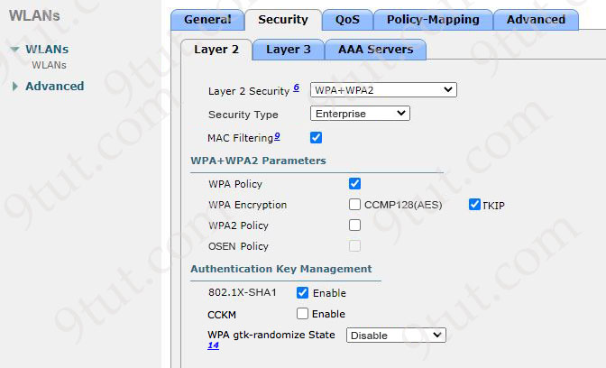
A guest WLAN must be created that prompts the client for a username and password on the local web page of the WLC. Which two actions must be performed on the Layer 2 tab before enabling the Authentication option on the Layer 3 tab? (Choose two)
A. Uncheck the MAC Filtering option check box.
B. Set the Security Type option to Personal.
C. Change the WPA Encryption option from TKIP to CCMP128(AES).
D. Set the Layer 2 Security option to None.
E. Uncheck the WPA Policy option check box, and check the WPA2 Policy option check box.
Answer: A D
Question 10.89
Which IPsec transport mode encrypts the IP header and the payload?
A. pipe
B. tunnel
C. control
D. transport
Answer: B
Question 10.90
What does WPA3 provide in wireless networking?
A. increased security and requirement of a complex configuration
B. backward compatibility with WPA and WPA2
C. optional Protected Management Frame negotiation
D. safeguards against brute force attacks with SAE
Answer: D
Question 10.94
A WLC sends alarms about a rogue AP, and the network administrator verifies that the alarms are caused by a legitimate autonomous AP. How must the alarms be stopped for the MAC address of the AP?
A. Place the AP into manual containment.
B. Remove the AP from WLC management.
C. Manually remove the AP from Pending state.
D. Set the AP Class Type to Friendly.
Answer: D
Question 10.95
Which security method is used to prevent man-in-the-middle attack?
A. authorization
B. authentication
C. anti-replay
D. accounting
Answer: C

