Question 1:

|  |  |
| --- | --- |
| **Requirements** | **Answers** |
| Select destination | The machine should display potential destinations and allow selection |
| Payment method | The machine should allow selection of payment such as Credit Card or QR code payment linked with banking system or digital wallet |
| Credit Card Payment | The machine should accept payment such as Credit Card and issue a paper ticket with a barcode |
| QR Code Payment | The machine should display QR code for digital wallet payment |
| Start button | A start button should be available to initiate the transaction |
| Validate Transaction | The credit card transaction should be validated before issuing the ticket |
| User interface | The machine should have a user-friendly interface for easy selection of destination and payment method |
| Reliable service | The payment processing system should be reliable and consistent |
| Secure payment processing | Secure payment processing should be employed for both credit card and digital payment. |
| Quick transactions | The payment and ticket issuance should be processed quickly |
| Durable hardware | The machine should have durable and robust hardware |
| Multilingual support | The machine should support multiple languages |
| High traffic conditions | The machine should be able to operate in high traffic conditions and extended hours |

Question 2:

Functional requirements:

* Acceptance of Cash and Cards
* Print Tickets
* Dispense Change
* Display Ticket Options
* Cancel Transaction
* Provide Receipt
* Ability to Change Prices

Non-functional requirements:

* User Friendly Interface
* Efficient and Quick Transaction Time
* Reliable and Consistent Service
* Secure Payment Processing
* Durable and Robust Hardware
* Ability to Operate in High Traffic Conditions
* Support Multiple Languages

Domain requirements:

* Tickets options should be limited to local transport.
* Tickets should be available for purchase 24/7
* Machines should be updated regularly.
* Ticket prices should be updated regularly.
* Machines should be accessible for people with disabilities.
* Machines should be placed in secure and highly visible locations.
* Provide customer support and maintenance on an ongoing basis.

Question 3:

Ticket Vendor Machine

Display QR code for Mobile Payment

Issue Paper Ticket

Pay with Digital Wallet

Pay with Credit Card

Select Payment Mode

Select Destination

Question 4:

Start 🡪 Display potential destinations 🡪 Select destination 🡪 Select payment mode 🡪

* If Credit Card is selected:

Enter Credit Card information 🡪Validate credit transaction 🡪 Issue paper ticket 🡪 End

* If QR Code payment is selected:

Display QR Code 🡪 Scan QR Code with mobile device 🡪 Confirm payment 🡪 Issue paper ticket 🡪 End

Question 5:

Class diagram:

Sequence diagram:

State diagram:

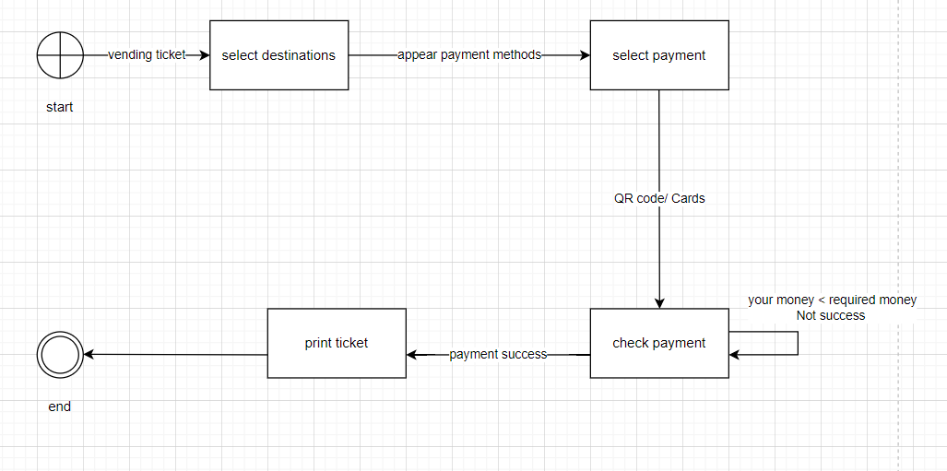

Question 6:

Question 7:

MVC architecture design:

Model

Database

View

Controller

Model: representing the data and the business logic of the system (including Payment, Processing and System Control)

View: representing the user interface of the system (including User interface and ticket printing)

Controller: acting as an interface between the Model and the View components

Development Diagram:

Hardware

MVC

API

Database

Database: stores the data related to the system

API: Provides an interface for the system to communicate with other systems, such as payment gateways.

MVC: the main system components, which includes the Model, View and Controller

Hardware: the physical components of the ticket vendor machine, such as the screen, buttons, and printer.