Congestion Control Specification

1. Congestion Control vs Flow Control
 | Flow control | Congestion control
Variable | rwnd (receive window) | cwnd (congestion window)
Protects | The receiver's buffer | The shared network (Wi-Fi, switches, routers, VPN)
Signal | Free buffer space advertised by the receiver | Packet loss, timeouts, RTT growth
The sender may have at most SWS = min(rwnd, cwnd) packets in flight.
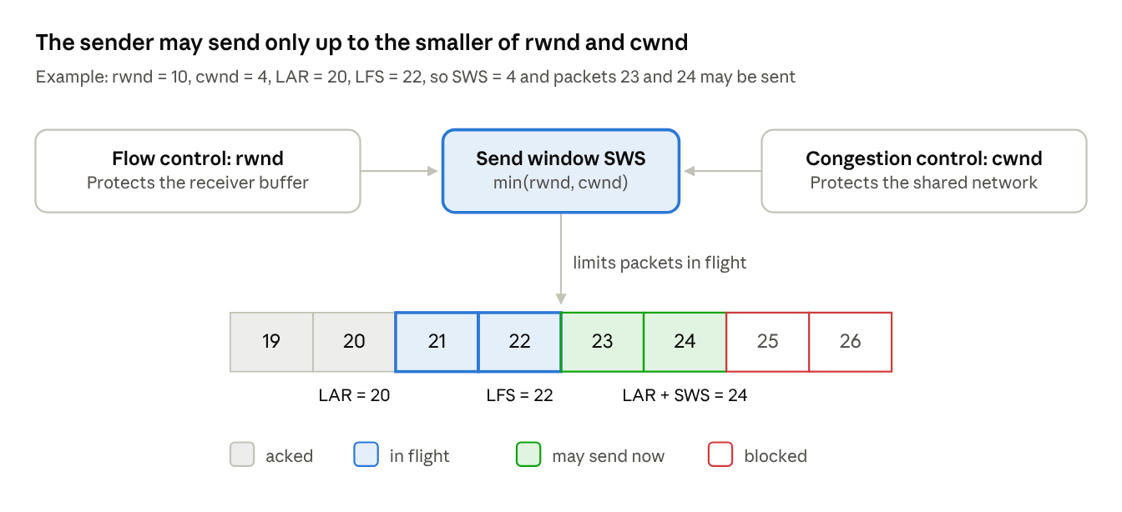
coupled window · rwnd and cwnd limit one sender
The strip shows the worked example from Section 2: packets 21 and 22 are in flight, 23 and 24 may be sent, and 25 is blocked.
Scenarios:
Scenario | Situation | Result
Receiver-limited | Fast LAN, but the receiver has only rwnd = 3 free slots while cwnd = 50 | Sender slows to 3 packets
Network-limited | Receiver has rwnd = 50, but a congested Wi-Fi router allows only cwnd = 4 | Sender sends only 4 packets
Chat during file transfer | A large FILE stream and an urgent MSG stream share one connection | Pacing spreads file chunks so the chat message can be sent at the next tick

2. Coupled Window and Variables
Variable | Name | Meaning
cwnd | Congestion window | Max unacknowledged packets the network can safely carry
rwnd | Receive window | Max unacknowledged packets the receiver can accept
SWS | Send window size | min(rwnd, cwnd)
ssthresh | Slow start threshold | Boundary between fast and cautious growth
LAR | Last ACK received | Highest contiguous packet acknowledged
LFS | Last frame sent | Highest packet sent; rule: LFS <= LAR + SWS
dupACKcount | Duplicate ACK counter | Counts ACKs with SACK-reported gaps; recovery starts at 3
W_max | Pre-loss window | cwnd just before the last loss (used by CUBIC)
BtlBw | Bottleneck bandwidth | Highest measured delivery rate (used for pacing)
RTprop | Minimum RTT | Shortest RTT seen (used for pacing)
Formulas (packets): SWS = min(rwnd, cwnd); inflight = LFS - LAR; allowed to send = SWS - inflight.
Worked example: rwnd = 10, cwnd = 4, LAR = 20, LFS = 22. SWS = 4, inflight = 2, so 2 more packets (23 and 24) may be sent; packet 25 is blocked.

3. Window Growth
Slow start: start with cwnd = 2 and ssthresh = 8. Each ACK adds 1 packet, so cwnd doubles every RTT (2, 4, 8). When cwnd >= ssthresh, switch to congestion avoidance.
Congestion avoidance: either standard AIMD (cwnd grows by 1/cwnd per ACK, about +1 packet per RTT) or CUBIC.
On loss: ssthresh = cwnd = floor(W_max * beta).
- K = cube root of (W_max * (1 - beta) / C).
- W(t) = C * (t - K)^3 + W_max, where t is the time since the loss.

4. Loss Detection and Reaction
Event | Trigger | Action
Mild loss (fast recovery) | 3 duplicate ACKs with SACK blocks, for example ACK = 10 with SACK = [12, 13, 14] | Save W_max = cwnd; ssthresh = cwnd = floor(cwnd * 0.7); retransmit only the missing packet (11)
Severe loss (timeout) | RTO expires with no ACKs | Save W_max = cwnd; ssthresh = max(floor(cwnd * 0.7), 2); cwnd = 1; return to slow start
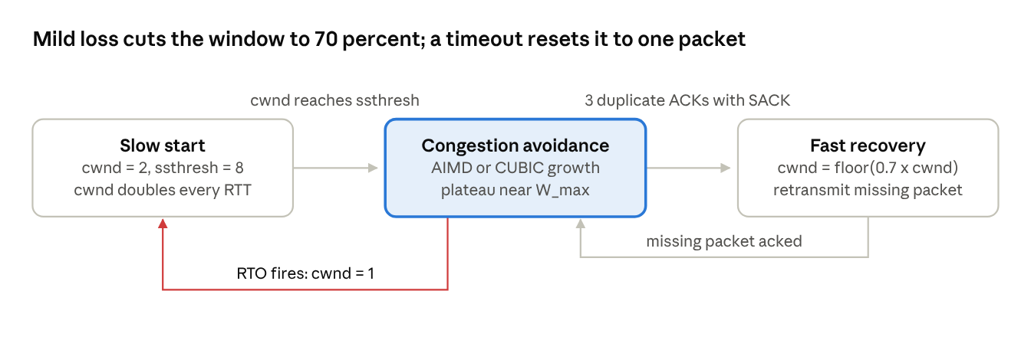
sender phases · 4 states, 3 transitions
A mild loss triggers fast recovery and returns to congestion avoidance once the missing packet is acknowledged; a timeout sends the sender back to slow start.

5. Rate Pacing
Problem: sending a full window in one loop creates a micro-burst that fills router queues and delays any chat message sent right after it.
Pacing spaces packets evenly:
- pacing_rate = pacing_gain * BtlBw (gain 1.0 in steady state)
- interval = packet size / pacing_rate
- Priority rule: at each pacing tick, chat (MSG) frames are sent before file (FILE) chunks.
Example: RTprop = 20 ms, BtlBw = 500,000 B/s, packet = 1,000 B. BDP = 10,000 B (10 packets) and the interval is 2 ms. A chat message created at 3 ms goes out at the 4 ms tick.

6. End-to-End Timeline
Time | Event | State
0.00 s | Start; rwnd = 10 | cwnd = 2, send packets 1-2
0.10 s | ACKs for 1-2 | cwnd = 4, send 3-6
0.20 s | ACKs for 3-6 | cwnd = 8 = ssthresh, switch to CUBIC, send 7-14
0.30 s | Packet 8 lost; 3 duplicate ACKs with SACK | W_max = 8, ssthresh = cwnd = 5, retransmit 8
0.40 s | Packet 8 arrives; receiver buffer shrinks to rwnd = 3 | SWS = min(3, 5) = 3, send 15-17

