Development Environment Setup, Part 3: Github and Browser Sync
(https://www.coursera.org/learn/html-css-javascript-for-web-developers/lecture/4T1t0/development-environment-setup-part-3-github-and-browser-sync)
- git clone https://github.com/ngadk799/HTML-CSS-and-Javascript-for-Web-Developers.git
- ls
- cd HTML-CSS-and-Javascript-for-Web-Developers/
- ls
- git status
- git checkout gh-pages
- git status
- la
- mkdir site – create index.html
- ls
- git status
- cd ..
- git status
- git add .
- git status
- git commit -m “My First page.”
- git status
- git push
- change index.html
- git status
- git add site/index.html
- git status
- git commit -m “Small addition to our page content”
- refresh trang site/ tren web thi k thay uploaded
- git status
- git push

- browser-sync start –server –directory –file “*”

browser-sync the sink as a command you could from the command line. Here I am just pulled it out from my history. Start to start the browser-sync. Start it in server mode. it’ll become like a local HTTP sever for you. --directory it will actually give you a directory listing of the folder( folder called site). --file meaning which files should browser-sync watch for. And if any of those files change, the browser-sync will go ahead and reload those things in the browser. So you don’t have to keep clicking reload over and over again.

Lecture 1: What is HTML?
(https://www.coursera.org/learn/html-css-javascript-for-web-developers/lecture/d5lAy/lecture-1-what-is-html)
HTML: Hypertext Markup Language
- Hypertext is text which contains links to other texts..
- Markup: to mark something up, to annotate the content to tell the browser. eg: tags
- Language: could actually code it up
Technologies That Drive The Web
- HTML: Structure
- CSS: Stype
- Javascript: Behavior

Lecture 3: Anatomy of an HTML tag
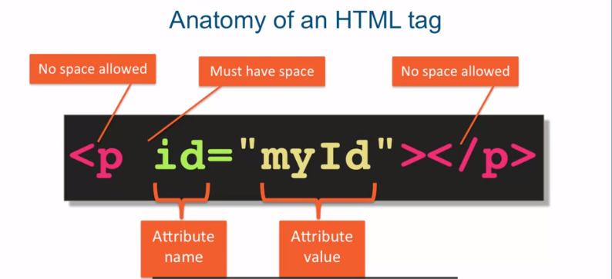

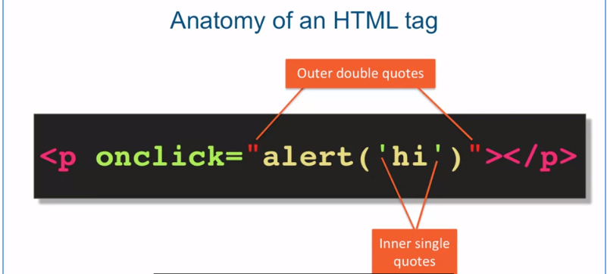

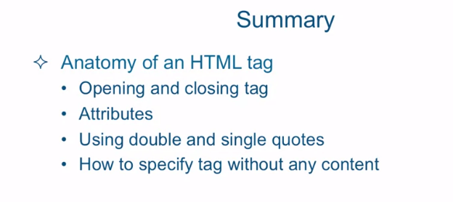

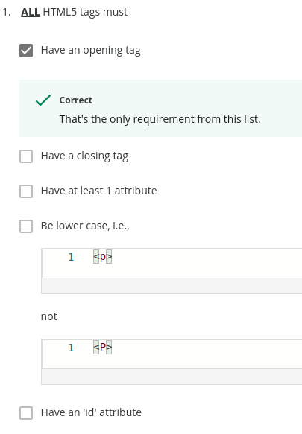

Lecture 11: Power of CSS (Cascading stype sheets)
CSS:
- provides the styling capability.
- works by associating rules with HTML elements.
- Govern how the content of specified elements should be displayed.
- affords us consistency and efficiency is writing CSS code.
- A stylesheet is a collection of CSS rules
CSS Rule consists of:
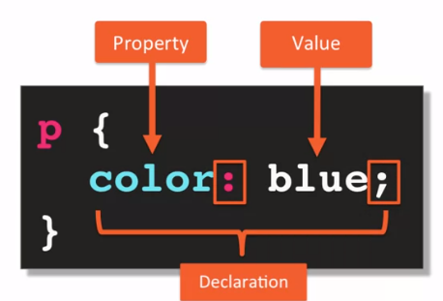
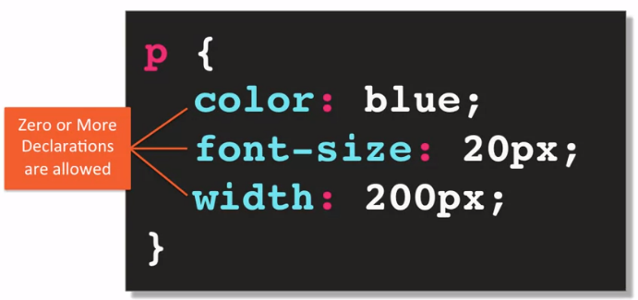

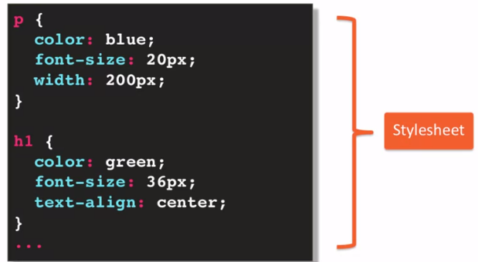
A semicolon is not requirement.

The collection of these CSS rules is what’s called a style sheet.

Lecture 13: Element, Class, ID Selectors
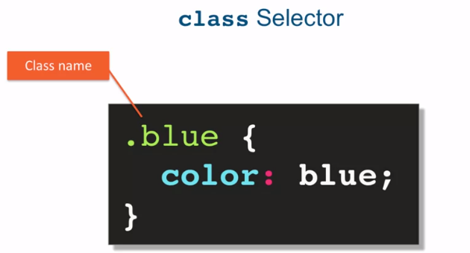
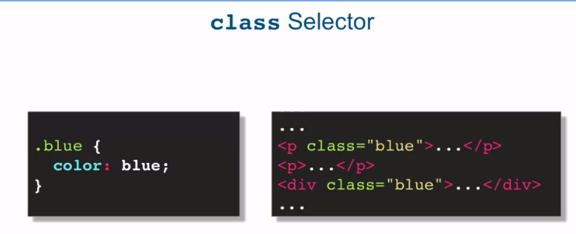

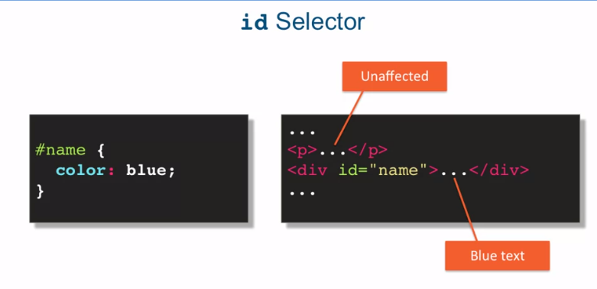

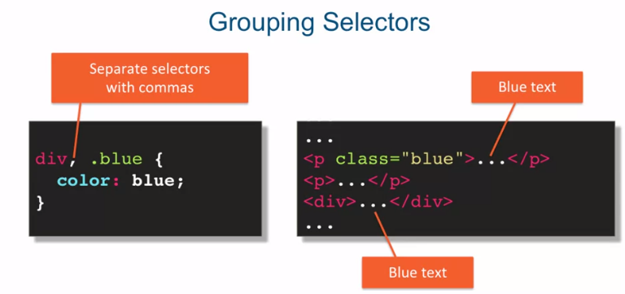
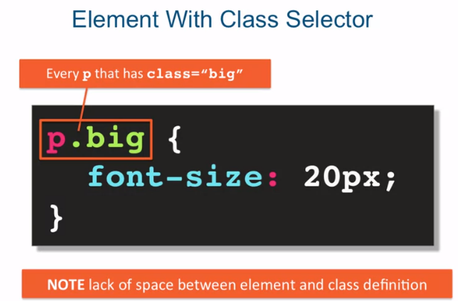
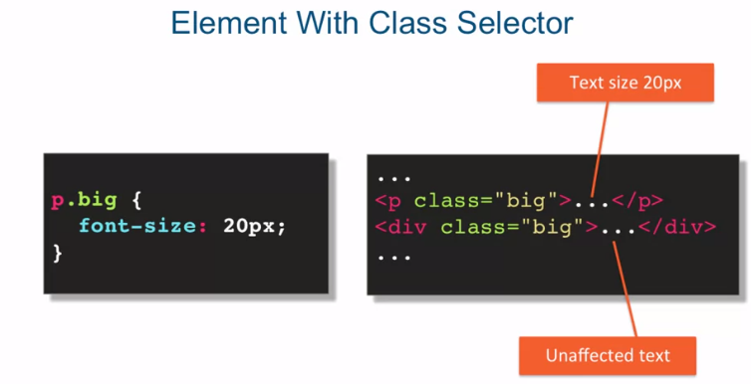
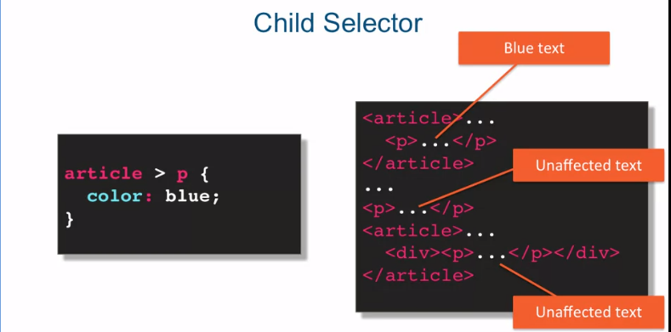
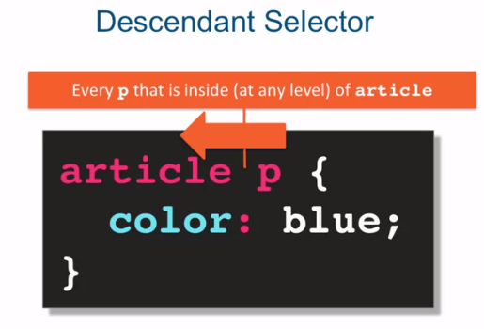

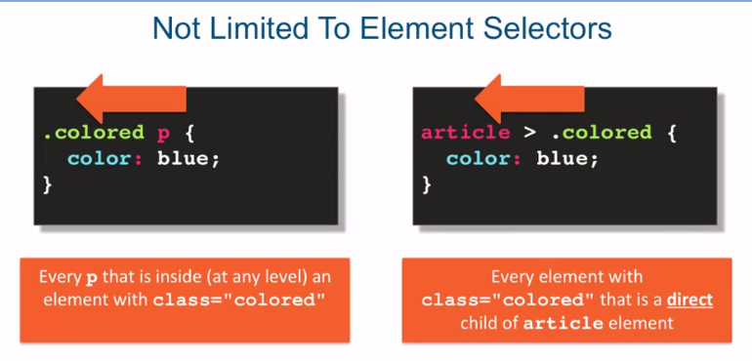

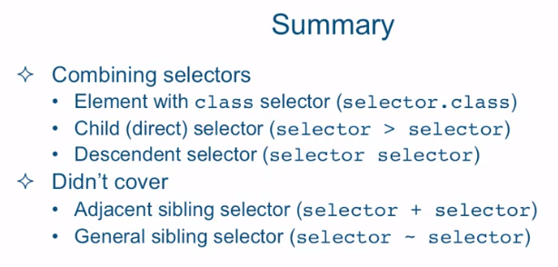

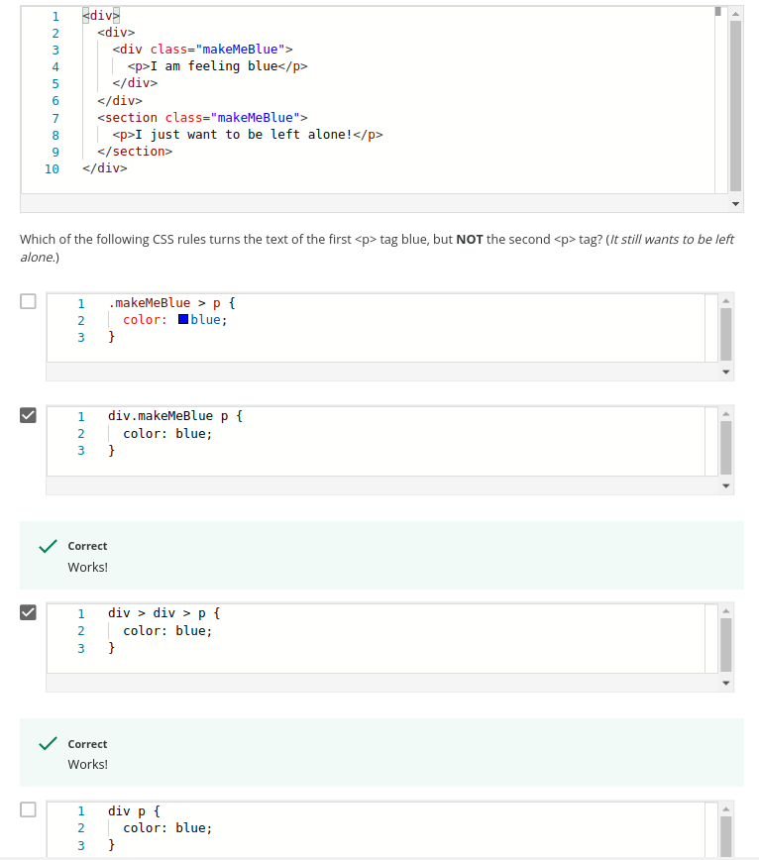

Lecture 15: Pseudo-Class Selectors
Pseudo-class selectors address targeting only the structures that can be targeted by simple combinations of regular selectors, or targeting the ability to style based on user interaction with the page.
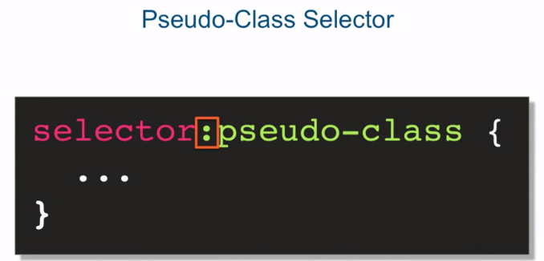
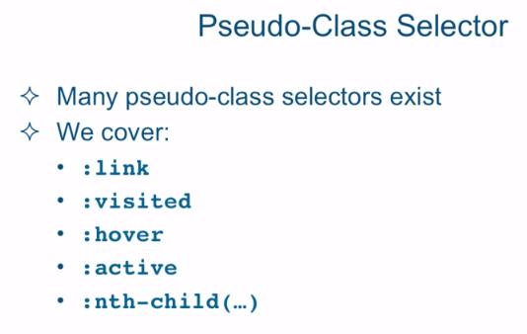

Lecture 17, Part 1: Conflict Resolution
- Concepts surrounding the cascading algorithm: origin, merge, inheritance, specificity, …
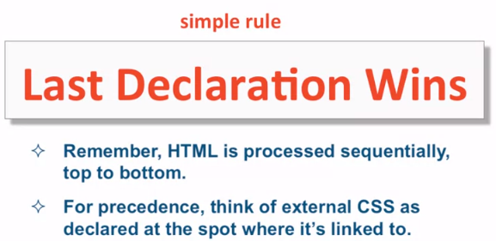

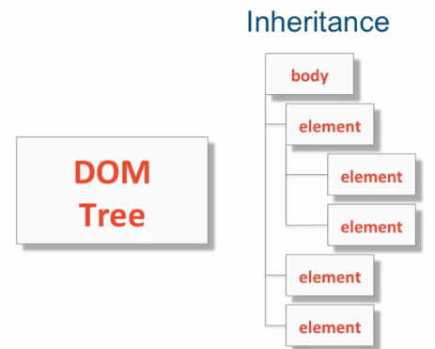
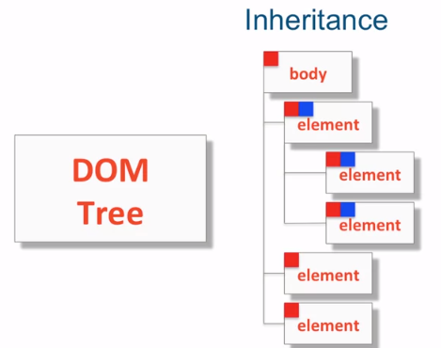

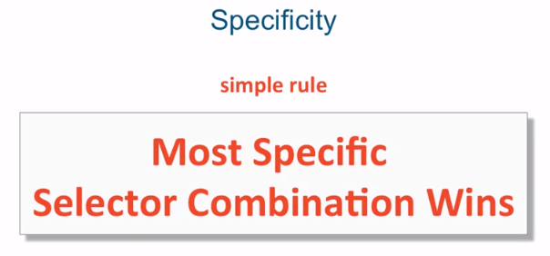
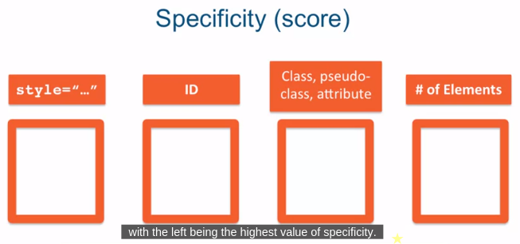

Take your CSS rule and fill in the number of times you see a particular type of selector being used in it's proper location
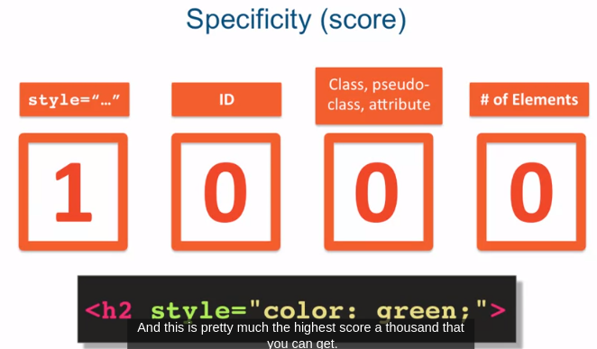
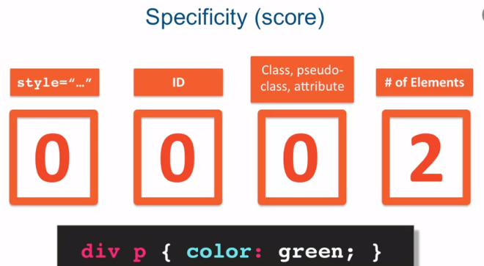

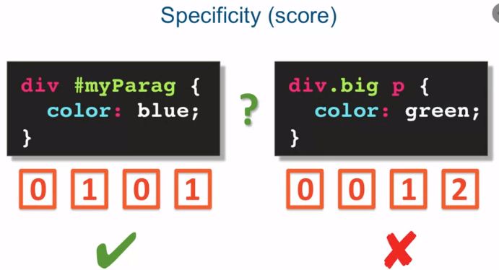

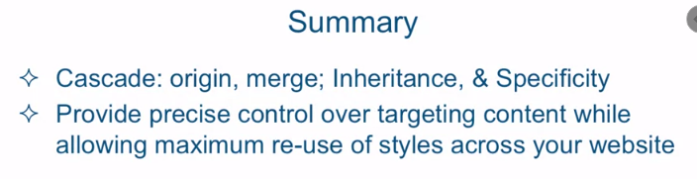

Lecture 19: The Box Model

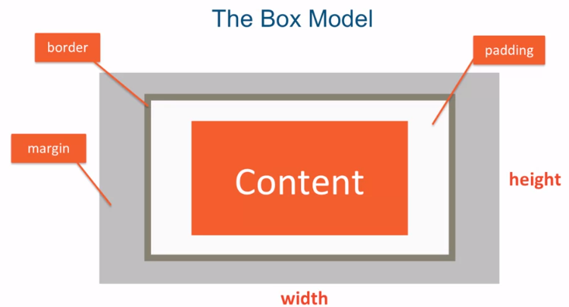

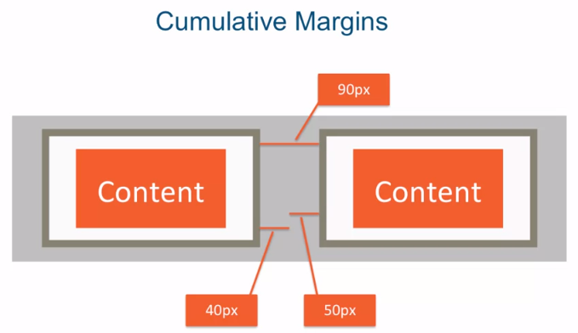
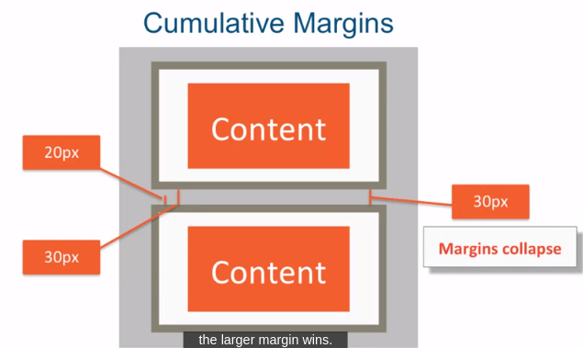

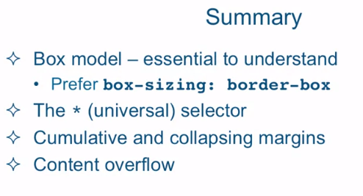

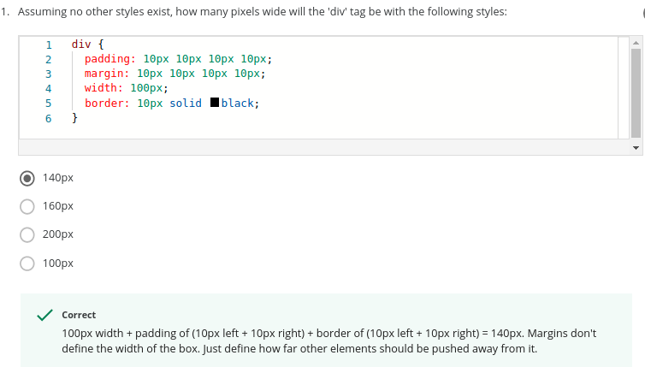
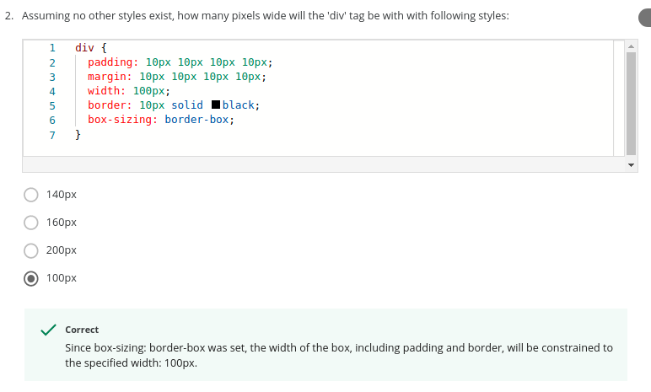

Lecture 21: Positioning Elements by Floating

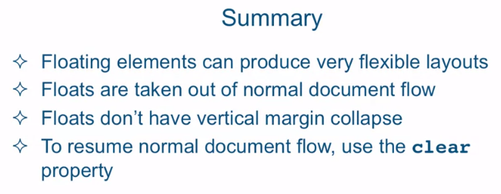

Lecture 22: Relative and Absolute Element Positioning
Relative and Absolute : allow to specify precise offsets to move the target elements to the different part of the page origin.
Alternative: alternative to the normal document flow. The element is positioned relative to its position in the normal document flow. If you were to apply offsets on that element, there will be offset, from the original normal document flow position of that element. when you position element as relative you're basically creating like an anchor for the offsets. So the elements top, bottom, left, and right edges become the boundaries from which you offset the element. The important thing to know about relative position is that the element that is set to relative positioning is not taken out of normal document flow. In fact even if it's moved by using the offsets, its original spot is preserved
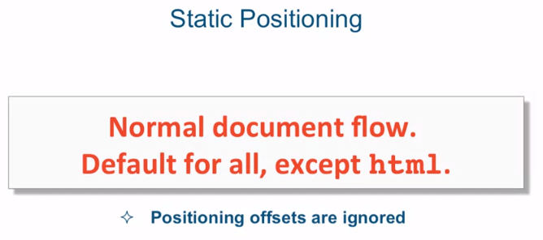
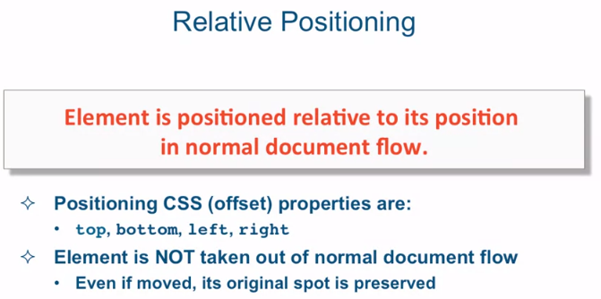

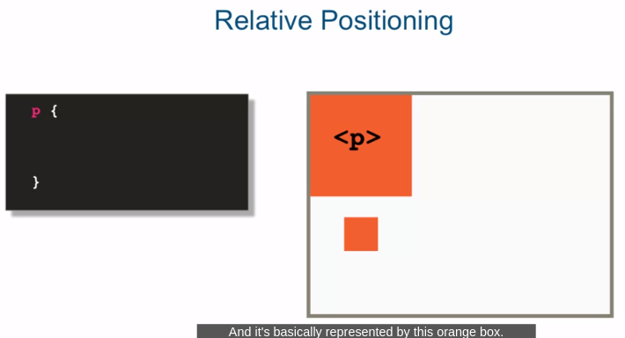
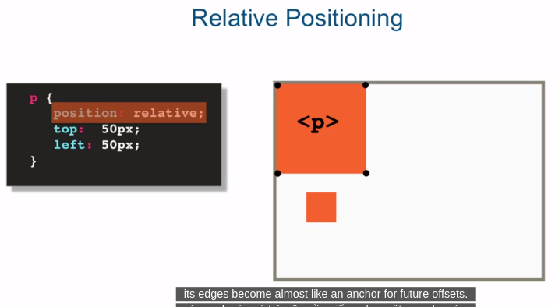

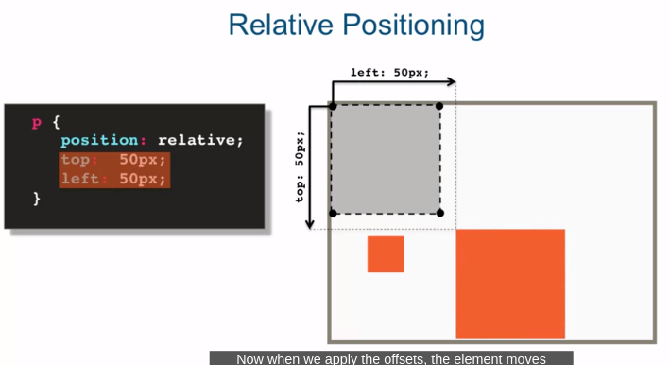
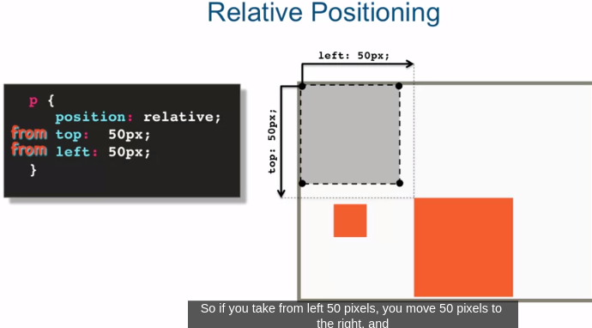

As soon as we set position: relative on the element, its edges become almost like an anchor for future offsets. Now when we apply the offsets, the element moves relatively to its original position in the normal document flow. So in this case it's moving top 50 pixels and left 50 pixels. Now these values might be a little bit confusing since we're saying left 50 pixels but yet we're moving the element to the right. So the way you could think about these offsets is really not top or left but more like from the top and from left. So if you take from left 50 pixels, you move 50 pixels to the right, and if you take from top 50 pixels, you're really removing 50 pixels from the top. Also note that nothing really changed about the document. And other than this element moving. The original space for that element still remains and the originally laid out elements around that element still remain exactly the same, because they think the element is still sitting in its original spot.
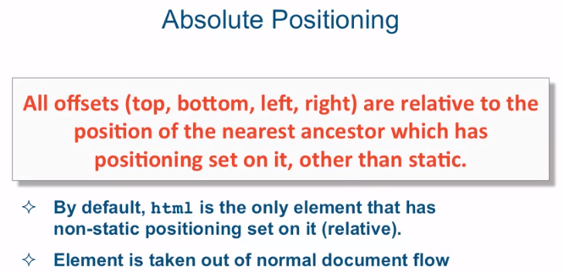
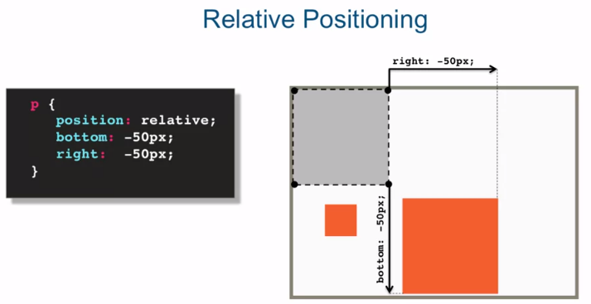

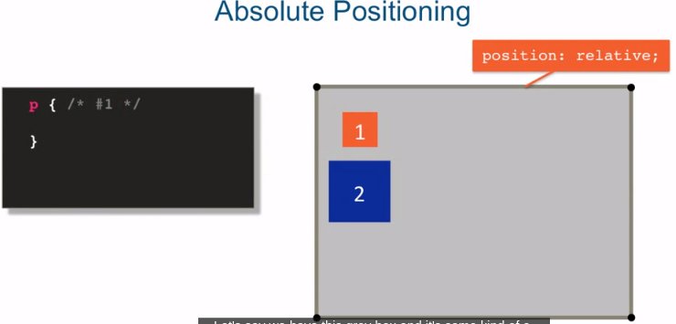
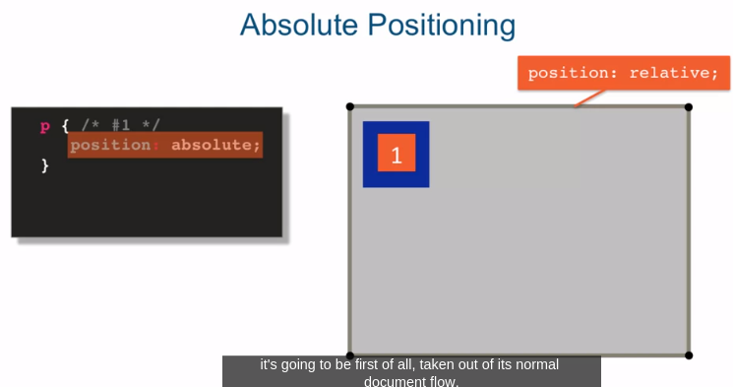
We have this gray box and it's some kind of a container element and it's position is set to relative. Then we have this box number one, that's the one we're going to target and some kind of box number two, some other element that's box number two. So if we set the position absolute on number one, what's going to happen is, it's going to be first of all, taken out of its normal document flow. And it's going to remain in the place where it was without any other offsets. So as you can see in this illustration, element two moved up underneath element one since element one is no longer part of the document flow. Element two doesn't think it's even there.

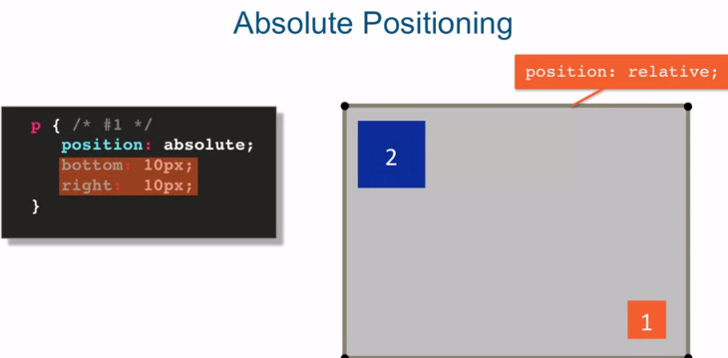
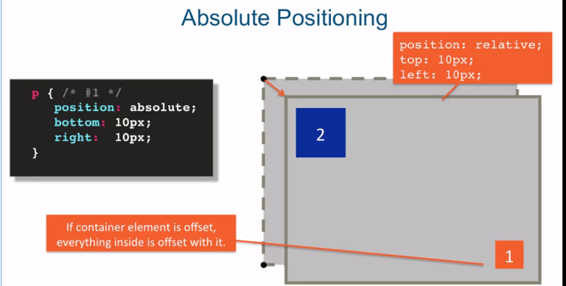
Now if we do some offsets, and in this case we're doing bottom right offsets, we're going to be relative to our container elements, since that container element's position is set to relative. And we're going to do from bottom 10 pixels, and then from right 10 pixels over. And that's how we end up with this number 1 box being in the bottom right of our container element.
A really cool feature of this combination is, that if your container element, is itself offset, everything inside of that container is offset with it. So you could set our particular layout with a container element. And then move that container element, or offset it all around the screen, without worrying about having to offset particular values, of every element within that container element.
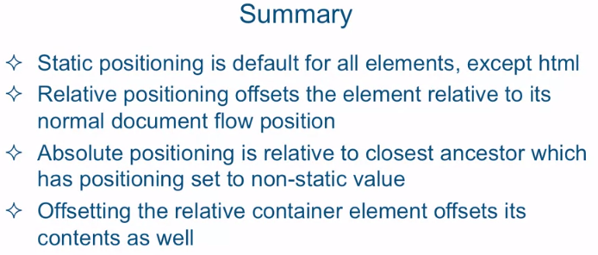
in summary, static positioning is default for all elements, except html. Html actually has it's positioning set to relative. Relative positioning offsets the element relative to it's normal document flow position. And the normal document flow is not affected what so ever, by moving or offsetting the relative position element.
Absolute positioning is relative to it's closest ancestor which has positioning set to a non-static value, which is either absolute or relative. The important thing to remember about absolute positioning is that the element is taken out out of it's normal document flow. And the rest of the elements basically behave as if that element doesn't exist.
Also you saw, offsetting the relative container element offsets its contents as well, which gives you great flexibility to move around a whole set of elements and not just one.

Lecture 23: Media Queries
Media queries allow you to group styles together and target them to devices based on some criteria.
For example, you can target a device by its width, its height, or orientation like landscape or portrait. Of course one of the most obvious differences between viewing a website on a desktop browser and your cell phone is the screen size. Remember that using CSS you have the power to produce very different web page layouts from the same HTML.
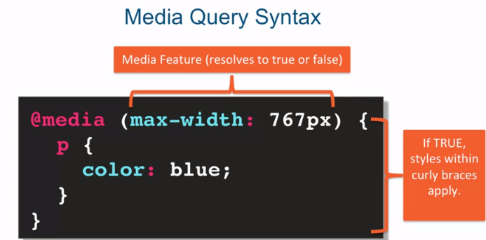
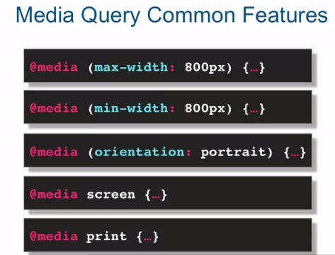

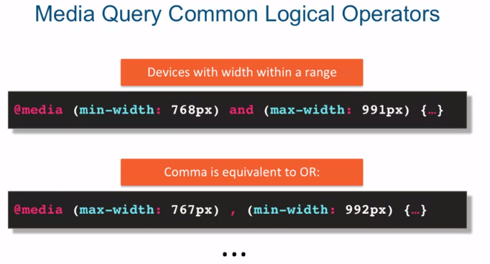

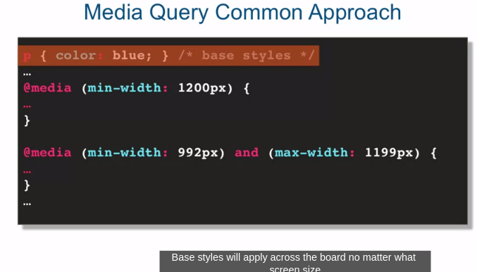
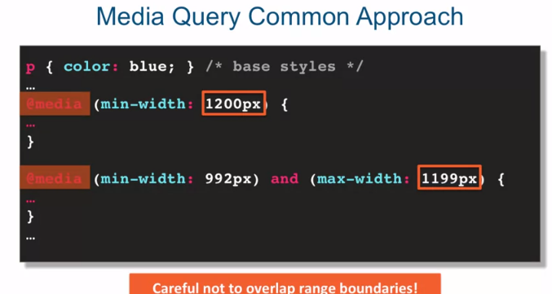
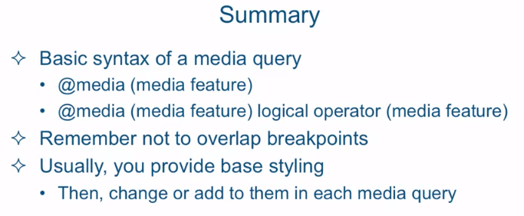

Lecture 24: Responsive Design
Responsive design was born primarily out of the need to deal with the explosion of mobile devices that started being able to browse the web much in the same way that a desktop browser user browsed the web.
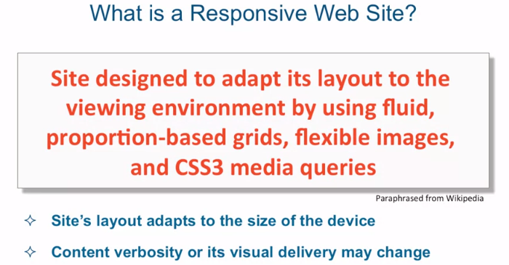
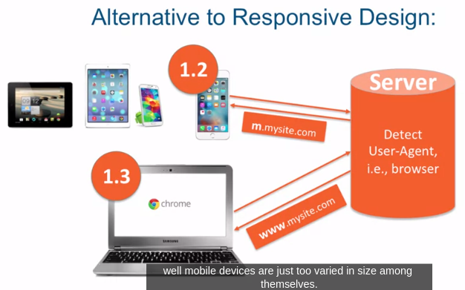

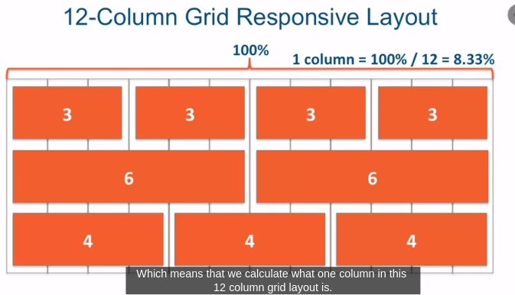
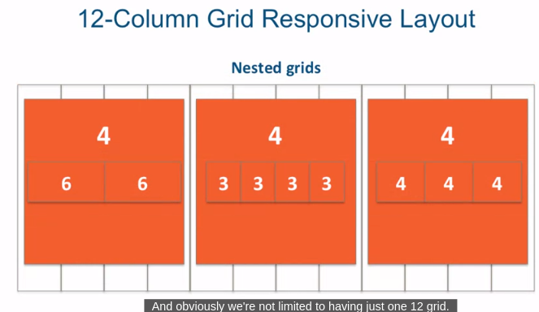

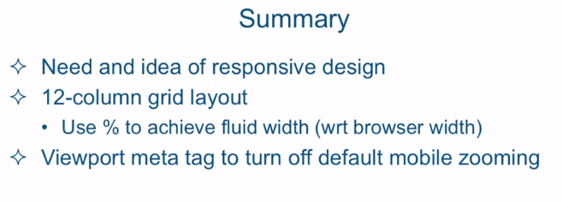

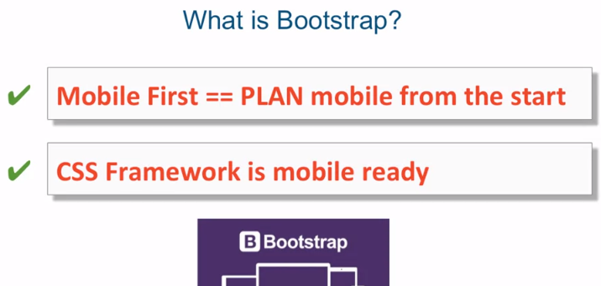
Lecture 25: Introduction to Twitter Bootstrap

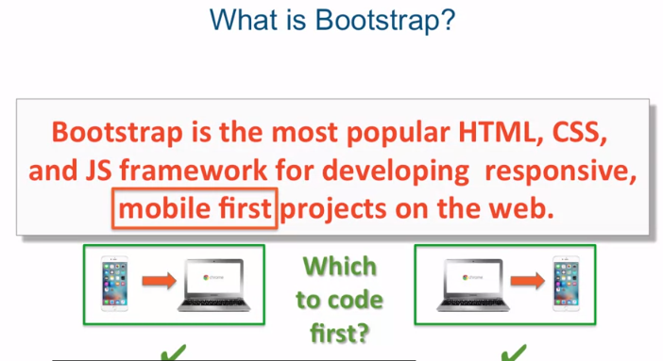

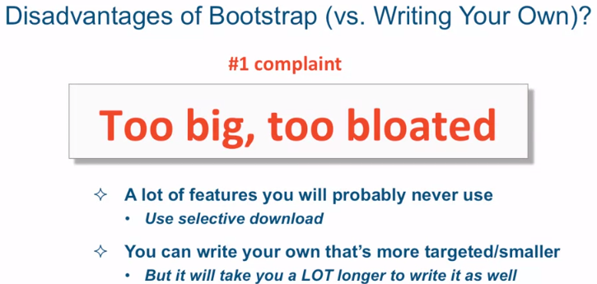

Lecture 41: Defining Variables, Function, and Scope
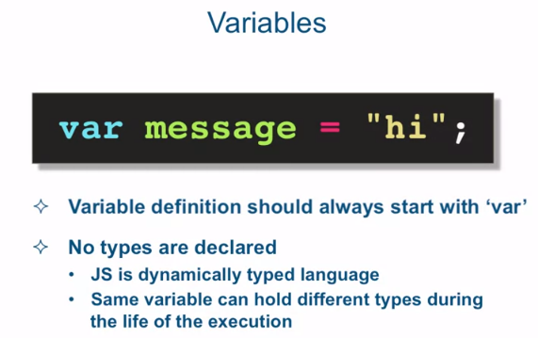
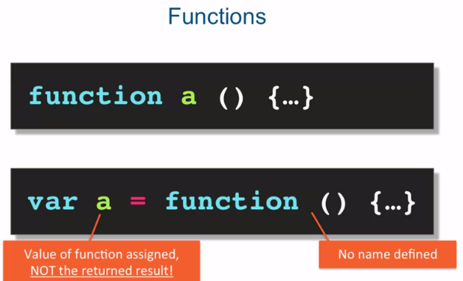
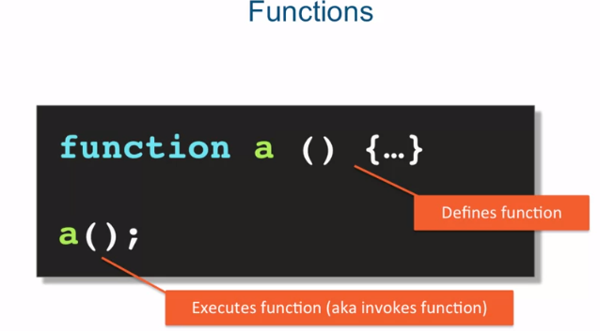

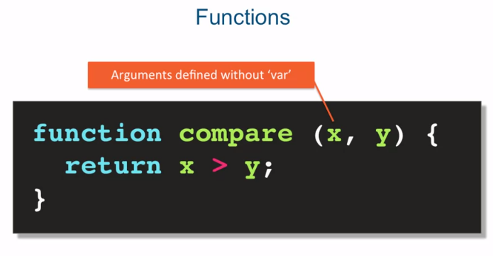

Now each function or variable lives within a particular scope. In JavaScript there's really two scopes, global scope and function, or otherwise known as lexical scope.
Now variables and functions defined in a global scope are available everywhere. Meaning any other functions that are defined in a global scope and so on can get access to these globally defined functions and variables. As far as function and lexical scope, variables and functions defined here are available only within this function.

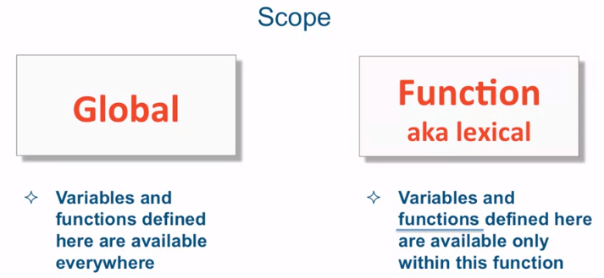
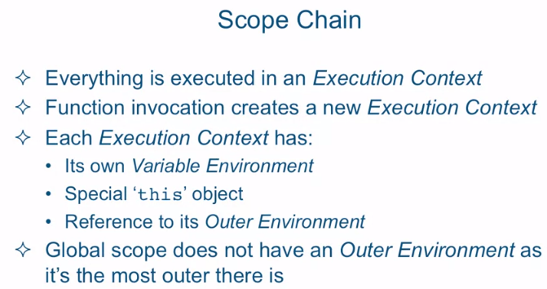

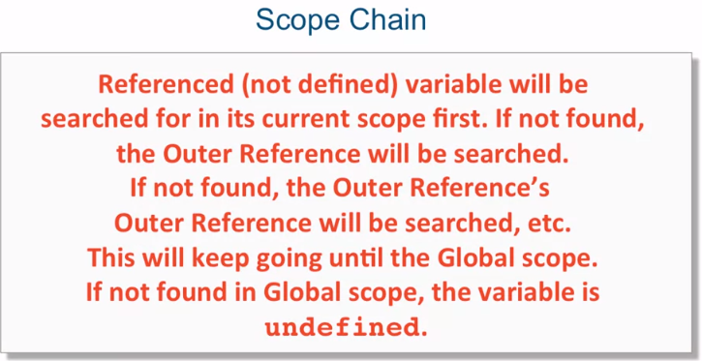
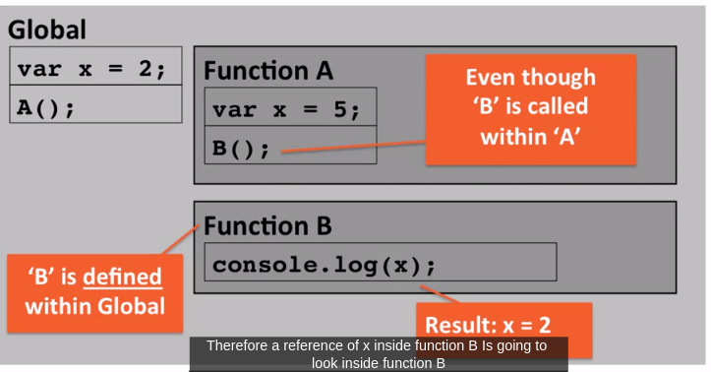

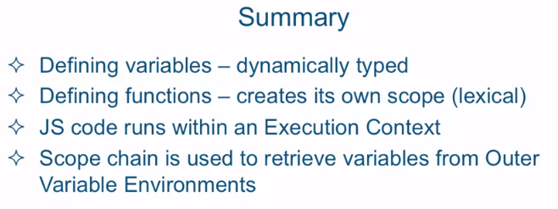

Lecture 42: Javascript Types
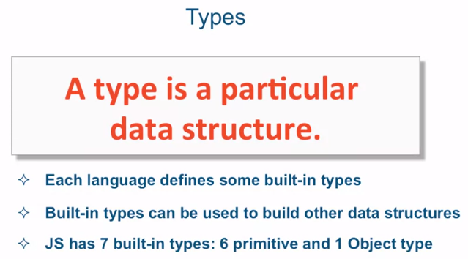

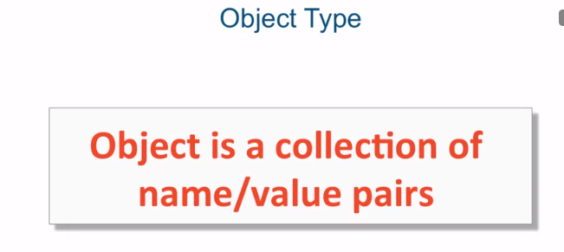
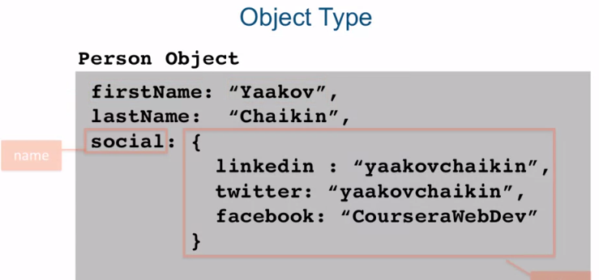
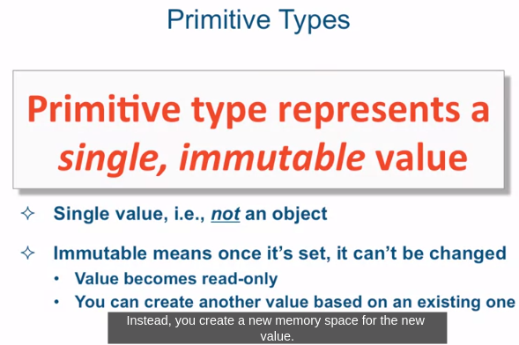
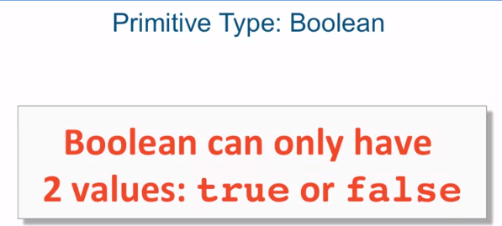

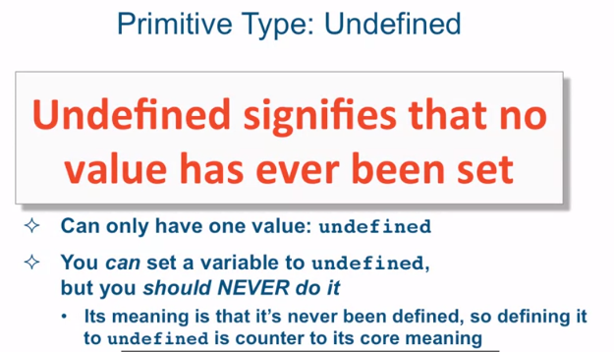
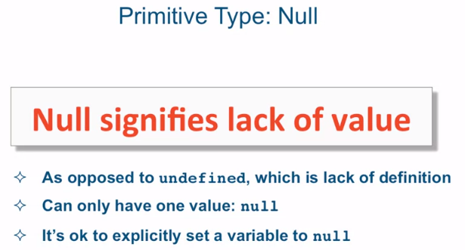

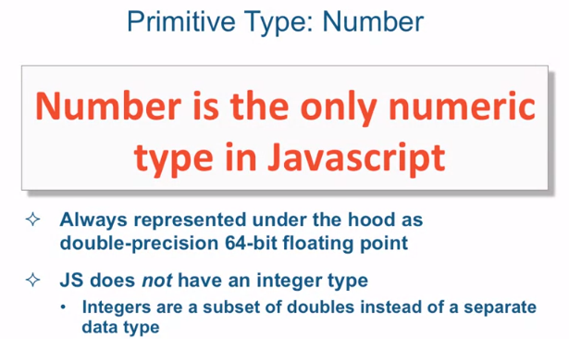
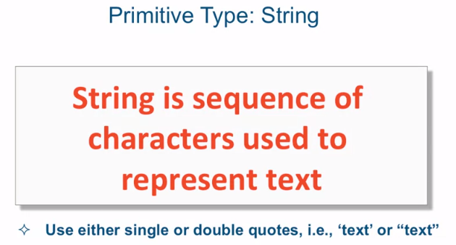
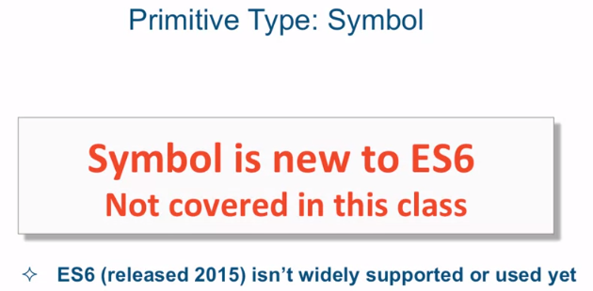
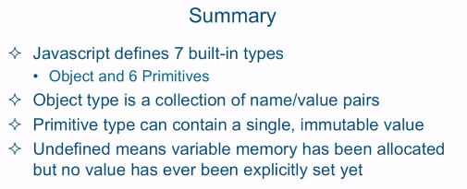

Lecture 43: Common Language Constructs

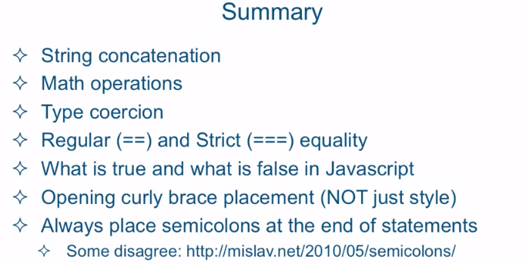

Lecture 47: Passing Variables by Value vs. Reference


