Radar Signal Processing Toolbox

1st Van Minh Duong   
*Falcuty of Radio-Electronic Engineering*  
*Le Quy Don Technical University*Hanoi, Vietnam  
minhktqs2008@gmail.com

2nd Thi Phuong Nguyen  
*Falcuty of Radio-Electronic Engineering*  
*Le Quy Don Technical University*Hanoi, Vietnam  
phuongnt@lqdtu.edu.vn  
  
3rd Van Manh Nguyen  
*The Institude of System Integration*  
*Le Quy Don Technical University*Hanoi, Vietnam  
vanmanh.isi@lqdtu.edu.vn

*Abstract*—The typical of most of signals in the engineering world is inconsistent with time, meaning that the frequency or spectral contents are not changing with respect to time. Detection and analysis those signals ask for many attempt, but the Fourier transform (FT) efficiently extracts frequency featurse to distinguish one signal form others. But it is not enough due to still lossing the spatial and temporal information of the signals. To deal with that, the time-frequency techniques were introduced, giving a comprehensive description of signals in time-frequency planes. Some typical time-frequency analysis methods, i.e., the short-time Fourier transform (STFT), continuous wavelet transform (CWT), Wigner-Ville distribution (WVD), and the Hilbert-Huang transform (HHT), were used to extract useful information, but performed separately. At our best knowledge, there has not been an integrated toolbox yet for analysing nonstationary signals. For that reason, we design a toolbox integrating many signal processing techniques. This tool is easy to use and very helpful for training students in laboratory. More importantly, It is a good preprocessing tool for signal processing methods using Convolutional Neural Network (CNN). In this paper, the toolbox is built, then tested with variety of signals. At the end, compared with the other methods, we find that the … is the technique get highest performance with shortest computational time and highest arccuracy, is a good approach for feature extraction in nonstationary signal processing.

Keywords—non-stationary signal, signal processing, toolbox, FFT, STFT, CWT, WVD, HHT

# Introduction

Processing of non-stationary signals separately in the time domain or in the frequency domain does not provide sufficient information as their spectral properties change over time. Time-frequency signal processing (TFSP) is a technique in which the two natural variables time (*t*) and frequency (*f*) are utilized concurrently, while traditional signal processing methods use either time *t* or frequency *f* independently. The Fourier transform [1] of signal *x(t)* (Eq. 1) presents for a typical traditional method working effectively in describing the signal in frequency domain, but it is not effective to observe the relationship between the time and frequency characteristics of the engineering signals.

 (1)

 (2)

TFSP is developed to overcome this problem of non-stationary signals. Beside to revealing a time-dependent energy distribution information, TFSP has successfully been applied in the estimationof parameters related to the analyzed signals. The basic idea of TFSP is to design a function, which can describe the characteristics of signals on a joint time-frequency plane [2]. Studies on TFSP have played an important role in research field; and many time-frequency representations were presented, and approved that they are good in non-stationary signal analysis. However, at our best knowledge, they are studied independently and there has not been an integrated toolbox designed until now. In this paper, we integrated five typical time-frequency techniques, i.e., the FFT, the STFT, CWT, WVD, and HHT as a toolbox and evaluated how it works. The paper is organized as follows. Section 2 will give an overview of five signal processing methods. The toolbox will be described and its performnace will studied in Section 3. At the end, an inconclusion and the final remarks will be drawn.

# Well-known Signal Processing Techniques

## Fast Fourier Transform

A fast Fourier transform (FFT) [3] is an [algorithm](https://en.wikipedia.org/wiki/Algorithm) that computes the [discrete Fourier transform](https://en.wikipedia.org/wiki/Discrete_Fourier_transform) (DFT) of a sequence *x[n]*  to reduce the computational complexity of DFT.

 (3)

 (4)

Spectral analysis techniques based on FT through FFT are efficient for analysis of signals with stationary characteristics; but not with non-stationary ones. For nonstationary operation, it is more difficult to determine the amplitude or frequency of the signal, since these quantities may vary over time, so it is helpful to introduce the concept of instantaneous amplitude and frequency[4]. To deal with these issues, TFSP methods are introduced combining time and frequency separating represention into a single representation, which presents how the spectral content of a signal changing over time and is a more appropriate tool for non-stationary signal analysis [2, 5].

## Short-time Fourier Transform

STFT is one of the techniques used in non-stationary signal  
analysis [6]. In this case, the signal is placed in two domains, time and frequency. The analysis gives information on when and which frequencies change. However, it is limited to the size of the window, which will be set the same for all frequencies [5]. The STFT of a signal *x(t)* and its inversion are described as:

  (5)

 (6)

## Wingner-Viller Distribution

Another widely used technique for non-stationary signal analysis is the Wigner-Ville distribution (WVD). The WVD achieves better time-frequency joint resolution compared to any linear transform; however, it suffers from a cross-term interference problem, which does not represent any signal information, i.e., the WVD of two signals is not the sum of their individual WVDs [6, 7]. The WVD of the signal *x(t)* and its inversion can be described as:

 (7)

 (8)

## Continuous Wavelet Transform

In this context of TFSP is introduced, the wavelet transform in order to deal with the window limitation of the STFT, and overcome the interference problems of the WVD. The CWT was proposed in order to overcome the limitation of the window length in STFT. The wavelet transform uses a variable window, where the resolutions vary along the time-frequency plane, so as to obtain all the information contained in the signal [8]. The CWT of the signal *x(t)* as follows:

 (9)

 (10)

where 

In (4), the term *ψ*(t)* is a continuous function in both the time domain and the frequency domain called the mother wavelet. The factor 1/√a ensures the normalization of energy to any scale.

## Hilbert-Huang Transform

A new time-frequency analysis method called HilbertHuang transform (HHT) was presented by Norden E.Huang et al in 1998. The HHT contains two important parts: empirical mode decomposition (EMD) and Hilbert transform [9]. First, the EMD is used to obtain the intrinsic mode function (IMF). Then Hilbert transform may be applied to obtain a time-frequency-amplitude distribution, i.e., the Hilbert spectrum [10]. A great  
contribution of HHT is that it can obtain the  
instantaneous frequency feature of the signals from the  
Hilbert spectra [11]. The target signal *x(t)* can be  
expressed as the sum of IMF *ci* (i=1,2,3,…,n) and the  
residue component *rn* after the EMD, i.e.,

 (11)

Imposing Hilbert transform on each IMF component,  
the Hilbert spectrum of *x(t)* can be obtained by taking the  
real part of the sum of the Hilbert transform results [12].  
Thus, the instantaneous frequency of signals is,

 (12)

# Signal Analysis Using toolbox

## Design of toolbox

Toolbox includes two part: the control panel and the display of simulation results. In the control panel part, the source of signals, type of analyzed signals and techniques, as well as parameters can be found. In the display part, signal in time domain, spectrum in frequency domain, or time-frequency images will be shown.

### Source of signals

With this toolbox, we set two types of source for signals. Signals may come from MATLAB, in which their parameters can be set as the Fig. 1, including carrier frequency, amplitude, and signal-to-noise ratio.etc. The second source of signal is from a generator. Types of analyzed signals are CW, AM, FM, LFM and…

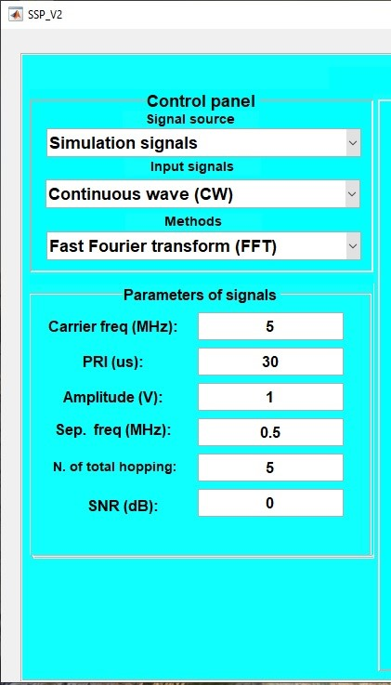

1. Control panel of toolbox

### Techiniques

The techniques we integrate into the tools as we mentioned in the Section 1.

## Simulation results

After choosing the source of signal, type of input signal and method being used, setting parameters, the simulation is run and results will be shown near by. Fig.2 and Fig. 3 is an example of analysing LFM from MATLAB, using WVD techniques. In Fig. 2, the left size is the signal in time and frequency domain from transmitter, and the right side is the signal received.

Fig. 3 shows images of LFM signal after applying the WVD method. The result indicates that even with additioning of noise, the signal is still detected successfully.

1. The LFM signal with and without noise

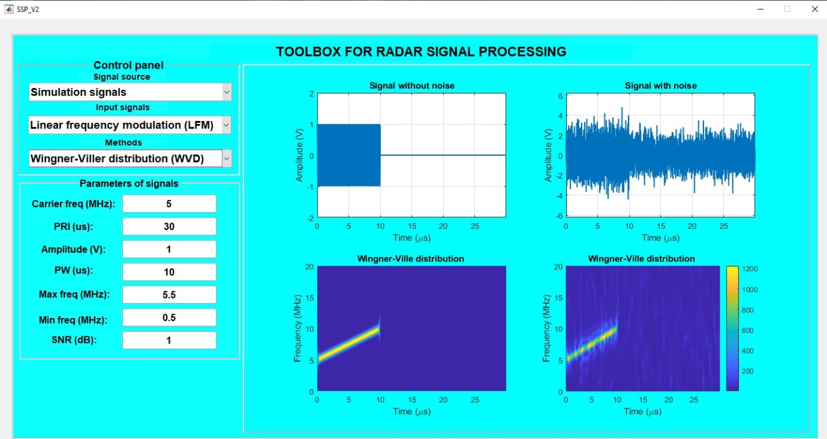

1. Time-frequency image of LFM signal

1. LFM image before and after flitering

After studying with different signals, different SNR levels with different techniques, we found that technique… is get the highest performance. Tab. 1 shows a comparison between techniques.

1. Performance comparison of techniques

| Techniques | Features | | |
| --- | --- | --- | --- |
| Execution Time | Accuracy |  | |
| FFT |  |  |  | |
| STFT |  |  |  | |
| WVD |  |  |  | |
| CWT |  |  |  | |
| HHT |  |  |  | |

# Conclusion

Recently, following the rapid development of deep learning algorithms which are artificial neural networks (ANN) with more than three layers, researchers combined the ability of TFSP methods to simultaneously represent a signal in both time and frequency domains, and the ability of deep networks to be trained and learn complex structures without manual feature extraction procedures. In recent years, TF images have been frequently utilized to train deep learning-based architectures [98,99]. Convolutional neural networks (CNN) are a type of  
deep learning architecture which are widely used in image processing applications. From a TF perspective, energy distribution resulting from any TF or TS analysis method may be treated as an image and used to train a CNN. Recently, state-of-the-art applications have been presented where images obtained by CWT, STFT, WVD, HHT, and other methods are used to train various CNN architectures to solve complex classification problems [99,103,106–111].

##### References

1. Steven T. Karris. *The Fourier transforms.* In *Signals and system with MATLAB computing and Simulink model,* 3rd, Orchard Publications, ISBN-10:0-9744239-9-8.
2. X. Zhang, “The analysis and processing of nonlinear signals,” National Defence Industry Press, Beijing, 1998.
3. J. W. Cooley, P. A. W. Lewis and P. D. Welch, "The Fast Fourier Transform and Its Applications," in IEEE Transactions on Education, vol. 12, no. 1, pp. 27-34, March 1969, doi: 10.1109/TE.1969.4320436.
4. J.L. Rojo-Alvarez, M. Martınez-Ramon, J.M. Mar, G. CampsValls, *Digital signal processing with Kernel methods* (Wiley Online Library, New York, 2018).
5. P. Flandrin, *Explorations in time-frequency analysis* (Cambridge  
   University Press, Cambridge, 2018).
6. Sivakumar, S. and Nedumaran, D. Discrete Time-Frequency Signal Analysis and Processing Techniques for Non-Stationary Signals. *Journal of Applied Mathematics and Physics*, **6**, 2018.
7. Damira, M., Victora, S. and Car Zlatana, B. Optimizing the Reference Signal in the Cross Wigner-Ville Distribution Based Instantaneous Frequency Estimation Method. *Procedia Engineering*, 100, 2015.
8. P.S. Addison, *The illustrated wavelet transform handbook:  
   introductory theory and applications in science, engineering,  
   medicine and finance* (CRC press, Boca Raton, 2017).
9. S. Mallat, “A Theory for Multi-Resolution Signal Decomposition Wavelet Representation,” IEEE Trans. On Pattern Analysis and Machine Intell. 11(7), 674-693, 1989.
10. N.E. Huang, M. Wu, S. Long, S. Shen, et al. “A confidence limit for the empirical mode decomposition and hilbert spectral analysis,” Proc. R. Soc. Lond. A, vol. 459, no. 2037, pp. 2317-2345, 2003.
11. P. Flandrin, G. Rilling, and P. Goncalves, “Empirical mode  
    decomposition as a filter bank,” *IEEE Sig. Proc. Lett.*, vol.  
    11, no. 2, pp. 112–114, 2004.
12. Z. Wu, N.E. Huang, “Ensemble empirical mode  
    decomposition: A noise-assisted data analysis method,” Adv.  
    Adapt. Data Anal, 2009, 1(1):1-41.
13. M. Varanis, R. Pederiva, Wavelet time-frequency analysis with  
    daubechies filters and dimension reduction methods for fault  
    identification induction machine in stationary operations. in  
    *Proceedings of the 23rd ABCM International Congress of  
    Mechanical Engineering (Cobem2015)*, (2015)
14. 106. M. Varanis, R. Pederiva, The influence of the wavelet filter in the  
    parameters extraction for signal classification: An experimental  
    study. Proc. Ser. Braz. Soc. Comput. Appl. Math. **5**(1) (2017)
15. 107. M. Varanis, R. Pederiva, Statements on wavelet packet energy–  
    entropy signatures and filter influence in fault diagnosis of  
    induction motor in non-stationary operations. J. Braz. Soc. Mech.  
    Sci. Eng. **40**(2), 98 (2018)