An Integrated Toolbox of Time-Frequency Techniques for Preprocessing in AI Networks

1st Trung Thanh Nguyen  
*Falcuty of Radio-Electronic Engineering  
Le Quy Don Technical University*Hanoi, Vietnam  
[thanhmta@gmail.com](mailto:thanhmta@gmail.com)

2nd Van Minh Duong   
*Falcuty of Radio-Electronic Engineering*  
*Le Quy Don Technical University*Hanoi, Vietnam  
minhktqs2008@gmail.com

3rd Thi Phuong Nguyen  
*Falcuty of Radio-Electronic Engineering*  
*Le Quy Don Technical University*Hanoi, Vietnam  
[phuongnt@lqdtu.edu.vn](mailto:phuongnt@lqdtu.edu.vn)

4th Van Manh Nguyen  
*The Institude of System Integration*  
*Le Quy Don Technical University*Hanoi, Vietnam  
vanmanh.isi@lqdtu.edu.vn

*Abstract* –Recently, the artificial neural networks has been widely used in classifying signals with high accuracy and without manual feature extraction procedures. Additionally, time-frequency (TF) images, simultaneously presenting signals in both time and frequency domains, have been frequently utilized as inputs to train convolutional neural network (CNN). Some typical TF analysis techniques, i.e., the short-time Fourier transform (STFT), continuous wavelet transform (CWT), Wigner-Ville distribution (WVD), and the Hilbert-Huang transform (HHT), have been approved the ability to solve complex classification problems in CNN-based architectures. However, those techniques were considered separately, and one network commonly uses only one technique for some types of signals. There is no tool to evaluate of which TF techniques are the best for which signals. This paper integrates a TF analysis toolbox to deal with that problem. From then, it will be an essential preprocessing step in CNN-based architectures to enhance the performance of classification.

Keywords – Joint time-frequency images, signal preprocessing, FFT, STFT, CWT, WVD, HHT, signal clasification

# Introduction

Modulation classification is an essential step to identify the modulation format of the received signal with little prior knowledge. With an outstanding model, CNN is a promising tool for identifying signal modulation. To do that, CNN-based architectures will treat the joint time-frequency (TF) images of signals received utilizing TF analysis techniques as the inputs for extraction procedures. The TF analysis method represents a signal in both time and frequency [1]. Thus, it provides more information than other 1-D methods (time or frequency).

Several TF analysis methods have been proposed to analyze radar signals, including, but not limited to, the STFT, CWT, HHT, WVD, and so on. These methods have been used effectively in modulation classification applications with various types of communication and radar signals. Zhang et al. [2] examined linear frequency modulation (LFM), non-linear frequency modulated, and frequency shift keying (FSK) signals using WVD with SNR ≥ 0dB to get low error rate for amplitude and frequency modulation (AM), (FM), FSK, and phase shift keying (PSK) signals were recognized using STFT in [3] with SNR ≥ 2dB to reach high accuracy (≥ 90%). Besides, Wang et al. studied more types of signals, such as BPSK, single frequency (SF), etc., but it still used STFT techniques, and the SNR threshold in this research is 6dB. In [4], in addition to the common radar signals mentioned, they also studied more with Costa FSK using WVD, and their minimum SNR was -2dB. Xiao et al. [5] studied CW, BPSK (binary), QFSK (quadrature), BPSK, and QPSK but still used the STFT-based technique, and SNR is better with -8dB of the threshold. In [6], the CWT was applied to recognize several radar signals: continuous wave (CW), LFM, SFM, and phase coded. The high accuracy they can achieve when SNR ≥ 0dB. Kohler et al. [7] also used the CWT technique for modulation classification, but the SNR threshold is higher, equal to 5dB. The efficiency of CWT was also confirmed with communication signals (ASK, PSK, PSK, and QAM) in [8].

# It can be seen that TF analysis techniques have been paid much attention to and studied a lot. However, to our best knowledge, they are studied independently, and an integrated toolbox has not been designed until now. Also, in the existing research, they did not mention execution time or make any specific comparisons to choose the most suitable technique for each type of signal. Moreover, they only recognized one type of signal from noise, not a mixture of each other. In this paper, we integrate five typical TF techniques, i.e., the FFT, the STFT, CWT, WVD, and HHT, as a toolbox and evaluate how it works and the performance of techniques related to computational time and SNR threshold with a single type of common radar signals and a mixture of them, i.e., two LFMs, a CW and an LFM, or a BPSK and an LFM. The toolbox is a promising preprocessing phase for CNN-based architecture in modulation classification. The paper is organized as follows. Section 2 will give an overview of five signal processing methods. The signal model will be introduced in Section 3. Section 4 describes the toolbox, and its performance will be evaluated. In the end, an conclusion and the final remarks will be drawn.

# Well-known Signal Processing Techniques

## Fast Fourier Transform

A fast Fourier transform (FFT) [9] is an [algorithm](https://en.wikipedia.org/wiki/Algorithm) that computes the [discrete Fourier transform](https://en.wikipedia.org/wiki/Discrete_Fourier_transform) (DFT) of a sequence *x[n]*  to reduce the computational complexity of DFT. It opened a new era for signal processing and still has been applied in many fields of communication and radar.

 (1)

 (2)

Spectral analysis techniques based on FT through FFT efficiently analyze signals with stationary characteristics; but not with non-stationary ones. To deal with these issues, TF analysis methods are introduced, combining time and frequency separating representation into a single representation, which presents how the spectral content of a signal changing over time and is a more appropriate tool for complex signal analysis [10].

## Short-time Fourier Transform

STFT is one of the powerful techniques used in non-stationary signal analysis. In this case, the signal is placed in two domains, time and frequency. The distinction between STFT and traditional FT is that STFT divides the signal into multiple sections for analysis, each of which is considered stationary. However, it is limited to the window size, which will be set the same for all frequencies [11]. The STFT of a signal *x(t)*and its inversion are described as:

  (3)

 (4)

## Wingner-Viller Distribution

Another widely used technique for non-stationary signal analysis is the Wigner-Ville distribution (WVD). The WVD achieves better joint TF resolution compared to any linear transform; however, it suffers from a cross-term interference problem, nonlinear frequency modulation signal, PSK and FSK, which does not represent any signal information, i.e., the WVD of two signals is not the sum of their individual WVDs [12]. The WVD of the signal *x(t)* and its inversion can be described as:

 (5)

 (6)

## Continuous Wavelet Transform

In the context of TF analysis, the wavelet transform is introduced to deal with the window limitation of the STFT and overcome the interference problems of the WVD. The CWT was proposed to overcome the limitation of the window length in STFT. The wavelet transform uses a variable window, where the resolutions vary along the time-frequency plane, to obtain all the information in the signal [13]. The CWT of the signal *x(t)*is as follows. In (7), the term *ψ*(t)* is a continuous function in both the time domain and the frequency domain, called the mother wavelet. 1/√a ensures the normalization of energy to any scale.

 (7)

 (8)

where 

## Hilbert-Huang Transform

Another TF analysis method is called Hilbert Huang transform (HHT). The HHT contains two critical parts: empirical mode decomposition (EMD) and Hilbert transform [14]. A significant contribution of HHT is that it can obtain the instantaneous frequency feature of the signals from the Hilbert spectra. The target signal *x(t)* can be expressed as the sum of *ci* (i=1,2,3,…,n) and the residue component *rn* after the EMD.

 (9)

Imposing Hilbert transform on each component, the Hilbert spectrum of *x(t)* can be obtained by taking the real part of the sum of the Hilbert to transform results. Thus, the instantaneous frequency of signals is,

 (10)

# Signal Model

The previous section gave the literature on five common TF methods that will be integrated into the toolbox. This section will show the model of the signal and a list of analyzed signals.

The analyzed signal after receiving from a transmitter is generally modeled by:

 (11)

where *n(t)* is the noise. It can be the additive white Gaussian noise (AWGN) or Rayleigh random noise, and *s(t)* is the modulated signal which can be given by:

 (12)

where *a(t*) is the instantaneous amplitude, and *φ(t)* is the  
generalized instantaneous phase, and *ω* is the carrier angle  
frequency. The differences of *a(t )* and *φ (t)* represent different  
modulations.

This paper examines several typical signals in radar and communication applications, including CW, Radio-pulse, AM, FM, LFM, and 13-Barker BPSK, Costas frequency coding, and mixtures of two LFMs, an LFM and a CW, and an LFM and a BPSK. Clearly, more types of signals can be added to the toolbox in the future, depending on the research purpose and the applications.

# The Joint time-frequency toolbox

The above sections present an overview of what will be integrated into the toolbox, and types of signals will be evaluated. The toolbox will be described in more detail in this section, and some simulation results will be illustrated. After that, a comparison in terms of time and SNR performance between TF techniques for each type of signal will be made.

## Design of toolbox

The The toolbox interface includes two parts: the control panel and the display of simulation results.

In the control panel part, the source of signals, type of analyzed signals, TF analysis techniques, and parameters of analyzed signals can be found. With this toolbox, we set two types of sources for signals: simulation signals from MATLAB and recorded signals generated from a real-time signal generator. Firstly, signals may come from MATLAB, where their parameters can be set, including carrier frequency, SNR, pulse repetition interval (PRI), amplitude, etc. Note that SNR is the most crucial parameter. To evaluate the performance of techniques, SNR will be tuned in a range to find out at which value the technique still help to calculate the correct frequency. The second signal source is a real-time generator PSG E8267C, which operates in the frequency range from 250 kHz to 20 GHz and produces different signals. In this case, the parameters of a signal can be adjusted directly in the generator. The signals after receiving will be saved as *.csv* files and then input to the tool for processing. In addition, the computational time is also shown for each simulation, which helps us to consider the time performance of the techniques. The techniques we mentioned in Section II will be integrated into the tool.

In the display part, the signal in the time domain, TF images before and after filtering will be shown (Fig. 2 and Fig. 3). Note that the TF image outputted from the technique is put into an adaptive threshold binarization and higher order statistics [15] to eliminate more noise to give a higher quality image.

## Simulation results

After choosing the signal source, type of input signal, the method being used, and setting parameters, the simulation is run, and results will be shown nearby. Fig.1, Fig. 2, and Fig. 3 are examples of analyzing LFM from MATLAB and a real-time generator using WVD techniques. In Fig. 1, the above is the LFM signal without noise in time, the TF image before and after filtering. The below indicates the LFM signal in the White and Rayleigh noise. It can be seen that with the SNR = -8dB with a computation time is about 6000 ms, the LFM signal with noise is still recognized clearly as the case without noise, using the WVD technique. Fig. 2 shows images of the LFM signal from the real-time generator after applying the WVD method. Like the simulation case, the real-time LFM signal can be observed successfully. Fig. 3 shows images of a mixture of an LFM and a BPSK signal in addition to White and Rayleigh noise with different SNR= - 6dB and -7 dB. It can be seen that with SNR = - 6dB with a computation time is about 7000 ms, the LFM signal is still displayed clearly, while it disappeared at SNR = -7dB run in 17000 ms. In conclusion, adding more complex noise will increase the SNR threshold and computation time. Also, we need more time to get the result when the SNR increases.

After studying different techniques with different signals in ranges of SNR levels (from -10dB to 10dB), we conclude results as Tab. 1. Tab. 1 shows that for each type of signal, the most suitable TF technique will be found. In particular, WVD is the best TF method for analyzing most signals with the lowest SNR threshold (SNR = -6dB), except the CW signal. The CWT technique is the right one for CW with the minimum SNR (SNR = 0dB); even compared to other signals using the same CWT, CW gets the highest SNR threshold. CWT works well most with the 4-FSK signal (SNR = -6dB). If time consumption is also considered, the FFT is the best option for most signals (t < 60ms). It is easy to understand when FFT is the best case among the five techniques about the SNR threshold but is the worst in computational time. Meanwhile, STFT and CWT should be considered when requiring a short time and a low SNR threshold.

# Conclusion

The paper proposed a TF toolbox serving as the preprocessing step, which is essential in CNN-based architectures for modulation classification. The toolbox helps researchers choose a suitable TF analysis method for the analyzed signal. In general, if recognization is the priority, the WVD is the most suitable, while the FFT is the best for the computation time. If both categories are considered, STFT or CWT can be picked up. The following research direction is that a CNN will be built and perform the classification with typical radar signals received from real-time generators.

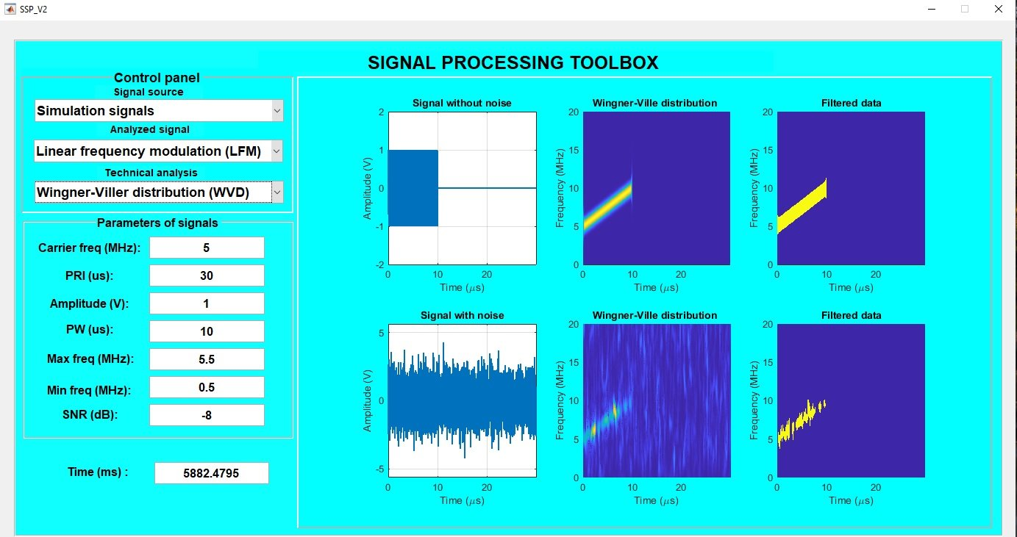

1. The simulated LFM signal analysis using WVD technique: signal without noise (above) and with White noise (below)

1. The real-time LFM signal analysis using WVD technique

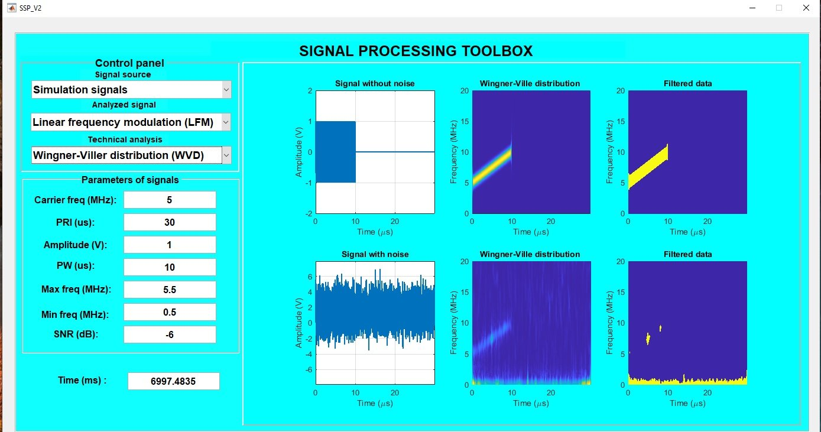

1. The simulated LFM signal analysis using WVD technique with White and Rayleigh noise at: SNR = -6dB (above) and SNR = -7dB (below)
2. Performance comparison of techniques

|  |  |  |  |  |  |  |  |  |  |  |
| --- | --- | --- | --- | --- | --- | --- | --- | --- | --- | --- |
|  | FFT | | STFT | | WVD | | CWT | | HHT | |
| Time (ms) | SNR  (dB) | Time  (ms) | SNR  (dB) | Time  (ms) | SNR  (dB) | Time  (ms) | SNR  (dB) | Time  (ms) | SNR  (dB) |
| CW | **11.84** | 3 | 79.23 | 0 | 7522.36 | -5 | 5982.03 | **1** | 174.20 | 6 |
| Radio-pulse | **8.87** | 3 | 271.07 | 0 | 6785.63 | **-6** | 3307.70 | -2 | 380.96 | 8 |
| AM | **31.29** | 6 | 93.90 | 6 | 6010.12 | **-6** | 4331.76 | -2 | 295.13 | 5 |
| FM | **10.06** | 6 | 244.23 | 6 | 6041.58 | **-6** | 1737.98 | -2 | 118.6 | 5 |
| LFM | **59.26** | 0 | 109.66 | 4 | 6720.76 | **-6** | 2302.57 | -2 | 349.11 | 5 |
| Barker 13 | **10.98** | 0 | 60.74 | 4 | 7198.03 | **-6** | 3818.12 | -2 | 532.49 | 5 |
| Costas frequency | **15.26** | 0 | 53.19 | 4 | 6972.29 | **-6** | 2347.08 | -2 | 377.34 | 5 |
| 2 LFMs | **-** | - | 66.63 | -2 | 6564.11 | **-4** | 915.06 | 4 | 569.01 | 8 |
| CW and LFM | **-** | - | 74.64 | 4 | 6222.68 | **-4** | 961.24 | 8 | 490.07 | 10 |
| BPSK and LFM | **-** | - | 75.38 | 4 | 6057.65 | **-4** | 1012.25 | 2 | 644.79 | 10 |

##### References

1. S. Qian and D. Chen, “Joint time-frequency analysis,” *IEEE  
   Signal Processing Magazine*, vol. 16, no. 2, pp. 52–67, 1999
2. Zhang, Juan et al. “Modulation classification method for frequency modulation signals based on the time–frequency distribution and CNN.” *Iet Radar Sonar and Navigation* 12 (2017): 244-249.
3. Zhang, Qianwen et al. “Modulation Recognition using Wavelet-assisted Convolutional Neural Network.” *2018 International Conference on Advanced Technologies for Communications (ATC)* (2018): 100-104.
4. Ahmad, Ashraf Adamu et al. “Sorting of Low Probability of Intercept Radar Signals Based on Frequency Modulation Constancy Using Wigner-Ville Distribution.” *2019 IEEE Asia-Pacific Conference on Applied Electromagnetics (APACE)* (2019): 1-5.
5. Xiao, Zhiling and Zhenya Yan. “Radar Emitter Identification Based on Novel Time-Frequency Spectrum and Convolutional Neural Network.” *IEEE Communications Letters* 25 (2021): 2634-2638.
6. Walenczykowska, Marta and Adam Kawalec. “Application of Continuous Wavelet Transform and Artificial Naural Network for Automatic Radar Signal Recognition.” *Sensors (Basel, Switzerland)* 22 (2022).
7. Kohler, Michael et al. “Transfer Learning based Intra-Modulation of Pulse Classification using the Continuous Paul-Wavelet Transform.” *2022 23rd International Radar Symposium (IRS)* (2022).
8. Walenczykowska, M.; Kawalec, A. Type of modulation identification using Wavelet Transform and Neural Network. *Bull. Pol.  
   Acad. Sci. Tech. Sci.* **2016**, *64*, 257–261.
9. J. W. Cooley, P. A. W. Lewis and P. D. Welch, "The Fast Fourier Transform and Its Applications," in IEEE Transactions on Education, vol. 12, no. 1, pp. 27-34, March 1969, doi: 10.1109/TE.1969.4320436.
10. P. Flandrin, *Explorations in time-frequency analysis* (Cambridge  
    University Press, Cambridge, 2018).
11. Sivakumar, S. and Nedumaran, D. Discrete Time-Frequency Signal Analysis and Processing Techniques for Non-Stationary Signals. *Journal of Applied Mathematics and Physics*, **6**, 2018.
12. Damira, M., Victora, S. and Car Zlatana, B. Optimizing the Reference Signal in the Cross Wigner-Ville Distribution Based Instantaneous Frequency Estimation Method. *Procedia Engineering*, 100, 2015.
13. P.S. Addison, *The illustrated wavelet transform handbook:  
    introductory theory and applications in science, engineering,  
    medicine and finance* (CRC press, Boca Raton, 2017).
14. S. Mallat, “A Theory for Multi-Resolution Signal Decomposition Wavelet Representation,” IEEE Trans. On Pattern Analysis and Machine Intell. 11(7), 674-693, 1989.
15. Fernando L.Taboada, “Detection and Classification of  
    LPI radar signals using Parallel filter array and Higher  
    order statistics”, September 2002.