

**Centre Name: ACE – HCMC – 2 – FPT (VN 033)**

**Address: 590 Cach Mang Thang 8 Street – District 3 – Ho Chi Minh City - Vietnam**

**THE COFFEE HOME**

**(Café Management App)**

|  |  |  |
| --- | --- | --- |
| **Mentor** | Lê Mộng Thúy | |
| **Batch** | T1.2302.E1 | |
| **Group** | 4 | |
| **Serial No.** | **Student Name** | **Enrollment Number** |
| 1 | NGUYEN QUOC DUONG | Student1457507 |
| 2 | HUYNH YEN PHUNG | Student1457502 |
| 3 | NGHIEM KHA AN | Student1457501 |
| 4 | PHAM DAO PHU QUI | Student1457505 |

# REVIEW 1

## ACKNOWLEDGE

## I extend my deepest thanks to Instructor Le Mong Thuy whose expertise and insights greatly enriched the project on the topic THE COFFEE HOME. She provided invaluable advice and played a crucial role in shaping the direction of our work.

## Secondly, we would like to express our sincere gratitude to all those who have contributed to the successful completion of this project. Their support, guidance, and encouragement were invaluable throughout the entire process.

## Special thanks go to the entire Project Team for their collaborative spirit and teamwork. Each member played a vital role in the project's success, and we are truly appreciative of our hard work and dedication.

## Finally, we want to express our gratitude to our family and friends for their understanding, patience, and encouragement during the project's demanding phases.

## This project would not have been possible without the collective effort of these individuals, and for that, we are sincerely thankful.

## INTRODUCTION

## In the dynamic and fast-paced world of the hospitality industry, effective management is crucial for the success of any establishment. Cafes shop - being popular social hubs, require efficient systems to handle various aspects of their operations. The Cafe Management System project aims to streamline and enhance the overall functioning of a cafe by integrating technology into its daily operations.

## CUSTOMER’S REQUIREMENTS SPECIFICATIONS

## **OBJECTIVE**

## The primary objective of the Cafe Management System is to automate and simplify the tasks involved in running a cafe, including order processing, inventory management, employee scheduling, and customer interactions. By leveraging technology, the system seeks to improve efficiency, reduce errors, and enhance the overall customer experience.

## **KEY FEATURE**

## **Order Management**

* Automated order processing to minimize errors and speed up service.
* Order tracking and status updates for both customers and staff.
* Integration with menu displays for easy updates and modifications.

## **Inventory Control:**

## Real-time monitoring of inventory levels to prevent stockouts or overstocking.

## **Employee Scheduling and Management:**

## **Access control to restrict unauthorized access to sensitive information.**

* 1. **Customer Relationship Management**
* Customer profiles and purchase history for personalized services.
* Loyalty programs and promotions to encourage repeat business.
  1. **Billing and Payment Processing**
* Generation of receipts and invoices.
  1. **Log**
* The log serves as a chronological record, providing insights into operations, transactions, and interactions.

## SCOPE OF WORK

## This scope of work outlines the functionalities, features, and components that the cafe management system application will encompass. It serves as a guide for development, ensuring that the application meets the specified requirements and provides a robust solution for cafe management.

**A cafe management system application, outlining the functions it will perform**

## ***Order Processing Module***

## Design and implement an intuitive user interface for order entry.

## Integrate with the menu display for real-time updates.

## ***Inventory Management Module***

## Develop a module for real-time monitoring of inventory levels.

## **Employee Module**

* Implement access controls to manage employee permissions.

1. ***Customer Relationship Management Module***

* Develop customer profiles and purchase history tracking.
* Implement loyalty programs and promotions.

## ***Billing and Payment Processing Module***

## **Generate receipts and invoices for transactions*.***

## ***System Administration Module***

## **Create an admin dashboard for easy system monitoring and management.**

## **Implement user access controls.**

## **Provide tools for system configuration and customization.**

HARDWARE/ SODTWARE REQUIREMENTS

* **HARDWARE:**

Web Server

|  |  |
| --- | --- |
| Processor | Intel Core I7 or higher. |
| Memory | 16 GB RAM or greater. |
| Modem/ADSL | Internet access is required. |

Client

|  |  |
| --- | --- |
| Processor | Intel Core I5 or higher. |
| Memory | 8 GB RAM or greater. |
| Monitor | Super VGA (1024x768) or higher resolution. |

**SOFTWARE**

Web Server

|  |  |
| --- | --- |
| Operation System | Window 10 or higher. |
| Browser | Google Chrome version 93. |
| Database | MySQL |
| Software | Internet Information Service |
| Java fx |

DEVELOPMENT SOFTWARE

* + Microsoft Windows 10.
  + MySQL.
  + Google Chrome.

TECHNOLOGY

* + Javascript.
  + HTML/CSS/Bootstrap
  + Javafx

## TASK SHEET REVIEW 1

|  |  |  |  |  |  |  |  |  |
| --- | --- | --- | --- | --- | --- | --- | --- | --- |
| Project: The Coffee Home | | Project Name | Activity  Plan Prepared  By | Date of Preparation of Activity Plan: | | | | |
| Sr./No. | Task | Actual Start Date | | Actual Days | Team member name | Status |
| 1 | Acknowledgment | The coffee Home | Phụng-Dương-Ân | 28 – Nov -  2023 | | 1 | Phụng | Completed |
| 2 | Introduction | 29 – Jun -  2023 | | 1 | Phụng | Completed |
| 3 | Problem Definition | 1 – Dec -  2023 | | 2 | Ân | Completed |
| 4 | Customer Requirement Specification (CRS) | 3 – Dec -  2023 | | 2 | Ân | Completed |
| 5 | Scope of Work | 4 – Dec -  2023 | | 1 | Dương | Completed |
| 6 | Hardware/Software Requirement | 5 – Dec -  2023 | | 1 | Dương | Completed |
| 7 | Task Sheet | 6 – Dec –  2023 | | 1 | Dương | Completed |
| Date: 13– Dec - 2023 | | | | | | | | |
| Signature of Instructor:  Ms. LÊ MỘNG THÚY | | | | | Signature of Team Leader:  Nguyễn Quốc Dương | | | |

# REVIEW 2

**Use Case Diagram**

## **ADMIN**

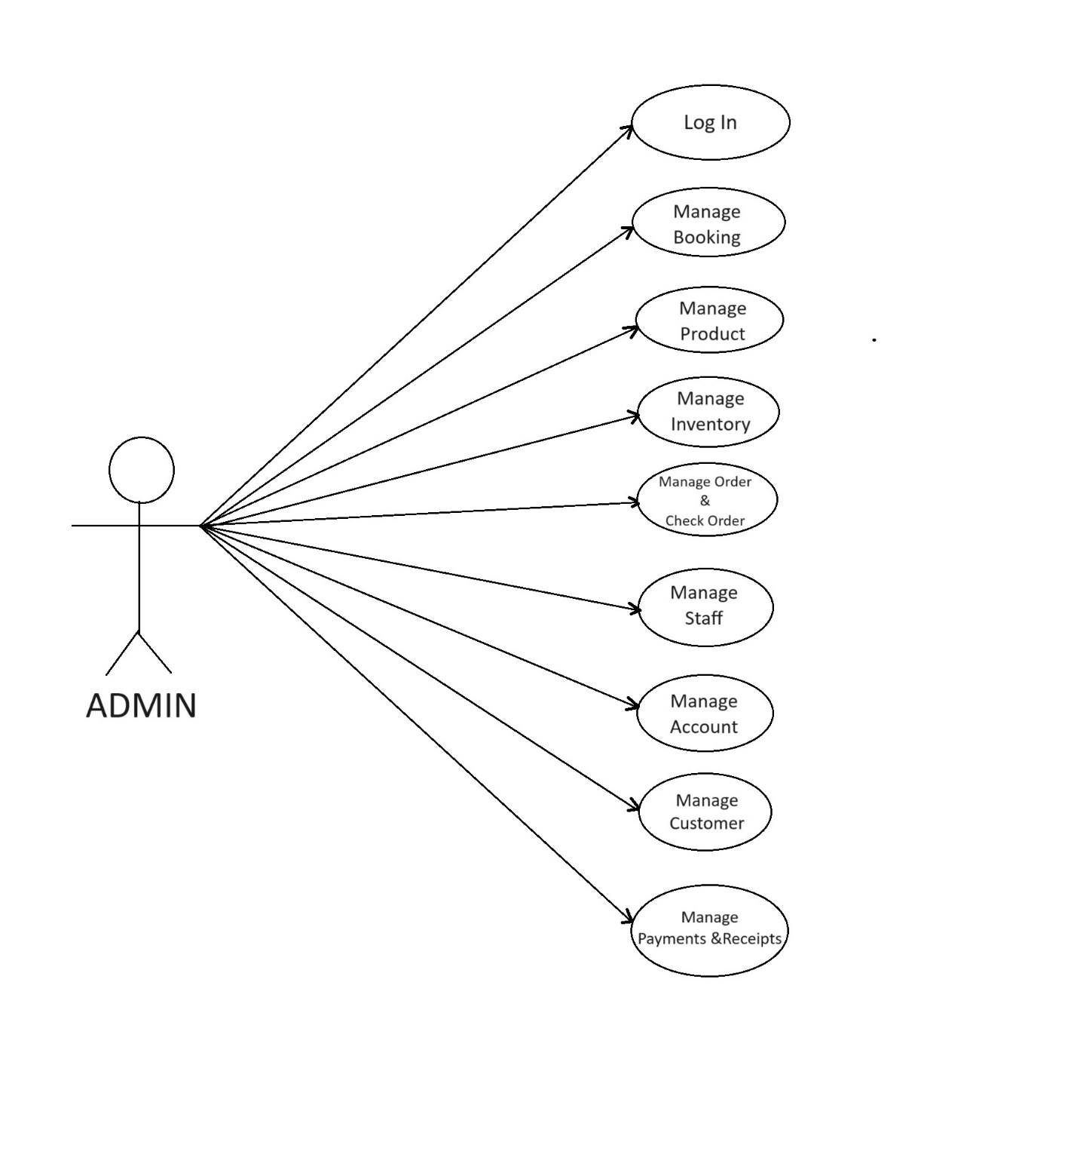

**ADMIN**

## USER

## 

**Sequence Diagram**

**I. Visitor**

**1. Register an account**

|  |  |  |
| --- | --- | --- |
| **Author** |  | |
| **Use case name** | Register account | |
| **Actors** | Visitor | |
| **Description** | Visitor want to register to become an user of App | |
| **Requirements** | Visitor must provide information | |
| **Status** | Success: The account will be created  Fail: Refill information | |
| **Basic flow** | Actor action:  1. Visitor click “Register” link.  3. Visitor provides registration  4. Visitor enter information, select “create” button  [Alternative 1] | System response:  2. System redirect to Registration form with following control:  - “First name” text field  - “Last name” text field  - “Email” text field  - “Password” text field  5. System validate information  [Exception 1]  6. System insert data into database and send notification message. |
| **Alternative flow** |  |  |
| **Exception** | Actor action:  [Exception 1]  -“First name” left blank and incorrect format.  -“Last name” left blank and incorrect format  -“Email” left blank and incorrect format  -“Password” left blank and incorrect format  [Exception 2]  - verification code is wrong | System response:  -“First name” cannot blank and correct format  -“Last name” cannot blank and correct format  -“Email” cannot blank and correct format  -“Password” cannot blank and correct format  -Please enter the correct verification code |

**2. View Menu details**

|  |  |  |
| --- | --- | --- |
| **Author** |  | |
| **Use case name** | View Menu detail | |
| **Actors** | Visitor | |
| **Description** | Visitor view Menu detail | |
| **Requirements** |  | |
| **Status** | Show Menu detail information | |
| **Basic flow** | Actor action:  1. Visitor click any Menu | System response:  2. System redirect to Menu detail and show information of this Menu |
| **Alternative flow** |  |  |
| **Exception** |  |  |

**3. Filter Menu**

|  |  |  |
| --- | --- | --- |
| **Author** |  | |
| **Use case name** | Filter Menu | |
| **Actors** | Visitor | |
| **Description** | Visitor can Filter Menu that match with their Filter keyword | |
| **Requirements** | Visitor provide Filter keyword | |
| **Status** | Success: Show all Menu that match Filter keyword  Fail: No Menu is show | |
| **Basic flow** | Actor action:  1. Visitor give Filter keyword  3. Actor click Menu’s title in list. | System response:  2. System show a list of Menus that match the Filter keyword |
| **Alternative flow** |  |  |
| **Exception** |  |  |

**II. User**

**1. Login**

|  |  |  |
| --- | --- | --- |
| **Author** |  | |
| **Use case name** | Login | |
| **Actors** | Visitor | |
| **Description** |  | |
| **Requirements** |  | |
| **Status** |  | |
| **Basic flow** | Actor action:  1. User click “Login” link  3. Actor provide “email” and “password” and click “login” button.  [Alternative 1] | System response:  2. System redirect to Login page with following control:  -“email” text field  -“password” text field  4. System validates information [Exception 1]  5. System check the email and password. If correct, the following message will show “Login successfully” and redirect to homepage. Otherwise, the message is “invalid email” or  “invalid password” |
| **Alternative flow** | Actor action:  [Alternative 1]  1. Actor click “Forget Password” button.  3. Actor provide email and click “Get verify code” button.  5. Actor enter the verify code and click “Send” button.  7. Actor enter new password and click “Submit” button. | System response:  2. System redirect to Forget password page.  4. System check user’s email in database. If correct, allow change password. Otherwise, return message “Email not found”.  6. System check verify code in database. If correct, redirect to “new password have sent in email” page. Otherwise, return message “Verify code failed”.  8. System validate password. If correct, system show a table required user create new password then insert new password to database and return message “change password completed”. |
| **Exception** | Actor action:  [Exception 1]  - “Email” left blank  -“Password” left blank | System response:  “Email” can not blank  “Password” can not blank |

**2. User can logout**

|  |  |  |
| --- | --- | --- |
| **Author** |  | |
| **Use case name** | Log out | |
| **Actors** | User | |
| **Description** | User can log out of the App | |
| **Requirements** |  | |
| **Status** |  | |
| **Basic flow** | Actor action:  1. Visitor click “Logout” link | System response:  2. System delete user session data. |
| **Alternative flow** |  |  |
| **Exception** |  |  |

**3. User can edit profile**

|  |  |  |
| --- | --- | --- |
| **Author** |  | |
| **Use case name** | Edit user’s profile | |
| **Actors** | User | |
| **Description** | User can edit profile information | |
| **Requirements** | User has logged in | |
| **Status** | Success: profile updated  Fail: Refill information | |
| **Basic flow** | Actor action:  1. User click “Edit profile” link in “account” page  3. User update information and click “Save” button  3.1. If user click “email” to change  3.1.2. Input current password  3.1.2. User input new email | System response:  2. System show “edit profile” form with the following control:  -“First name” text field  -“Last name” text field  -“Day of birth” text field  -“Phone” text field  -“Address 1” text field  -“Address 2” text field  -“Save” button  2.1. “Email” field  2.1.1. System show “password” blank field for input.  2.1.3. If correct, send verify code to user’s email. Otherwise, return message “verify code is incorrect”.  2.1.4. When verify code correct. System show “New email” blank field input  2.1.5. System change new email into database and send notification message.  4. System check information  5. System update account in database. |
| **Alternative flow** |  |  |
| **Exception** |  |  |

**4. User can recover password**

|  |  |  |
| --- | --- | --- |
| **Author** |  | |
| **Use case name** | Reset password | |
| **Actors** | User | |
| **Description** | User who has registered an account can reset password | |
| **Requirements** | - User provide email, phone  - User must register an account | |
| **Status** | Success: Allow change password  Fail: Refill information | |
| **Basic flow** | Actor action:  1. User click “Forgot password” link in “Log in” page  3. User input “email” and click the “Send” button. | System response:  2. System redirects to “Reset password” page with the following control:  - “Email” text field  3. System send new password is @123 to email  4. System update data into database and send notification message.  5. System check information  5. System update the new password in database. |
| **Alternative flow** |  |  |
| **Exception** | -“Email” text field left blank  -Actor input invalid email | System will show message to user:  -“Email” is required  -Please type a valid email |
|  |  |  |

**5. User can review Menu**

|  |  |  |
| --- | --- | --- |
| **Author** |  | |
| **Use case name** | Review Menu | |
| **Actors** | User | |
| **Description** | User can review Menu and rating | |
| **Requirements** | User is logged in | |
| **Status** | Success: show  Fail: Refill information | |
| **Basic flow** | Actor action:  1. User click on a particular Menu to view Menu details  3. User choose rating score out of 5 star and writes review content. | System response:  2. System redirect to Menus detail page.  4. System validate the input  5. System add review to database and show review in Menu detail. |
| **Alternative flow** |  |  |
| **Exception** |  |  |

**6. User can place order**

|  |  |  |
| --- | --- | --- |
| **Author** |  | |
| **Use case name** | Place order | |
| **Actors** | User | |
| **Description** | User can add Menu to shopping cart and checkout | |
| **Requirements** | User is logged in | |
| **Status** | Success: show message successful.  Fail: show message failed. | |
| **Basic flow** | Actor action:  1. Actor choose a Menu.  2. Actor choose Menu quantity and click “add to cart” button  4. Actor click to cart icon. | System response:  2. System redirect to Menu detail page.  3. System add Menu to shopping cart and update Menu quantity.  5. System redirect to “Checkout” page.  7. System validate the order. If success, system redirect to success message. Otherwise, system redirect to checkout page. |
| **Alternative flow** |  |  |
| **Exception** |  |  |

**III. Admin**

**1. Admin can login**

|  |  |  |
| --- | --- | --- |
| **Author** |  | |
| **Use case name** | Log in | |
| **Actors** | Admin | |
| **Description** | Admin can login to admin dashboard | |
| **Requirements** | Admin provide email and password | |
| **Status** | Success: show login message successful.  Fail: show message failed. | |
| **Basic flow** | Actor action:  1. Admin type username and password, then click “Login” button. | System response:  2. System validate information. If correct, redirect to admin dashboard. Otherwise, show failed login message. |
| **Alternative flow** |  |  |
| **Exception** | - Actor type invalid email and password. | System show message:  - “Wrong email or password” |

**2. Admin can logout**

|  |  |  |
| --- | --- | --- |
| **Author** |  | |
| **Use case name** | Log out | |
| **Actors** | Admin | |
| **Description** | Admin can log out of the admin dashboard | |
| **Requirements** |  | |
| **Status** |  | |
| **Basic flow** | Actor action:  1. Admin click “Logout” link | System response:  2. System delete admin session data. |
| **Alternative flow** |  |  |
| **Exception** |  |  |

**3. Admin can manage Menus**

**3a. Add new Menu**

|  |  |  |
| --- | --- | --- |
| **Author** |  | |
| **Use case name** | Add new Menu | |
| **Actors** | Admin | |
| **Description** | Admin can add new Menu | |
| **Requirements** | Admin is logged in | |
| **Status** |  | |
| **Basic flow** | Actor action:  1. Admin click “New Menu” link | System response:  2. System add new Menu to database. |
| **Alternative flow** |  |  |
| **Exception** |  |  |

**3b. Edit Menu**

|  |  |  |
| --- | --- | --- |
| **Author** |  | |
| **Use case name** | Log out | |
| **Actors** | Admin | |
| **Description** | Admin can edit Menu | |
| **Requirements** | Admin is logged in | |
| **Status** |  | |
| **Basic flow** | Actor action:  1. Admin click “Edit” link | System response:  2. System edit Menu database. |
| **Alternative flow** |  |  |
| **Exception** |  |  |

**3c. Delete Menu**

|  |  |  |
| --- | --- | --- |
| **Author** |  | |
| **Use case name** | Delete Menu | |
| **Actors** | Admin | |
| **Description** | Admin can delete Menu | |
| **Requirements** | Admin is logged in | |
| **Status** |  | |
| **Basic flow** | Actor action:  1. Admin click “Delete” link | System response:  2. System delete Menu database. |
| **Alternative flow** |  |  |
| **Exception** |  |  |

**3d. Filter Menu**

|  |  |  |
| --- | --- | --- |
| **Author** |  | |
| **Use case name** | Filter Menu | |
| **Actors** | Admin | |
| **Description** | Admin can Filter Menu | |
| **Requirements** | Admin is logged in | |
| **Status** |  | |
| **Basic flow** | Actor action:  1. Admin input name of Menu and click “Find” link | System response:  2. System show Menu name. |
| **Alternative flow** |  |  |
| **Exception** |  |  |

**4. Admin can manage orders**

**4a. Add new order**

|  |  |  |
| --- | --- | --- |
| **Author** |  | |
| **Use case name** | Manage orders | |
| **Actors** | Admin | |
| **Description** | Admin can mange orders | |
| **Requirements** | Admin is logged in | |
| **Status** |  | |
| **Basic flow** | Actor action:  1. Admin click “Add new order” link | System response:  2. System add new order to order database |
| **Alternative flow** |  |  |
| **Exception** |  |  |

**4b. Edit order**

|  |  |  |
| --- | --- | --- |
| **Author** |  | |
| **Use case name** | Edit order | |
| **Actors** | Admin | |
| **Description** | Admin can edit order | |
| **Requirements** | Admin is logged in | |
| **Status** |  | |
| **Basic flow** | Actor action:  1. Admin edit information of order then click “Edit” link | System response:  2. System edit order then change order database |
| **Alternative flow** |  |  |
| **Exception** |  |  |

**4c. Delete order**

|  |  |  |
| --- | --- | --- |
| **Author** |  | |
| **Use case name** | Delete order | |
| **Actors** | Admin | |
| **Description** | Admin can delete order | |
| **Requirements** | Admin is logged in | |
| **Status** |  | |
| **Basic flow** | Actor action:  1. Admin click “delete” link | System response:  2. System delete order in order database. |
| **Alternative flow** |  |  |
| **Exception** |  |  |

**4d. Filter order**

|  |  |  |
| --- | --- | --- |
| **Author** |  | |
| **Use case name** | Filter order | |
| **Actors** | Admin | |
| **Description** | Admin can Filter order | |
| **Requirements** | Admin is logged in | |
| **Status** |  | |
| **Basic flow** | Actor action:  1. Admin input name of order and click “Find Order” link | System response:  2. System show order follow name admin had input. |
| **Alternative flow** |  |  |
| **Exception** |  |  |

**5. Admin can manage users**

**5a. Add new user**

|  |  |  |
| --- | --- | --- |
| **Author** |  | |
| **Use case name** | Add new user | |
| **Actors** | Admin | |
| **Description** | Admin can add new user | |
| **Requirements** | Admin is logged in | |
| **Status** |  | |
| **Basic flow** | Actor action:  1. Admin click “add new user” link | System response:  2. System add new user to database. |
| **Alternative flow** |  |  |
| **Exception** |  |  |

**5b. Edit user**

|  |  |  |
| --- | --- | --- |
| **Author** |  | |
| **Use case name** | Edit user | |
| **Actors** | Admin | |
| **Description** | Admin can edit user | |
| **Requirements** | Admin is logged in | |
| **Status** |  | |
| **Basic flow** | Actor action:  1. Admin click “Edit user” link | System response:  2. System edit user information to database. |
| **Alternative flow** |  |  |
| **Exception** |  |  |

**5c. Delete user**

|  |  |  |
| --- | --- | --- |
| **Author** |  | |
| **Use case name** | Delete user | |
| **Actors** | Admin | |
| **Description** | Admin can log delete user | |
| **Requirements** | Admin is logged in | |
| **Status** |  | |
| **Basic flow** | Actor action:  1. Admin click “Delete user” link | System response:  2. System delete user to database. |
| **Alternative flow** |  |  |
| **Exception** |  |  |

**5d. Filter user**

|  |  |  |
| --- | --- | --- |
| **Author** |  | |
| **Use case name** | Filter user | |
| **Actors** | Admin | |
| **Description** | Admin can Filter user | |
| **Requirements** | Admin is logged in | |
| **Status** |  | |
| **Basic flow** | Actor action:  1. Admin input name of user and click “Find User” link | System response:  2. System show user follow name admin had input. |
| **Alternative flow** |  |  |
| **Exception** |  |  |

**6. Admin can create reports**

|  |  |  |
| --- | --- | --- |
| **Author** |  | |
| **Use case name** | Create report | |
| **Actors** | Admin | |
| **Description** | Admin can create reports | |
| **Requirements** | Admin is logged in | |
| **Status** |  | |
| **Basic flow** | Actor action:  1. Visitor click “Create report” link | System response:  2. System make file pdf name “report” and ask for download. |
| **Alternative flow** |  |  |
| **Exception** |  |  |

**Entity Relationship Diagram (ERD)**

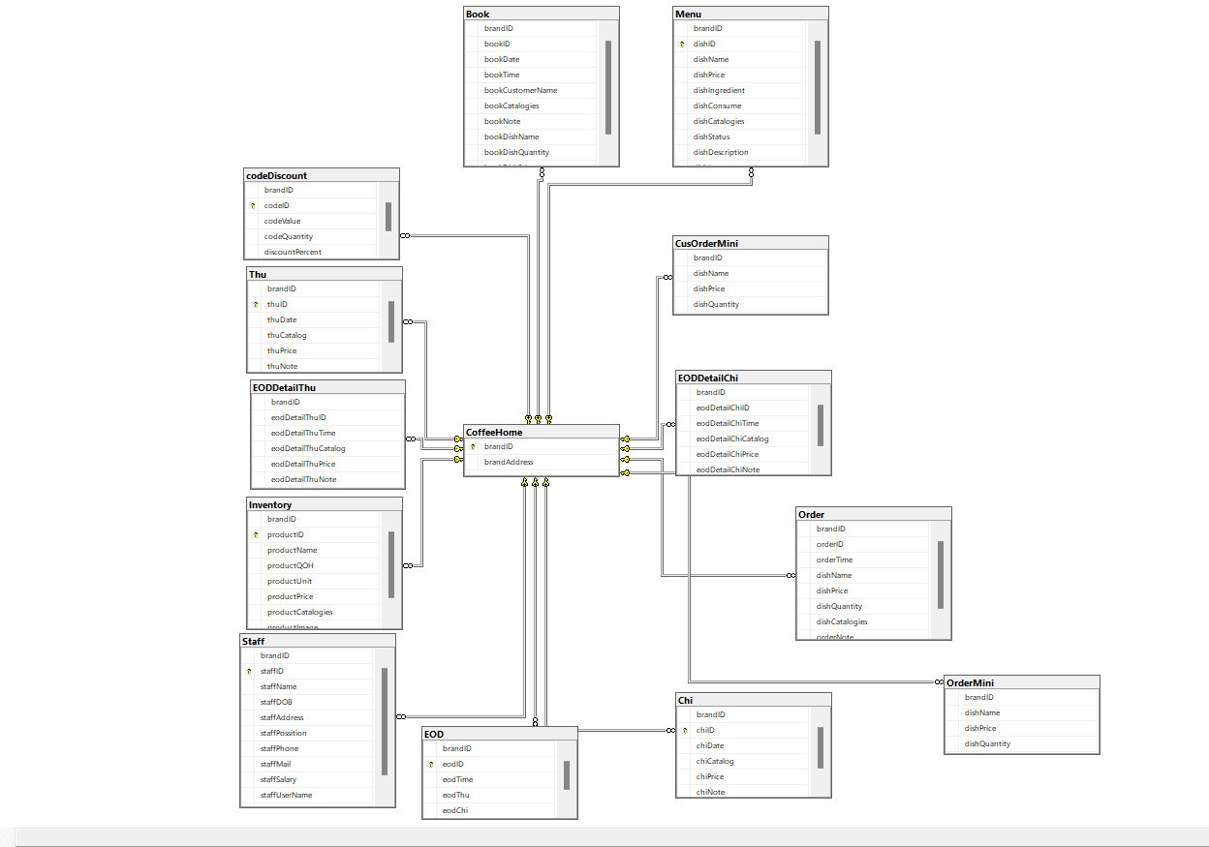

## TABLE DESIGN

## Customer

## 

## Account

## 

## Order

## 

## Menu

## 

## Order_Menu

## 

## Staff

## 

## TASK SHEET REVIEW 2

|  |  |  |  |  |  |  |  |  |
| --- | --- | --- | --- | --- | --- | --- | --- | --- |
| Project: The Coffee Home | | Project Name | Activity  Plan Prepared  By | Date of Preparation of Activity Plan: | | | | |
| Sr./No. | Task | Actual Start Date | | Actual Days | Team member name | Status |
| 1 | Usecase | The coffee Home | Phụng-Dương | 20 – Dec -  2023 | | 1 | Dương | Completed |
| 2 | Entity Relationship Diagram (ERD) | 20 - Dec -  2023 | | 1 | Dương | Completed |
| 3 | Table Design | 20 – Dec -  2023 | | 2 | Phụng | Completed |
| 4 | Sequence Diagran | 20 – Dec -  2023 | | 4 | Phụng | Completed |
| Date: 26– Dec - 2023 | | | | | | | | |
| Signature of Instructor:  Ms. LÊ MỘNG THÚY | | | | | Signature of Team Leader:  Nguyễn Quốc Dương | | | |