BECAMEX BUSINESS SCHOOL
MIS 443 - BUSINESS DATA MANAGEMENT
Assignment 2: PostgreSQL Database Development and SQL Practice
Schema: Banking
Lecturer: Mr. Dang Thai Doan
Group: D2NB
No. | Student's Name | Student's ID
1 | Vu Dong Duong | 2032300044
2 | Than Que Ngoc | 2232300060
3 | Van Vu Quynh Nhu | 2232300079
4 | Do Hoang Bao | 2232300071

Quarter 4, Academic Year 2025-2026

1. Introduction
This report documents Group D2NB's implementation of the Banking schema for Assignment 2 of MIS 443 - Business Data Management. The Banking schema was selected from SQL Practice Online and recreated in PostgreSQL using pgAdmin 4. The database simulates a simplified retail banking system, allowing the group to practice schema analysis, table and constraint design, data preparation, and SQL querying across filtering, joins, aggregation, subqueries, window functions, and common table expressions (CTEs).
The Banking dataset models five business entities: bank branches, customers, accounts, transactions, and loans. A customer is registered at one branch, can hold multiple accounts, and can take out multiple loans. Each account can have many transactions (deposits and withdrawals). This structure supports analysis such as branch performance, customer portfolio composition, cash-flow tracking, and loan exposure.

2. Database Description

2.1 Main Tables
- branches - stores information about each bank branch (branch_id, branch_name, city, state).
- customers - stores customer profile data and the branch each customer is registered at (customer_id, first_name, last_name, email, branch_id, account_opened_date).
- accounts - stores each customer's bank account(s) (account_id, customer_id, account_type, balance, opened_date).
- transactions - stores deposit/withdrawal activity tied to an account (transaction_id, account_id, transaction_type, amount, transaction_date).
- loans - stores loan agreements tied to a customer (loan_id, customer_id, loan_amount, interest_rate, status, start_date).

2.2 Relationships
branches (1) - (N) customers: each customer is registered at exactly one branch, and a branch can serve many customers.
customers (1) - (N) accounts: each customer can hold zero or more accounts.
customers (1) - (N) loans: each customer can hold zero or more loans.
accounts (1) - (N) transactions: each account can have zero or more transactions.
All foreign keys reference their parent primary key (branch_id, customer_id, account_id) to preserve referential integrity. Tables were created in dependency order: branches -> customers -> accounts -> transactions / loans.

2.3 Entity-Relationship Diagram (ERD)
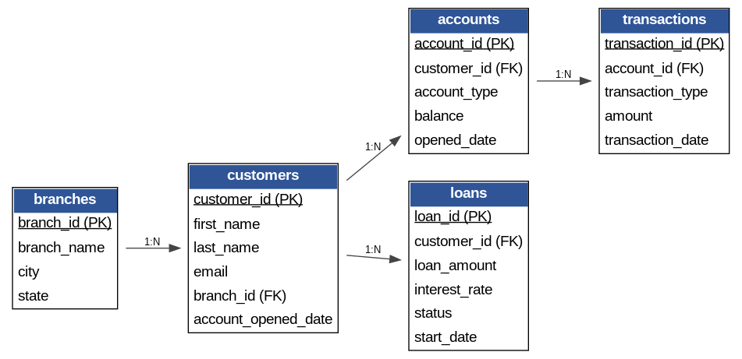

3. Database Implementation Summary
The database was implemented in PostgreSQL through pgAdmin 4 using four SQL scripts, executed in order:
- 01_create_database.sql - creates the banking database.
- 02_create_tables_relationships.sql - creates all five tables with PostgreSQL-appropriate data types (INTEGER, VARCHAR, REAL, DATE), primary keys, foreign keys, NOT NULL and UNIQUE constraints.
- 03_insert_data.sql - inserts sample data for all five tables (5 branches, 7 customers, 8 accounts, 8 transactions, 4 loans), matching the CSV files provided in the data/ folder.
- 04_questions_01_30.sql - contains all 30 SQL practice questions, each labelled with its question number and description as a comment.
All scripts were tested and executed successfully in pgAdmin 4 against a PostgreSQL 17 server, and results were verified against the expected output shown on SQL Practice Online.

4. Summary of the 30 SQL Questions
The 30 questions progress from basic retrieval to advanced analytical queries. A summary by technique is provided below (full solutions are in codes/04_questions_01_30.sql; this report summarises rather than reproduces the SQL).
Questions | Technique / Focus
Q1-Q8 | Basic SELECT, WHERE filtering, COUNT, SUM
Q9-Q10 | DISTINCT, date range filtering, sorting
Q11-Q12 | LEFT JOIN with IS NULL to find non-matching records
Q13-Q14, Q17-Q18, Q20 | GROUP BY with COUNT/SUM aggregation
Q15-Q16, Q19, Q21 | INNER/LEFT JOIN across multiple tables
Q22 | Conditional aggregation (CASE WHEN inside SUM)
Q23 | Date formatting with TO_CHAR and monthly grouping
Q24 | Correlated subquery with NOT EXISTS
Q25 | UNION ALL to combine two result sets
Q26-Q27 | Aggregate subquery / HAVING-style filtering, LIMIT
Q28-Q29 | Window functions (RANK, PARTITION BY)
Q30 | Common Table Expression (CTE) with CASE-based tiering

5. Selected Screenshots from pgAdmin
Screenshots of query execution and results for all 30 questions were captured during development and are documented in the group's Activity 1 submission (MIS 443_Activity 1_Group D2NB), which was used as the working basis for this assignment. Representative examples include the ERD relationship view in pgAdmin's Object Explorer, and Data Output panels confirming row counts and result sets for each question.

6. Challenges Encountered and Solutions Applied
- Date function compatibility: the original question wording referenced STRFTIME (a SQLite function). Since PostgreSQL does not support STRFTIME, the group used TO_CHAR(transaction_date, 'YYYY-MM') instead to group transactions by month.
- Handling customers with zero accounts/loans: standard INNER JOIN excluded customers with no related records. The group used LEFT JOIN combined with IS NULL checks (Q11, Q12) and LEFT JOIN with COUNT (Q13) to include zero counts.
- Ranking within groups: Q28 and Q29 required per-category and per-branch ranking rather than a single global rank, which was solved using the RANK() window function with PARTITION BY.
- Maintaining referential integrity while inserting data: because tables reference each other via foreign keys, data was inserted in dependency order (branches -> customers -> accounts -> transactions/loans) to avoid foreign-key violations.

7. Responsibilities and Contributions
Member | Contribution
Vu Dong Duong | Schema analysis, database & table creation, questions 1-10, report consolidation
Than Que Ngoc | Data preparation (CSV files), questions 11-18
Van Vu Quynh Nhu | Questions 19-25, ERD design
Do Hoang Bao | Questions 26-30, GitHub repository setup and README

All group members reviewed the final database, SQL scripts, and report before submission.

8. Conclusion
Through this assignment, Group D2NB successfully recreated the Banking schema in PostgreSQL, defined appropriate keys, constraints, and relationships, and solved all 30 SQL practice questions covering filtering, joins, aggregation, subqueries, window functions, and CTEs. The exercise strengthened the group's practical understanding of relational database design and PostgreSQL-specific SQL syntax, and produced a reproducible project published to each member's personal GitHub repository.

9. GitHub Repository Links
Student Name | Student ID | Repository URL
Vu Dong Duong | 2032300044 | [to be added]
Than Que Ngoc | 2232300060 | [to be added]
Van Vu Quynh Nhu | 2232300079 | [to be added]
Do Hoang Bao | 2232300071 | [to be added]

