 | FINAL EXAM PAPER  Quarter: 4 - Academic year: 2025 – 2026  Becamex Business School
Course code: MIS 443 |  | Exam code: 01
Course name: Business Data Management |  | Duration: 90 minutes
Type of Exam: Open Book |  | Maximum mark: 100
STUDENT NAME: VU DONG DUONG |  | IRN: 2032300044
Instructions:
- COMPUTER AND INTERNET YES NO
- OPEN BOOK YES NO
This paper consists of SIX practice questions, carrying a total of 100 marks. Questions 1 and 2 are worth 10 marks each, while questions 3 to 6 carry 20 marks each.
Students have 90 minutes to answer all the questions. No extra time is given for reading the questions. Additional Exam Booklet is provided on Moodle. Students use computers with PostgreSQL, MySQL or SQL Server to complete the questions.
Students must submit the Exam Answer via Moodle. (script .sql and details report as .docx)
File Name format: MIS443_ID_FullName.zip.
----------------------------------------------------------------------------------------------------------------
Business Scenario and Dataset
The Customer Insights database represents an international retailer selling products through retail and online channels. Management uses the database to analyse customers, orders, markets, product categories, and sales performance.
The database contains five tables:
- customers: customer age, first purchase, rewards membership, and email permission;
- orders: order date, customer, sales channel, and country;
- country: country name and head-office location;
- products: product category and unit price;
- baskets: products and quantities included in each order.
Key relationships:
- One customer can place many orders.
- One country can have many orders.
- Orders and products have a many-to-many relationship through baskets.
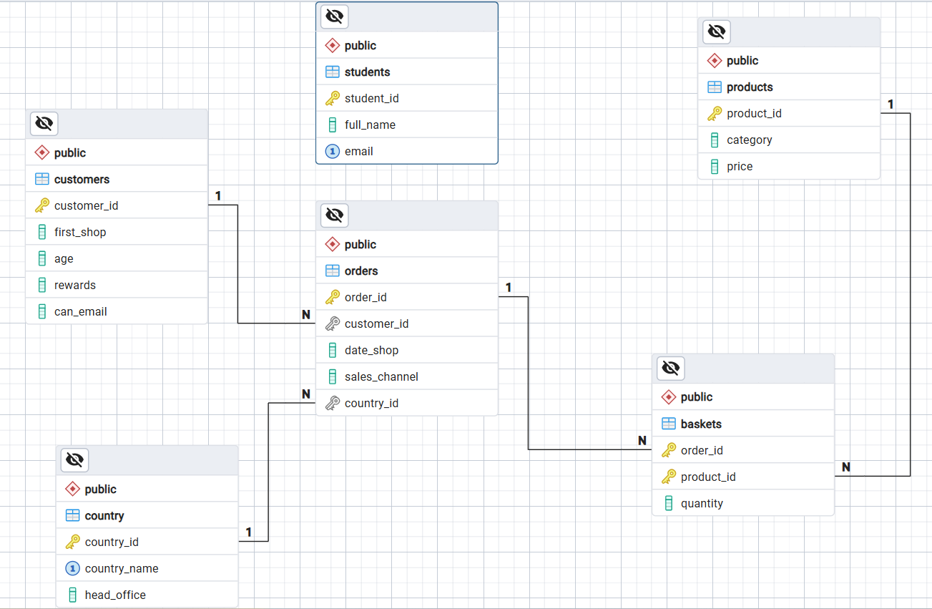
Sample ERD (include students table)
Examination Questions
Question 1 – Database Setup (10 marks)
(a) Load the database – 5 marks
Create a PostgreSQL database using your full name in lowercase, without spaces or Vietnamese diacritics. Connect to the database and execute:
MIS443_Customer_Insights_PostgreSQL.sql
Confirm that country, customers, orders, products, and baskets are available in the public schema.
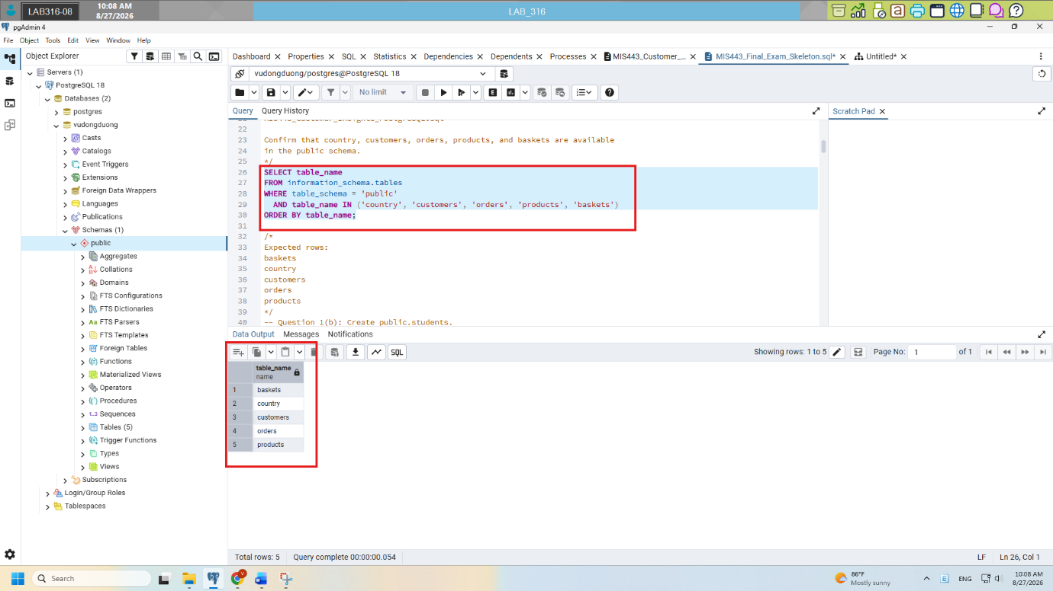
(b) Create the student table – 5 marks
Create public.students with:
- student_id: exactly 10 characters and primary key;
- full_name: required;
- email: required and unique.
Insert your actual information and display the inserted record.
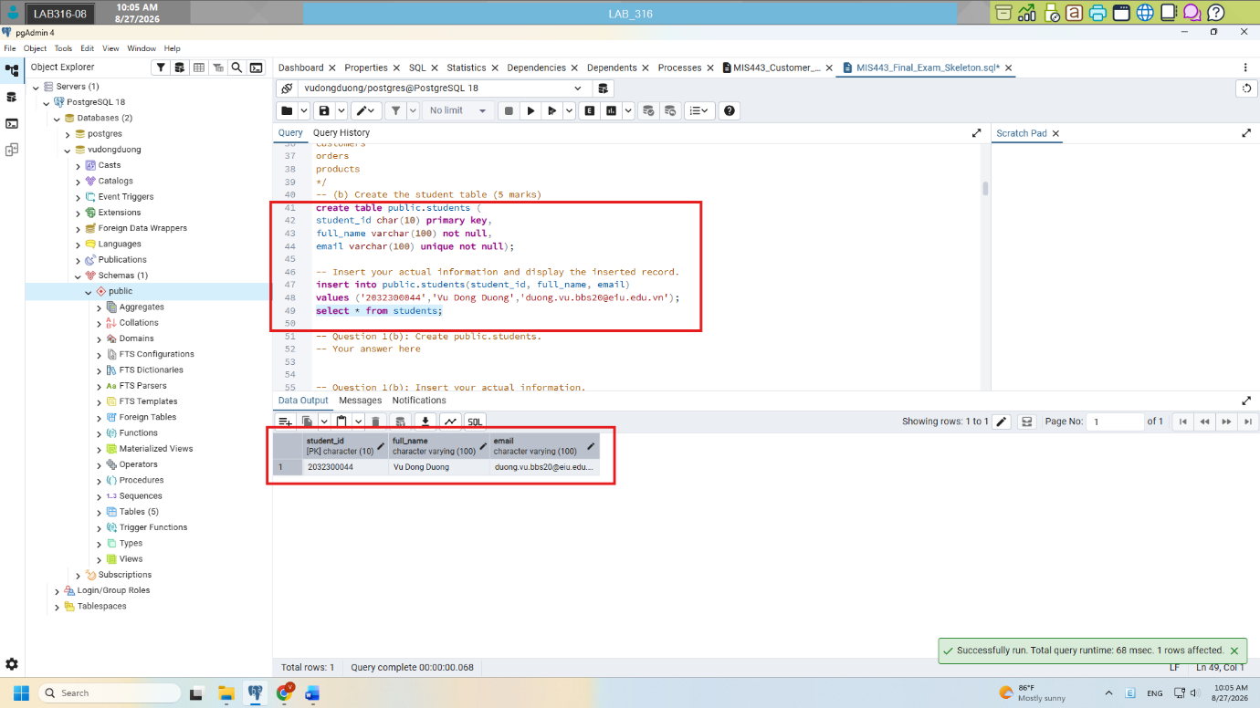
Question 2 – Customer Profile (10 marks)
The Marketing Manager wants to understand customers who permit marketing emails. Calculate their average age, name the result average_age, and round it to two decimal places.
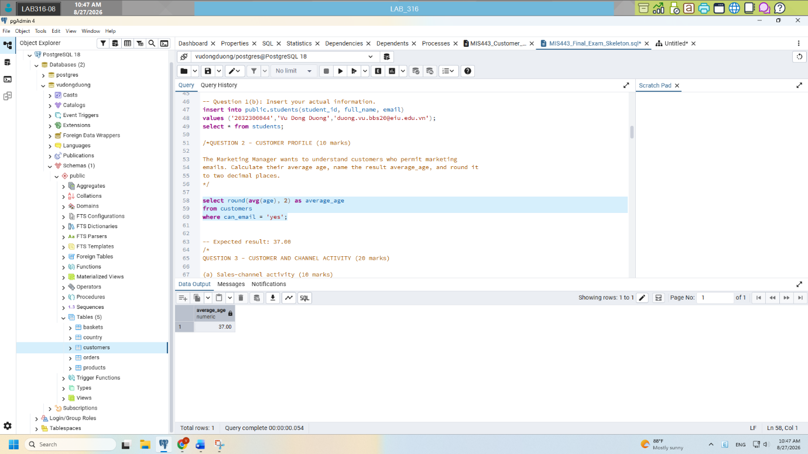
Question 3 – Customer and Channel Activity (20 marks)
(a) Sales-channel activity – 10 marks
The Sales Manager wants to compare retail and online channel usage. Calculate the number of orders for each sales_channel. Name the result total_orders and sort it from highest to lowest.
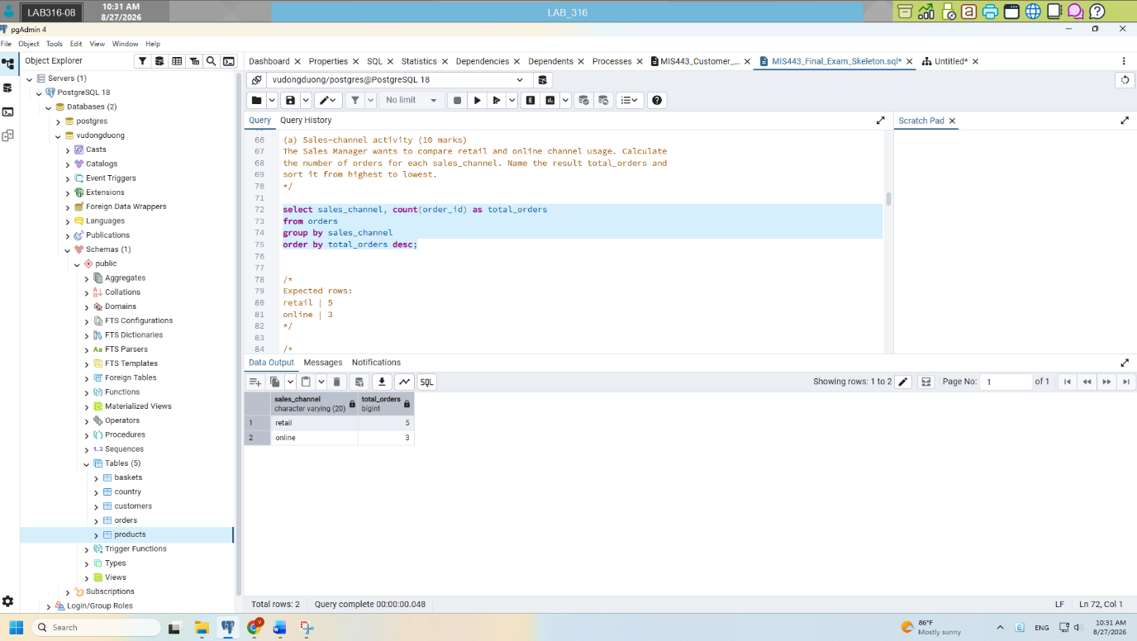
(b) Repeat customers – 10 marks
The Customer Relationship Manager wants to identify customers who placed more than one order. Display customer_id, age, and total_orders. Sort by total_orders descending and then customer_id ascending.
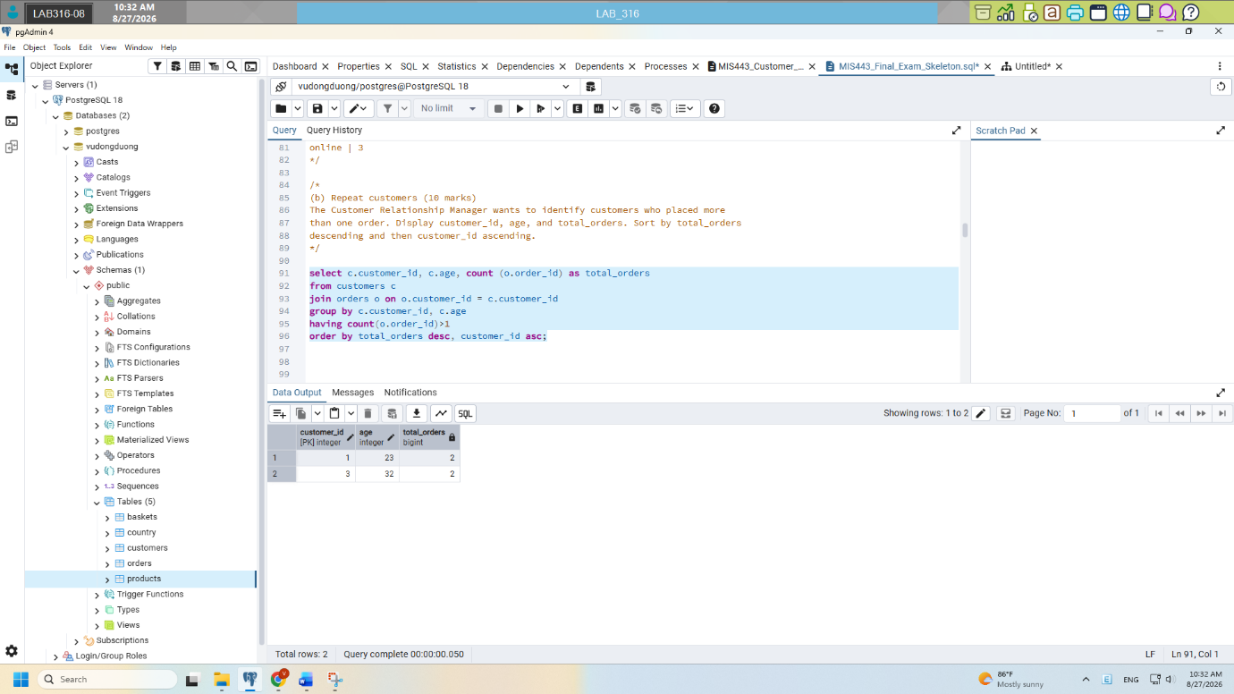
Question 4 – Order and Country Analysis (20 marks)
(a) Order-monitoring report – 10 marks
Create an order report showing order_id, date_shop, sales_channel, customer age as customer_age, and country_name. Sort by the newest order date and then by order_id.
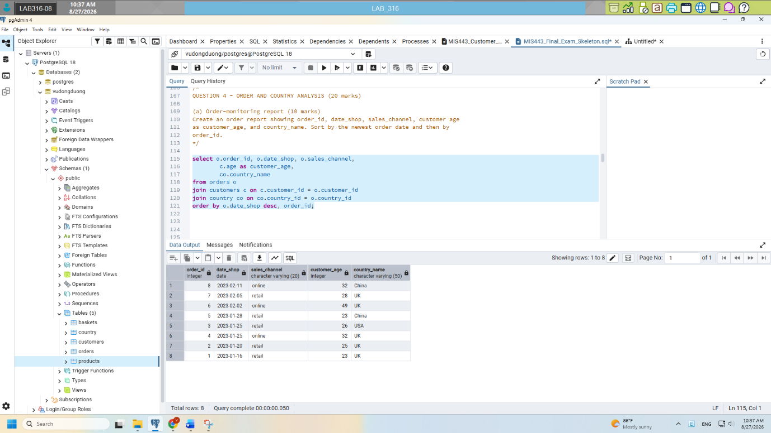
(b) Country performance – 10 marks
Calculate the number of orders for each country, including countries with no orders. Display country_name and total_orders. Sort by total_orders descending and then country_name alphabetically.
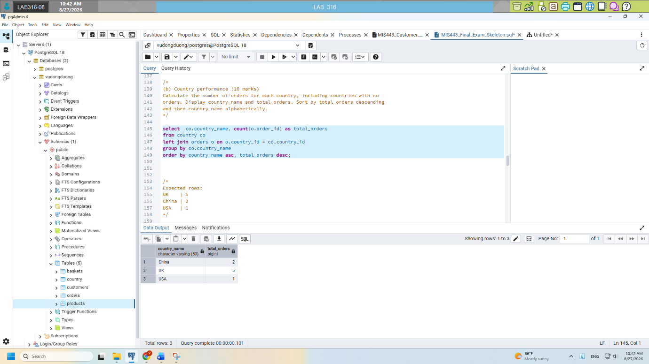
Question 5 – Product and Revenue Analysis (20 marks)
(a) Category performance – 10 marks
For each product category, calculate total_quantity and total_revenue. Revenue equals price multiplied by quantity. Round revenue to two decimal places and sort from highest to lowest revenue.
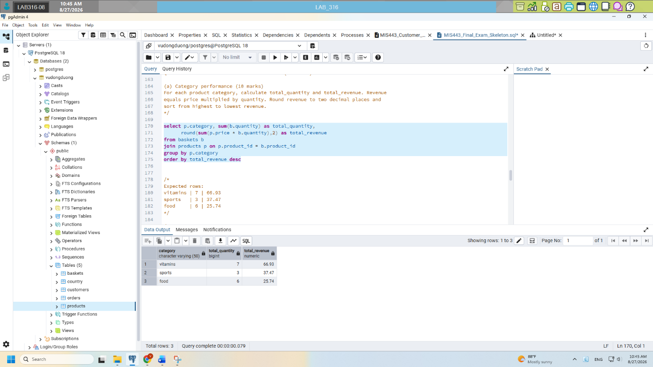
(b) High-value orders – 10 marks
Calculate the total value of each order and return only orders worth more than 20.00. Display order_id and total_order_value, rounded to two decimal places. Sort from highest to lowest value.
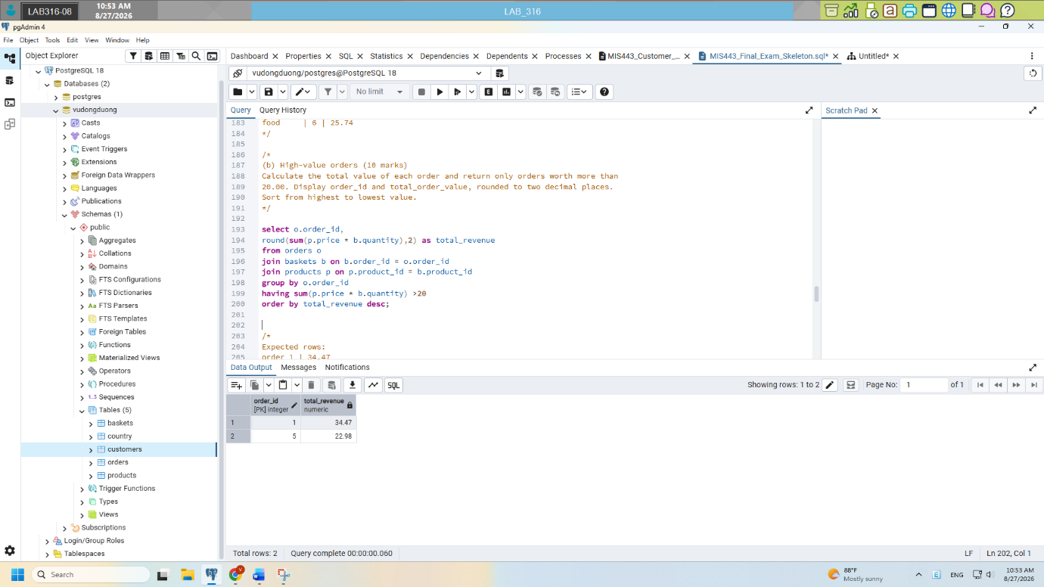
Question 6 – Advanced Business Analysis (20 marks)
(a) Customer purchase recency – 10 marks
For every customer who permits marketing emails, display customer_id, age, and their latest order date as latest_order_date. Include eligible customers with no orders and sort by customer_id.
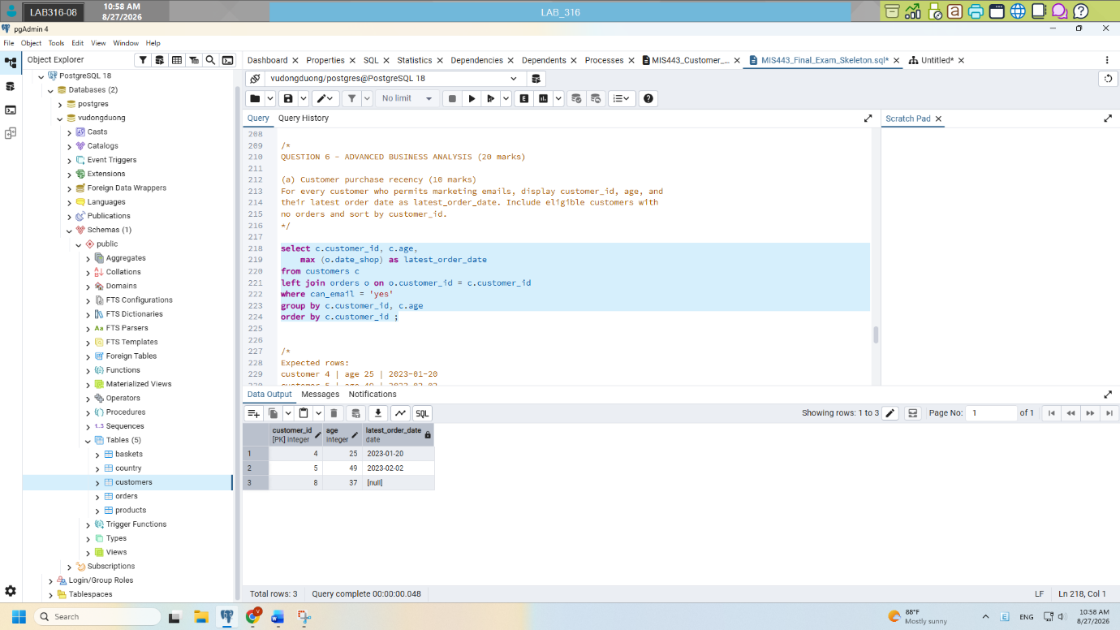
(b) Customer activity ranking – 5 marks
Rank all customers by their number of orders. Customers with equal totals must receive the same rank without ranking gaps. Include customers with no orders.
Display customer_id, age, total_orders, and activity_rank. Do not use a CTE.
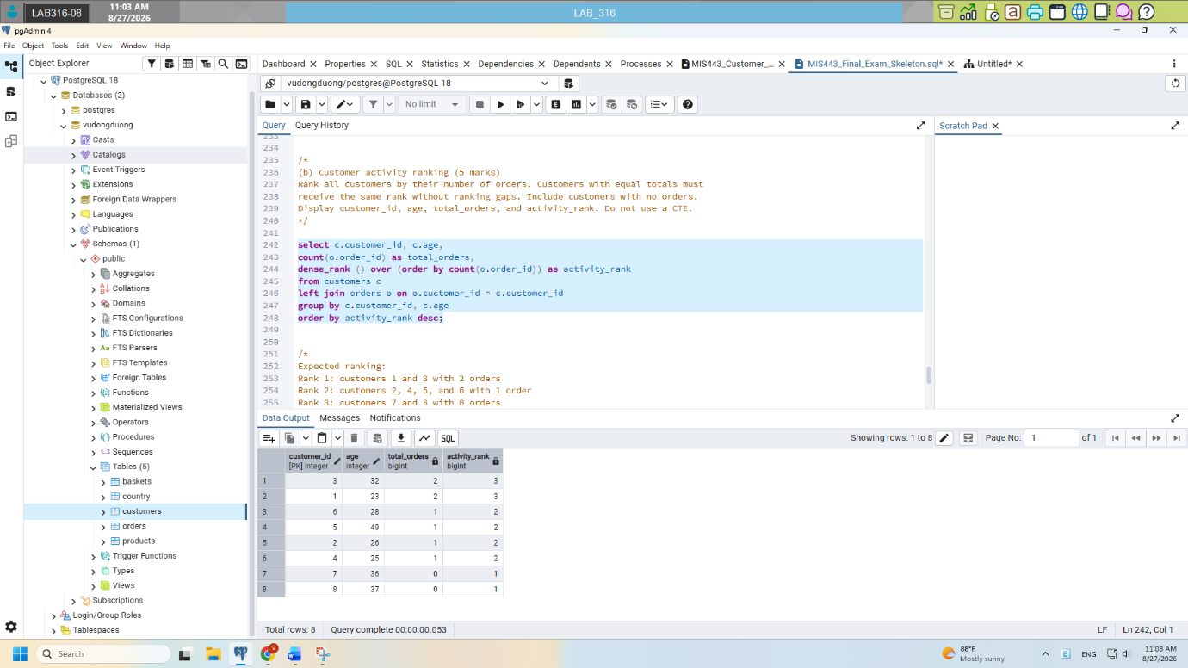
(c) Channel performance using a CTE – 5 marks
Use a CTE to calculate each order’s total value. Then summarise performance by sales_channel.
Display:
- sales_channel;
- total_orders;
- total_revenue;
- average_order_value.
Round monetary values to two decimal places and sort by total_revenue descending.
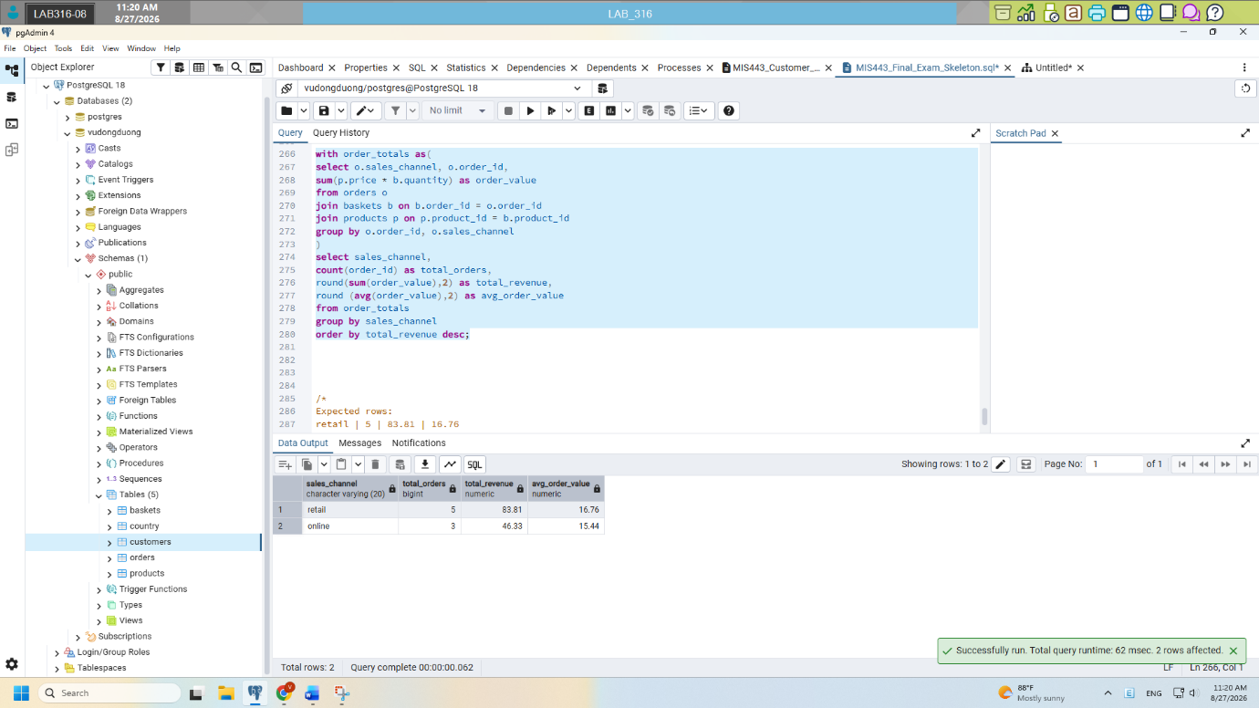

------ End ------
Lecturer’s signature

Dang Thai Doan

