ASSIGNMENT 0
Basic SQL Install and Load Database with PostgreSQL

1. Installing PostgreSQL and Creating the sqlda Database
PostgreSQL version 17.10 was installed. The psql command-line tool was used to create a new database and import the sample dataset.
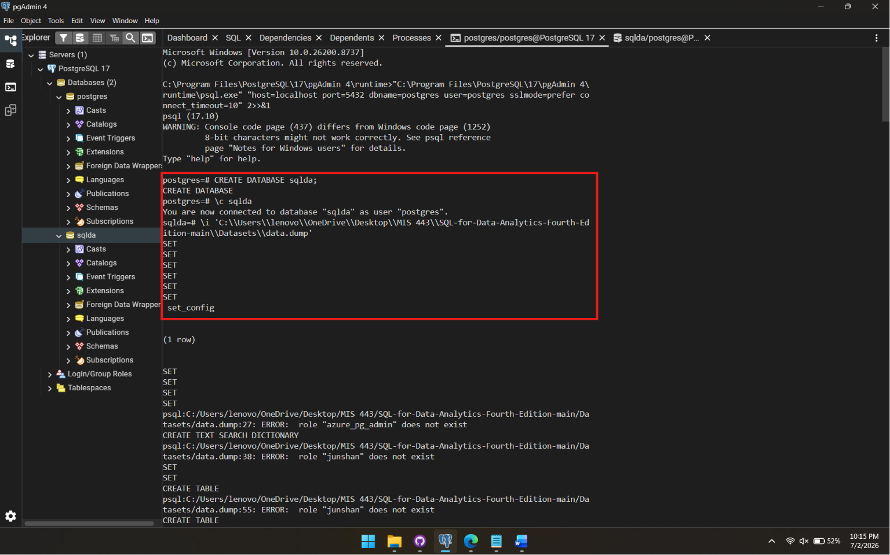
The connection was then verified in pgAdmin:
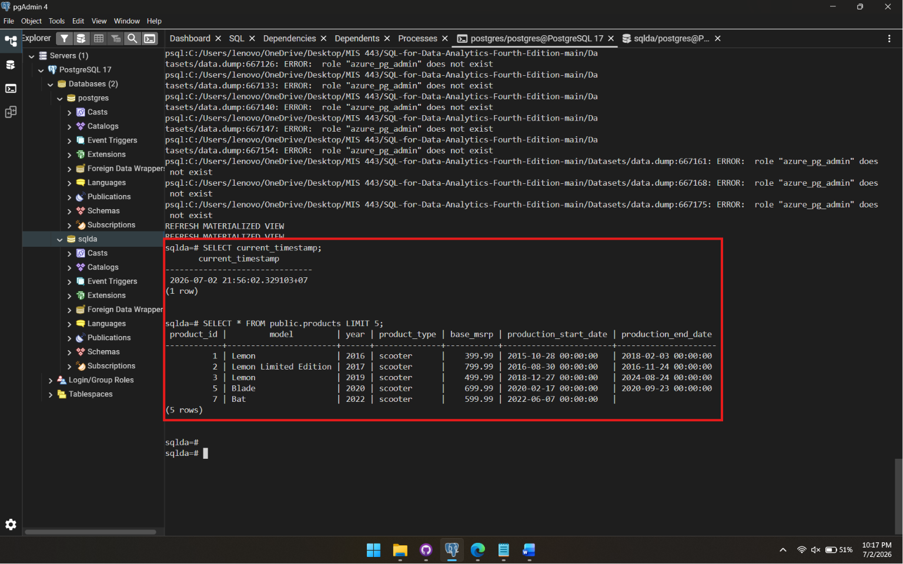

2. Assignment Question
Create SQL statements to fetch the first 20 rows of each table in the sqlda database, then answer the following two questions.
QUESTION 1 Which table is empty?
METHOD First, run a SELECT ... LIMIT 20 query on every table to preview the data:
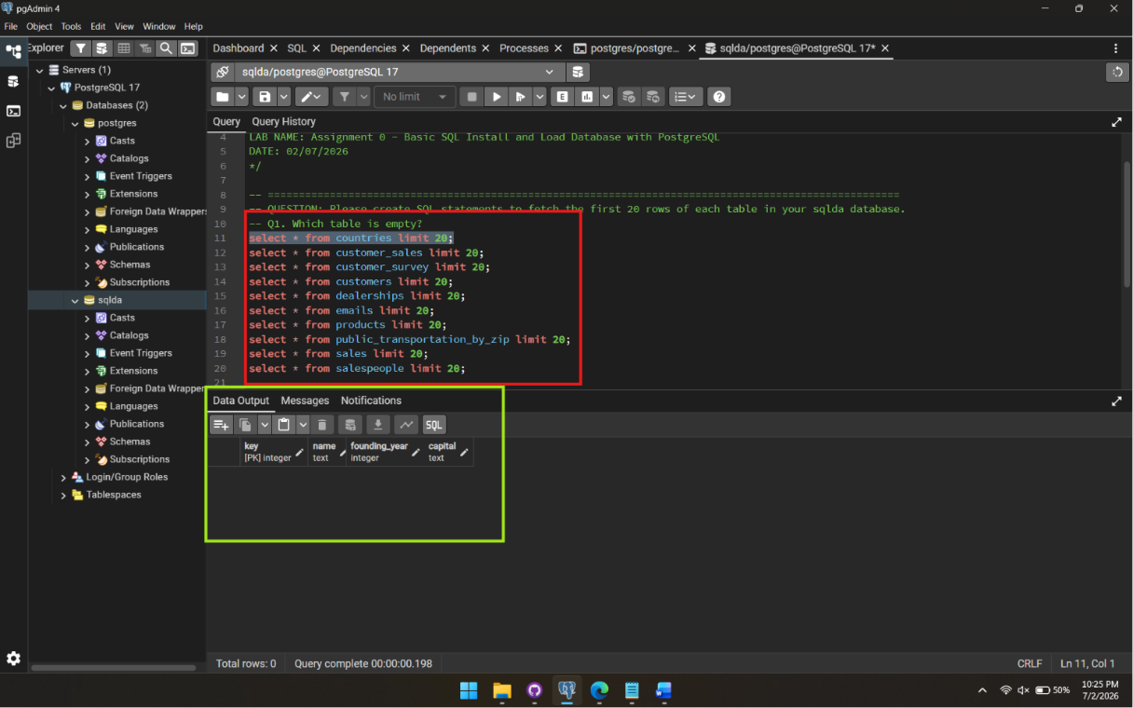
Figure 1: Selecting Table Countries

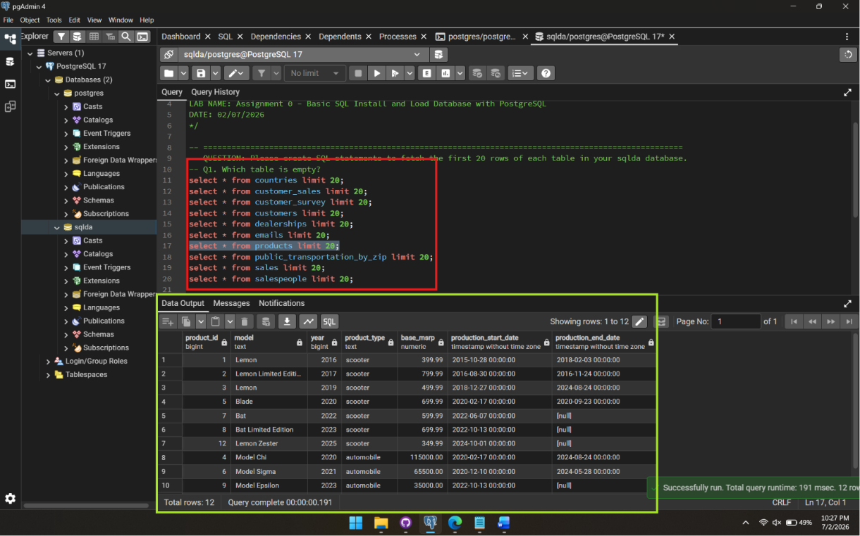

Figure 2: Selecting Products Table
EXPLANATION
SELECT * retrieves every column of the table, FROM specifies which table to query, and LIMIT 20 caps the output at the first 20 rows so the result set stays readable.
ANSWER
The countries table is empty (0 rows).

QUESTION 2 Which table has fewer than 20 records?
METHOD Using COUNT(*) combined with UNION ALL to get the exact row count for every table.
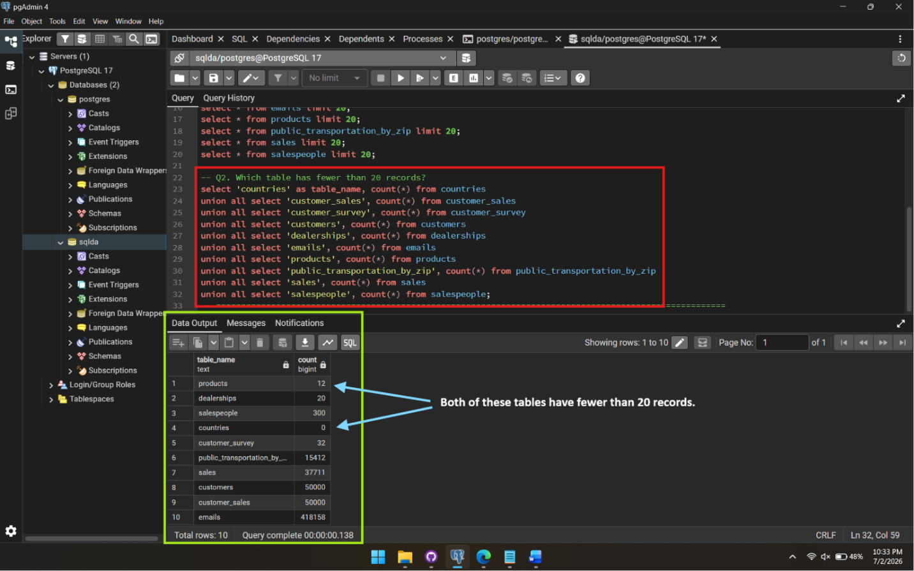EXPLANATION
"COUNT(*) returns the exact row count of a table. Each sub-query is labeled with a sub-name (table_name), so the result shows which table each count belongs to. UNION ALL then combines all ten counts into a single result set for easy comparison."
ANSWER
Two tables have fewer than 20 records: countries (0 rows) and products (12 rows).

