MIS 443 - Business Data Management
Assignment 4 - Individual PostgreSQL Database Project
School Database Schema

Student Name | Vũ Đông Dương
Student ID | 2032300044
Course | MIS 443 - Business Data Management
Database Assigned | School Schema (PostgreSQL)

GitHub Repository Link
https://github.com/DuongvuBBS20/MIS443-Q4-2025_2026/tree/main/MIS443_2032300044_School

ERD
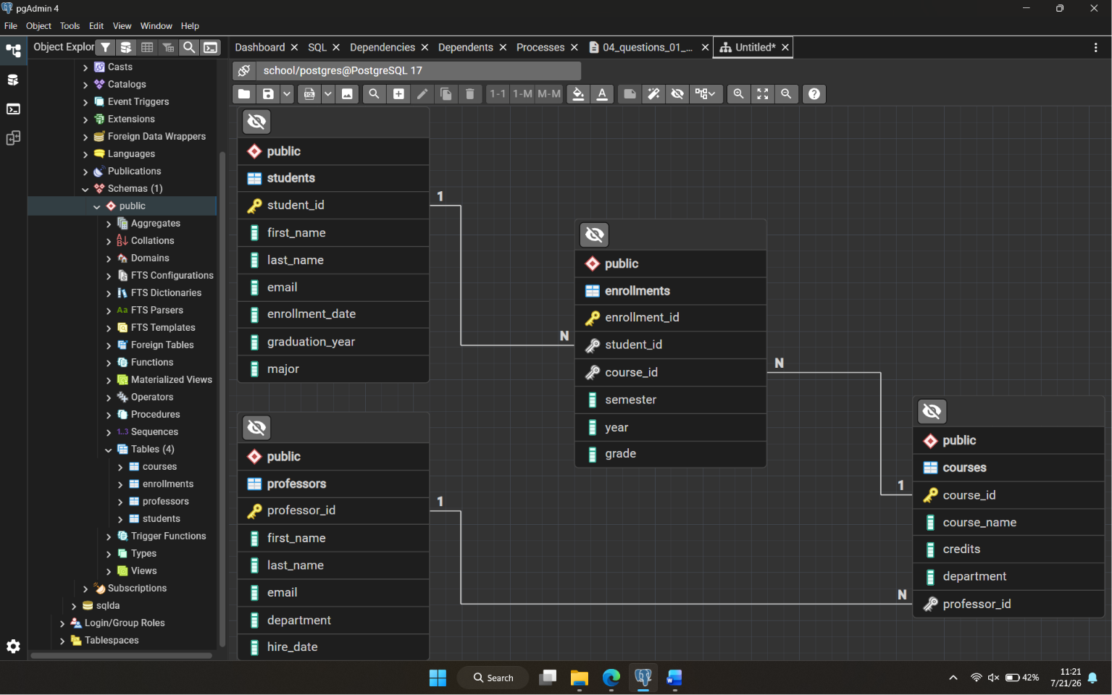

1. Return the complete student roster from the students table.
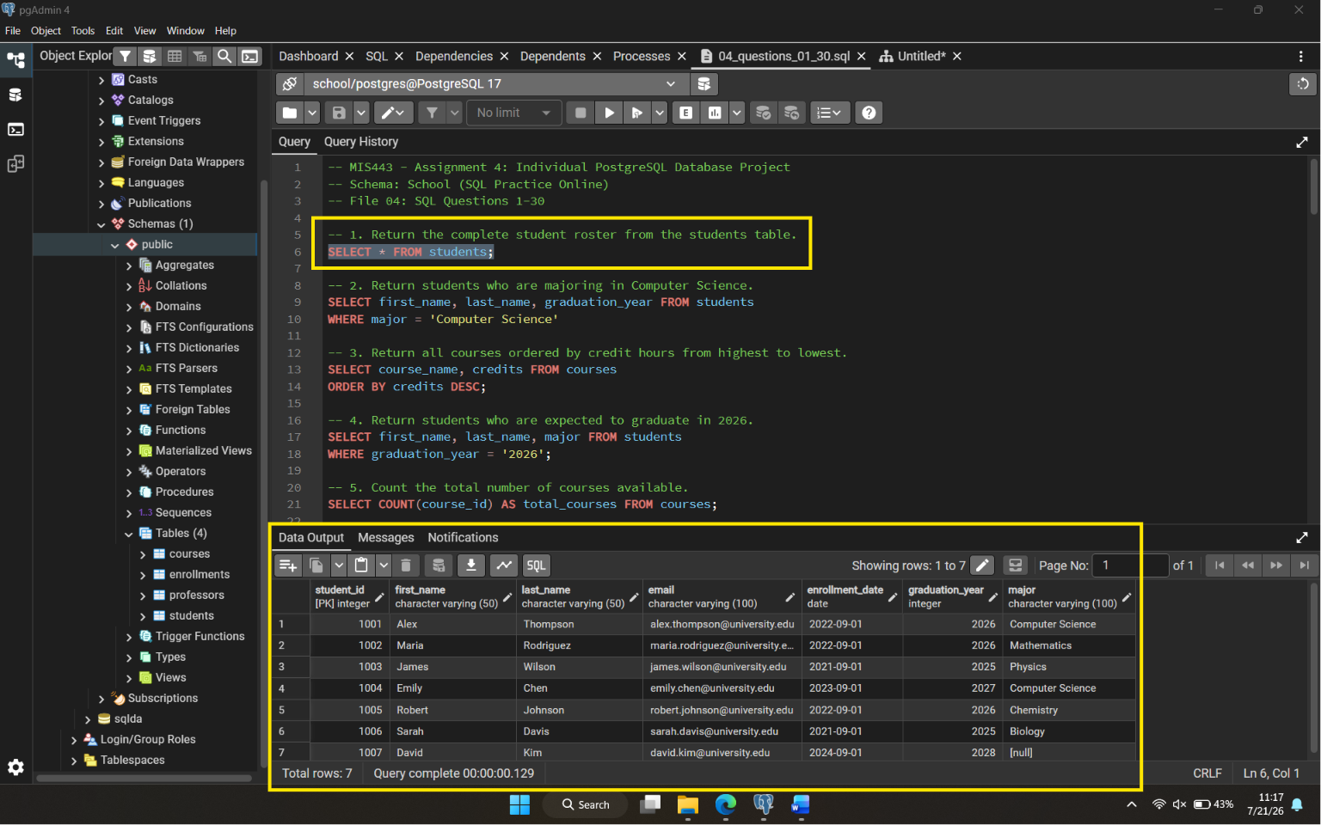

2. Return students who are majoring in Computer Science.
