#1

What shape of wheels is the best?
I will define the environments of planets as the pre-conditions. I will suggest Moon and Mars.
 | Moon [1] | Mars [2]
Surface Gravity | 0.166 g  (1/6 compared with Earth) | 0.376 g
Atmospheric Pressure | 3 * 10^-15 atm  Vacuum | Only 0.6% that of Earth
Surface | Regolith *1 | Volcano, soil
Surface Temperature Range | -173℃ to 127℃ | -130℃ to 27℃
Water | Few  (Water ice has been detected.) | Composed of water and carbon dioxide ice(Polar Ice Caps)

*1 Regolith is broken rock.

From these above conditions, I got two conclusions.
Firstly, rubber wheels are not suitable. Secondly, ground contact area is important.
- Why is rubber not suitable?
  - These surface temperature ranges are huge.
Rubber becomes hardening and collapses under low temperature. And, rubber becomes softening under high temperature.
  - These atmospheric pressures are too low.
Results outgas.
  - Regolith
On the moon regolith covers the surface. The shape of regolith is too shape and it suffers rubber wheels.
Moreover, ultraviolet light and cosmic rays suffer rubber wheels.
- Why is ground contact area important?
  - Traction is the force which shows how much to move forward kicking ground. It is defined as a below calculation.
$$F_{max}=μN$$
μ is friction coefficient and N is normal force. This formula shows that lower gravity, weaker force on the ground. On the other hand, we are supposed to other theories to sand place.
$$P=\frac{W}{A}$$
P is pressure, W is weight and A is ground contact area.
$$τ=c+σ\tan{∅}$$
τ is shear strength, c is adhesive strength, σ is pressure and φ is internal friction angle.
Moreover, we can calculate traction on sand place as a below function.
$$F=τ×A$$
Larger ground contact area, weaker pressure and leads low τ. However, ground contact area is more powerful so, larger ground contact area leads higher traction.

Next, I am considering shape of a wheel.
 | Merit | Demerit | Reference
Circle | Circle efficient is the best.  Small vibration.  Easy control. | Possible to dip in sand.  Small grip. | Perseverance rover which is the vehicle on Mars uses circle. [3]
Polygon | Strong for steps. | Big vibration.  Needs robust of vehicle.  Small efficient.
Star | High grip.  Can sweep out sand. | Needs power.  Wear.
Spike | Good for ice. | Weak for regolith

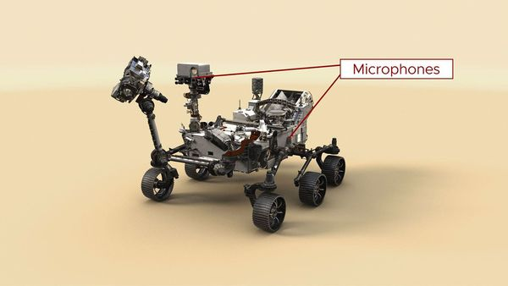

What is “Meta heuristics”?
- Consider vibration, energy loss and traction under each wheel shapes.
- Plan: shape -> size -> wheel speed

What is “CoppeliaSim”? [4]
CoppeliaSim is based on a distributed control architecture; each object / model can be individually controlled via:
  - an embedded script (Python or Lua)
  - a plugin (C, C++)
  - a remote API client (Python, Lua, Java, MATLAB, Octave, C, C++, Rust)
  - a custom solution
CoppeliaSim is used for fast algorithm development, factory automation simulations, fast prototyping and verification robotics related education, remote monitoring, safety double-checking as digital twin, and much more.
CoppeliaSim has 5 physics engines, which are MuJoCo, Bullet Physics, ODE, Newton and Vortex Dynamics for fast and customizable dynamics calculations, to simulate real-world physics and object interactions.
CoppeliaSim can calculate kinematics both of forward and inverse for any type of mechanism.
CoppeliaSim’s sensor simulation is powerful, realistic and exact volumetric proximity. It performs an exact minimum distance calculation within a customizable detection volume.
CoppeliaSim supports path planning and motion planning in a very flexible way via the OMPL library wrapped in a plugin.

Reference
[1]: Anne Helmenstine. (2025, Dec). Moon Facts. https://sciencenotes.org/moon-facts/
[2]: Anne Helmenstine. (2026, Jan). Mars Facts – Fourth Planet From the Sun. https://sciencenotes.org/mars-facts-fourth-planet-from-the-sun/
[3]: Nasa. (). Mars 2020: Perseverance Rover. https://science.nasa.gov/mission/mars-2020-perseverance/
[4]: COPPELIA ROBOTICS. (). . https://www.coppeliarobotics.com/

Next Step

English
- 構文
English | 日本語
This study defines… | 本研究では～を定義する。
This leads to… | これにより～が導かれる。
The following *** are considered. | 以下の～を検討する。
It is assumed that… | ～と仮定する。
It should be noted that… | ～である点に注意すべきである。
Under *** conditions, … | ～の条件下では、
In contrast to ***, … | ～とは対照的に、
This suggests that… | これは～を示唆する。
The trade-off between A and B must be examined. | AとBのトレードオフを検討する必要がある。

- 単語
English | 日本語
hypothesis | 仮説
brittle | もろい
soften | 柔らかくする
require | 必要とする
low | 低い
abrasion | 摩耗

