**Component 2**

**Student Name:** Kiran Dura

**Student ID:** 6837 (TBC ID)

**Faculty:** BSC in Computing

**Course:** Advanced Web Engineering (level 6 -Group ‘B’)

**Composer version installed**

I have installed the Composer as shown in the screenshot below:

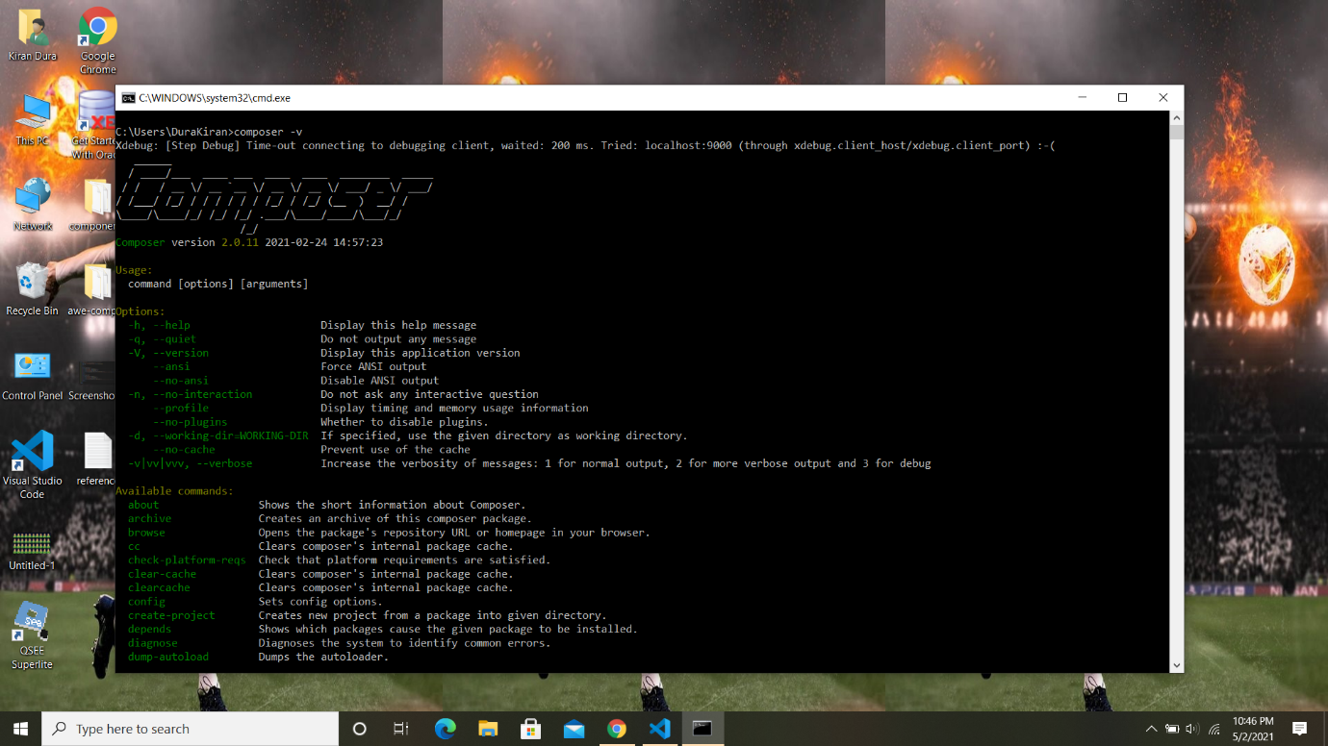

**Laravel version installed**

I have installed the Laravel as shown in the screenshot below:

Using via cmd :

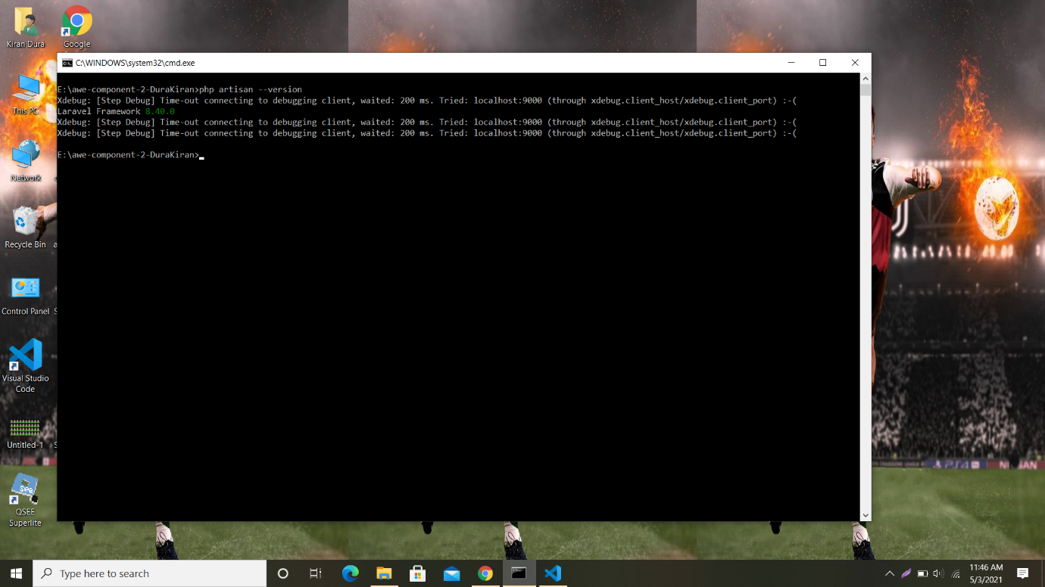

Using via manually:

