1. Download and install XAMPP 5.6.24 from site:

<https://sourceforge.net/projects/xampp/files/XAMPP%20Windows/5.6.24/>

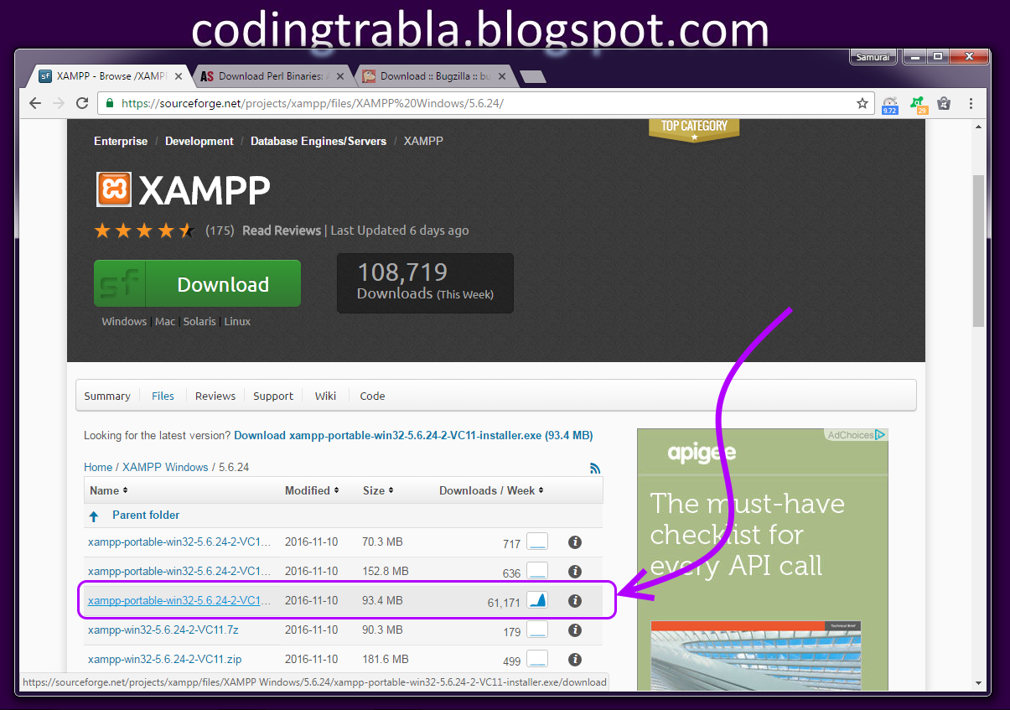

1. Download and install ActivePerl 5.24.0 for Windows ( x64 ) from official site

<http://www.activestate.com/activeperl/downloads>

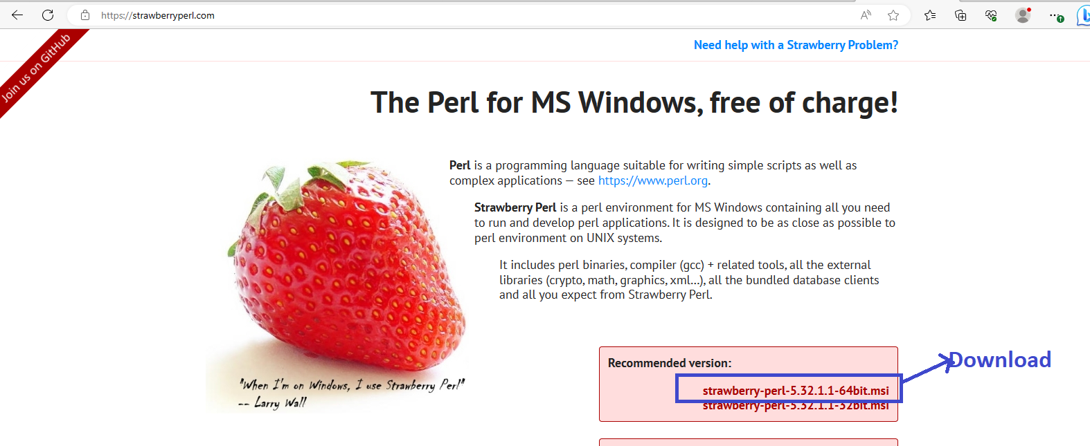

1. Download bugzilla latest version for below website.

Official site: <https://www.bugzilla.org/download/>

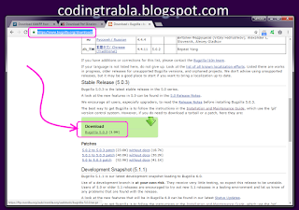

1. Extract bugzilla download zip file.(Use in software - Winrar & 7 zip)



1. Create folder bugzill in local C drive - C:\bugzilla

Note: copy all files from extract folder to c drive bugzilla folder

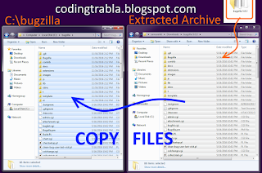

1. Run **XAMPP Control Panel   
   -**open **Apache( httpd.conf )** file ( **Apache ->  Config-> Apache( httpd.conf )** )

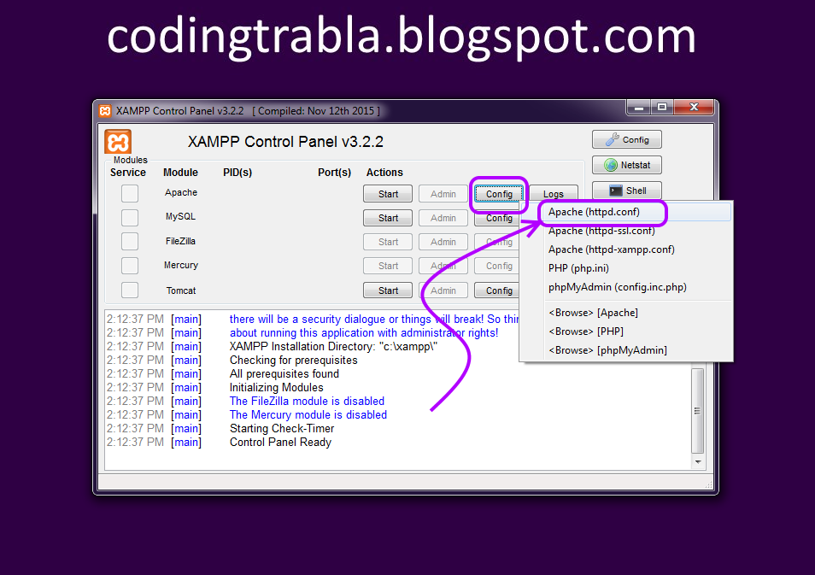

**add**following text string  
  
**Alias /bugzilla/ "C:/bugzilla/"**  
  
**after**text **ScriptAlias /cgi-bin/ "C:/xampp/cgi bin/"**

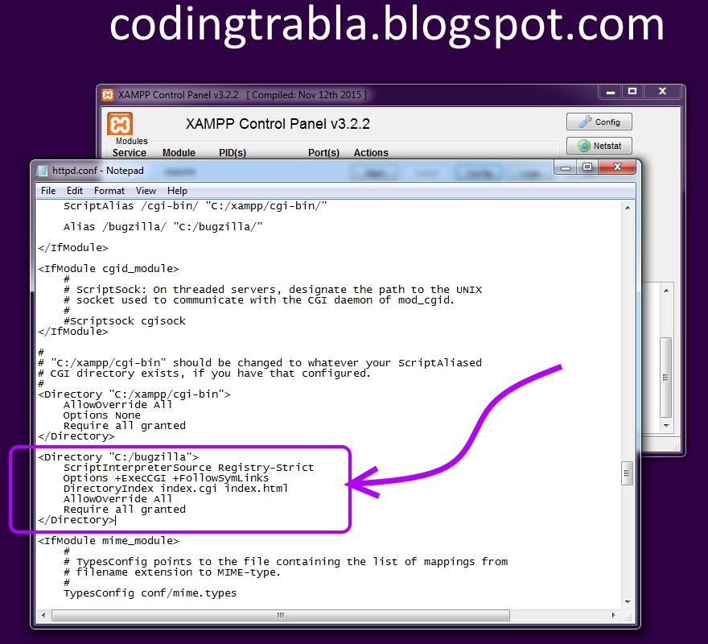

**after**text  
**<Directory "C:/xampp/cgi-bin">**  
**AllowOverride All**  
**Options None**  
**Require all granted**  
**</Directory>**  
**add**following text  
**<Directory "C:/bugzilla">**  
**ScriptInterpreterSource Registry-Strict**  
**Options +ExecCGI +FollowSymLinks**  
**DirectoryIndex index.cgi index.html**  
**AllowOverride All**  
**Require all granted**  
**</Directory>**

save  & close **Apache( httpd.conf )**

open **my.ini** file ( **MySQL->  Config-> my.ini** )

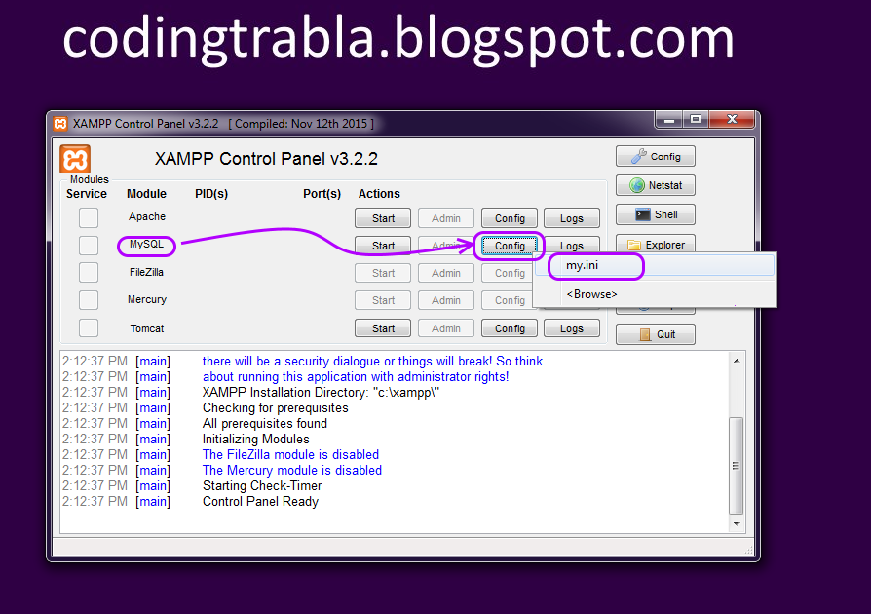

**Find max_allowed_packet**  
**change**value to **16M**  ( default is 1M )

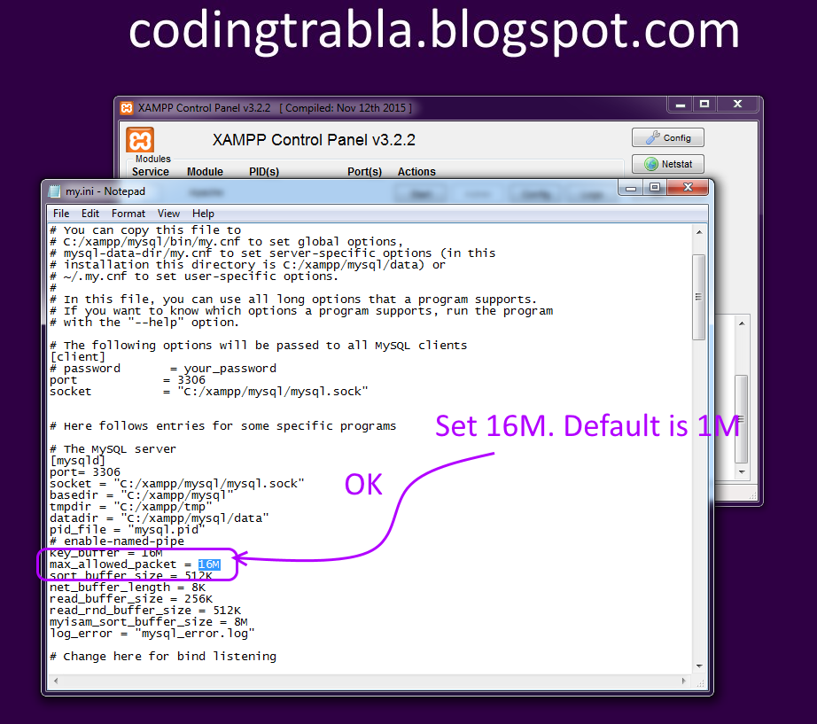

- **After**string  
**log_error = "mysql_error.log"**  
**add**text string  
**ft_min_word_len=2**

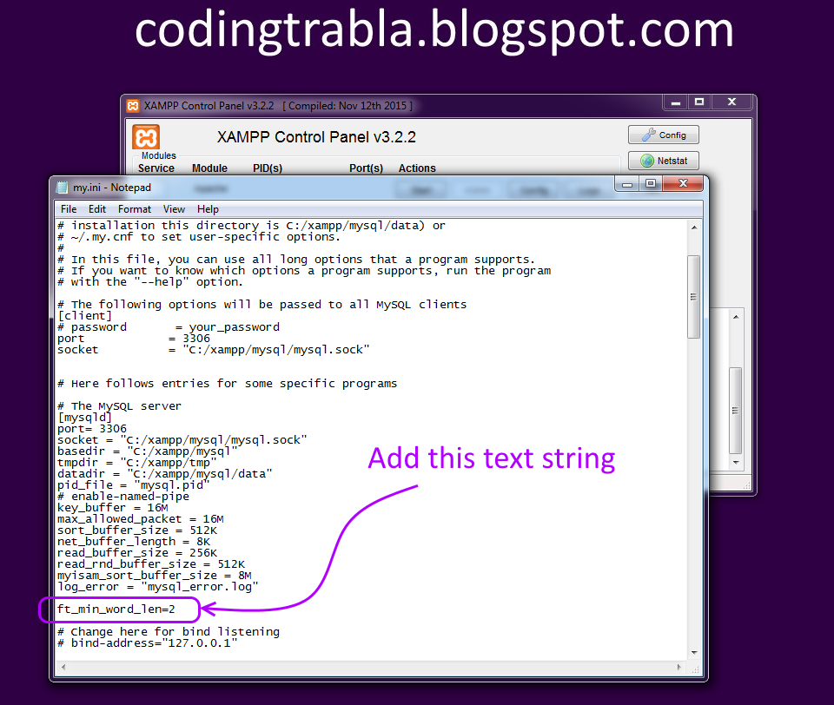

start **Apache** & **Database**

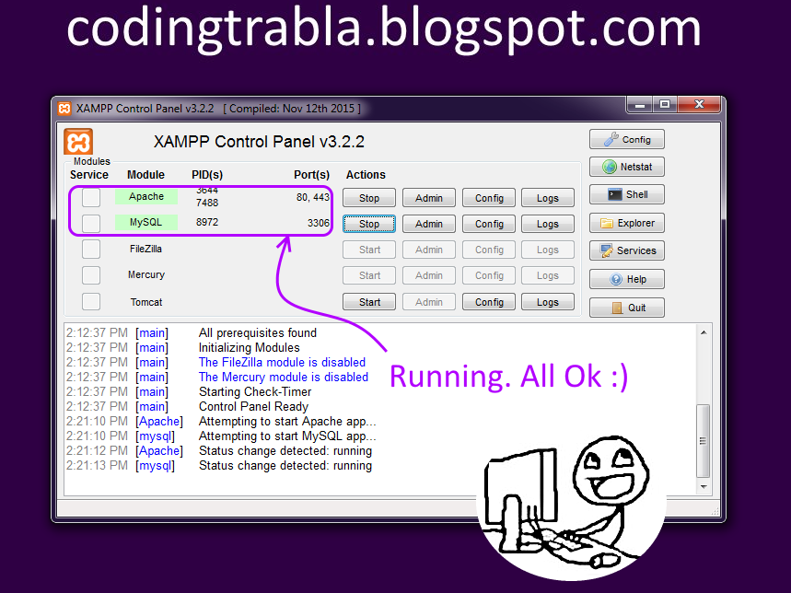

Now we need to create **Database**

1. Open phpMyAdmin in new browser tab (or window :) ) -  
     
    http://localhost:8080/phpmyadmin  
   **2)** Open SQL tab  
   **3)** Execute following query

**CREATE DATABASE `bugzilla`**  
**DEFAULT CHARACTER SET utf8 COLLATE utf8_general_ci;**  
**CREATE USER 'bugzilla-owner'@'localhost';**  
**CREATE USER 'bugzilla-owner'@'127.0.0.1';**  
**CREATE USER 'bugzilla-owner'@'::1';**  
**SET PASSWORD**  
**FOR 'bugzilla-owner'@'localhost' = PASSWORD('bugzilla123$%');**  
**SET PASSWORD**  
**FOR 'bugzilla-owner'@'127.0.0.1' = PASSWORD('bugzilla123$%');**  
**SET PASSWORD**  
**FOR 'bugzilla-owner'@'::1' = PASSWORD('bugzilla123$%');**  
**GRANT ALL PRIVILEGES ON**  
**`bugzilla`.* TO 'bugzilla-owner'@'localhost' WITH GRANT OPTION;**  
**GRANT ALL PRIVILEGES ON**  
**`bugzilla`.* TO 'bugzilla-owner'@'127.0.0.1' WITH GRANT OPTION;**  
**GRANT ALL PRIVILEGES ON**  
**`bugzilla`.* TO 'bugzilla-owner'@'::1' WITH GRANT OPTION;**

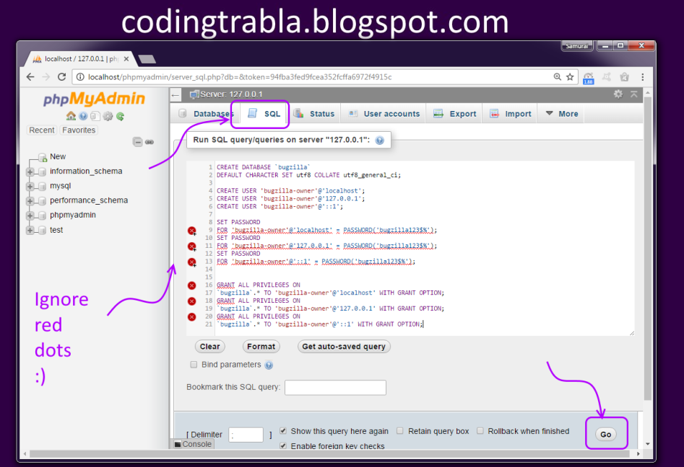

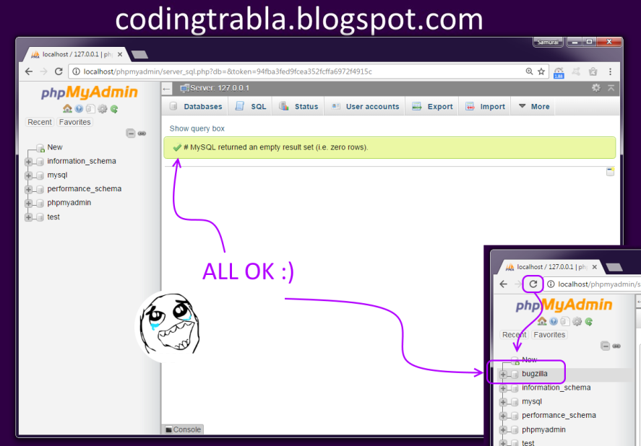

1. **Installation - Perl** 
   1. Open cmd
   2. Change directory file location for

cd c:\bugzilla

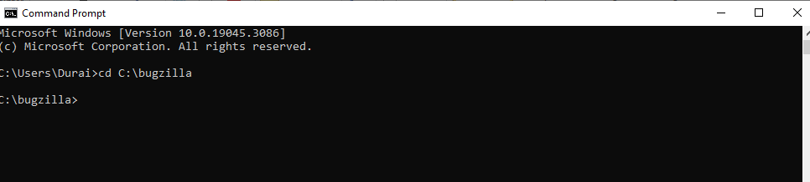

* 1. Type command - perl checksetup.pl

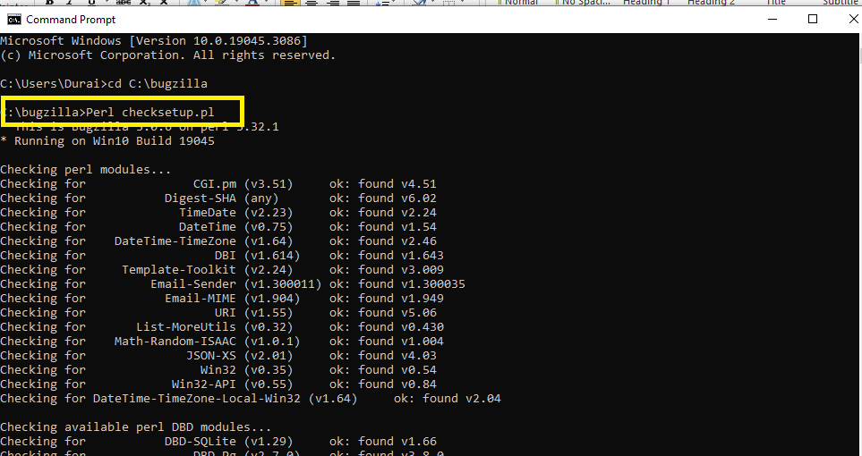

* 1. Copy and pasted for below commandin cmd:

C:\Strawberry\perl\bin\perl.exe install-module.pl --all

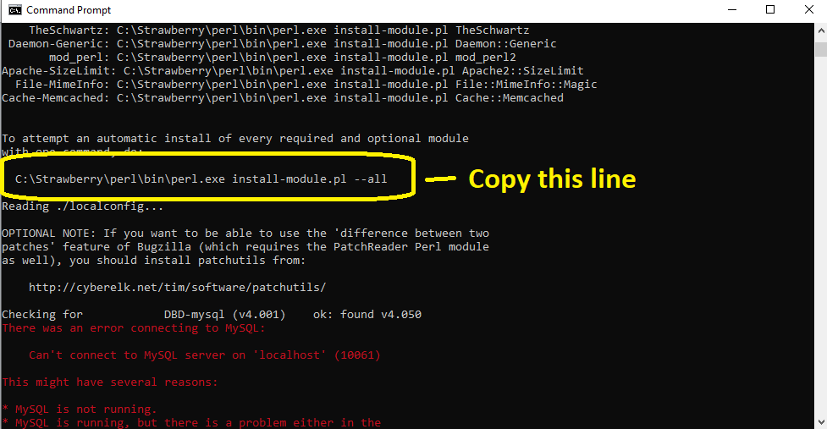

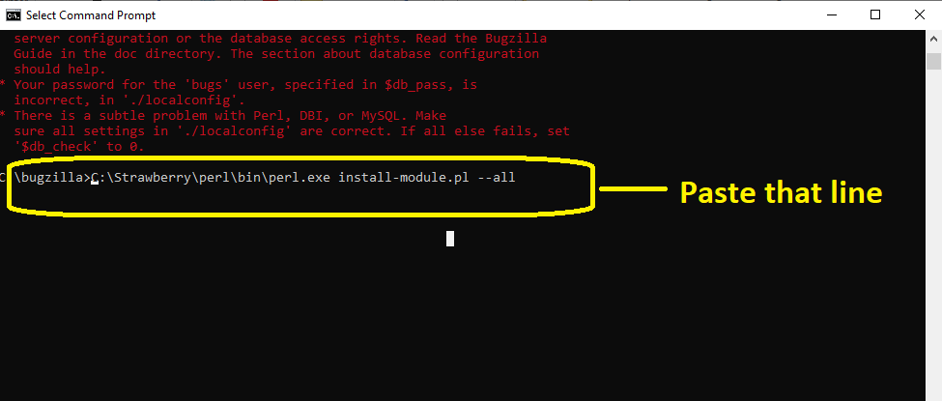

Note : Wait some time take to install strawberry.

* 1. Open local drive C - go to clock bugzilla folder - open file for "Localconfig" to notepad

C:\bugzilla\localconfig

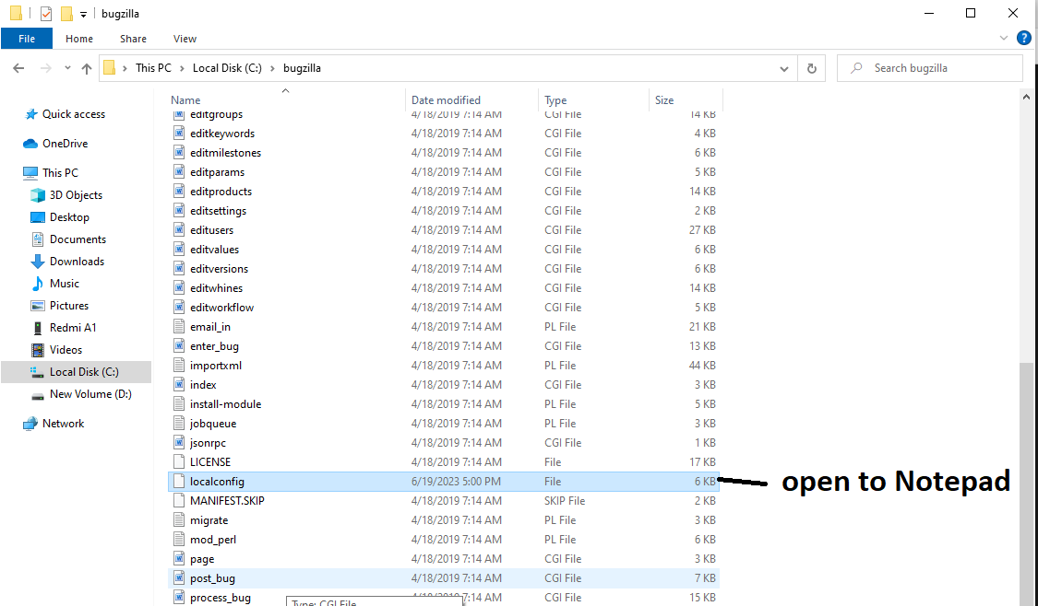

* 1. Configure some changes is file below.

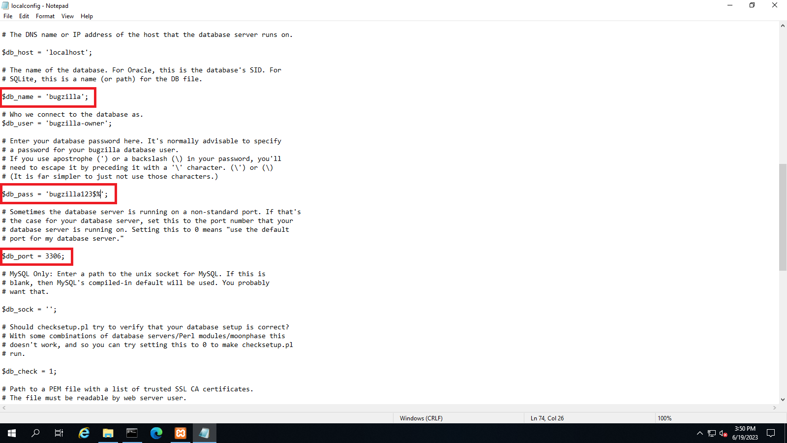

7. Go to-"Register editer"

a. Right Click "Computer\HKEY_CLASSES_ROOT"-create new key name ".cgi"

b. Right Click ".cgi"-create new key name "Shell"

c. Right Click "shell"-create new key name "ExecCGI"

d. Right Click "ExecCGI"-create new key name "Command"

e. Right Click "default"-click "modify" - set "Value Data" type "C:\Strawberry\perl\bin\perl.exe -T"

f. Close the register editer window.

1. Goto browser - Browse localhost:8080/bugzilla/
2. 