**Assignment -1**

Python Programming

|  |  |
| --- | --- |
| Assignment Date | 27 September 2022 |
| Student Name | A.Shanthini |
| Student Roll Number | 421319104025 |
| Maximum Marks | 2 Marks |

**Question-1:**

Write a program to test a given number is prime or not

**Solution:**

|  |
| --- |
| n=5 |
|  | if(n%2)==0: |
|  | print("n is not a prime") |
|  | else: |
|  | print("n is a prime") |

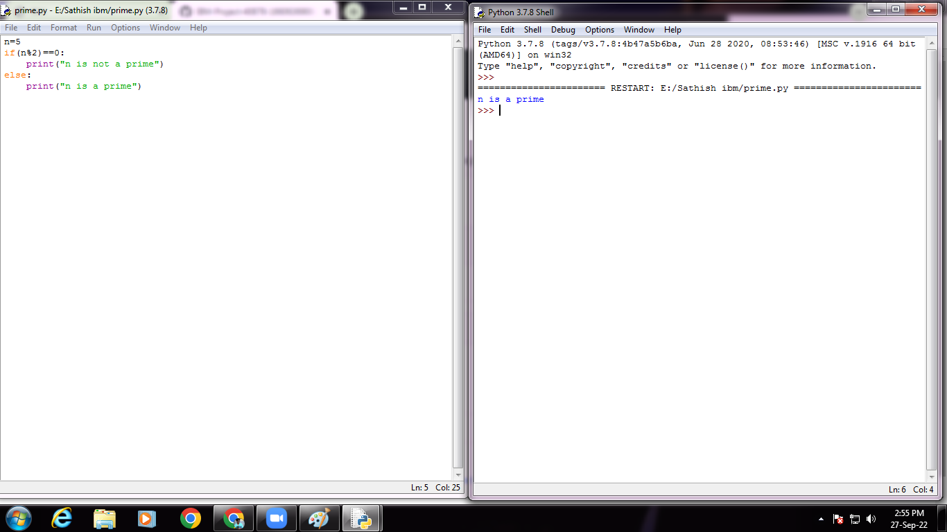

**Question-2:**

Write a python program to generate odd numbers from m to n using while loop

**Solution:**

|  |
| --- |
| List=[23,65,76,12,19,98,43,61] |
| i=0 |
| while(i<8): |
| if(list[i]%2)!=0: |
| print(list[i]) |
| i+=1 |

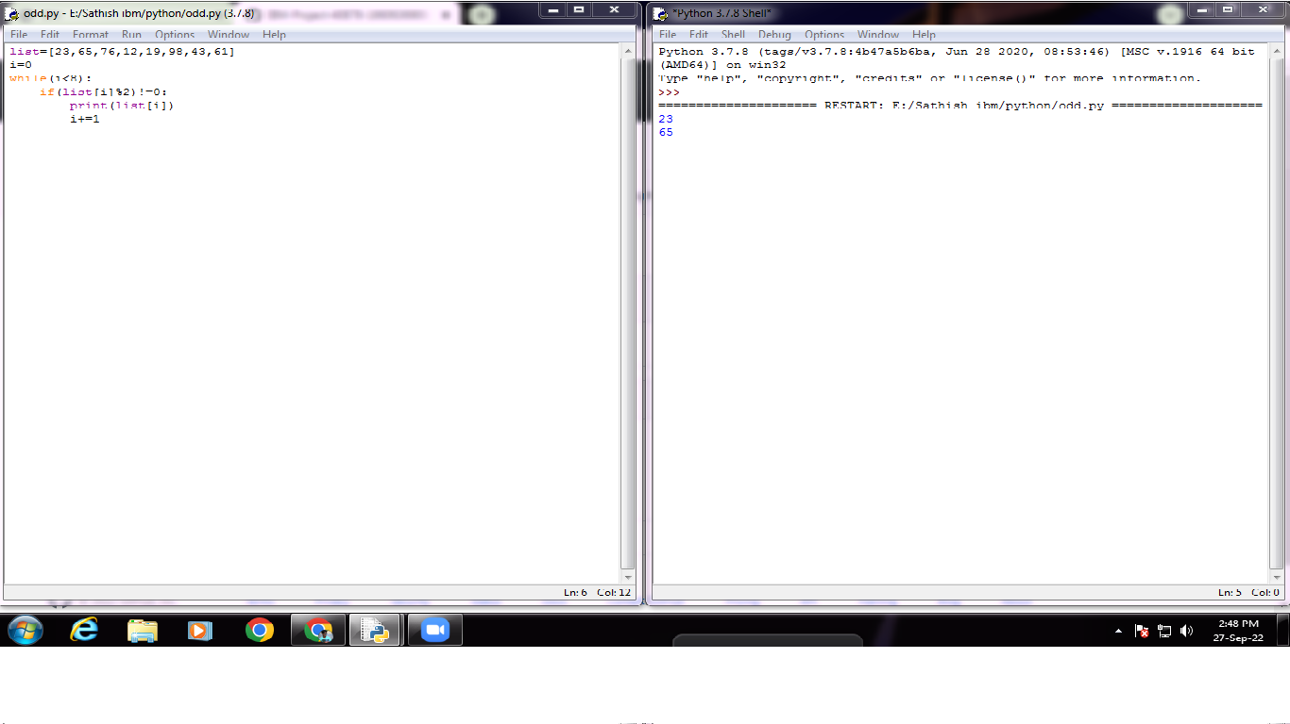

**Question-3:**

Write a python program to display prime number series up to given number

**Solution:**

|  |
| --- |
| start=int(input("enter the starting range:")) |
| end=int(input("enter the ending range:")) |
| for num in range(start,end+1): |
| if num>1: |
| for i in range(2,num): |
| if (num%2)==0: |
| break |
| else: |
| print(num) |
| **C:\Users\NETWORK LAB\Downloads\Prime series (1).png**  **Question-4:**  Write a python program to generate Fibonacci series |

**Solution:**

|  |
| --- |
| num=10 |
| n1,n2=0,1 |
| print("Fibonacci series are:") |
| for i in range(0,num): |
| n3=n1+n2 |
| n1=n2 |
| n2=n3 |
| print(n3) |

