1. Download a OVPN file from any of OVPN service providers ( in my case I take VPNGate)

2. Open it using a text editor

3. Now we're going to create certificates from this
i. Copy the text that is in between <ca> </ca> and save it as
ca_base64.crt(if it contains begin certificate end certificate go to step 6)
ii. Copy the text that is in between <cert></cert> and save it as
clientcert_base64.crt(if it contains begin certificate end certificate go to step 6)
iii. Copy the text that is in between <key></key> and save it as
clientkey_base64.key(if it contains begin key end key go to step 6)

4. Now we're going to decode the base64 encoded certs and keys

openssl base64 -d -in ca_base64.crt -out ca.crt
openssl base64 -d -in clientcert_base64.crt -out clientcert.crt
openssl base64 -d -in clientkey_base64.key -out clientkey.key

5. Now we're going to convert the certs and keys as PEM encoding from DER

openssl x509 -inform der -in ca.crt -out ca.pem
openssl x509 -inform der -in clientcert.crt -out clientcert.pem
openssl rsa -inform der -in clientkey.key -out clientkey.pem

6. Now we're going to create P12 file

openssl pkcs12 -export -out clientp12.p12 -inkey clientkey.pem -in clientcert.pem -certfile ca.pem

FYI: It'll ask for password and give something and remember it.

7.Verify the P12 file using the following command

openssl pkcs12 -in client.p12 -nodes -passin pass:"password of p12" | openssl x509 -noout -subject

8. Open up the iPhone Configuration utility

9. Choose Configuration Profiles and you can select General

The things that are filled in below diagram can be varied.Its our choice
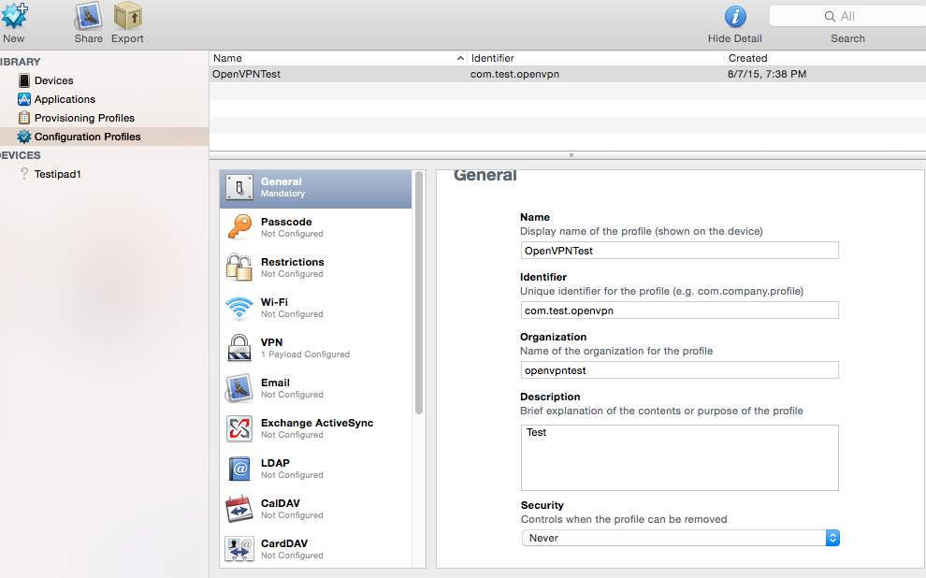

10. Choose Credentials then click on Configure on right side

A dialog box will come choose the p12 file that is created and give the password that is given for the
p12 file

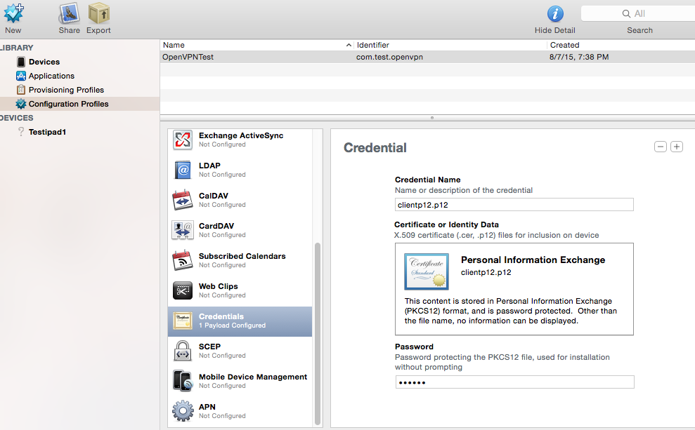

11. Choose VPN and

i. In the rght side choose Connection Type as Custom SSL
ii. Give net.openvpn.OpenVPN-Connect.vpnplugin for Identifier
iii. Give anyname for Connection Name,Account
iv. In OVPN file copy what is right side of remote keyword and paste it on Server
v. In the User Authentication choose Certificate and in the Credential you have to choose the p12 file
that was added earlier
vi.Check Enable VPN On Demand
add plus Match domain or host give *
choose Always Establish in On Demand Action
vii. In Custom Data click plus
Copy the key and values from OVPN and add as Key and value in custom data one by one by clicking plus
If there is no value then add Key and leave the value as value

We have to add ca as key and value as what is in between <ca></ca> and we have to add \n correctly

<key>ca</key>

<string>-----BEGIN CERTIFICATE-----\n

MIIE5TCCA82gAwIBAgICAnowDQYJKoZIhvcNAQEFBQAwga8xJTAjBgkqhkiG9w0B

CQEWFmNlcnRzQGNsZWFycGF0aG5ldC5jb20xCzAJBgNVBAgTAkNBMQswCQYDVQQG

EwJVUzEsMCoGA1UEA
-----END CERTIFICATE-----\n

-----BEGIN CERTIFICATE-----\n

dfg
-----END CERTIFICATE-----

</string>

Note:

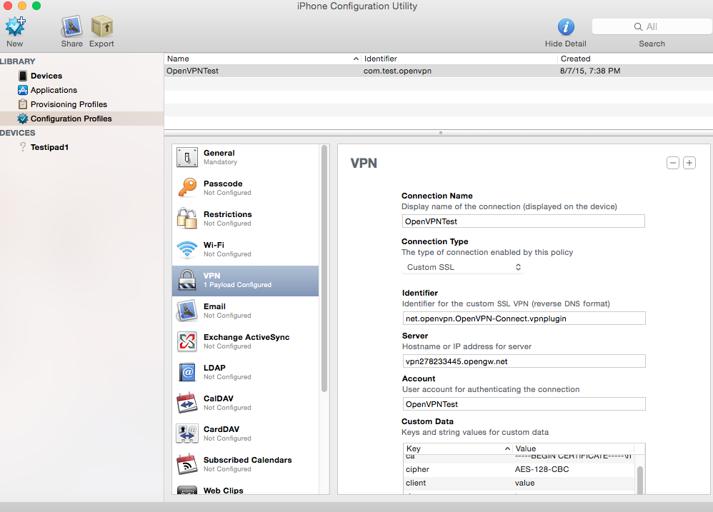

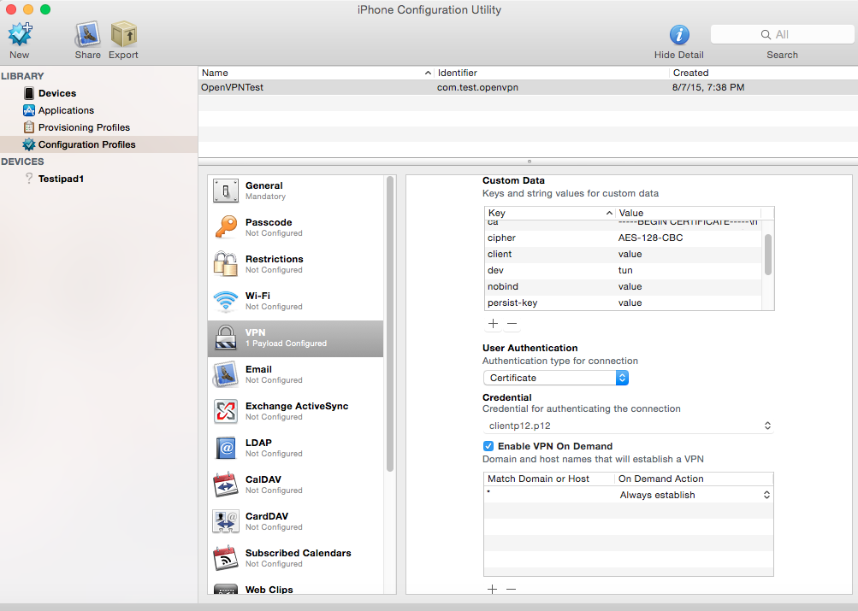

12 . You can install the profile like this on device directly

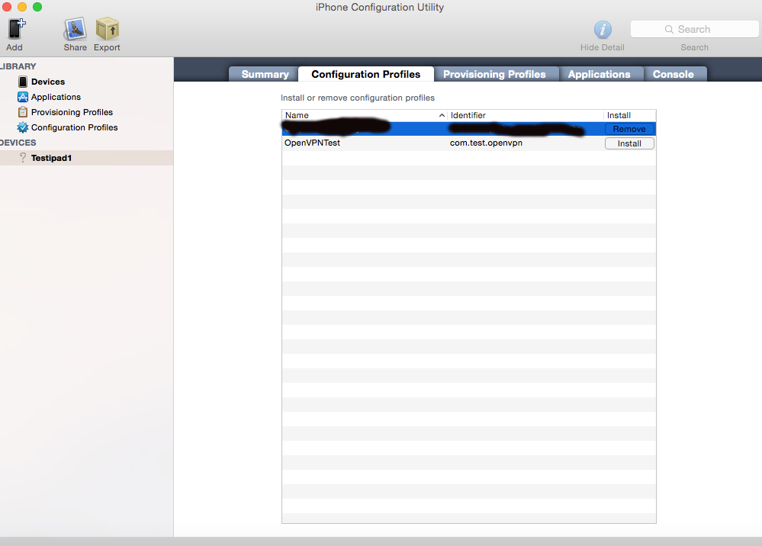

or we can export it from iPCU and send it through mail to install it on the device

Here are the screenshots for things that happens while installing the profile

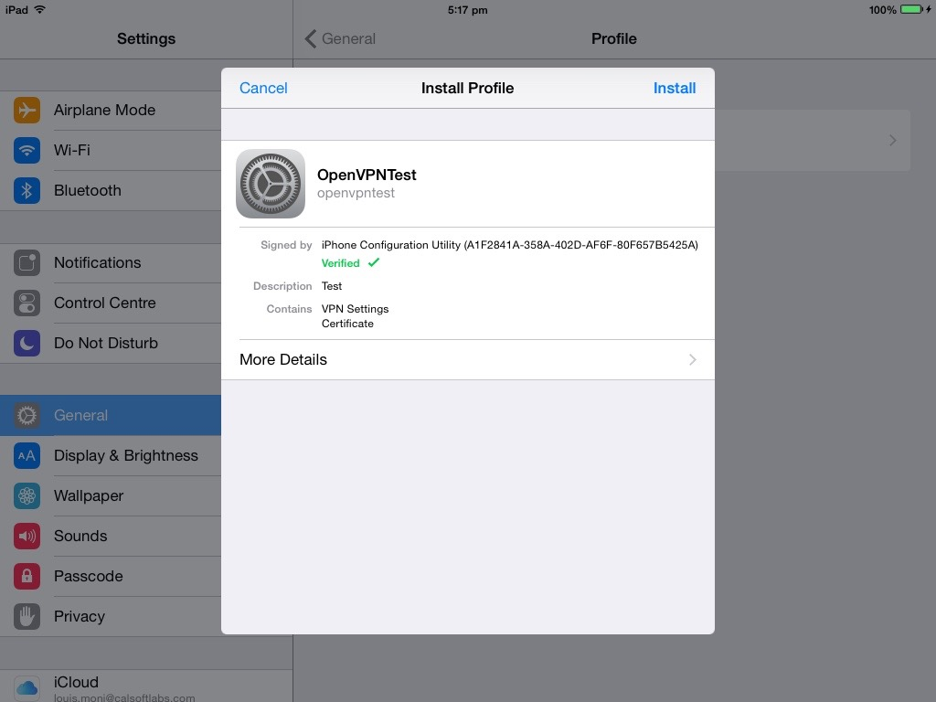

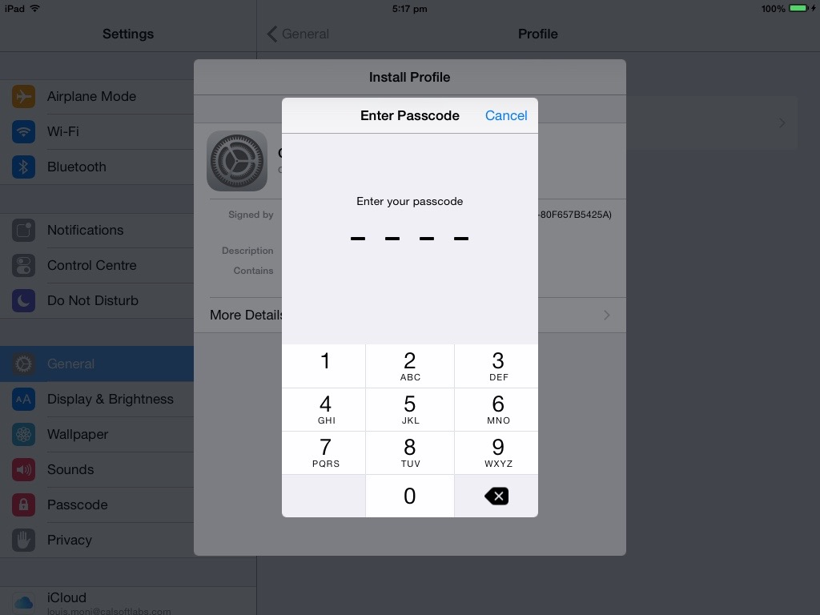

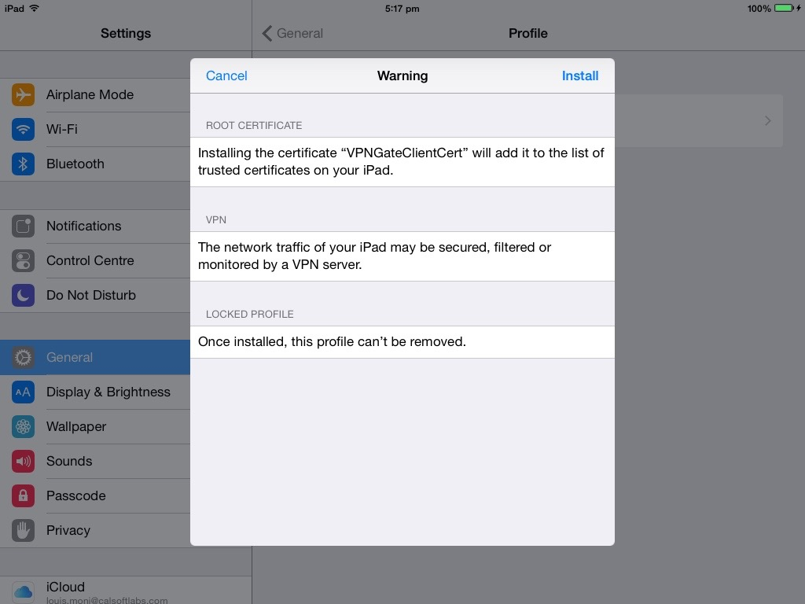

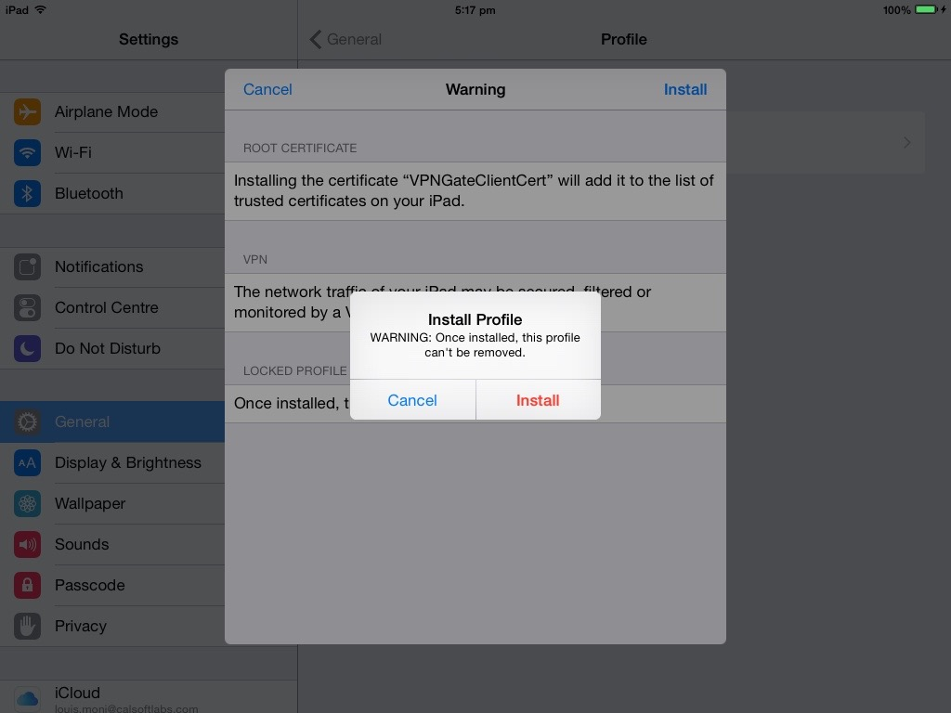

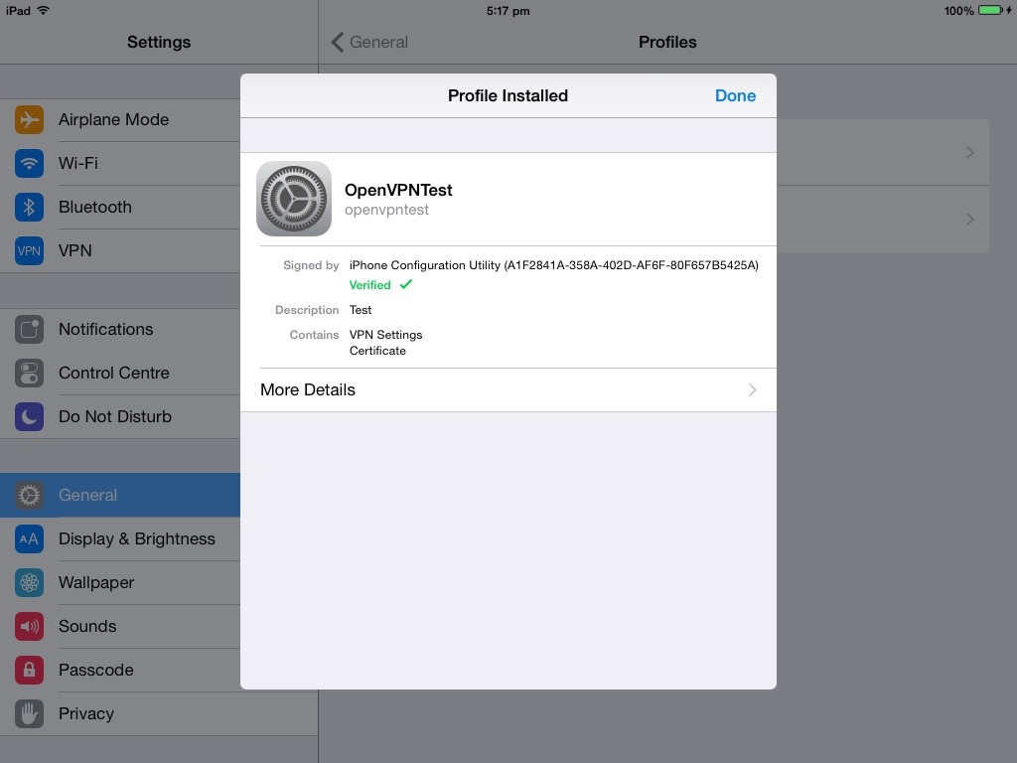
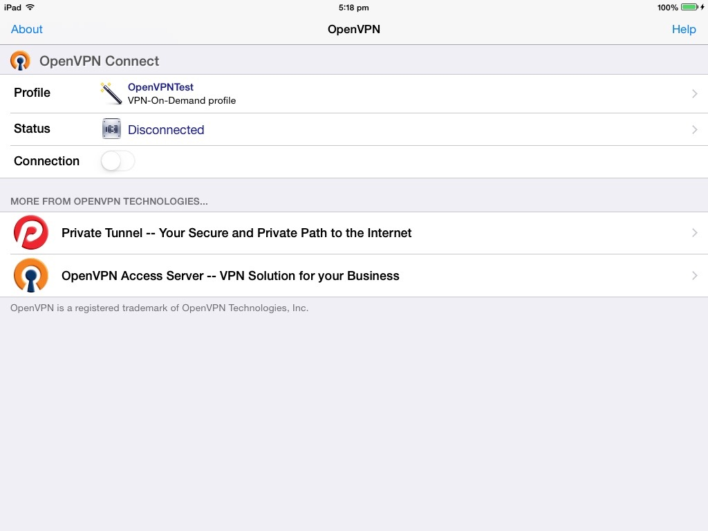

You should have installed OpenVPN Connect for this whole VPN process to work

Note:

Using OVPN directly into OpenVPN Connect

1. You can import .ovpn file into OpenVPN Connect by directly going into iTunes and using iTunesFileSharing you can import it into the app.

By this way you can compare if you have created right mobile config for ovpn

2. You can mail the OVPN file to you by clicking you can install it on the device.

Here is the link to OpenVPN Connect FAQ

https://docs.openvpn.net/docs/openvpn-connect/openvpn-connect-ios-faq.html

Here is the link to OpenVPN Connect App

itms-apps://itunes.apple.com/us/app/openvpn-connect/id590379981?mt=8&uo=4

