KnowledgeHub Redux – Flow of Execution

What the app does
KnowledgeHub is a small articles app. A user logs in, sees a dashboard with totals, browses articles, and can Like or Favourite each one. Data comes from a mock API (json-server on port 3001).
It uses the same idea as the Multiple Slices demo, one store with two slices, plus two new things:
- Async thunks (createAsyncThunk): login and article loading call the API, so each dispatch produces pending then fulfilled or rejected actions.
- Selectors in the slice file: components never write state.auth.user directly; they call selectCurrentUser, selectDashboardStats, and so on.

Piece | What it does in this app | File
createSlice (x2) | auth slice (who is logged in) and articles slice (the list + loading status) | authSlice.ts, articlesSlice.ts
createAsyncThunk (x2) | loginUser calls GET /users; fetchArticles calls GET /articles | authSlice.ts, articlesSlice.ts
extraReducers | Handles the thunk's pending / fulfilled / rejected actions | both slice files
createSelector | selectDashboardStats works out totals and only recalculates when articles change | articlesSlice.ts
configureStore | reducer: { auth, articles }; thunk support and DevTools built in | store/store.ts
Typed hooks | useAppSelector and useAppDispatch so TypeScript knows the state shape | store/hooks.ts
Provider | One store for the whole app, wrapped around the router | main.tsx

User does | Actions dispatched (in order) | Result on screen
Opens the app | none | Redirected to /login
Logs in with a wrong password | auth/login/pending, auth/login/rejected | "Incorrect username or password."
Logs in as anita / anita123 | auth/login/pending, auth/login/fulfilled, articles/fetchAll/pending, articles/fetchAll/fulfilled | /dashboard: Welcome back, Anita · 6 Articles · 51 Total likes · 3 Favourites
Opens Articles | none (data already in the store) | 6 cards; article 1 shows Likes: 12
Clicks Like on article 1 | articles/likeArticle | Likes: 13
Clicks Favourite on article 1 | articles/toggleFavourite | ★ Favourite badge; button says Unfavourite
Opens article 1 | none | Detail page shows Likes: 13 and ★ Favourite
Back to Dashboard | none | 52 Total likes · 4 Favourites
Clicks Logout | auth/logout | Back to /login
Logs in as rahul / rahul123 | auth/login/pending, auth/login/fulfilled (no fetch) | Welcome back, Rahul · still 52 likes · 4 Favourites
Reloads the browser | none | Back to /login; the store starts empty again

Files touched
Moving from Context API to Redux added four files and changed every component that shares state. ArticlesContext.tsx was removed.

Redux files (new)
File | Role | Key code
src/store/store.ts | The one store | configureStore({ reducer: { auth: authReducer, articles: articlesReducer } }); exports RootState, AppDispatch
src/store/hooks.ts | Typed hooks | useAppDispatch = useDispatch.withTypes<AppDispatch>(), useAppSelector = useSelector.withTypes<RootState>()
src/features/auth/authSlice.ts | Login state | loginUser thunk; logout reducer; selectors selectCurrentUser, selectAuthStatus, selectAuthError
src/features/articles/articlesSlice.ts | Articles state | fetchArticles thunk; likeArticle, toggleFavourite reducers; selectors incl. selectArticleById, selectDashboardStats

Components (changed)
File | Reads from the store | Dispatches
src/main.tsx | – | – (wraps the app in <Provider store={store}>)
src/App.tsx | selectCurrentUser (drives the route guards) | fetchArticles() once a user is logged in
src/Login.tsx | selectAuthStatus, selectAuthError | loginUser({ username, password })
src/Header.tsx | selectCurrentUser | logout()
src/Dashboard.tsx | selectCurrentUser, selectArticlesLoading, selectArticlesError, selectDashboardStats | –
src/ArticleList.tsx | selectAllArticles, selectArticlesLoading, selectArticlesError | –
src/ArticleCard.tsx | – (gets the article as a prop) | likeArticle(id), toggleFavourite(id)
src/ArticleDetail.tsx | selectArticleById(state, id), loading, error | likeArticle(id), toggleFavourite(id)

No Redux code: Footer.tsx, NotFound.tsx, types.ts (shared Article and User types).
The state shape:
{
auth: { // owned by authSlice.ts
user: null, // User object after login
status: 'idle', // 'idle' | 'loading' | 'failed'
error: null
},
articles: { // owned by articlesSlice.ts
items: [], // Article[] after fetch
status: 'idle', // 'idle' | 'loading' | 'succeeded' | 'failed'
error: null
}
}

Flow of execution
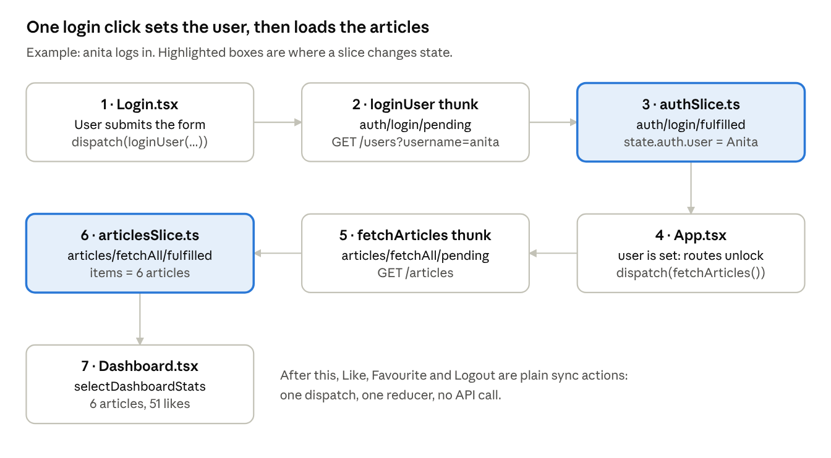

login click · 2 thunks, 2 slices, 7 steps
One click on Login sets off two async thunks in a row: loginUser fills the auth slice, and that change makes App dispatch fetchArticles, which fills the articles slice. The Dashboard then reads both slices. A wrong password stops at step 2: the thunk dispatches auth/login/rejected and Login shows the error from state.auth.error.

Step by step

Phase A: app starts (runs once)
- main.tsx imports store from ./store/store, which runs store.ts.
- store.ts imports authReducer and articlesReducer. Importing each slice file runs its createSlice and createAsyncThunk calls.
- store.ts calls configureStore({ reducer: { auth, articles } }). State is { auth: { user: null, status: 'idle', error: null }, articles: { items: [], status: 'idle', error: null } }.
- main.tsx renders <Provider store={store}> → <BrowserRouter> → <App />.
- App.tsx reads selectCurrentUser → null. The route guards send the user to /login. Header and Footer are hidden. No actions have been dispatched yet.

Phase B: user logs in (async)
- Login.tsx keeps the username and password in local useState (form fields are not Redux state). On submit it runs await dispatch(loginUser({ username, password })).unwrap().
- The loginUser thunk dispatches auth/login/pending. The auth reducer sets status = 'loading', so the button shows it is busy.
- The thunk calls GET http://localhost:3001/users?username=anita with axios and compares the password.
- Password matches → the thunk returns the user, and RTK dispatches auth/login/fulfilled with the user as payload. The reducer sets state.auth.user = { id: 1, name: 'Anita', … }.
  - Password wrong → rejectWithValue('Incorrect username or password.') → auth/login/rejected → state.auth.error is set and Login shows it. The flow stops here.
- unwrap() resolves in Login, which calls navigate('/dashboard').
- App.tsx re-renders because selectCurrentUser changed. The route guards now allow /dashboard, Header and Footer appear, and the useEffect runs dispatch(fetchArticles()).

Phase C: articles load (async)
- The fetchArticles thunk first runs its condition: status is 'idle', so it continues. (If articles were already loaded, it would stop here without a request.)
- It dispatches articles/fetchAll/pending → status = 'loading'. Dashboard shows "Loading dashboard…".
- It calls GET /articles, gets 6 articles, and RTK dispatches articles/fetchAll/fulfilled → items = [6 articles], status = 'succeeded'.
- Dashboard.tsx re-renders. selectDashboardStats (a createSelector) adds up the totals: 6 articles, 51 likes, 3 favourites.

Phase D: Like, Favourite, Logout (sync)
- ArticleCard.tsx Like → dispatch(likeArticle(1)) → { type: 'articles/likeArticle', payload: 1 } → the reducer finds article 1 and runs article.likes += 1 (Immer makes a new object). ArticleList, ArticleDetail and Dashboard all see 13 likes because they read the same store.
- Favourite → dispatch(toggleFavourite(1)) → article.isFavourite = !article.isFavourite.
- Header.tsx Logout → dispatch(logout()) → the auth reducer sets user = null. App re-renders and the guards send the user back to /login.

What changes

State on each action
Action | Slice | auth after | articles after
(start) | – | user: null, status: 'idle' | items: [], status: 'idle'
auth/login/pending | auth | status: 'loading' | unchanged
auth/login/rejected (wrong password) | auth | status: 'failed', error: 'Incorrect username or password.' | unchanged
auth/login/fulfilled | auth | user: Anita, status: 'idle' | unchanged
articles/fetchAll/pending | articles | unchanged | status: 'loading'
articles/fetchAll/fulfilled | articles | unchanged | items: 6 articles, status: 'succeeded'
articles/likeArticle (id 1) | articles | unchanged | article 1 likes: 12 → 13
articles/toggleFavourite (id 1) | articles | unchanged | article 1 isFavourite: false → true
auth/logout | auth | user: null, status: 'idle' | unchanged (items and likes kept)

Multiple Slices demo vs KnowledgeHub
 | Multiple Slices demo | KnowledgeHub
Slices | counter + cart | auth + articles
Where data comes from | Starting values in the slice | A mock API (json-server)
Kinds of action | Sync only | Sync (likeArticle, toggleFavourite, logout) + async thunks (loginUser, fetchArticles)
Handling thunk results | – | extraReducers with pending / fulfilled / rejected cases
Loading and errors | – | status and error fields in each slice
Reading state | Inline state => state.cart.itemCount | Named selectors in the slice file, plus createSelector for derived totals
Hooks | useSelector / useDispatch | Typed useAppSelector / useAppDispatch from store/hooks.ts
Router | None | React Router; route guards read selectCurrentUser

